**Do Now: Geometry pre-quiz problems**

*For problems 1-7, select the best geometry statement from the right section that would set up an equation after variables are substituted. (some can be used multiple times)*

**Geometry statements**

1. *AB* = *BC*
2. *AB* + *BC* = *AC*

$m∠ABC+m∠DEF=90$

$m∠ABC+m∠DEF=180$

$m∠ABC=m∠DEF$

**1.** Given that 

**2.** Given two supplementary angles,  and .

**3)** Given that *AB =* 5*x*, *BC = x* + 2, and *AC = 20*.

*C*

*B*

*A*

**4)**  and  are congruent angles.

**5)** Point *B* bisects .

6) Given the figure

Angle ABC Angle DEF

**7)** Points *A, B,* and *C* are collinear and *B* bisects $\overline{AC}$.

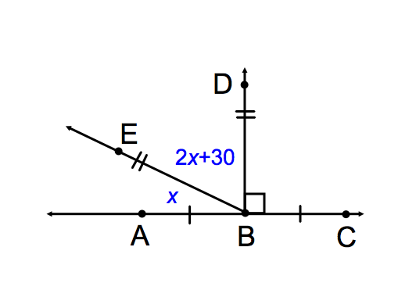**8)**Write a geometric statement, followed by an algebraic substitution, for the given diagram.

*The following pairs do not mean the same thing. Explain what they mean and what the difference is. Use complete sentences.*

**9)  , **

**10)  , **