**2.5 Distance Formula Homework**

*Find the distance between each pair of points.*

*If it cannot be simplified, leave in radical form*

**1.** *K*(0, 5), *L*(7, 9) Write the Distance Formula.

Substitute (0, 5) for (*x*1, *y*1) and (7, 9) for (*x*2, *y*2).

 = 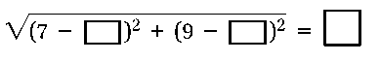

**2.** *C*(−2, 6), *D*(10, −8) **3.** *W*(−3, −5), *X*(−9, 4)

**4.** *G*(−12, −11), *H*(5, −9) **5.** *A*(6, 2), *B*(−3, −1)