**Test: Analytic Geometry**

*Justify all answers with proper notation and calculations. Leave fractions in simplest terms.*

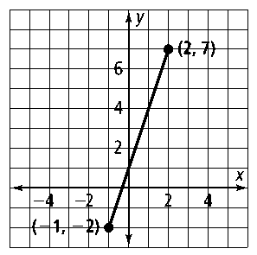1. What is the slope of the line segment to the right?

2. What is the slope of the line containing   
the points (1, 6) and (5, 4)?

3. What is the slope of the line represented by the equation **?**

Use the given information to find the equation of the line. *You may use point-slope or slope-intercept form.*

4. Slope of –2 and passes through the point (0, 1)

5. Passes through points (2, 1) and (–3, 5)

State the slopes of $\overline{LM}$ and $\overline{QR}$*.* Then determine whether $\overline{LM}$ and $\overline{QR}$ are *parallel, perpendicular,* or *neither.* Justify your answer.

6. *L*(–2, –4), *M*(8, 6) *Q*(6, –4), *R*(–2, 4)

7. *L*(2, 1), *M*(4, –2), *Q*(2, 6), *R*(6, 0)

Determine whether the following pairs of lines are *parallel, perpendicular,* or *neither.*

8.  9.*y* = 3*x* − 2

3*x* + *y* = 2 −3*x* + *y* = 5

For questions 10-14 use the diagram on the right with parallel lines, *a*||*b & c*||*d.*

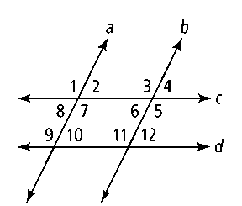

10. ∠2 and ∠10 are what kind of angles?

11. ∠3 and what angle are alternate interior angles?

12. ∠9 and ∠8 are what kind of angles?

13. If *m*∠2 = 55˚ then *m*∠3 = _________

14. If *m*∠4 = 70˚ then *m*∠11 = _________

15. In the given diagram the lines *x* || *y*, and  and . Solve for *x*.



16. Given with ,  and. What is the measure of angle *B*?

A

B

C

17. Two angles of a triangle measure 45 and 100 degrees respectively. What is the measure of the third angle?

18. Right triangle *ABC* shown at right. and.   
  
What is the measure of angle C?

A

B

C

19. In the diagram of  at right,  is extended through *H. (not to scale)*

E

F

G

H



What is the measure of the external ?

20. Applying slope: Plot and label : A(-3, -3), B(1, 5), C(7, 2)

Calculate the slopes of the triangle’s legs:

a) Slope  =

b) Slope  =

c) Slope  =

21. What is the equation of the line ?

22. What is the equation of the line ?

23. Are the two lines  and $\overset{⃡}{BC}$ parallel, perpendicular, or neither. Justify your answer.

24.

**

25. What is the equation of a line through (1, 5) and *perpendicular* to *y* = (3/2)*x* + 3 ?

26. What is the equation of a line *perpendicular* to 2*x* + *y* = 1 through (-2, 4)?

27.

