3.1 & 3.2 Extension Problems

*+1 HW extra credit point for every correct problem with ALL work shown*

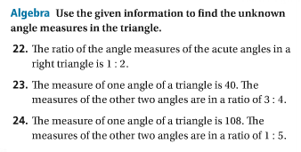

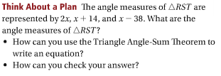

Screen%20Shot%202016-10-18%20at%209.48.54%20AM.png

