3.10 Homework

*There are multiple ways to do the following proof.*

*Write two separate two column proofs for the following problem*

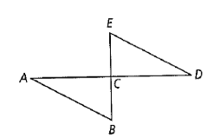

Given:

In the figure, AB || ED and C is the midpoint of both EB and AD.

Prove:

∆*ABC* ≅ ∆*DEC* in 2 different ways.