**Homework Review: Tools of Geometry on the Coordinate Plane**

Midpoint and Distance

1. FG has endpoints *F* (−2, 3) and *G* (1, 1). What are the coordinates of its midpoint?
2. M is the midpoint of *AB* and is located at M(3, 5). A is located at A(1,2). What is the coordinate of the other endpoint, B?
3. What is the distance between points *D* (32, 4) and *E*(20, 8)?

Directed Line Segments

1. Plot the line segment XZ with endpoints X(-4,5) and Z(6,10). Point Y is on XZ such that XY:YZ is 2:3. Find the coordinates of point Y. Plot it on the grid.

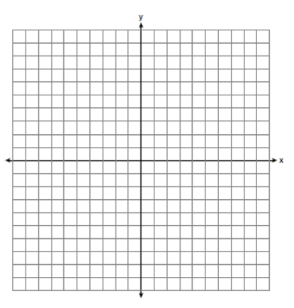

Equations of Lines

Use the given information to write the equation of the line.

1. slope  and *y*-intercept 4
2. What is the slope of the line perpendicular to ?

Parallel and Perpendicular Lines

Find the slope of  and *****.* Then determine whether  and  are *parallel, perpendicular,* or *neither.* Explain.

1. *L*(10, 2), *M*(6, –6), *Q*(10, 6), *R*(9, 4)
2. *L*(–3, 8), *M*(2, –7), *Q*(14, 16), *R*(10, 4)

Spiral Review – Two Parallel Lines cut by a Transversal

1. 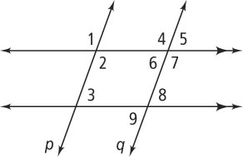Name a pair of the following type of angles:
   1. Corresponding
   2. Alternate interior
   3. Vertical
   4. Same-side interior
   5. Same-side exterior
2. *m*∠2 = 50 and *m*∠3 = _______ ? **11.** *m*∠4 = 100 and *m*∠2 = _________ ?
3. *m*∠1 = 75 and *m*∠3 = _________ ? **13.** *m*∠5 = 110 and *m*∠8 = __________ ?