**Classwork:** Review + Extension Problems

*Use loose leaf paper. Show work*

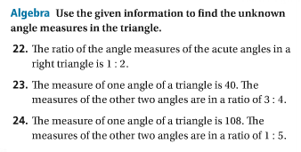

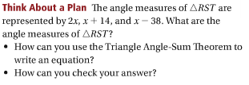

Screen%20Shot%202016-10-18%20at%209.48.54%20AM.png

