BECA/Dr. Huson/Geometry Name:

16 Jan 2019

**Inverse Trig**

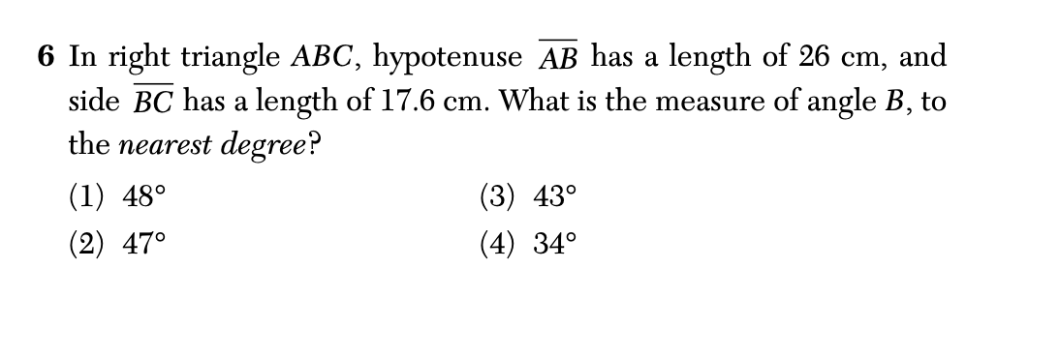

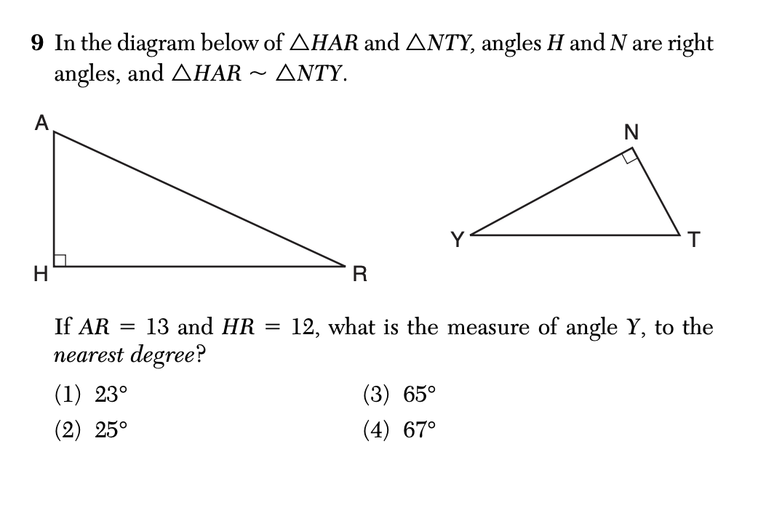

1. a

BECA/Dr. Huson/Geometry Name:

16 Jan 2019

**Similar Right Triangles**

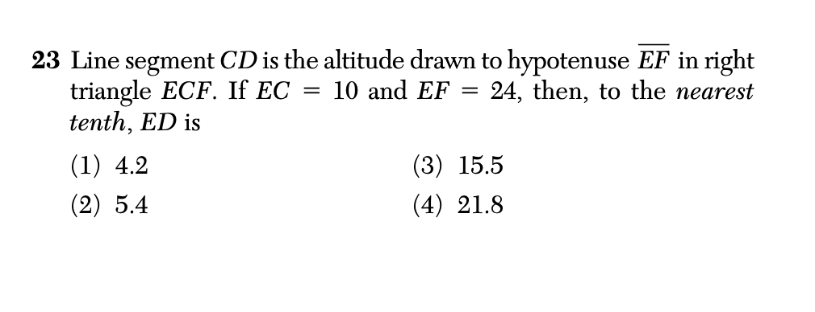

1. A

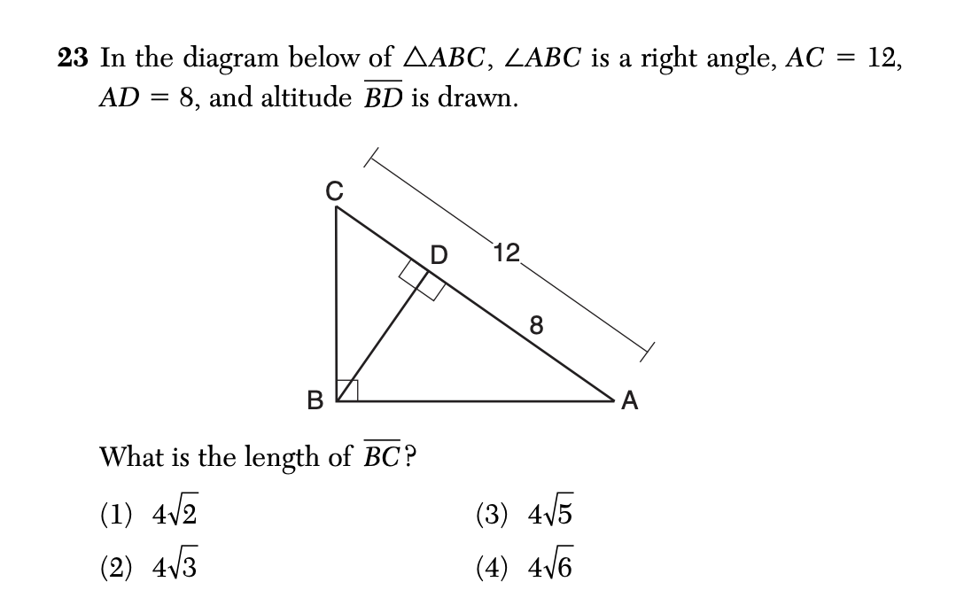

1. A
2. 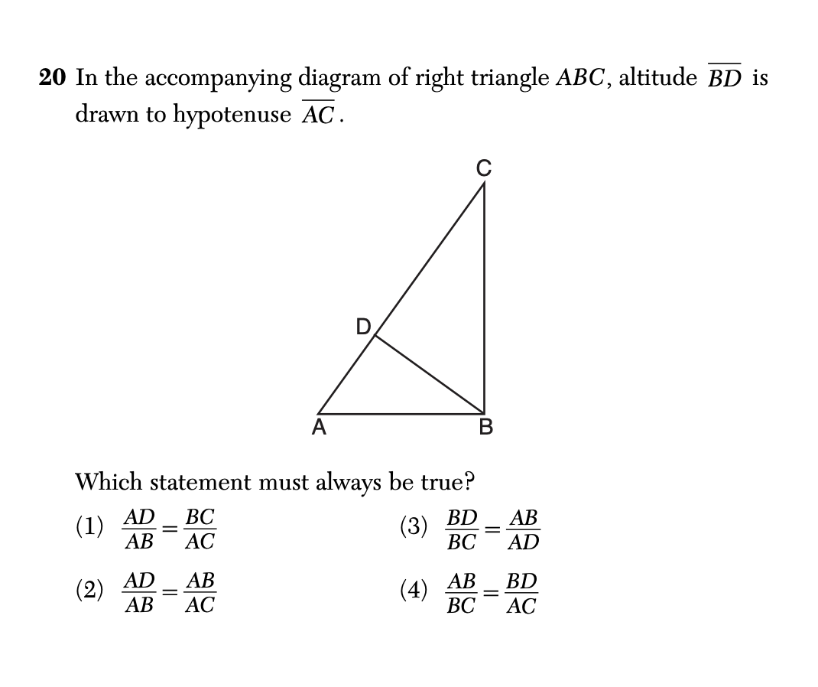**a**

