**6-7 Homework: Similarity ratio problems**

1. Are the two triangles similar? Explain how you know and be sure to name the postulate or theorem if applicable.   
  
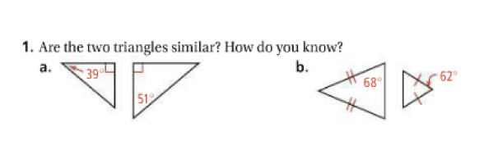

2. Are the two triangles similar? Explain how you know and be sure to name the postulate or theorem if applicable.   
  
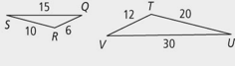

3. Name the three ways (postulates or theorems) to prove these two triangles similar and use the numbers to justify.

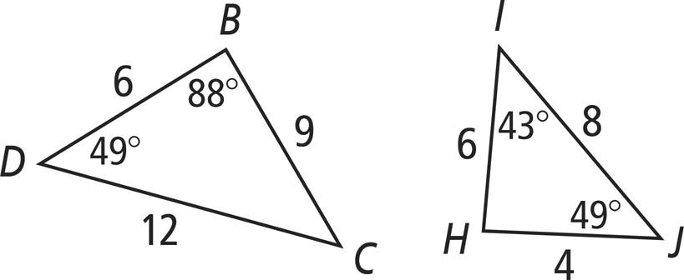

4. Solve for side KJ.

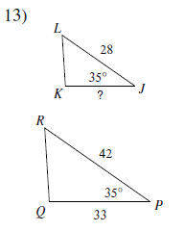

5. Solve for x.   
 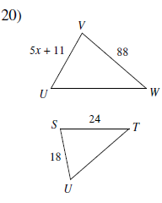

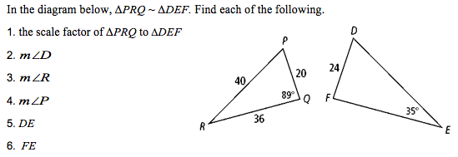6.

**7.** Solve for x.

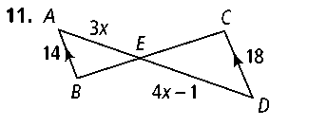

8.

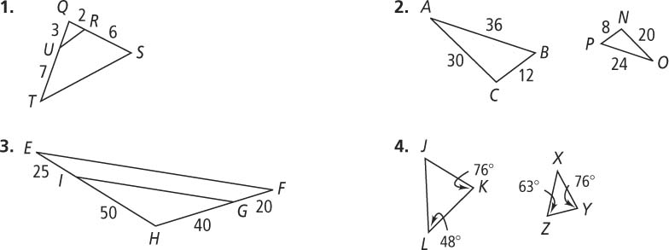**Given:** AB=36, AC=30, BC=12, PN=8, NO=20, PO=24

**Prove:** Triangle ABC ~ Triangle OPN

9.

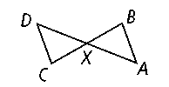**Given:** AB||DC

**Prove:** Triangle XDC ~ Triangle XAB

**Similarity SAT Problems**

