Demo Sample

Dr. Huson

10th Grade Geometry

2 April 2019

The Power Laws of Area and Volume

When objects are dilated, their dimensions are scaled by a linear factor, *k*. The surface area and volume of the object, however, do not scale in a simple, linear way, however. Instead, they follow a power law. Area measures scale in proportion to $k^{2}$ and volumes in proportion to $k^{3}$. An example in terms of a cube’s dimensions, the area of each of its faces, and its volume is shown below (table 1).

Table 1

Cubes of Various Dimensions Showing the Side Length, Face Area, and Volume

|  |  |  |
| --- | --- | --- |
| Length | Area | Volume |
| $$L=s$$ | $$A=s^{2}$$ | $$V=s^{3}$$ |
| 1 | 1 | 1 |
| 2 | 4 | 8 |
| 3 | 9 | 27 |
| 4 | 16 | 64 |
| 5 | 25 | 125 |

The effect is the same when any 3-dimensional shape is dilated: the dimensions grow linearly while the object’s area measures increase by the square of the increase and its volume by the third power of the scale factor. Consider the case of a right rectangular prism (box shape) with dimensions of 2 by 3 by 4. The prism has three different sized faces, each with its area, *A*, calculated below, as well as the volume of the cube, *V*.

$$A_{1}=2×3=6$$

$$A_{2}=2×4=8$$

$$A_{3}=3×4=12$$

$$V=2×3×4=24$$

If the prism is dilated by a factor of two, its measures will be as follows: 4 by 6 by 8, and $${A'}_{1}=4×6=24$$

$${A'}_{2}=4×8=32$$

$${A'}_{3}=6×8=48$$

$$V'=4×6×8=192$$

Note that the areas have not doubled, they increased by a factor of four (two squared), and the volume increased eightfold (two cubed). A 3-dimensional representation of the two prisms is shown below (figure 1).

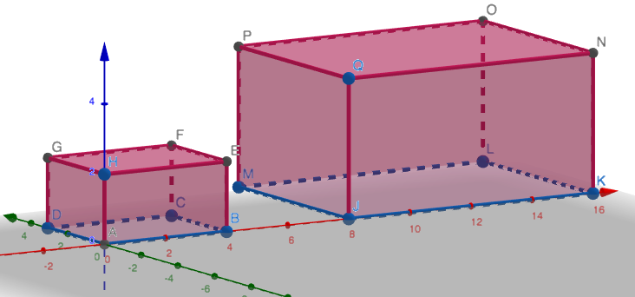

Figure 1. A prism and its image scaled by a factor of k=2.

Source: The image file was downloaded from <https://math.huson.com>.