**9.1 Introduction to Polyhedrons**

1. Name the polyhedron (3D solid) formed by stacking 1000 congruent shapes shown.

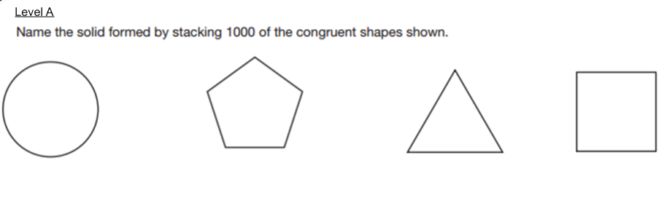

2. Name the polyhedron (3D solid) formed by stacking 1000 similar shapes shown.

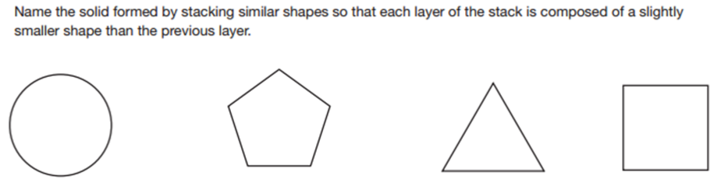

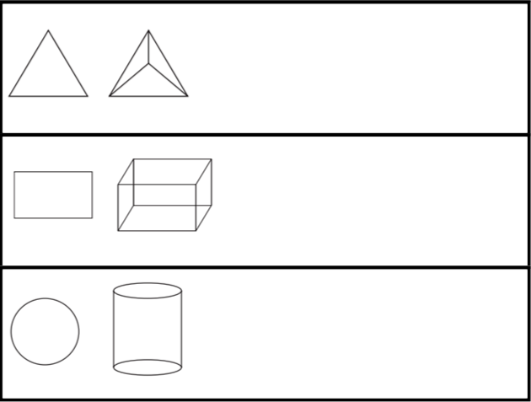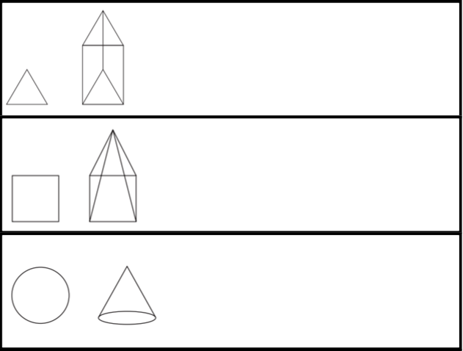3. State whether the 2D figure on the left is a **horizontal cross section**, **vertical cross section**, or **both** of the 3D figure (polyhedron) on the right.

4. Name the 2D shape made by the cross section through the polyhedron.

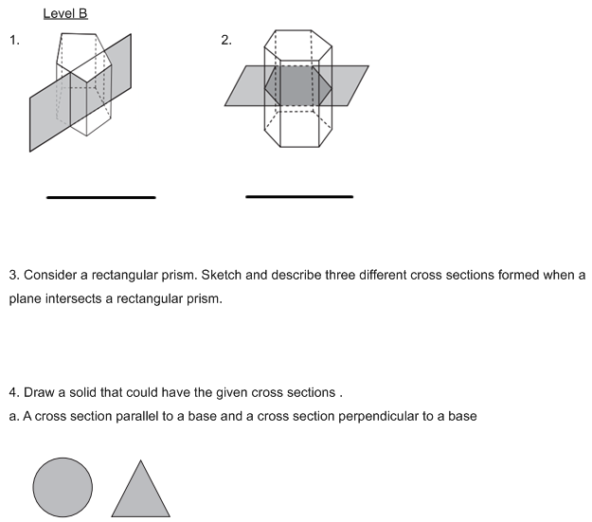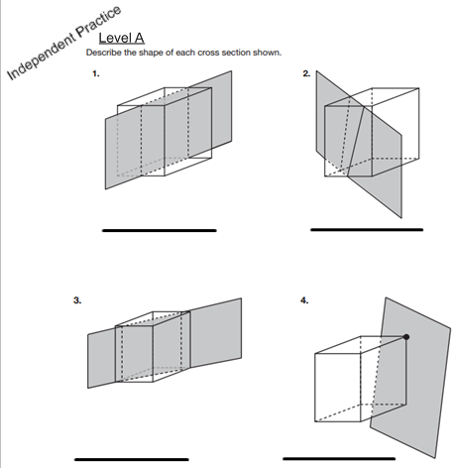

**Regents Ready!**

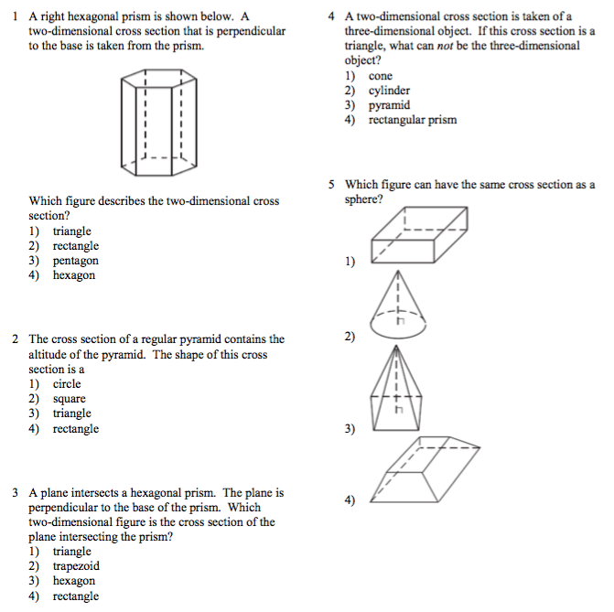

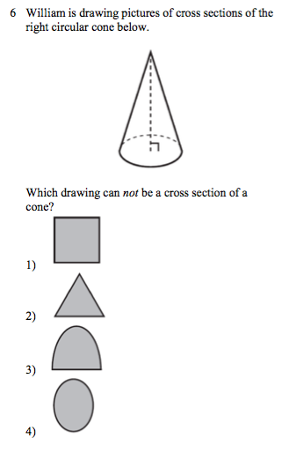

5. Sketch and describe 3 different cross sections formed when a plane intersects a rectangular prism.

6. Draw 2 polyhedrons that could have the given cross sections

1. One should have the circle parallel to the base and the triangle perpendicular
2. One should have the circle perpendicular to the base and the triangle parallel



7. Draw and name 2 polyhedrons that could have each 2D shape as a cross section parallel to the base.

