**9.3 Surface Area of Cones and Cylinders**

1. 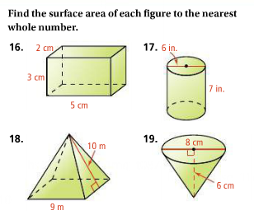  
   1. What type of polyhedron is this?
   2. What 2D shape is formed by a cross section perpendicular to the base?
   3. What 2D shape is formed by a cross section parallel to the base?
   4. Which Lateral Area Formula and which Surface Area Formula should be used for this polyhedron?
   5. What is the Lateral Area of this polyhedron?
   6. What is the Surface Area of this polyhedron?
2. 1. What type of polyhedron is this?
   2. What 2D shape is formed by a cross section perpendicular to the base?
   3. What 2D shape is formed by a cross section parallel to the base?
   4. Which Lateral Area Formula and which Surface Area Formula should be used for this polyhedron?
   5. What is the Lateral Area of this polyhedron?
   6. What is the Surface Area of this polyhedron?

**Regents Ready! Show your work.**

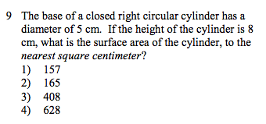

**Challenge Questions (+2 extra credit points of HW each!)**

1. What is the Surface Area of this polyhedron?

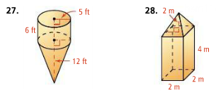

2.

