**9.6 Mixed Volume of Polyhedrons**

1. 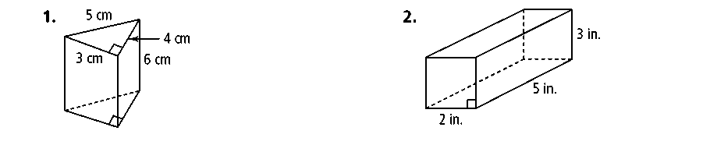  
   1. What type of polyhedron is this?
   2. What is the Volume of this polyhedron?
   3. 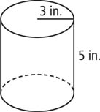What type of polyhedron is this?
   4. What is the Volume of this polyhedron?
   5. 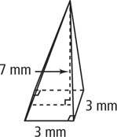What type of polyhedron is this?
   6. What is the Volume of this polyhedron?

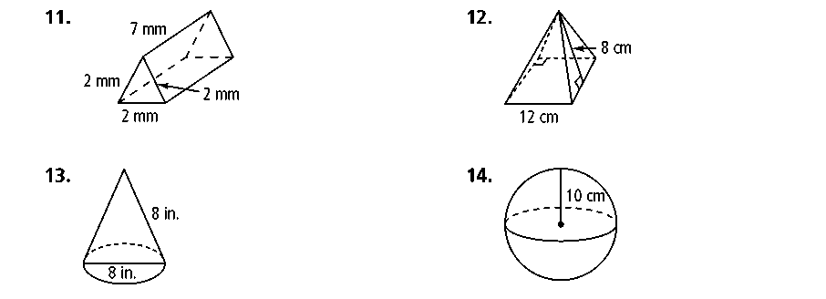

1. What type of polyhedron is this?
2. What is the Volume of this polyhedron?
3. 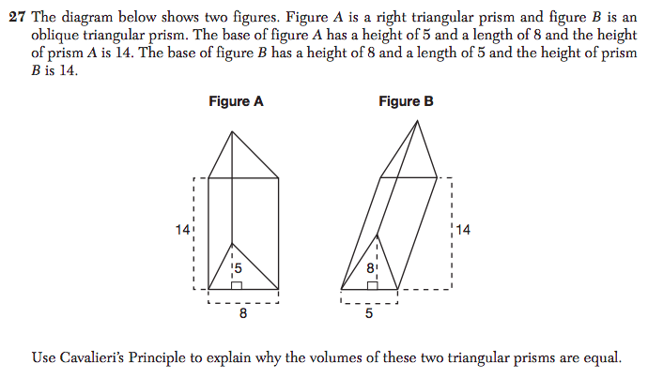

1. A food company makes a certain type of cylindrical soup can. The radius is 5 cm. The height is 12 cm. What is the volume of the tall soup can in cubic inches3? *(1 inch = 2.54 centimeters)*



* 1. Calculate the Surface Area of this Sphere.

* 1. Calculate the Volume of this sphere.

1. The surface area of a sphere is 100π*.* What is its volume in terms of π*?*