**9.7 Volume, Conversion, and Density Regents Problems**

*Draw a picture and show work to receive full credit*

1. Screen%20Shot%202017-04-28%20at%207.30.36%20AM.png
2. A hemispherical water tank has an inside diameter of 10 feet. If water has a density of 62.4 pounds per cubic foot, what is the weight of the water in a full tank, to the nearest pound?
3. 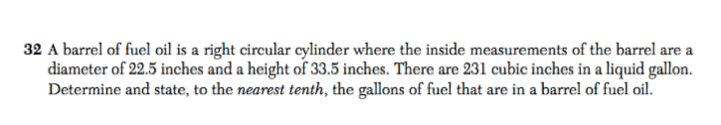
4. A shipping container is in the shape of a right rectangular prism with a length of 12 feet, a width of 8.5 feet, and a height of 4 feet. The container is completely filled with contents that weigh, on average, 0.25 pound per cubic foot. What is the weight, in pounds, of the contents in the container?
5. The density of the American white oak tree is 752 kilograms per cubic meter. If the trunk of an American white oak tree has a circumference of 4.5 meters and the height of the trunk is 8 meters, what is the approximate number of kilograms of the trunk?

