**Angle Relationships Riddle**

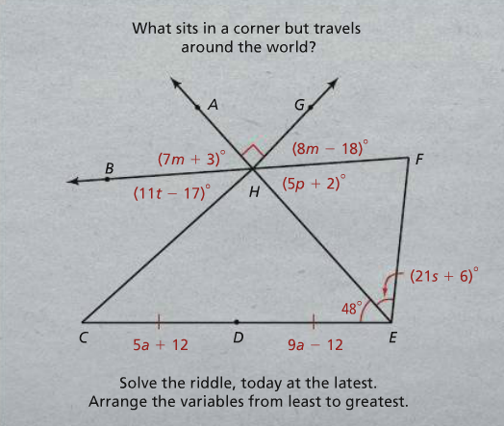

**Angle Relationships Challenge Problems**

