[model student]

Dr. Huson

10.1 Geometry

15 October 2019

Bisector of an Angle

This paper demonstrates a classical geometry construction using dynamic software. The requirement is as follows: Given $∠ABC$, construct a ray $\vec{BF}$ which will be a bisector.

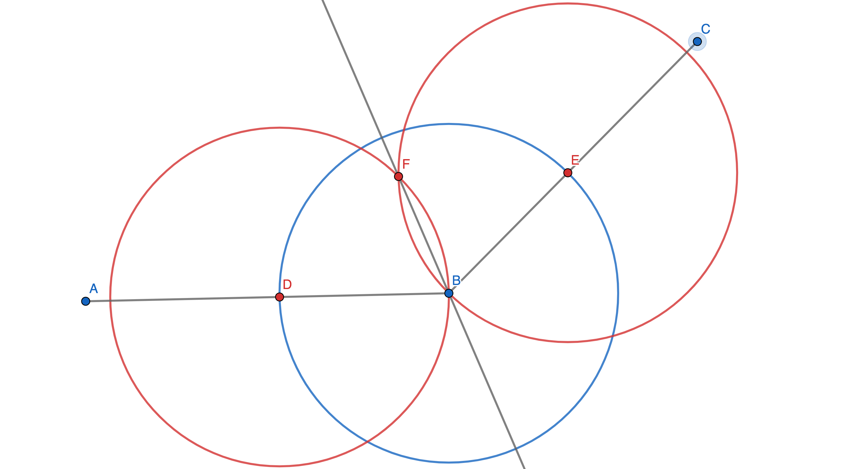

When adjusting a circle’s size, GeoGebra adjusts the other 2 circles to keep point *F* as a bisector. Geogebra also adjusts the midpoint when you change the angle itself to make sure point *F* is always a bisector. This is because all of the points are connected so GeoGebra knows that point F will always have to bisect $∠ABC$ so it adapts to any changes made to the construction to make sure that points *B, D, E,* and are all the same distance.