Demo Sample Huson 1

Dr. Huson

10.1 Geometry

15 November 2019

An Illustration of the Fibonacci Sequence

Create an image in Geogebra based on a spiral layout of the Fibonacci sequence, as shown, for example, in Figure 1. Copy it to MS Word and write a short exposition. You should show the recursive formula for the sequence (use the Equation Editor).

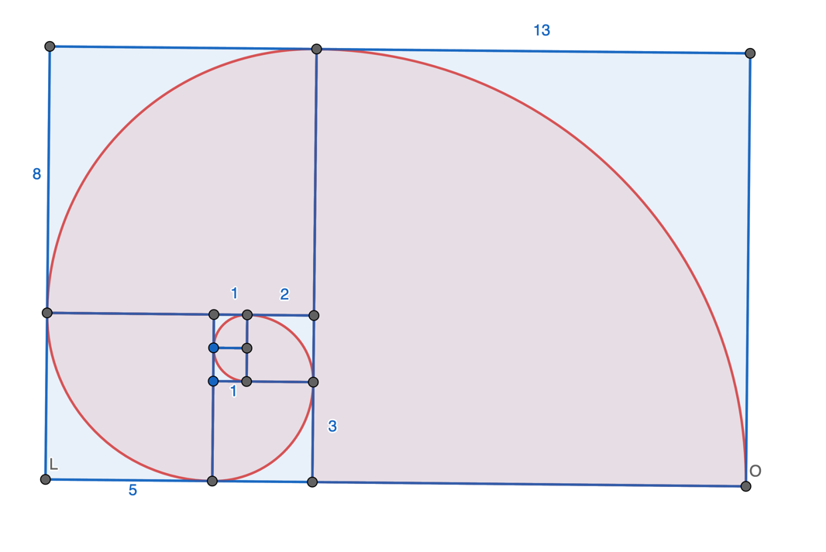

Figure 1: Fibonacci sequence depicted as squares laid out in a spiral pattern

The first two terms of the sequence are both one. Consecutive terms are the sum of the prior two terms: 1, 1, 2, 3, 5, 8, 13, 21, 34, 55, 89, 144, 233, …. Defined algebraically, the sequence is specified as $a_{1}=1$, $a_{2}=1$, and $a_{n+2}=a_{n+1}+a_{n}$.

As a further exploration, consider the ratio of consecutive terms in the sequence. At the limit, they go to the Golden Mean.