**7.9 Classwork: Similarity ratio problems**

1. Are the two triangles similar? Explain how you know and be sure to name the postulate or theorem if applicable.   
  
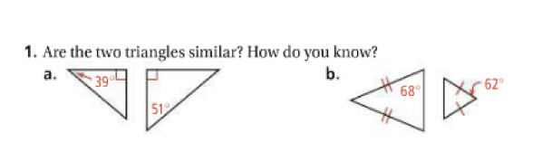

2. Are the two triangles similar? Explain how you know and be sure to name the postulate or theorem if applicable.   
  
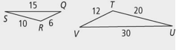

3. Name the three ways (postulates or theorems) to prove these two triangles similar and use the numbers to justify.

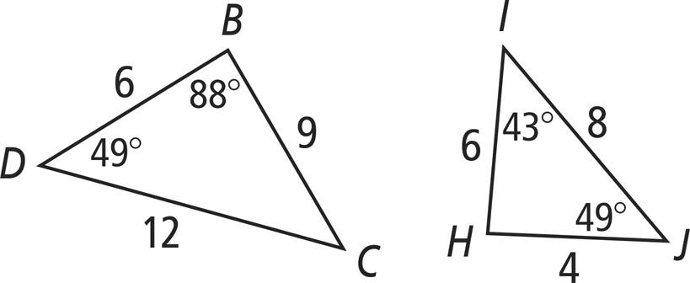

4. Solve for side KJ.

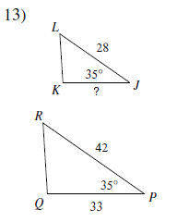

5. Solve for x.   
 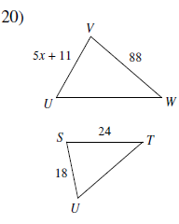

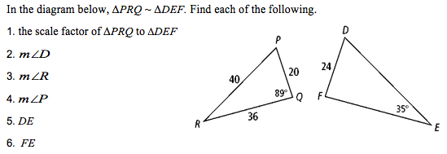6.

**7.** Solve for x.

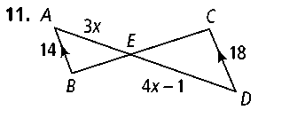

**8.** A cubical block of metal weighs 6 pounds. How much will another cube of the same metal weigh if its sides are twice as long?

A. 48  B. 32  C. 24  D. 18  E. 12

**Similarity SAT Problems**

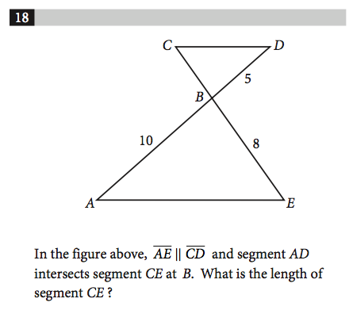

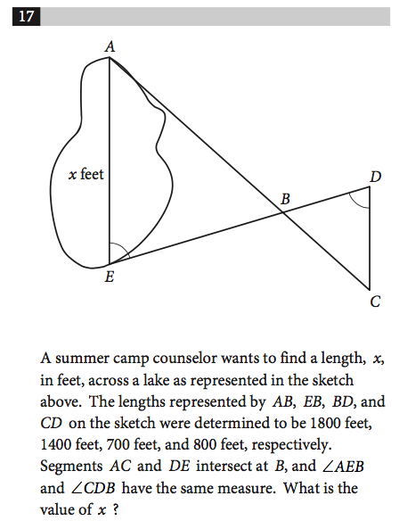

**9.** In the figure above AD = 4, AB = 3 and CD = 9. What is the area of triangle AEC ?