BECA / Huson / Algebra 2

Lesson 2.6

Distribution of multiplication over addition – binomials practice

Using a grid layout is a good way to organize multiplying two polynomials. Here is an example:

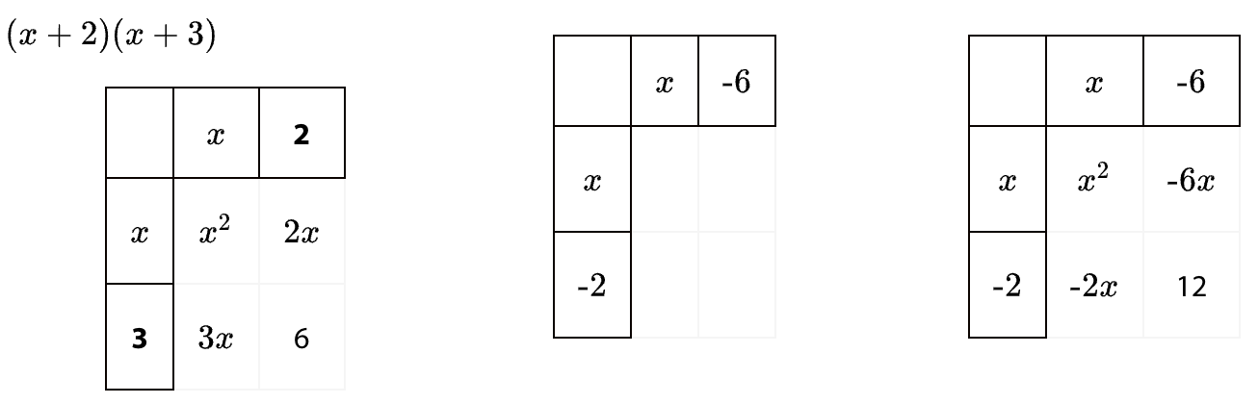

Use the method to complete these problems on loose leaf paper.

