Classwork: Probability exam problems

4a. In a class of 21 students, 12 own a laptop, 10 own a tablet, and 3 own neither.
The following Venn diagram shows the events “own a laptop” and “own a tablet”.
The values , , and represent numbers of students.
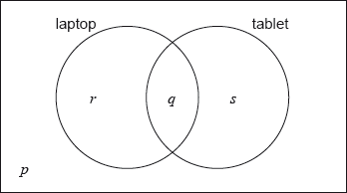
(i) Write down the value of .
(ii) Find the value of .
(iii) Write down the value of and of . [5 marks]
4b. A student is selected at random from the class.
(i) Write down the probability that this student owns a laptop.
(ii) Find the probability that this student owns a laptop or a tablet but not both. [4 marks]
4c. Two students are randomly selected from the class. Let be the event a “student owns a laptop”.
(i) Copy and complete the following tree diagram. (Do not write on this page.)
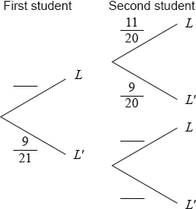
(ii) Write down the probability that the second student owns a laptop given that the first owns a laptop.
[4 marks]

1. A bag contains two red sweets and three green sweets. Jacques takes one sweet from the bag, notes its colour, then eats it. He then takes another sweet from the bag.
Complete the tree diagram below to show all probabilities.
(a) What is the probability two red sweets are taken from the bag?
(b) What is the probability at least one red sweet is taken from the bag?
(c) Assuming at least one red sweet is drawn, what is the probability both sweets are red?

Working:
(Total 4 marks)

5a. A factory has two machines, A and B. The number of breakdowns of each machine is independent from day to day.
Let be the number of breakdowns of Machine A on any given day. The probability distribution for can be modelled by the following table.
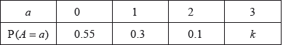
Find . [2 marks]
5b. (i) A day is chosen at random. Write down the probability that Machine A has no breakdowns.
(ii) Five days are chosen at random. Find the probability that Machine A has no breakdowns on exactly four of these days. [3 marks]
5c. Let 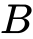 be the number of breakdowns of Machine B on any given day. The probability distribution for can be modelled by the following table.
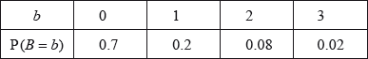
Find 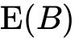. [2 marks]
5d. On Tuesday, the factory uses both Machine A and Machine B. The variables and are independent.
(i) Find the probability that there are exactly two breakdowns on Tuesday.
(ii) Given that there are exactly two breakdowns on Tuesday, find the probability that both breakdowns are of Machine A. [8 marks]
6a. Let  and  be independent events, with 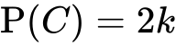 and 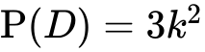, where 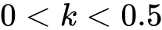.
Write down an expression for 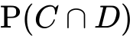 in terms of . [2 marks]
6b. Find 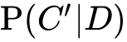. [3 marks]

