Do Now: Probability exam problems
1a. In a group of 20 girls, 13 take history and 8 take economics. Three girls take both history and economics, as shown in the following Venn diagram. The values p and q represent numbers of girls.
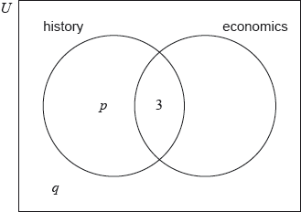
Find the value of p; [2 marks]

1b. Find the value of q. [2 marks]

1c. A girl is selected at random. Find the probability that she takes economics but not history. [2 marks]

Working:
(Total 6 marks)
2a. The following Venn diagram shows the events and 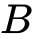, where 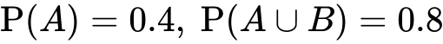 and 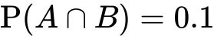. The values and are probabilities.
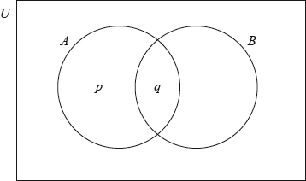
(i) Write down the value of .
(ii) Find the value of . [3 marks]
2b. Find 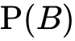. [3 marks]

3a. Events and  are independent with 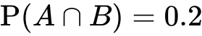 and 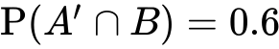.
Find 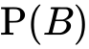. [2 marks]

3b. Find 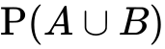. [4 marks]

4. Nene and Deka both play netball. The probability that Nene will score a goal on her first attempt is 0.75. The probability that Deka will score a goal on her first attempt is 0.82.
Calculate the probability that
(a) Nene and Deka will both score a goal on their first attempts;
(b) neither Nene nor Deka will score a goal on their first attempts. [4 marks]

