La Scuola d’Italia / Huson / IB Mathematics Name:
10 February 2026
4.13 Classwork: Binomial distribution

3. a. A box holds 240 eggs. The probability that an egg is brown is 0.05.
Find the expected number of brown eggs in the box. [2 marks]
b. Find the probability that there are 15 brown eggs in the box. [2 marks]
c. Find the probability that there are at least 10 brown eggs in the box. [3 marks]

4a. The following table shows the probability distribution of a discrete random variable X.
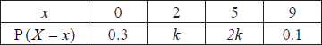
Find the value of k. [3 marks]
b. Find 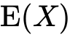 . [3 marks]
5. The random variable X has the following probability distribution.
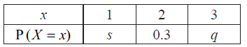
Given that 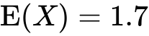 , find q. [6 marks]

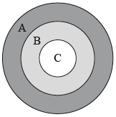
6a. The following diagram shows a board which is divided into three regions ,  and .

A game consists of a contestant throwing one dart at the board. The probability of hitting each region is given in the following table.
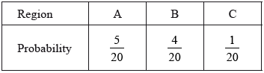
Find the probability that the dart does not hit the board. [3 marks]
b. The contestant scores points as shown in the following table.
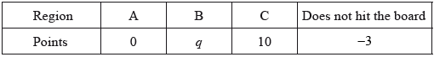
Given that the game is fair, find the value of q. [4 marks]

