4.13 Classwork: Normal distributions
1a. The random variable 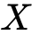 is normally distributed with a mean of 100. The following diagram shows the normal curve for .
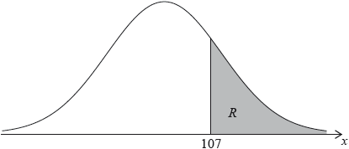
Let 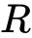 be the shaded region under the curve, to the right of 107. The area of  is 0.24.
Write down 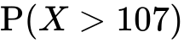. [1 mark]
1b. Find 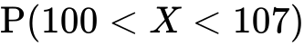. [3 marks]
1c. Find 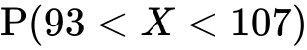. [2 marks]

2a. A random variable  is distributed normally with a mean of 20 and standard deviation of 4.
On the following diagram, shade the region representing 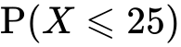. [2 marks]
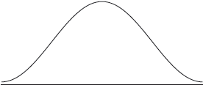
2b. Write down 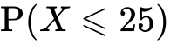, correct to two decimal places. [2 marks]
2c. Let 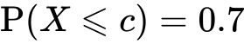. Write down the value of . [2 marks]

3a. The time taken for a student to complete a task is normally distributed with a mean of 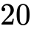 minutes and a standard deviation of 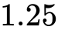 minutes.
A student is selected at random. Find the probability that the student completes the task in less than 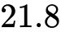 minutes. [2 marks]
3b. The probability that a student takes between and  minutes is 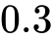. Find the value of . [5 marks]
4a. The weights, , of newborn babies in Australia are normally distributed with a mean 3.41 kg and standard deviation 0.57 kg. A newborn baby has a low birth weight if it weighs less than kg.
Given that 5.3% of newborn babies have a low birth weight, find . [3 marks]
4b. A newborn baby has a low birth weight.
Find the probability that the baby weighs at least 2.15 kg. [3 marks]
5a. The masses of watermelons grown on a farm are normally distributed with a mean of 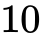 kg.
The watermelons are classified as small, medium or large.
A watermelon is small if its mass is less than kg. Five percent of the watermelons are classified as small.
Find the standard deviation of the masses of the watermelons. [4 marks]
5b. The following table shows the percentages of small, medium and large watermelons grown on the farm.
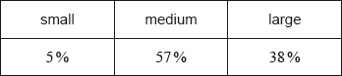
A watermelon is large if its mass is greater than kg.
Find the value of . [2 marks]
5c. All the medium and large watermelons are delivered to a grocer. [3 marks]
The grocer selects a watermelon at random from this delivery. Find the probability that it is medium.

6a. The maximum temperature , in degrees Celsius, in a park on six randomly selected days is shown in the following table. The table also shows the number of visitors, , to the park on each of those six days.
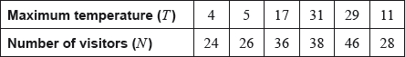
The relationship between the variables can be modelled by the regression equation 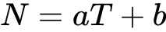.
Find the value of and of . [3 marks]
6b. Write down the value of . [1 mark]
6c. Use the regression equation to estimate the number of visitors on a day when the maximum temperature is 15 °C. [3 marks]
7a. The price of a used car depends partly on the distance it has travelled. The following table shows the distance and the price for seven cars on 1 January 2010.
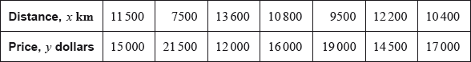
The relationship between and can be modelled by the regression equation 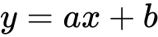.
(i) Find the correlation coefficient.
(ii) Write down the value of and of . [4 marks]
7b. On 1 January 2010, Lina buys a car which has travelled 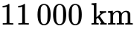.
Use the regression equation to estimate the price of Lina’s car, giving your answer to the nearest 100 dollars. [3 marks]
7c. The price of a car decreases by 5% each year.
Calculate the price of Lina’s car after 6 years. [4 marks]
7d. Lina will sell her car when its price reaches 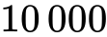dollars.
Find the year when Lina sells her car. [4 marks]

