Classwork: Statistics and probability
1a. The following cumulative frequency graph shows the monthly income, dollars, of  families.
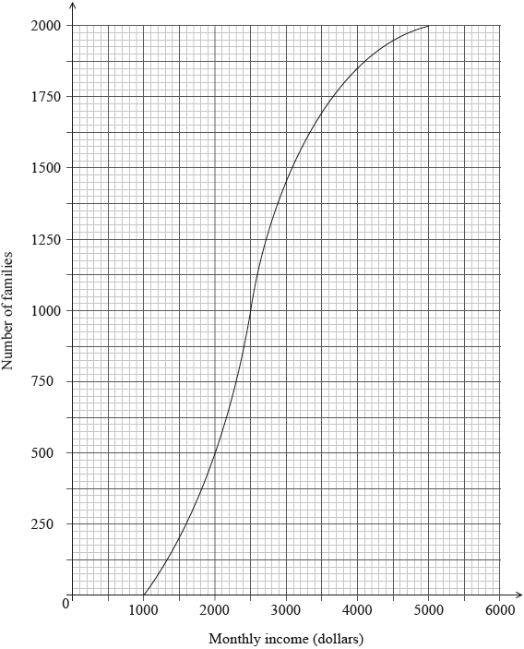
Find the median monthly income. [2 marks]

1b. [4 marks]
(i) Write down the number of families who have a monthly income of dollars or less.

(ii) Find the number of families who have a monthly income of more than  dollars.

1c. The families live in two different types of housing. The following table gives information about the number of families living in each type of housing and their monthly income .
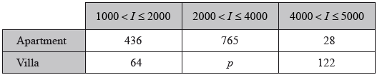
Find the value of . [2 marks]

14d. [2 marks]
A family is chosen at random.
(i) Find the probability that this family lives in an apartment.

(ii) Find the probability that this family lives in an apartment, given that its monthly income is greater than dollars.

14e. Estimate the mean monthly income for families living in a villa. [2 marks]

2a. The histogram below shows the time T seconds taken by 93 children to solve a puzzle. [3 marks]
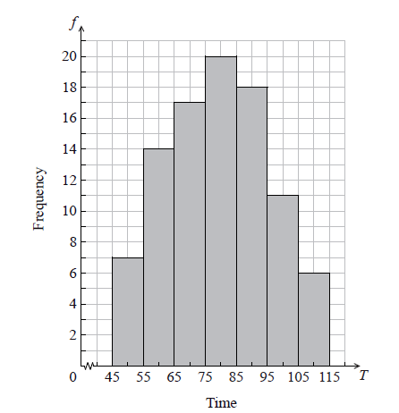
The following is the frequency distribution for T .
(i) Write down the value of p and of q .

(ii) Write down the median class.

2b. A child is selected at random. Find the probability that the child takes less than 95 seconds to solve the puzzle. [2 marks]

2c. Consider the class interval 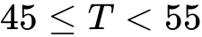 .
(i) Write down the interval width.

(ii) Write down the mid-interval value. [2 marks]

2d. Hence find an estimate for the
(i) mean;
(ii) standard deviation. [4 marks]

3. The following table shows the sales, millions of dollars, of a company, years after it opened.
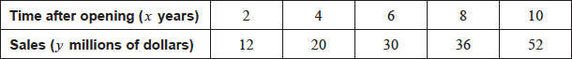
The relationship between the variables is modelled by the regression line with equation 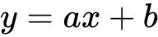.
(i) Find the value of and of .

(ii) Write down the value of . [4 marks]

13. The following diagram shows [AB], with length 2 cm. The line is divided into an infinite number of line segments. The diagram shows the first three segments.
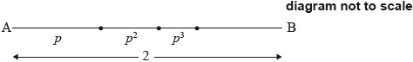
The lengths of the line segments are , where 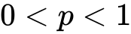.
Show that 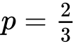. [5 marks]

