La Scuola / Huson / IB Mathematics Name:
12 January 2026

4.7 Classwork: Cumulative distributions
1a. A fisherman catches 200 fish to sell. He measures the lengths, l cm of these fish, and the results are shown in the frequency table below.
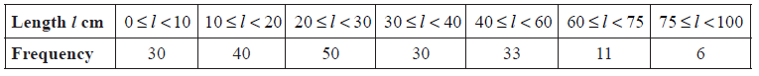
Calculate an estimate for the standard deviation of the lengths of the fish. [3 marks]

1b. A cumulative frequency diagram is given below for the lengths of the fish.
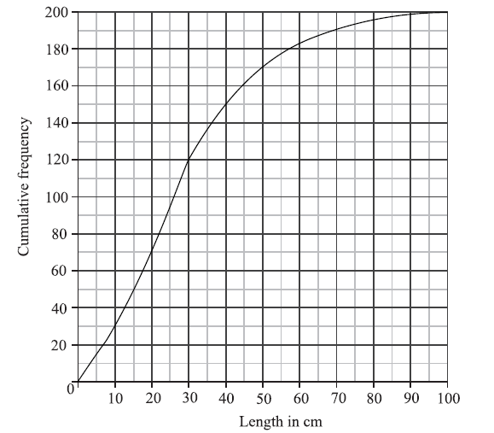
Use the graph to answer the following. [6 marks]
- Estimate the interquartile range.

(ii) Given that  of the fish have a length more than 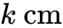, find the value of k.

1c. In order to sell the fish, the fisherman classifies them as small, medium or large.
Small fish have a length less than .
Medium fish have a length greater than or equal to but less than .
Large fish have a length greater than or equal to .
Write down the probability that a fish is small. [2 marks]

1d. The cost of a small fish is , a medium fish , and a large fish .
Complete the following table, which gives a probability distribution for the cost 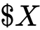 .
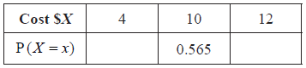 [2 marks]

1e. Find 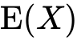 . [2 marks]

