Classwork: Statistics practice
Answer in the space provided
1a. Ten students were surveyed about the number of hours, x, they spent browsing the Internet during week 1 of the school year. The results of the survey are given below.
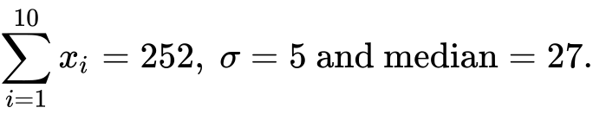
Find the mean number of hours spent browsing the Internet. [2 marks]

1b. During week 2, the students worked on a major project and they each spent an additional five hours browsing the Internet. For week 2, write down
(i) the mean;

(ii) the standard deviation. [2 marks]

1c. During week 3 each student spent 5% less time browsing the Internet than during week 1. For week 3, find
(i) the median;

(ii) the variance. [6 marks]

1d. During week 4, the survey was extended to all 200 students in the school. The results are shown in the cumulative frequency graph:
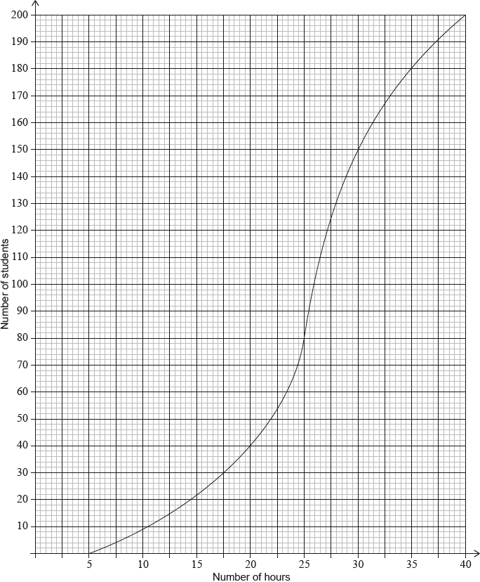
(i) Find the number of students who spent between 25 and 30 hours browsing the Internet.
(ii) Given that 10% of the students spent more than k hours browsing the Internet, find the maximum value of k. [6 marks]
1e. Complete the frequency table
Hours | 5-10 | 10-15 | 15-20 | 20-25 | 25-30 | 30-35 | 35-40
Frequency

Cumulative frequency
3a. A running club organizes a race to select girls to represent the club in a competition.
The times taken by the group of girls to complete the race are shown in the table below.
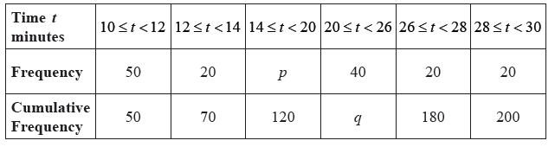
Find the value of p and of q. [4 marks]
3b. A girl is chosen at random.
(i) Find the probability that the time she takes is less than 14 minutes.
(ii) Find the probability that the time she takes is at least 26 minutes. [3 marks]
3c. A girl is selected for the competition if she takes less than minutes to complete the race.
Given that 40% of the girls are not selected,
(i) find the number of girls who are not selected;
(ii) find x. [4 marks]
3d. Girls who are not selected but took less than 25 minutes to complete the race, are allowed another chance to be selected. The new times taken by these girls are shown in the cumulative frequency diagram below.
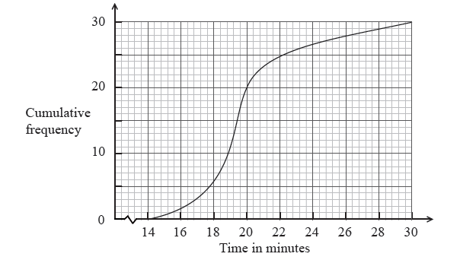
(i) Write down the number of girls who were allowed another chance.
(ii) Find the percentage of the whole group who were selected. [4 marks]

Sequences: challenging (answer on lined paper)
2a. Consider the following sequence of figures.
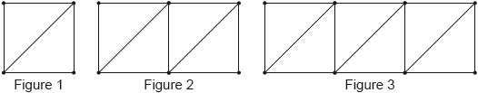
Figure 1 contains 5 line segments.
Given that Figure contains 801 line segments, show that 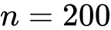. [3 marks]
2b. Find the total number of line segments in the first 200 figures. [3 marks]
3a. The following diagram shows [AB], with length 2 cm. The line is divided into an infinite number of line segments. The diagram shows the first three segments.
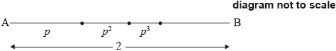
The lengths of the line segments are , where 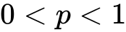.
Show that 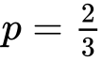. [5 marks]
3b. The following diagram shows [CD], with length 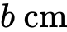, where 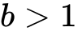. Squares with side lengths 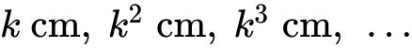, where 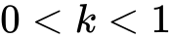, are drawn along [CD]. This process is carried on indefinitely. The diagram shows the first three squares.

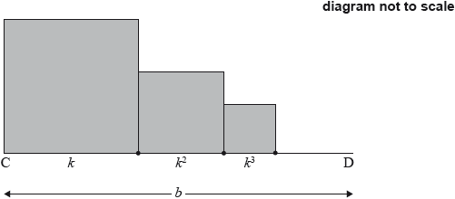
The total sum of the areas of all the squares is 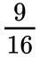. Find the value of . [9 marks]

