Name
Class
Date

1.11 Angles and Parallel Lines Homework

Identify all the numbered angles that are congruent to the given angle.

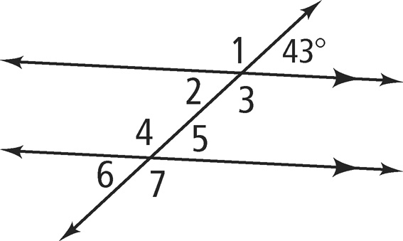
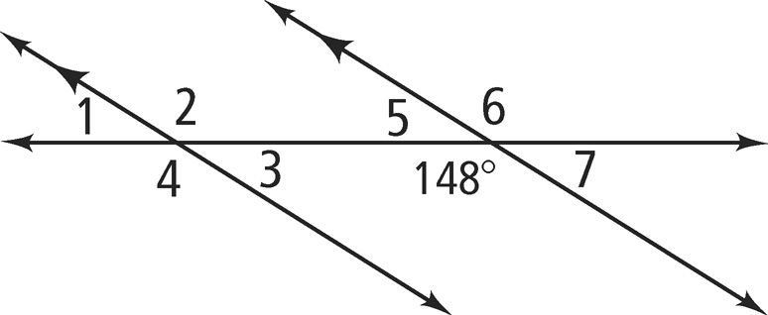
1. 2.

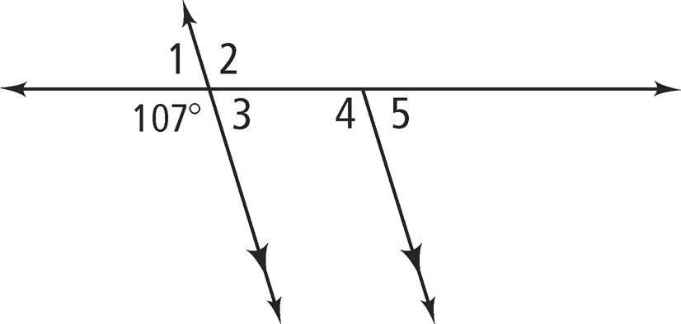
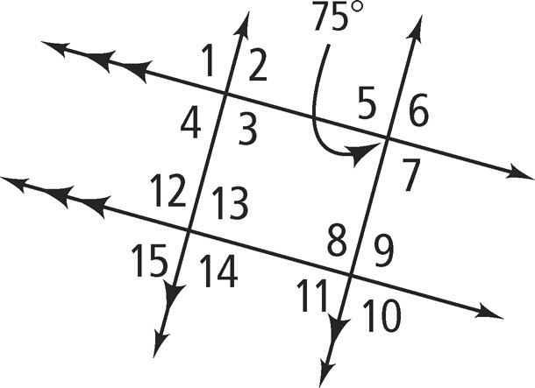
3. 4.
Find m∠1 and m∠2. Justify each answer.
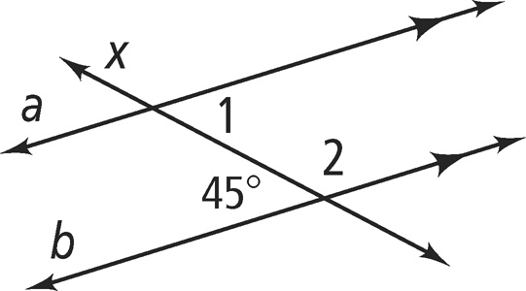
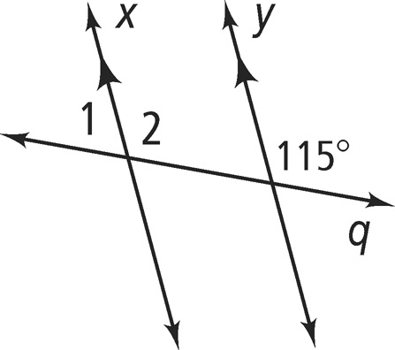
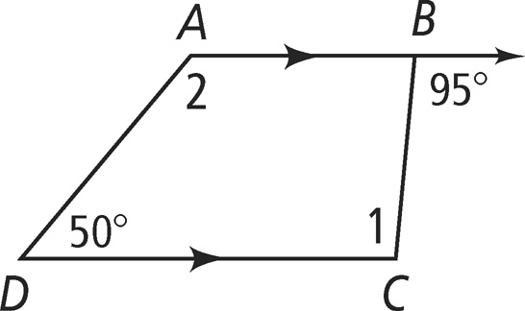
5. 6. 7.

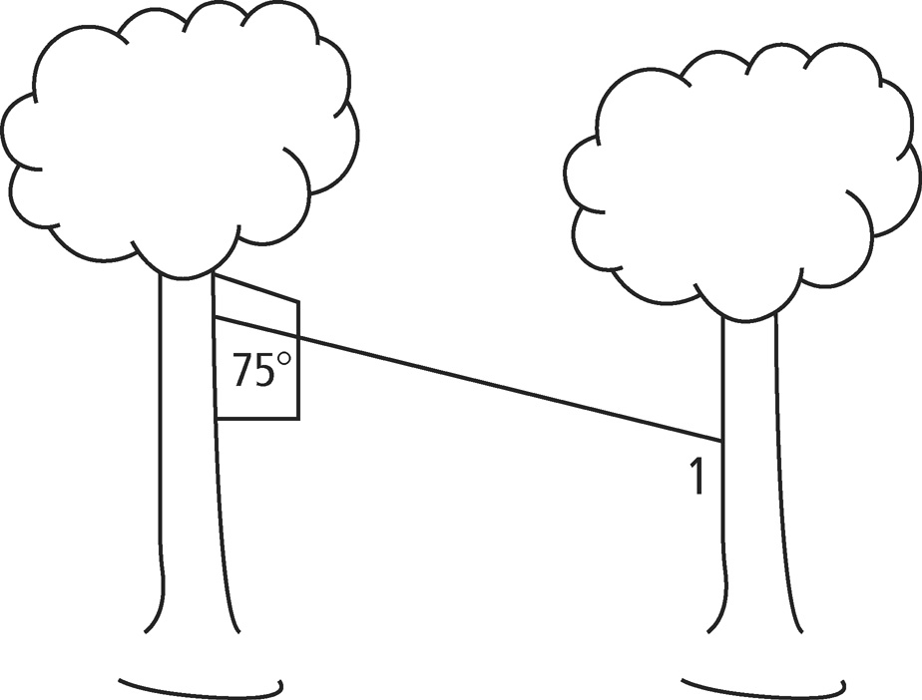

8. Ana made a zip line for her tree house. To do this, she attached a pulley to a cable. She then strung the cable at an angle between the tree house and another tree. She made the drawing of the zip line at the right. The two trees are parallel.
a. What is the measure of ∠1?
b. Are ∠1 and the given angle same-side interior angles, alternate interior angles, or corresponding angles?

Name
Class
Date

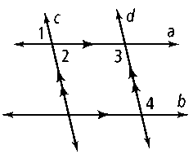
9. Developing Proof Supply the missing
reasons in the two-column proof.
Given: 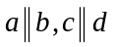
Prove: ∠1 and ∠4 are supplementary.
Statements | Reasons
1) 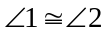 | 1)
2) 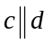 | 2) Given
3) ∠2 and ∠3 are supplementary. | 3)
4) 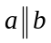 | 4) Given
5) 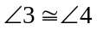 | 5)
6) ∠1 and ∠4 are supplementary. | 6)

Algebra Find the value of x. Then find the measure of each labeled angle.

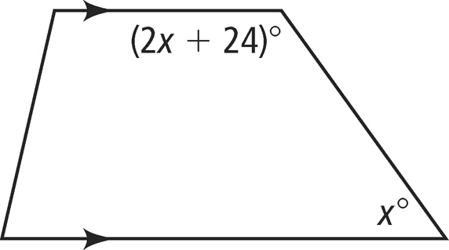
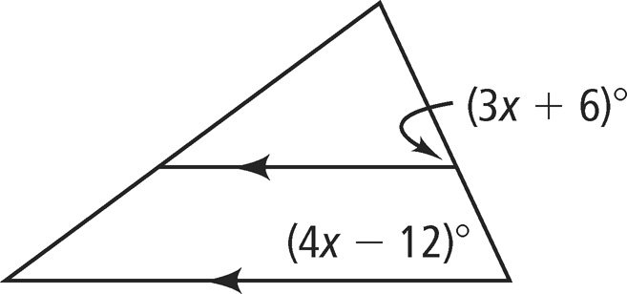
10. 11.

Algebra Find the values of the variables.

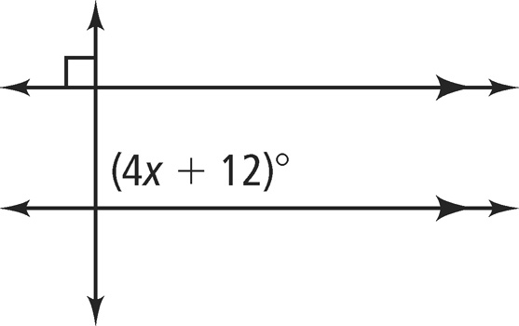
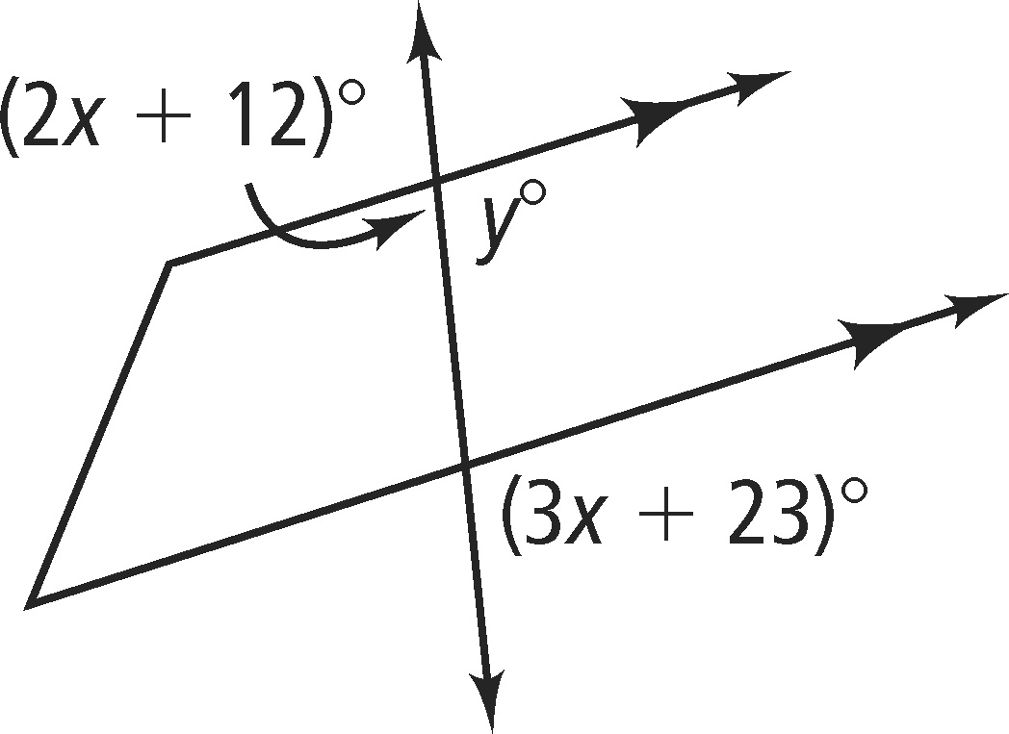
12. 13.

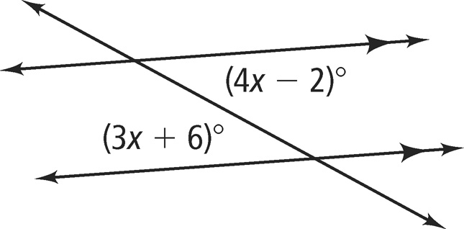
14. Error Analysis Which solution for the value of x
in the figure at the right is incorrect? Explain.


A. B.

4x – 2 = 3x + 6
x = 8

4x – 2 + 3x – 6 = 180
7x – 8 = 180
x = 24.6

