Name
Class
Date


Puzzle: What Is a Line’s Favorite Kind of Fruit?
1.2
Measuring Segments (10 points)
Solve the problems below to answer the riddle. YOU MUST SHOW ALL WORK TO RECEIVE FULL CREDIT!

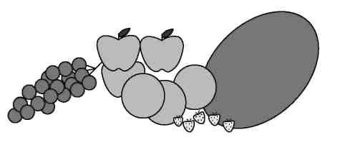
What is a line’s favorite kind of fruit?
Look for your answer in the key at the right and put the corresponding letter in the answer blank at the bottom of the page.
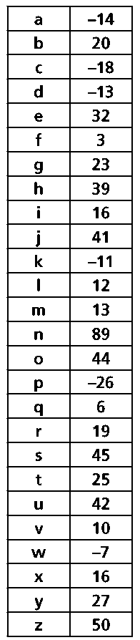

1. Points A, B, and C are collinear and A is between B and C. AB = 4x − 3, BC = 7x + 5, and AC = 5x − 16.
Find each value.
a. BC
b. AB
c. AC

2. On a number line, G = 8 and H = –3. If H is the midpoint of 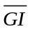, find the coordinate of I.

3. J is the midpoint of 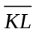. Find KJ if KL = 38.
For 4–6, refer to the number line below.
- Suppose O is the midpoint of 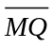 and N is the midpoint of 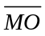. If NO = 8, find MQ.

- Suppose P is the midpoint of 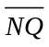, OP = 11, and OQ = 35. Find NO.

- If NO = 2y + 11, OP = 3y − 2, NP = 6y + 3, and MP = 64, find each value.
a. NO
b. MN

