|  | 1.2 Your PaycheckStudent Activity PacketUNIT: TAXES & FUNDAMENTALS OF ALGEBRA |
| --- | --- |

### 

### Name:

| IN THIS LESSON, YOU WILL: | |
| --- | --- |
| * Calculate percentages * Read a pay stub * Complete a W-4 * Identify common payroll deductions | |

|  | **INTRO** |
| --- | --- |

**VIDEO:** [**FinCap Friday: That's Gross!**](https://www.youtube.com/watch?v=fb1xi5OXIe8)

In this video, Yanely discusses your paycheck and why it’s so important for you to understand how to read it. After watching the video, answer the questions below.

1. **What type of information should you see when you look at your paystub?**
2. **Why is it important for you to understand how to read your pay stub?**

|  | **LEARN IT** |
| --- | --- |

**ARTICLE:** [**Types of Income**](https://www.imb.com.au/themoneytree/earning-an-income/types-of-income.html)

You can earn money in a lot of different ways. Read the article about types of income and answer the questions.

1. **What is the main difference between salary and wage work?**
2. **What are two ways that you can earn income without working?**

**VIDEO:** [**Filling Out the W-4 Form**](https://youtu.be/rcu5Bx-fneY?t=16)

A W-4 form is completed when you start a new job so that your employer knows how to calculate your federal tax withholdings. Watch the video about completing a W-4 and use it to answer the questions.

1. **What steps of the W-4 are required for every employee?**
2. **Which step must you fill out if you have multiple jobs?**

**ARTICLE:** [**What are Payroll Deductions?**](https://www.patriotsoftware.com/blog/payroll/an-overview-of-payroll-deductions/)

There are many different types of payroll deductions. Some are required while others are voluntary. Read the article and use it to answer the questions about payroll deductions.

1. **What are payroll deductions?**
2. **Which deductions will everyone see on their paycheck?**
3. **Why might someone voluntarily have money deducted from their paycheck?**

**EDPUZZLE:** [**How to Read a Pay Stub**](https://edpuzzle.com/media/5c1838585c0e2640f16a13f0)

A pay stub details your earnings, taxes, voluntary deductions, and many pieces of important information. Watch this video to learn more about how to read a pay stub. Then, answer the questions either in EdPuzzle or below.

1. **What is the difference between gross pay and net pay?**
   1. Net pay is before taxes and deductions are subtracted; Gross pay is your take-home pay
   2. There is no difference between gross and net pay
   3. Gross pay is before taxes and deductions are subtracted; Net pay is your take-home pay
2. **What are pre-tax deductions and contributions?**
   1. Contributions taken out of your paycheck AFTER taxes are calculated on your income
   2. Contributions taken out of your paycheck BEFORE taxes are calculated on your income
3. **What are two examples of Employer Contributions?**
   1. Health Insurance & 401k
   2. 401k & Roth IRA
   3. Federal & State Taxes
   4. Traditional & Roth IRA

|  | **MATH CONNECTION - ANALYZING PERCENTAGES** |
| --- | --- |

Now that we understand how to read a pay stub and the types of deductions that might show up, let’s do some analysis to see how much of our gross pay is being deducted.

**Carl’s Paycheck**

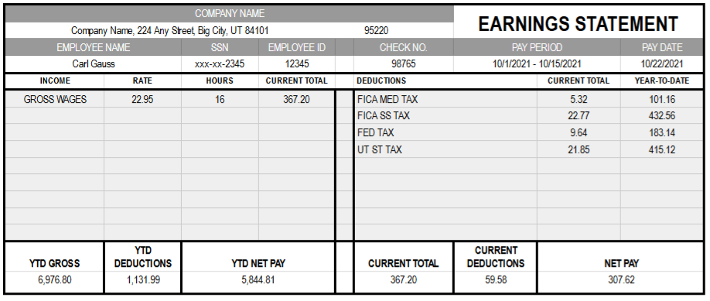

1. **What was Carl’s gross pay for the current pay period?**
2. **How much did Carl pay in taxes during the current pay period?**
3. **What percentage of Carl’s total gross wages was paid in taxes?**
4. **How much did Carl pay in FICA Social Security taxes during the current pay period?**
5. **What percentage of total taxes was paid in FICA Social Security taxes?**

**Alan’s Paycheck**

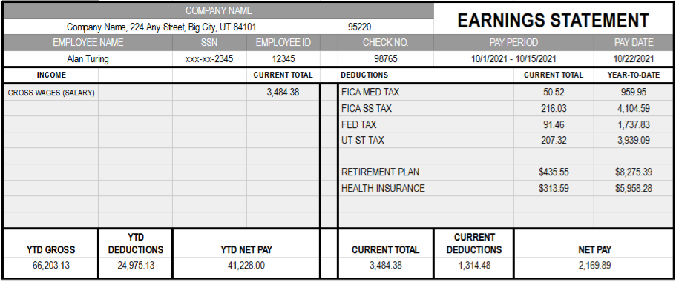

1. **What percentage of Alan’s gross income was deducted for health insurance?**
2. **What percentage of total deductions were voluntary deductions?**
3. **What percentage of Alan’s gross pay did he take home after all deductions?**
4. **Write a function that Alan can use to estimate his take-home pay, where x represents gross pay and y represents net pay.**

|  | **EXIT TICKET** |
| --- | --- |

Follow your teacher’s instructions to complete the Exit Ticket.

**Teachers,** you can find exit ticket questions on the Lesson Guide.