## 4.8 Exam: Exponential Functions and Equations Check Your Readiness

1. For which function $k$  does the output increase by 20% every time the input increases by 1?
$k\left(x\right)={0.020}^{x}$

$k\left(x\right)={0.20}^{x}$

$k\left(x\right)={1.20}^{x}$

$k\left(x\right)={20}^{x}$

2. The value of a stock in 1940 is $1.25. Its value grows by 7% each year after 1940.
   1. Write an equation representing the value of the stock $V\left(t\right)$, in dollars, $t$ years after 1940.
   2. What does $V\left(50\right)$ represent in this situation?
3. The table shows the area $A\left(n\right)$, in square centimeters, of a piece of paper after it is folded in half $n$ times.

|  |  |
| --- | --- |
| * 1 | * 140 |
| * 2 | * 70 |
| * 3 | * 35 |
| * 4 | * 17.5 |
|  |  |

* 1. What is the area of the sheet of paper?
  2. Write an equation expressing the area $A$ as a function of the number of folds $n$.

1. Here are the graphs of two different exponential functions, $f$ and $g$.

* 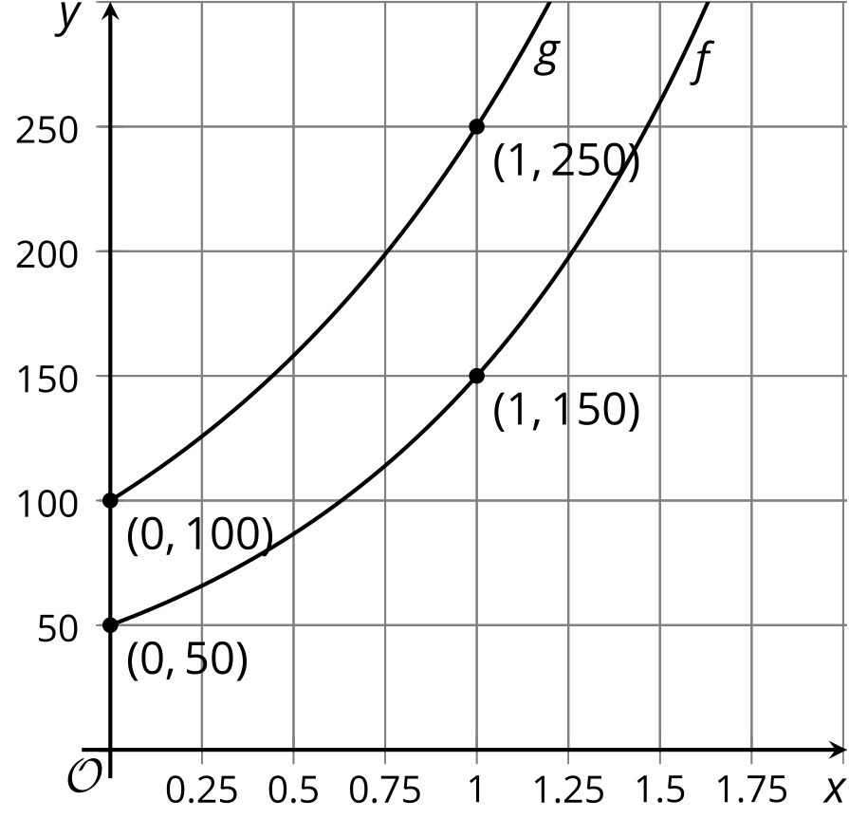
  1. By what factor do the values of $f$ grow when the input increases by 1? By 10?
  2. By what factor do the values of $g$ grow when the input increases by 1? By 10?

1. $2,000 is deposited in a bank account and no further deposits or withdrawals are made. The account receives 6% annual interest compounded monthly. Which expressions represent the account balance, in dollars, after 5 years?
$2,​000⋅{\left(1.06\right)}^{5}$

$2,​000⋅{\left(1+\frac{6}{12}\right)}^{5}$

$2,​000⋅{\left({\left(1+\frac{0.06}{12}\right)}^{12}\right)}^{5}$

$2,​000⋅{\left(1+\frac{0.06}{12}\right)}^{60}$

$2,​000⋅{\left(1+\frac{0.06}{12}\right)}^{5}$

2. The value of a particular used car has been decreasing at the same rate each year since 2010. The equation $C\left(t\right)=25,​000⋅{\left(0.78\right)}^{t}$ represents the value of the car $C\left(t\right)$, in dollars, as a function of $t$, the number of years since 2010.
   1. What do the numbers 25,000 and 0.78 tell us about this situation?
   2. What is the percent decrease of the value of the car each year?
   3. Sketch a graph of $C$.
   * 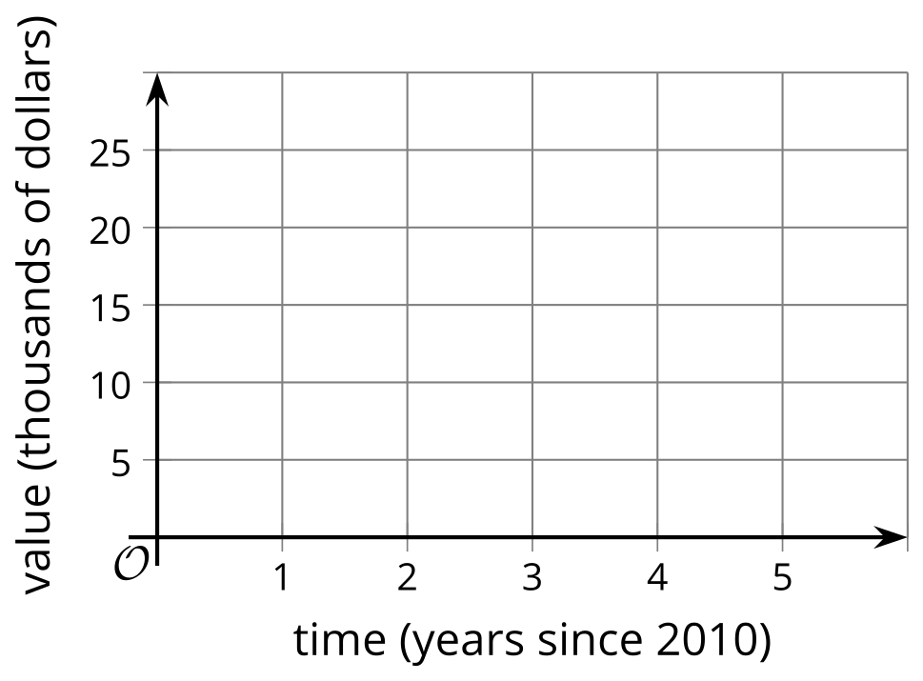

© CC BY 2019 by Illustrative Mathematics®