## 4.19 Exponential Functions and Equations: End-of-Unit Assessment

1. Which are true of $x=\log_{10}31,​500$? Select **all** that apply.
$x<4$

$x=4$

$x>4$

$x<5$

$x=5$

$x>5$

2. The equation $p(t)=1•e^{t}$ represents a population of bacteria, in thousands, $t$ days after it was first counted. Here is a graph of $y=p(t)$.

Select **all** the true statements.

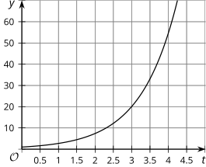

1. $ln(30)$ is the number of days until the population reaches 30,000.
2. The graph shows that 3 is a reasonable approximation for $ln20$.
3. $ln(t)=y$ is the logarithmic form of $y=e^{t}$.
4. The value of $e^{4}$ is greater than 50, so the value of $ln(50)$ is less than 4.
5. The graph shows that 10 is a reasonable approximation for $ln(2.3)$.
6. Technetium-99m is used as a radioactive tracer for certain medical tests. It has a half-life of 1 day. Consider the function $T$ where $T(d)=100{\left(2\right)}^{-d}$ is the percent of Technetium-99m remaining $d$ days after the test. Which expression represents the number of days until only 5% remains?
$\log_{20}2$

$-\log_{2}20$

$\log_{2}\frac{1}{20}$

$-\log_{2}\frac{1}{20}$

7. Here is a graph of .

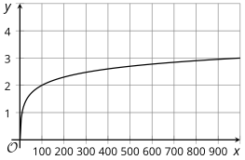

* 1. Explain why the point $(100,2)$ is on the graph.
  2. What is the $x$-intercept of the graph? Explain how you know.
  3. When will the graph meet the line $y=5$? Explain how you know.

1. Solve each equation as an exact solution. (an expression with logs if not an integer)
$7•{10}^{n}=700$

$3•{10}^{2y}=3,​600$

$5•2^{x}=\frac{5}{16}$

2. The expression $1•e^{0.034t}$ models the balance, in thousands of dollars, where $t$ represents time in years after the account was opened.
   1. What does the 0.034 represent in this context?
   2. Write an expression for the number of years after which there will be 15,000 dollars in the account.
3. Here are graphs of the area covered by two different types of mold $d$ days after they were first measured.

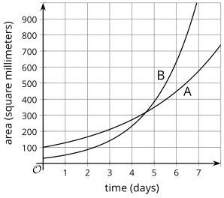

* 1. What are the approximate coordinates of the point of intersection of the two graphs? What does this mean in terms of the two mold populations?
  2. The area of mold A is given by the function . When will this mold cover 1000 square millimeters? (exact solution) Explain or show your reasoning.

**August 2019, #18**

The Fahrenheit temperature, $F(t)$, of a heated object at time $t$, in minutes, can be modeled by the function below. $F_{s}$ is the surrounding temperature, $F_{0}$ is the initial temperature of the object, and $k$ is a constant.

$$F(t)=F_{s}+\left(F_{0}-F_{s}\right)e^{-kt}$$

Coffee at a temperature of 195°F is poured into a container. The room temperature is kept at a constant 68°F and $k=0.05$. Coffee is safe to drink when its temperature is, at most, 120°F. To the *nearest minute*, how long will it take until the coffee is safe to drink?

1. 7
2. 10
3. 11
4. 18

**January 2023, #35**

Graph $c\left(x\right)=-9{\left(3\right)}^{x-4}+2$.

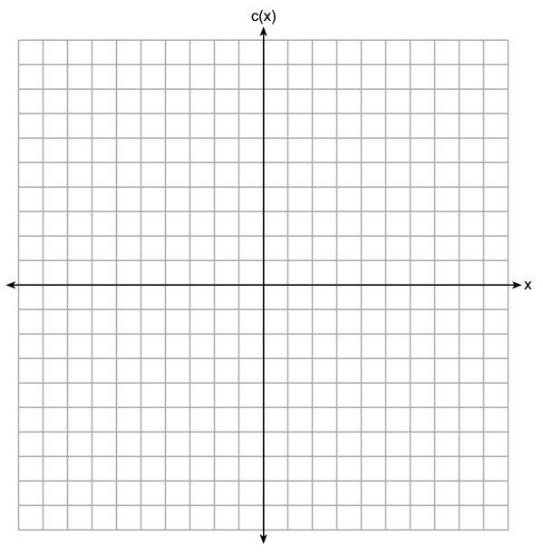

Describe the end behavior of $c(x)$ as $x$ approaches positive infinity.

Describe the end behavior of $c(x)$ as $x$ approaches negative infinity.