Proposal for TDM - workpackage lead by Vienna, Child and Adolescent Psychiatry, MUW Vienna
Short title: Atypical neuroleptics in anorexia nervosa: a naturalistic observational study including measurement of serum concentrations

Title: Atypical neuroleptics (olanzapine, aripiprazol, risperidone, quetiapine, clozapine, ziprasidone, amisulpirid, zotepine) in the treatment of adolescents with anorexia nervosa: a first step - an observational study analysing adverse events, weight gain/reduction, symptom reduction and blood level concentrations.

Authors: Andreas Karwautz, MD, FAED, Univ. - Prof., Julia Huemer, MD, Harald Eder, MD

Medical University Vienna; Department of Child and Adolescent Psychiatry, Waehringer Guertel 18-20, A-1090 Vienna, Austria; Eating Disorders Unit and Ward 06

Background:
In the last years, interest in using antipsychotics to treat anorexia nervosa (AN) has been increased with the upcoming of the atypical drugs with their broader variety of targeted symptoms and different range of side-effects compared to first generation antiopsychotics like haloperidol (14). Several papers of using atypical antipsychotics for AN have been published (13, all recently reviewed in: 9).
As shown by Mehler-Wex et al. (9), in a small subset of patients with severe, treatment-resistant anorexia nervosa, extreme weight phobia, delusional body image disturbances or severe hyperactivity atypical antipsychotics might be considered as indications.
Neuroleptics were explored for AN due to a partial overlap in psychopathology between AN and psychosis: both disorders involve disturbances of thoughts and perceptions (2).
Olanzapine and risperidone were the most frequently used drugs in uncontrolled studies (14, 27). Studies showed that olanzapine can significantly improve specific aspects of AN (15, 25, 26). Olanzapine is hypothesized to facilitate weight gain, while decreasing levels of agitation and decreasing resistance to treatment in young women with AN (11).
Most recently studies using quetiapine are under way, the study includes adults older than 18 only (Kaye et al). One RCT study comparing the effects of olanzapine and aripiprazole in the management of anorexia nervosa in adults has shown in a very small sample of patients (n=10 vs. 12) a small weight gain in OLA and a small weight decrease in ARI patients (32). One recent RCT in 34 adult AN patients (OLA vs placebo) showed good tolerability for OLA and a significantly higher weight gain during a day hospital treatment than in the placebo group (33).

Weight gain as outcome measure:
Generally, weight gain is a significant side effect of some neuroleptics (1). Antipsychotic drugs (AP) induce weight gain in up to 50 % of patients (16, 17). Besides from haloperidol, there have been four case reports and two uncontrolled open trials reporting that olanzapine can lead to an increase in weight (3, 4).
The mechanisms of AP causing weight gain are complex (18, 19) and involve several pharmacological systems such as serotoninergic, histaminergic, dopaminergic and adrenergic neurotransmissions (16, 23, 22).
Weight gain seems to be due mainly to an increase in global caloric intake (20), although it remains unclear whether this phenomenon occurs following an increase in appetite and/or alterations of satiety control (21).
Results by Khazaal et al. (29) strongly suggest that weight gain in AP-treated patients results from a raised body weight set-point, as has been already investigated in an animal model (24).
Fleischhacker et al. (5) found that the average weight gain was significantly higher for olanzapine group (mean = 4.6kg, SD = 1.9) than for risperidone (mean = 2.8kg, SD = 1.3), and for clozapine (mean = 2.5kg, SD = 2.9). Olanzapine and risperidone, but not clozapine, caused a disproportionately higher weight gain in children and adolescents in comparison to adults, also proved in Dittmann et al. (6).
Smith et al. (30) found that weight gain is inversely associated with age when examining a sample of participants with psychotic depression receiving olanzapine.
Furthermore, the study by Aichhorn et al. (7) demonstrates an age effect for olanzapine but not for risperidone resulting in higher olanzapine plasma levels in younger patients.
The results found by Kluge et al. (10) suggest that both clozapine and olanzapine can induce food craving and binge eating, however, olanzapine possibly to a greater extent.

Genes associated with olanzapine weight profiles may be related to peripheral lipid homeostatic axes, whereas those associated with risperidone may be related to brain appetite peptide regulation (8). In vivo studies (12) suggest a direct influence of second generation antipsychotics on peripheral insulin resistance. Engl et al. (12) analyzed that olanzapine might alter glycogen synthesis and the insulin-signalling cascade in L6 myotubes. As has been shown in this study, olanzapine inhibited insulin-stimulated IRS-1-associated PI3K activity in a dose-dependent manner. Finally, Engl concludes that olanzapine impairs glycogen synthesis via inhibition of the classical insulin-signaling cascade and that this inhibitory effect may lead to the induction of insulin resistance in olanzapine-treated patients.

Study design

The study follows an innovative design by correlating clinical data on symptom severity, adverse events, blood levels of medication and changes in body mass index (BMI) in adolescent patients with AN of both subtypes.
Participants recruited in Vienna will be patients of ward 06 and ward 07 treated as inpatients at the Department of Child and Adolescent Psychiatry.
Cooperating centers: ….
Adolescent female and male patients with anorexia nervosa-restrictive type and –binge/ purging type, following full ICD-10 diagnostic criteria, thus showing weight phobia and delusional body image disturbances, are included in the study (F50.00 Anorexia nervosa restricting type, F50.01 AN binge/purging type, F50.1 AN atypical).
Age range: 11 – 19yrs.)
Included are patients receiving one of the atypical neuroleptics in a dosage as decided by clinical impression by the doctors treating the patients.
(Examples: For Olanzapine dosage 10-20 mg are the range suggested by standard procedures – see: Book) OLA is normally starting with 2.5 mg morning and reaching the target dosage after beginning of week 4. For aripiprazol dosage the suggested range is 10-15 mg for adolescents staring with 2.5 mg and reaching the target dosage in beginning of week 4. )
Blood levels of the atypical neuroleptics are measured following the TDM-guidelines:
Blood collection at baseline (visit 0 before the patient has received her/his first tablet) is conducted before the start of medication. Visit 1 (second blood collection) follows after 5 half-lives (see TDM-document delivered yb the network), thus examining a blood level concentration in a steady state after having reached the preliminary target dosage.
If the dosage remains at the same level, visits 2-x are conducted every two weeks.
If the dosage is changed, a blood collection should be done again 5 half-lives after having reached the desired dosage.
We will measure at day 14 and at day 28.

The components of each visit do not only include blood collection but also the evaluation of clinical features. These features involve patient’s characteristics, medication adverse events (measured using the PAERS), CGI and GAF.
If the patient shows comorbid depression (more than 80 do so), CDRS likewise needs to be completed at visit 2, 4 (approximately 7 weeks after the beginning of medication), 6, 8 etc. until psychopathological stabilisation.

Apart from that, eating disorders specific measures are included at the time of each visit, these involve the EDE (Eating Disorders Examination, Fairburn et al. 1990, Hilbert et al 2006 and 2008) validly measuring symptoms on a gold-standard level. EDE total and main scores are the main outcome measure for symptom change.

At baseline and at T2 EDI-2 (Garner et al, 1991, German version Rathner, Waldherr 1997) is filled in by the patients and the interview is performed.

Body weight and body height are measured and BMI is calculated regularly starting at the time of entry into TDM. Measuring the BMI is done in correlation with the above described visits on a weekly basis. Also BMI-Percentiles are calculated (BMI for age).

Aim of the study

The aims of the of the study are to
- naturalistically assess the use of atypical neuroleptics in adolescents with AN (which neuroleptic, dosage, duration,…),
- report in detail severity and number of adverse events occurring during treatment
- assess validly with appropriate instruments clinical symptoms of AN and comorbid symptoms
- assess serum concentrations of neuroleptics given and co-medication
- measure body weight and height and calculate BMI and BMI percentiles,
- correlate clinical impression, body mass index and blood level concentrations of atypical neuroleptics.

Cooperating centres:

University Ulm, Prof. Mehler-Wex, Dr Klampfl, Prof Fegert
University Essen/Duisburg, Dr. Schimmelmann ?
University Zurich, Prof. Walitza. ?
…
…

Bitte, wer hat Lust mitzumachen?

References
1. Cohen JA, Perel JM. Adolescent weight loss during treatment with olanzapine. J Child Adolesc Psychopharmacol. 2004 Winter;14(4):617-20.
2. Andrea Riedl; Janine Becker; M. Rauchfuss; Burghard F. Klappa. Psychopharmacotherapy in Eating Disorders: A Systematic Analysis Psychopharmacol Bull. 2008;41(1):1-22.
3. Cassano GB, Miniati M, Pini S, Rotondo A, Banti S, Borri, C et al; Six-month
open trial of haloperidol as an adjunctive treatment for anorexia nervosa: a preliminary report. Int J Eat Disord.2003;33:172-7.
4. Malina A, Gaskill J, McConaha C, Frank G, LaVia M, Scholar L, et al; Olanzapine treatment of anorexia nervosa: a retrospective study. Int J Eat Disord.2003;33(2):234-7.
5. Fleischhaker C, Heiser P, Hennighausen K, Herpertz-Dahlmann B, Holtkamp K, Mehler-Wex C, Rauh R, Remschmidt H, Schulz E, Warnke A.Weight gain associated with clozapine, olanzapine and risperidone in children and adolescents. J Neural Transm. 2007 Feb;114(2):273-80. Epub 2006 Nov 17.
6. Dittmann RW, Meyer E, Freisleder FJ, Remschmidt H, Mehler-Wex C, Junghanss J, Hagenah U, Schulte-Markwort M, Poustka F, Schmidt MH, Schulz E, Mästele A, Wehmeier PM. Effectiveness and tolerability of olanzapine in the treatment of adolescents with schizophrenia and related psychotic disorders: results from a large, prospective, open-label study. J Child Adolesc Psychopharmacol. 2008 Feb;18(1):54-69
7. Aichhorn W, Marksteiner J, Walch T, Zernig G, Hinterhuber H, Stuppaeck C, Kemmler G. Age and gender effects on olanzapine and risperidone plasma concentrations in children and adolescents. J Child Adolesc Psychopharmacol. 2007 Oct;17(5):665-74
8. Ruaño G, Goethe JW, Caley C, Woolley S, Holford TR, Kocherla M, Windemuth A, de Leon J. Physiogenomic comparison of weight profiles of olanzapine- and risperidone-treated patients. Mol Psychiatry. 2007 May;12(5):474-82. Epub 2007 Jan 2
9. Mehler-Wex C, Romanos M, Kirchheiner J, Schulze UM. Atypical antipsychotics in severe anorexia nervosa in children and adolescents--review and case reports. Eur Eat Disord Rev. 2008 Mar;16(2):100-8.
10. Kluge M, Schuld A, Himmerich H, Dalal M, Schacht A, Wehmeier PM, Hinze-Selch D, Kraus T, Dittmann RW, Pollmächer T Clozapine and olanzapine are associated with food craving and binge eating: results from a randomized double-blind study. J Clin Psychopharmacol. 2007 Dec;27(6):662-6
11. Spettigue W, Buchholz A, Henderson K, Feder S, Moher D, Kourad K, Gaboury I, Norris M, Ledoux S. Evaluation of the efficacy and safety of olanzapine as an adjunctive treatment for anorexia nervosa in adolescent females: a randomized, double-blind, placebo-controlled trial. BMC Pediatr. 2008 Jan 31;8:4
12. Engl J, Laimer M, Niederwanger A, Kranebitter M, Starzinger M, Pedrini MT, Fleischhacker WW, Patsch JR, Ebenbichler CF. Olanzapine impairs glycogen synthesis and insulin signaling in L6 skeletal muscle cells. Mol Psychiatry 2005 Dec;10(12):1089-96.
13. Bosanac P, Kurlender S, Norman T, Hallam K, Wesnes K, Manktelow T, Burrows G (2007) An open-label study of quetiapine in anorexia nervosa. Human Psychopharmacology Clinical and Experimental 22:4, 223
14. Claudino AM, Hay PJ, Lima MS, Schmidt U, Bacaltchuk J, Treasure JL. Antipsychotic drugs for anorexia nervosa. (Protocol) Cochrane Database of Systematic Reviews 2007, Issue 4. Art. No.: CD006816. DOI: 10.1002/14651858.CD006816
15. Brambilla F, Garcia C, Fassino S et al. Olanzapine therapy in anorexia nervosa: psychobiological effects. Int Clin Psychopharmacol. 2007 Jul;22(4):197-204
16. Baptista T. Body weight gain induced by antipsychotic drugs: mechanisms and management. Acta Psychiatr Scand 1999; 100: 3-16.
17. Baptista T, Kin NM, Beaulieu S, de Baptista EA. Obesity and related metabolic abnormalities during antipsychotic drug administration: mechanisms, management and research perspectives. Pharmacopsychiatry 2002; 35: 205-19.
18. Aquila R, Emanuel M. Interventions for Weight Gain in Adults Treated With Novel
Antipsychotics. Prim Care Companion J Clin Psychiatry 2000; 2: 20-3.
19. Werneke U, Taylor D, Sanders TA. Options for pharmacological management of obesity in patients treated with atypical antipsychotics. Int Clin Psychopharmacol 2002; 17: 145-60.
20. Bromel T, Blum WF, Ziegler A, Schulz E, Bender M, Fleischhaker C, Remschmidt H, Krieg JC, Hebebrand J. Serum leptin levels increase rapidly after initiation of clozapine therapy. Mol Psychiatry 1998; 3: 76-80.
21. Leadbetter R, Shutty M, Pavalonis D, Vieweg V, Higgins P, Downs M. Clozapine induced weight gain: prevalence and clinical relevance. Am J Psychiatry 1992; 149: 68-72.
22. Nasrallah H. A review of the effect of atypical antipsychotics on weight. Psychoneuroendocrinology 2003; 28 Suppl 1: 83-96.
23. Allison DB, Fontaine KR, Heo M, Mentore JL, Cappelleri JC, Chandler LP, Weiden PJ, Cheskin LJ. The distribution of body mass index among individuals with and without schizophrenia. J Clin Psychiatry 1999; 60: 215-20.
24. Thornton-Jones Z, Neill JC, Reynolds GP. The atypical antipsychotic olanzapine enhances ingestive behaviour in the rat: a preliminary study. J Psychopharmacol 2002; 16: 35-7.
25. Barbarich NC, McConaha CW, Gaskill J, La Via M, Frank GK, Achenbach S, et al. An open trial of olanzapine in anorexia nervosa. Journal of Clinical Psychiatry 2004;65(11):1480–2.
26. Mondraty N, Laird Birmingham C, Touyz S, Sundakov V, Chapman L, Beaumont P. Randomized controlled trial of olanzapine in the treatment of cognitions in anorexia nervosa. Australasian Psychiatry 2005;13(1):72–5.
27. Gaskill J, Treat T, McCabe E, MarcusM. Does olanzapine affect the rate of weight gain among inpatients with eating disorders? Eating Disorders Review 2001;12:1–2.
28. Powers PS, Santana CA, Bannen YS. Olanzapine in the treatment of anorexia nervosa: an open label trial. International Journal of Eating Disorders 2002;32:146–54.
29. Khazaal Y, Chatton A, Claeys F, Ribordy F, Zullino D, Cabanac M. Antipsychotic drug and body weight set-point, Physiology & Behavior (2008), doi: 10.1016/j.physbeh.2008.05.013
30. Smith E, Rothschild A, Heo M et al. Weight gain during olanzapine treatment for psychotic depression: effect of dose and age. International Clinical Psychopharmacology 2008, 23: 130-137
31. Attia E, Walsh BT (2007) Am J Psychiatry Editorial
32. Attia E (2008) Olanzapine vs. aripiprazole in adult anorexia nervosa. RCT. Paper presented at EDRS meeting Montreal Sept 2008 (preliminary data at the EDRS meeting Toronto 2005).
33. Bissada H et al. Olanzapine in the Treatment of Low Body Weight and Obsessive Thinking in Women With Anorexia Nervosa: A Randomized, Double-Blind, Placebo-Controlled Trial. Am J Psychiatry 2008
Attachment (recent review by Mehler-Wex et al. 2008, EEDR):
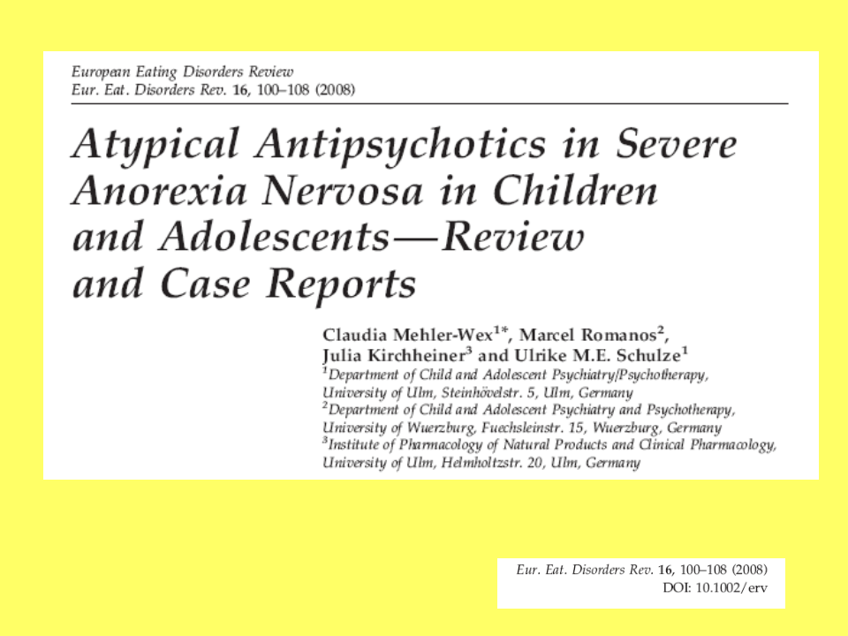

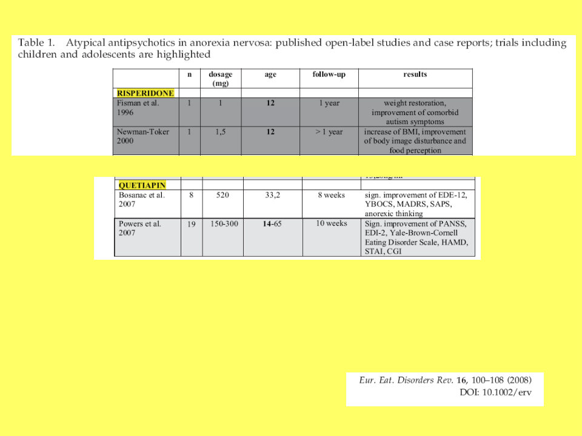
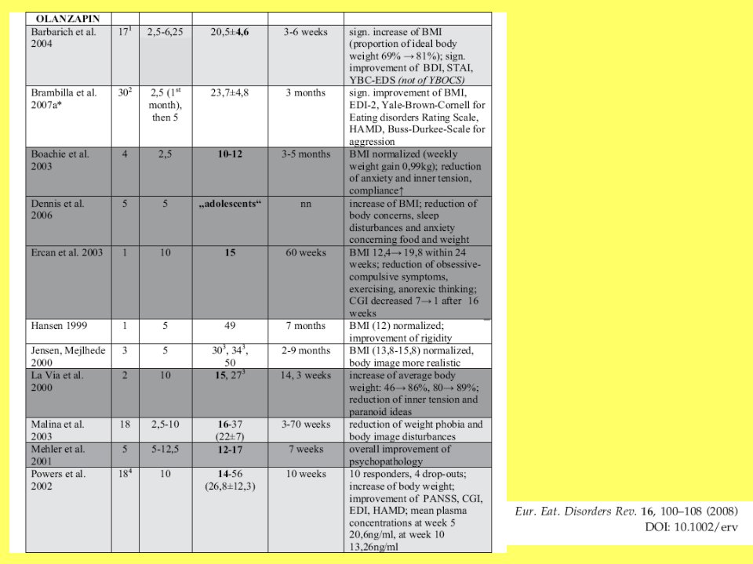

Table:
Needed documents as additional tools in the TDM database:

EDE

EDE-Q

EDI-2
BMI
BMI-percentile
Genetic ethical documents?

