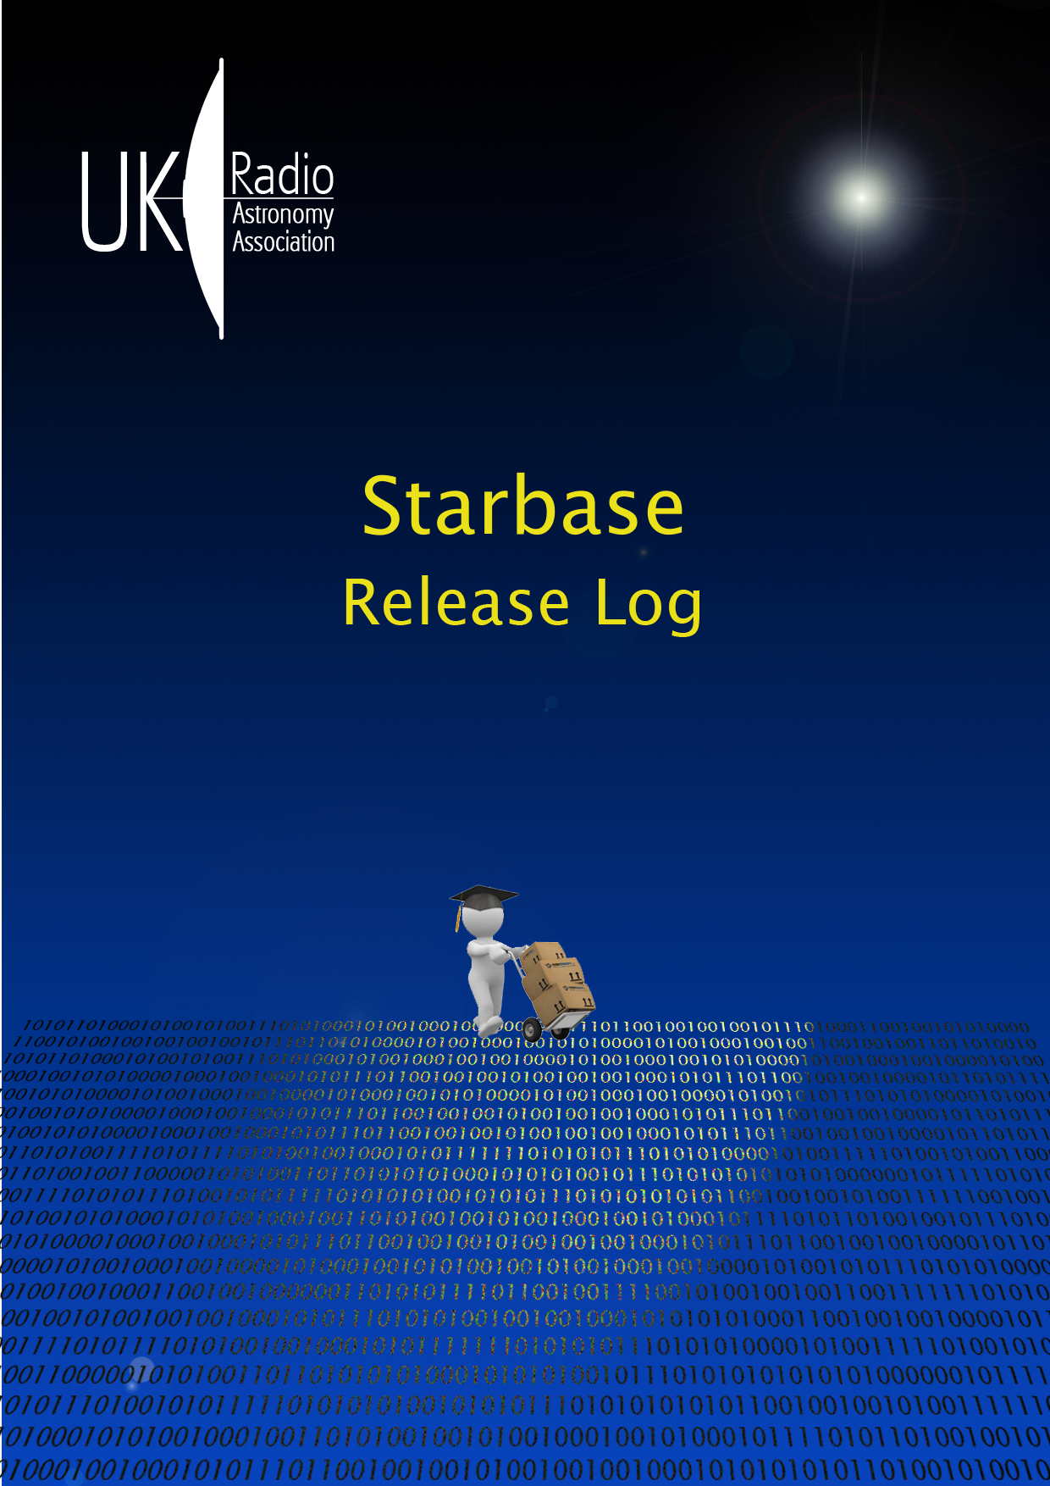
Table of Contents
Introduction 2
What's New 2
Known Issues 4
What's Coming Next 4
Star News 4
Release 2.2.1 6
Framework and Infrastructure 6
Observatory Instruments 6
Default Staribus Addresses 9
Default Starinet Addresses 9
Java Version 9
Release 2.1.1 10
Build 986 12
Build 719 15
Build 700 17
Build 638 17
Acknowledgement 19
Contacts 19
The Starbase Licence 20
GNU GENERAL PUBLIC LICENSE 20
Preamble 20
TERMS AND CONDITIONS 21
Revision History 29

Introduction
This document gives the details of the changes in Starbase between the current and previous releases. If you are in a real hurry, just read the first three pages. Ideally, read in conjunction with the following documents, which are provided with the Starbase distribution in install_root/doc. Both documents are incomplete, but they are a good starting point to understanding the inner workings of the software.
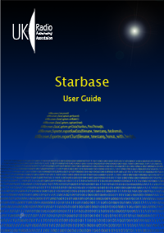  User Guide | 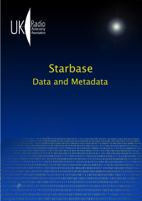  Data and Metadata

What's New
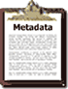 | DataTypes, Metadata, POI, LOI  The internal implementation of DataTypes, Metadata, PointsOfInterest and LinesOfInterest have all been significantly changed. This has resulted in much 'stricter' use of metadata, and it should be much more difficult to have invalid combinations of DataTypes and Units. PLEASE NOTE: It is possible that some existing data files with metadata headers will now fail validation, and some minor editing may be required to correct this. We apologise for this inconvenience, but we hope the more accurate and robust data handling is some compensation.
Toolbars
Several Toolbars have been improved, as shown below. For instance, it is now possible to remove a dataset to save memory, or to just remove the visible data report. You can select how many data items to display, to again save memory or to improve performance. The Command Log can also be truncated (at right).
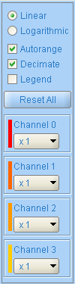 | Charts  The operation of the charting facility has been improved, with the addition of a simple slider to allow selection of a range of data, the range being shown by cursors on the chart. The channel selection panel (shown at left) can now select between a logarithmic or linear display, autoranging, decimation, and application of gain factors to each channel. These selections do not affect the underlying raw data, which are preserved for later analysis.  There is now a DataProcessor command which can segment a dataset into lengths of Days, Hours, or even Minutes. This is particularly useful if a logger contains a week's data, which is easier to visualise as individual day records on the chart.
Data Filters
The data filters have been completely rewritten, to make addition of new filters much simpler: the LinearTransform function is now implemented as a filter. The filters are shown in the ObservatoryInstaller list of plugins, and later developments should allow deployment and installation of filters separately from the main program, as plugins in their own right.
Distinction between Capture and Import
Part of the improvements in Metadata handling resulted in a clearer distinction between the action of Capturing data (for instance from a logger), and of Importing data, (for instance from a local file). The command buttons which result in captured or imported data are now shown with different icons to remind you of the source of the data and of the associated metadata.
 | Sandbox Instrument  A new instrument called the 'Sandbox' has been added, as a general-purpose testbed. This instrument has all of the possible information tabs available (including RSS newsfeed), and can show data in a variety of ways.
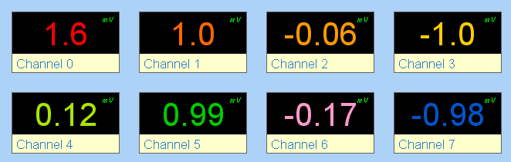 | Digital Panel Meter Tab  All logger instruments which can display numeric data now have a Digital Panel Meter tab, with one meter for each data channel. This is sometimes useful during setting up, when it is easier to see the output of each channel as a number rather than a point on a moving chart.
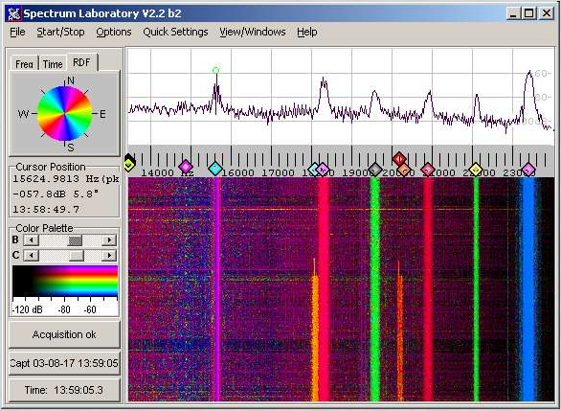 | SpectrumLab Support  SpectrumLab CSV files may now be imported up to a maximum of 32 channels, provided that the correct metadata appear at the start of the file. Sample files are provided to show how this is done.

Known Issues
 | Some dates that are displayed on reports and charts will show Daylight Saving Time (DST) applied, rather than the required Universal Time (UT). This has proved to be a difficult fault to find, and we apologise for leaving this fault in this release.  Imported Observatory metadata will show default Colours which are intended to be used on the charts. These metadata are not yet carried through to the charting facility, and so please note that if you edit them, the changes will not be visible on the charts.

What's Coming Next
 | The development roadmap of Starbase tends to be driven by user requirements and the whims of the developers (we are supposed to be doing this for fun!), however some of the main goals are (still) on the list:  Chart Overlays – the facility to overlay multiple datasets to allow comparisons  Ethernet Logger – a fast controller with SD card data storage and NTP clock  Macros - a scripting language for task automation  Repository – a central database to store and examine observations.

Star News
We thought you might like to see some of those responsible for the development and testing of Starbase. At a recent meeting, below, from the left: Alan Melia, with experience in reliability, testing and amateur radio, he is our software Delivery Manager; he regularly tests the operation of Starbase with its many peripheral devices. Laurence Newell is the project Java programmer with a mission to encode the World as a concise XML document, and to give it a consistent user interface. Chris Green is developing 'Starbase Futures' with the C coding of an Ethernet-based data logger and controller; he is experienced in embedded systems development, and Linux.
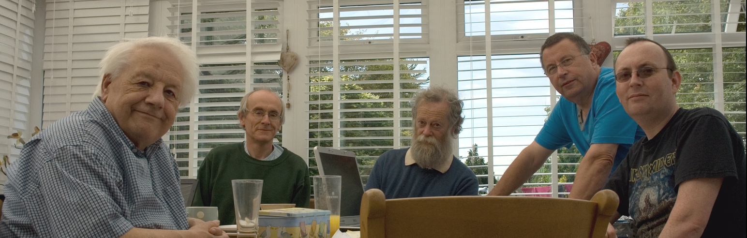
Alan Melia Laurence Newell Chris Green Martin Richmond-Hardy Mark Horn
Martin Richmond-Hardy is our Apple Mac specialist, with interests in astronomy and amateur radio. Mark Horn is our systems expert, with skills in many operating systems, databases, building and bug reporting tools. David Farn (not present) was responsible for the development of the Staribus communications protocol, and its implementation on the UKRAA Futurlec Controller.
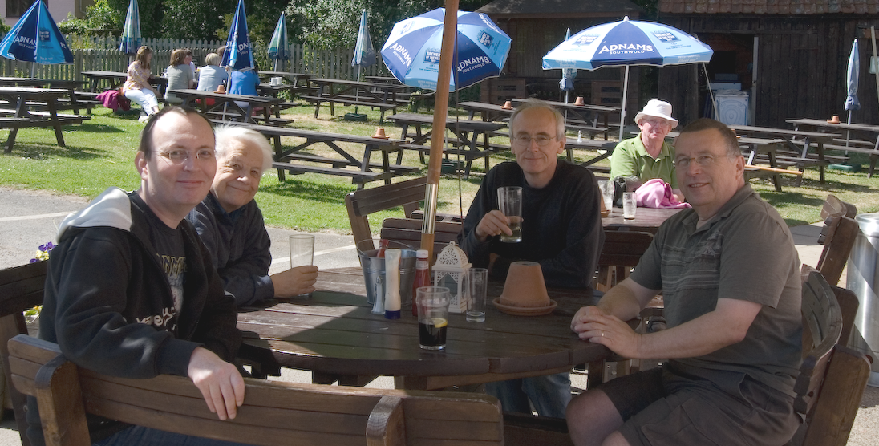 | Mark, Alan, Laurence and Martin during a rigorous Design Review. Notice the Adnams sponsorship, and the Sun is shining, so that narrows it down a bit.

Martin, Mark and Alan discussing Starbase on an Apple Mac, in the lab. Starbase is now fully supported on 32bit and 64bit Microsoft Windows, Linux and Apple Mac (except for an anomaly in 64bit serial communications, under investigation). | 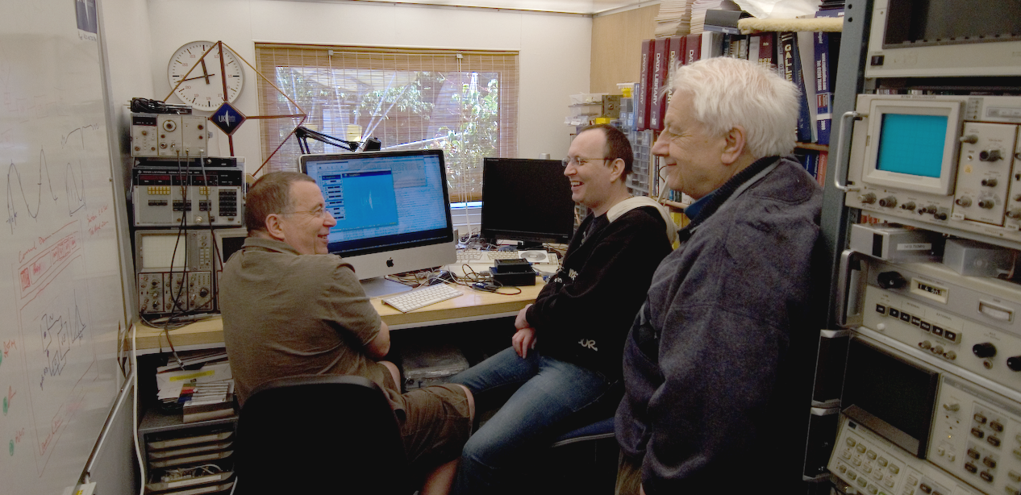

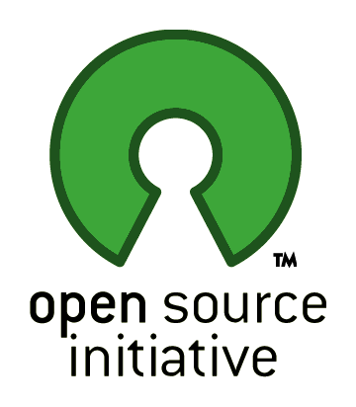 | Starbase is now Open Source. You are free to use Starbase in any way that you like. Please note that there is NO WARRANTY of any kind that it is fit for ANY purpose whatsoever, and UKRAA and Laurence Newell cannot be held responsible for ANY errors, omissions or damage caused. Please see the section on the Starbase Licence Terms and Conditions for full details.
If you have any stories or photographs of Starbase being used for observation or control, please let us know! Any feedback or fault reports should be sent to starbase@ukraa.com. I would particularly like to hear how you are using the software, and if you have any suggestions for additional features. Files of observational data which can be used for testing are also very welcome.
Laurence Newell
2012-06-10

Release 2.2.1
The principal changes have been to the Observatory plugin, but the Framework itself has also had some attention this time round. We are also improving the quality of the development, test and build cycle, by using some modern Continuous Integration methods.

Framework and Infrastructure
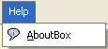 | The Framework About 'box' now has an Acknowledgements tab detailing the many third-party libraries used in the software. To the best of my knowledge and belief, their licence conditions allow use in this software development. Please visits these websites for full details about these libraries.
 | There is a new user login named builder, with a user Role of Builder, for those users who wish to rebuild everything from scratch. The only difference is that some new commands are accessible in this role. It is possible to create your own instrument XML configuration files, and the C source files required to recompile the operating system of the Ethernet controller (currently in development).
 | Starbase is now built automatically using the Jenkins Continuous Integration tool. A build is initiated whenever a developer commits code changes to the Subversion server. When the build is completed, a new beta installation package is sent to the UKRAA webserver using FTP. See more about Jenkins at: http://jenkins-ci.org  Keep an eye on the latest builds at: http://www.ukraa.com/www/starbase/jenkins.html

Observatory Instruments
 | Observatory Clock  The Ephemeris can now be driven directly by metadata, i.e. any instrument providing a coordinate pair can be linked to the generation of an ephemeris. This can be used to plot a point on the StarMap, so for instance the location of an antenna can be dynamically updated. The ephemeris can also be generated from a Starscript command, and exported.  See the Data Guide for full details.
 | Communicator  Information tabs have been added to Communicator to give RSS newsfeeds from the Mantis bug reporting system, from the Subversion configuration management system, and from Jenkins, the continuous integration builder. These will enable you to keep track of current work without having to wait for the next release.
 | Observatory Explorer  There are no changes in ObservatoryExplorer. Sadly the automatic discovery process is still to be fully implemented!
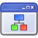 | Generic Instrument  The GenericInstrument shares the upgrades of the DataProcessor and MetadataManager tabs, giving consistent use of data filters, and of metadata manipulation.
 | GOES Xray Client  The main changes to GOES relate to the improvements in the Chart tab, shared by all instruments.
 | GPS Receiver  The GPS Receiver and Simulated GPS Receiver now have a ScatterPlot tab, which can accumulate GPS fixes over a long period of time. The calculated centroid of the fixes is shown, and should give a much more accurate position if enough fixes are taken. There are of course limitations to the accuracy obtainable, such as the precision supplied by the NMEA output of the receiver. The location centroid may be used to automatically update the Framework and Observatory locations.
 | Observatory Installer  The only change to ObservatoryInstaller relates to the display of the new DataFilter plugins on the ObservatoryPlugins tab. This work is the first step to the deployment of Filters as separate plugins, perhaps from different authors.
 | Observatory Monitor  There have been no changes to the ObservatoryMonitor.
 | NTP Client  The NTP client command which obtains time events and shows the clock offset on the Chart has been renamed to show that it is a Capture command, for consistency with the revised methods for handling metadata.
 | Sandbox  As explained earlier, a new instrument called the 'Sandbox' has been added, as a general purpose testbed. This instrument has all of the possible information tabs available (including RSS newsfeed), and can show data in a variety of ways. Use this instrument if you just want to experiment with the XML configuration, or to add features of your own.
 | SpectraCyber  There have been no changes to the SpectraCyber Receiver, Client or Server, other than to upgrade the Chart support and the DataProcessor and MetadataManager modules in line with other instruments. Capture commands are now clearly indicated as such.
 | Starcam  There have been no changes to Starcam, other than to indicate the distinction between capturing an image from a camera, and importing an image from a file.
 | Magnetometer  The main changes to the Magnetometer relate to the distinction between Capture and Import of data. For instance DataCapture.getData() and DataCapture.captureRealtime() are both Capture commands, but MagnetometerPlugin.getRealtimeData() is not. Importer.importLocal() is clearly an Import command.
 | Starinet Controller  The StarinetController is currently under development, but the instrument has been left in the Observatory so that you can see what is coming soon. The majority of the Modules and Commands are now implemented (with the exception of the data logging).
 | Terminal Emulator  There have been no changes to the TerminalEmulator.
 | VLF Receiver  The main changes to the VLF Receiver relate to the distinction between Capture and Import of data. For instance DataCapture.getData() and DataCapture.captureRealtime() are both Capture commands, but VlfPlugin.getRealtimeData() is not. Importer.importLocal() is clearly an Import command.  Please note that Martyn Kinder's remote VLF Receiver has been removed in this release. This is owing to some problems in decoding the RadioSky Pipe data files. We hope to be able to restore service eventually.
 | Web Server  There have been no changes to the embedded WebServer.

If you decide to go ahead and do your own XML configuration of these instruments, please note that when editing the files you must use a plain text editor such as Windows Notepad, not a word processor!
In XML files, remember to use forward-slash (/) in all pathnames, regardless of the host platform! This is because the backslash will be treated differently by the XML file. Edit only those values between “>” and “</”, e.g. <Name>EditThisValue</Name>

Default Staribus Addresses
Staribus is the Starbase Instrument Bus, for RS485 based devices (RS232 if used stand-alone). UKRAA products are shipped with the following default bus addresses in the XML contained in the configuration EEPROMs:
001 Four Channel Logger
002 Eight Channel Logger
003 VLF Rx
004 Magnetometer

Default Starinet Addresses
Starinet is the Starbase Instrument Network, for Ethernet-based devices. The Ethernet controller currently in development, and accessible via the Workshop Instrument Starinet Controller, is set to use the following address by default:
192.168.1.65 Four Channel Controller
You may wish to change the above addresses for your observatory.

Java Version
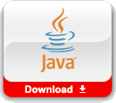 | Starbase 2.2.1 was created with Java 6, release 27.  http://www.oracle.com/technetwork/java/javase/downloads/index.html
 | The development system was IntelliJ v11.1  http://www.jetbrains.com

The remainder of this document details the history of previous releases, and may safely be ignored if you are looking only for what's new in the current release.

Release 2.1.1
Release 2.1.1 was created with Java 6, release 27.
In this release there have been many, many bug fixes and low-level improvements, and...
Changes in current build:
Starbase User Guide updated to cover v2.1
Framework
Starbase is now Open Source (see http://www.opensource.org/), supplied with the General Public Licence (GPL) - shown on login tab.
Creation of a cross-platform installer to simplify distribution.
The garbage collector has been 'tuned' to significantly improve performance on lower specification computers.
User Interface restyled to improve appearance and usability.
Addition of metadata to each Command to allow custom timeout tuning.
More useful documents added to install_root/doc.
install_root/loader.properties has a few more debug options.
Observatory
UI widget to allow the instrument rack to be hidden and the command area maximised.
Parameter group now tabbed, to show Response data and context-sensitive help for each command.
Addition of 'choosers' to parameters for easier selection of e.g. files.
Tabs on each instrument rationalised to show all possible data available for each instrument.
Command execution buttons now grouped differently, to improve usability.
Improvements to the Chart UI to allow channel selection and scaling.
Also a facility to cut long datasets into a series of time-sliced files. Cropping in development.
Toolbar added to tabulated reports and PDF readers to improve memory handling and convenience of viewing.
Rationalisation of commands to manage metadata and points of interest, sample files in GenericInstrument.
Clock now shows UT and sidereal time.
VLF Rx has a SignalProcessor module, with a simple oscillator using the sound card, as a tuning aid (to be a wobbulator in next version).
Changes to Magnetometer following testing with new UKRAA product.
Changed multichannel logger control panels to show all channels of data.
GPS Rx NMEA parser updated to handle v3.0 of protocol.
Eight channel logger moved to Workshop group (in case you wondered where it was).
Several additional tabs on ObservatoryMonitor.
Addition of the Moon to list of Ephemeris objects.
Ephemeris target objects now added via an XML file, for user configuration.
Ephemeris target definition via metadata to allow dynamic tracking of objects.
Changes to metadata operation to allow mapping any metadata item to control panel indicator.
Convenience command to get the version of software running on the controller.
An experimental command for the import of FITS images.
Improved sample files under install_root/workspace.
Staribus
WARNING! We have discovered that not all USB COM adaptors will work reliably - please contact for further details.
Full support for 32 and 64 bit Windows, Linux and Mac serial communications.
Rewrite of parts of Staribus comms to improve fault tolerance, timeouts and retries.
Changed operation to allow most controller commands while a capture is active.
Command to write an EEPROM configuration from a file.
Command reset(Staribus) to flush all buffers and reinitialise the bus.
All failed blocks are logged in install_root/logs for later examination.

Build 986
install_root/datastore/distribution now has a set of JAR files containing each of the Observatory instruments. This is the first step to having a method of downloading and installing new instruments one by one, in the field, without having to reinstall everything (JAR files are just special ZIP files). This was a major low-level change to the architecture, and a few things may appear to be different, but this is the reason for it! (For the technically minded, the Ant build script was rewritten to recursively gather all the bits for each JAR from the folders of the fractal architecture).
All documentation moved to install_root/doc, where you will find the Starbase User Guide and many other items, including the ReadMe for each platform. Read the Radio Sky Pipe document if you use RSP with Starbase. Read about Java Memory Management if you can't sleep. The user guide and VLF manuals are also available in the user interface (UI), on the Help tabs.
Observatory HelpViewer (main menu bar) gives the main user guide. I am trying to move all embedded documentation to PDF format, which is much easier to generate than HTML.
I intend to remove the 'exports' item from Frameworks.xml unless I receive strong encouragement not to do so! This is because it is very old code, and the Observatory exporters are much better. As part of the preparation for this I have removed the export options from the menu bar.
The print option remains, and yes, I know it is not very good.
install_root/maps has a ReadMe explaining how to add new RegionalMaps to Starbase, with the appropriate projection. This isn't as hard as it sounds :-)
install_root/workspace has many new sub-folders with example and test data files, including those for programming into instrument EEPROMs. Use these files to get a feel for how things work, and for example use of e.g. metadata.
A few tweaks have been made to the Staribus protocol in response to user testing.
Correction of an XML fault in SpectraCyber configuration.
Name of "properties-StaribusPort.xml" changed to "StaribusPort-properties.xml" as part of the rationalisation of all plugins in advance of dynamic updating. THIS NEW NAME IS NOT IN THE USER GUIDE.

New flag "Enable.Validation.XML" in loader.properties, Set 'true' or 'false' to control use of XML validation, e.g. on imports. Leaving XML validation OFF will improve performance, but at the risk of using an invalid data file. This option is not applicable to CSV and TSV formats.
The default garbage collector has been changed as an experiment (See the BAT and sh files). It may well be that we have to change back again later...
The Geophysics tab now groups VLF, magnetometry etc. with blue separators. If you don't like this, it can easily be removed by editing the attributes XML file. Later releases will allow more facilities on the instrument rearranger menu.
The login panel now sets the focus correctly!
Significant changes to Instruments
Geophysics:StaribusMagnetometer
Geophysics:StaribusLogger
Geophysics:StaribusVLFReceiver
GenericInstrument
All the above have improved import/export commands, for TSV and CSV, as well as XML. See install_root/doc/Imports and Exporters.pdf for a full list of what is supported, and what is planned.
A new module "DataProcessor" gives extensive support for metadata, you can now add metadata at any level, i.e. Observatory, Observer, Observation, Instrument, Plugin and so on. The metadata come from files in observatory/imports, and so are easily configurable by the user. If you don't find the file you need, just create it with the right name (follow the examples.... accurately). The data are saved with any export, and reloaded on import. In addition, the World Magnetic Model metadata can be added, for magnetometer users.
PointsOfInterest (and LinesOfInterest) have also been made accessible via files in observatory/imports. Now it is much easier to add your own POIs.
DataProcessor also performs a Pearson correlation test of a data channel against a temperature channel, if available. If you suspect that your data are varying with temperature, this is a simple way to see what's happening. No guarantees, but it is a useful tool.

GenericInstrument
This instrument has a "Macros" module, with one example non-functioning macro, to show how I intend to embed macros in the UI. Macros are the next major milestone on the Starbase roadmap, and will give the ability to program (script) complex tasks as a single command. Macros can also be exchanged between users. Suggestions welcome for macro functions, and for ideas on how to record macros in the UI.
Geophysics:GOESXrayClient
This now retrieves the latest GOES xray image as well as the data for the chart. Very interesting to compare the two. Images can be archived by the exporter, as can the chart.
Services:Communicator
A completely new instrument, giving Twitter and RSS newsfeeds, configurable by the user. I'd appreciate knowing of any useful feeds you might need. A few of the obvious feeds are given as examples. The UI may improve in later releases, but for now it is 'functional'.
Manager:ObservatoryExplorer
Skeleton commands to show how instrument "discovery" will work. (Inactive) commands for serial and Ethernet discovery, which have very different mechanisms. The discovered instruments will appear in the rack, and may then be distributed around the various tabs as you see fit. Save the configuration as explained in the user guide.
Manager:ObservatoryInstaller
Skeleton UI to show how dynamic plugin installation will work. The idea is that the UI shows the plugins you have installed, and those available on the server for download. It currently shows those installed, but no server connection yet. Plugin authors needed!
Manager:ObservatoryMonitor
A new tab "Java Console" which when enabled will capture the messages going to the DOS/console window. This tab may be exported in the usual way, and is useful for debugging. Revert to the DOS/console by executing the enable(false) command.

Help
Help Tabs for the following are either empty or very sparse:
ObservatoryClock | SpectraCyberServer | StarinetController
StaribusMagnetometer | Starcam | StarinetTester
StaribusLogger (4ch and 8ch) | NtpClient | ObservatoryExplorer
GenericInstrument | TerminalEmulator | ObservatoryInstaller
SpectraCyber | Communicator | ObservatoryMonitor
SpectraCyberClient | WebServer

Your help would be much appreciated to fill in these gaps! The preferred method of delivery would be a PDF file (I can specify the page aspect ratio) which I would normally produce in Open Office. I am trying to move away from the old style HTML help tabs, far too clunky to produce content.
Known Issues
Not all tabs can be exported in all formats.
Some commands are just 'skeletons', i.e. they appear to complete correctly, but do nothing.
e.g. get/setStaribusAddress() and the Explorer/Installer commands.
Macros don't appear in the CommandLexicon.
The 'Help' is usually very poor :-)
All software contains bugs, or unintended behaviours. Let me know what they are, and I will try to fix them :-)

Build 719
Staribus protocol changed to allow multiple variations of each command for different instrument types. We have called the extra field 'CommandVariant', and a list is given below of the current values. Any existing controllers you may have will need a software upgrade before the new Starbase will function correctly. The reason for the change is to simplify the coding required for new controller developments. The new protocol may be disabled (for testing) by a switch in the file "install_root/loader.properties". This file may be edited with a simple text editor (not a wordprocessor).

Two switches are relevant:
Enable.Debug.Protocol=true
Enable.CommandVariant=true
Several changes to CommandCodeBases to make things easier to read; this is unlikely to affect any users.
The Core commands for configuration are now implemented. So e.g. getConfiguration() will read all XML from any attached I2C plugin, and assemble the parts into one XML document. This is the penultimate step to a full 'Discovery' process.
All EEPROMs on attached plugins can now be written by the user, using setModuleConfiguration(). The compression option can typically save about 30% of storage space, hence speeding up downloads.
The setModuleConfiguration() command may now be tested 'off line' using test data in "workspace/staribus-stub". Read the Help tab for details.
Stardata importer and exporter now split into a Formatted and a Compressed variant. The Compressed form can save a lot of file space.
Many Exporters and Importers now pre-populate their parameters, to save a bit of typing!
Observatory 'General' group tab renamed to 'Discovered' in preparation for needing somewhere to park those Instruments which have just been discovered on Staribus or Ethernet.
Excel export now works correctly in all contexts. Please let us know if this is not the case.

GOES Xray Client Help updated to reflect recent changes in their file naming convention.
Many minor bug-fixes, too numerous to mention...
Known issues:
XML compression in Stardata Exporter does not work on the header Metadata, under investigation.
John Cook's data imports have little or no metadata to identify the type of file.

Build 700
Autoscaling checkbox on most charts.
New RegionalMap, for Europe, with instructions in install_root/maps on how to create a map of your own.
New Utilities command copyResponseToClipboard().
Completion of command set for the Ethernet-based StarinetController (under development).
Improvements in data import for John Cook's logger format; all historical files are now readable.
Testing and bug fixing for the Staribus Logger, VLF and Magnetometer.
Change of all default data import filter selections to 'PassThrough'.
Addition of <PluginManifest> to the Instrument XML to aid the discovery mechanism (under development).
Some changes to the <Plugin><Software> element in the XML, but this will change again shortly :-)

Build 638
Rebranded for UKRAA
Instruments are now mapped to Groups and to User Roles, in instruments-attributes.xml. This removes the dependency on these items from the hardware. Later versions will allow dynamic run-time mapping. You can change these mappings as you wish.
There is a new user 'wirral' of role 'Educational', password 'starbase'.
Renamed Observatory CommonPort to StaribusPort, which is now more meaningful. StaribusPort defaults to COM1. Look in StaribusPort-properties.xml.
Renamed a few XML files to have more meaningful names.
Instrument Controller addresses expanded to include StaribusAddress and IPAddress. If you use an IP instrument you will need to examine the XML change to see where to put the address.

Converted Starcam, SpectraCyberClient and StarinetController to have a proper IPAddress in Instrument XML definition rather than the 'Virtual' address of zero used previously.
Fixed ABORT bug when downloading with getData(), now terminates correctly.
Chart colours now added to Instrument DataCapture Metadata. You can change at will! Later we hope to have a Metadata editor
SpectraCyberClient and SpectraCyberServer now work reliably.
GPS NMEA bugs with some receivers fixed, I hope.
Staribus 4 channel logger added, awaiting testing with Futurlec code.
Ethernet Starinet 4 channel logger added.
COM Port closure bug on stopping and restarting Observatory fixed, I hope.
Configurable debug messages for GPS Receiver and Staribus.
properties-GpsReceiver.xml --> GpsReceiver.Enable.Debug
properties-Staribus.xml --> Staribus.Enable.Debug
properties-StaribusController.xml
properties-StarinetController.xml
both have flags to enable download of data even after errors:
Dao.OnError.Continue

Acknowledgement

I would like to take this opportunity to thank the Council of the BAA for awarding me the Horace Dall Medal in 2009,  “... to a person who has shown marked ability in the making of astronomical instruments”,  which was a gratefully-received vote of confidence in the project. | 

Contacts
The UK Radio Astronomy Association
Springfield
Rookery Hill
Ashtead Park
Ashtead
Surrey
KT21 1HY

Limited by Guarantee Reg. No. 6481611
Registered UK Charity No. 1123866

E-mail: info@ukraa.com
Website: www.ukraa.com
Fax: 0870 132 3728
Telephone: 01372 279066

Starbase Information
Website: www.ukraa.com/www/starbase.html

BAA Radio Astronomy Group
Website: www.britastro.org/radio

The Starbase Licence

 | See: http://www.gnu.org/licenses/gpl.html
Copyright 2000, 2001, 2002, 2003, 2004, 2005,
2006, 2007, 2008, 2009, 2010, 2011, 2012
Laurence Newell
starbase@ukraa.com
radio.telescope@btinternet.com
This file is part of Starbase.
Starbase is free software: you can redistribute it and/or modify it under the terms of the GNU General Public License as published by the Free Software Foundation, either version 3 of the License, or (at your option) any later version.
Starbase is distributed in the hope that it will be useful, but WITHOUT ANY WARRANTY; without even the implied warranty of MERCHANTABILITY or FITNESS FOR A PARTICULAR PURPOSE. See the GNU General Public License for more details.
You should have received a copy of the GNU General Public License along with Starbase. If not, see http://www.gnu.org/licenses/.

GNU GENERAL PUBLIC LICENSE
Version 3, 29 June 2007
Copyright © 2007 Free Software Foundation, Inc. <http://fsf.org/>
Everyone is permitted to copy and distribute verbatim copies of this license document, but changing it is not allowed.

Preamble
The GNU General Public License is a free, copyleft license for software and other kinds of works.
The licenses for most software and other practical works are designed to take away your freedom to share and change the works. By contrast, the GNU General Public License is intended to guarantee your freedom to share and change all versions of a program--to make sure it remains free software for all its users. We, the Free Software Foundation, use the GNU General Public License for most of our software; it applies also to any other work released this way by its authors. You can apply it to your programs, too.
When we speak of free software, we are referring to freedom, not price. Our General Public Licenses are designed to make sure that you have the freedom to distribute copies of free software (and charge for them if you wish), that you receive source code or can get it if you want it, that you can change the software or use pieces of it in new free programs, and that you know you can do these things.
To protect your rights, we need to prevent others from denying you these rights or asking you to surrender the rights. Therefore, you have certain responsibilities if you distribute copies of the software, or if you modify it: responsibilities to respect the freedom of others.
For example, if you distribute copies of such a program, whether gratis or for a fee, you must pass on to the recipients the same freedoms that you received. You must make sure that they, too, receive or can get the source code. And you must show them these terms so they know their rights.
Developers that use the GNU GPL protect your rights with two steps: (1) assert copyright on the software, and (2) offer you this License giving you legal permission to copy, distribute and/or modify it.
For the developers' and authors' protection, the GPL clearly explains that there is no warranty for this free software. For both users' and authors' sake, the GPL requires that modified versions be marked as changed, so that their problems will not be attributed erroneously to authors of previous versions.
Some devices are designed to deny users access to install or run modified versions of the software inside them, although the manufacturer can do so. This is fundamentally incompatible with the aim of protecting users' freedom to change the software. The systematic pattern of such abuse occurs in the area of products for individuals to use, which is precisely where it is most unacceptable. Therefore, we have designed this version of the GPL to prohibit the practice for those products. If such problems arise substantially in other domains, we stand ready to extend this provision to those domains in future versions of the GPL, as needed to protect the freedom of users.
Finally, every program is threatened constantly by software patents. States should not allow patents to restrict development and use of software on general-purpose computers, but in those that do, we wish to avoid the special danger that patents applied to a free program could make it effectively proprietary. To prevent this, the GPL assures that patents cannot be used to render the program non-free.
The precise terms and conditions for copying, distribution and modification follow.

TERMS AND CONDITIONS

0. Definitions.
“This License” refers to version 3 of the GNU General Public License.
“Copyright” also means copyright-like laws that apply to other kinds of works, such as semiconductor masks.
“The Program” refers to any copyrightable work licensed under this License. Each licensee is addressed as “you”. “Licensees” and “recipients” may be individuals or organizations.
To “modify” a work means to copy from or adapt all or part of the work in a fashion requiring copyright permission, other than the making of an exact copy. The resulting work is called a “modified version” of the earlier work or a work “based on” the earlier work.
A “covered work” means either the unmodified Program or a work based on the Program.
To “propagate” a work means to do anything with it that, without permission, would make you directly or secondarily liable for infringement under applicable copyright law, except executing it on a computer or modifying a private copy. Propagation includes copying, distribution (with or without modification), making available to the public, and in some countries other activities as well.
To “convey” a work means any kind of propagation that enables other parties to make or receive copies. Mere interaction with a user through a computer network, with no transfer of a copy, is not conveying.
An interactive user interface displays “Appropriate Legal Notices” to the extent that it includes a convenient and prominently visible feature that (1) displays an appropriate copyright notice, and (2) tells the user that there is no warranty for the work (except to the extent that warranties are provided), that licensees may convey the work under this License, and how to view a copy of this License. If the interface presents a list of user commands or options, such as a menu, a prominent item in the list meets this criterion.

1. Source Code.
The “source code” for a work means the preferred form of the work for making modifications to it. “Object code” means any non-source form of a work.
A “Standard Interface” means an interface that either is an official standard defined by a recognized standards body, or, in the case of interfaces specified for a particular programming language, one that is widely used among developers working in that language.
The “System Libraries” of an executable work include anything, other than the work as a whole, that (a) is included in the normal form of packaging a Major Component, but which is not part of that Major Component, and (b) serves only to enable use of the work with that Major Component, or to implement a Standard Interface for which an implementation is available to the public in source code form. A “Major Component”, in this context, means a major essential component (kernel, window system, and so on) of the specific operating system (if any) on which the executable work runs, or a compiler used to produce the work, or an object code interpreter used to run it.
The “Corresponding Source” for a work in object code form means all the source code needed to generate, install, and (for an executable work) run the object code and to modify the work, including scripts to control those activities. However, it does not include the work's System Libraries, or general-purpose tools or generally available free programs which are used unmodified in performing those activities but which are not part of the work. For example, Corresponding Source includes interface definition files associated with source files for the work, and the source code for shared libraries and dynamically linked subprograms that the work is specifically designed to require, such as by intimate data communication or control flow between those subprograms and other parts of the work.
The Corresponding Source need not include anything that users can regenerate automatically from other parts of the Corresponding Source.
The Corresponding Source for a work in source code form is that same work.

2. Basic Permissions.
All rights granted under this License are granted for the term of copyright on the Program, and are irrevocable provided the stated conditions are met. This License explicitly affirms your unlimited permission to run the unmodified Program. The output from running a covered work is covered by this License only if the output, given its content, constitutes a covered work. This License acknowledges your rights of fair use or other equivalent, as provided by copyright law.
You may make, run and propagate covered works that you do not convey, without conditions so long as your license otherwise remains in force. You may convey covered works to others for the sole purpose of having them make modifications exclusively for you, or provide you with facilities for running those works, provided that you comply with the terms of this License in conveying all material for which you do not control copyright. Those thus making or running the covered works for you must do so exclusively on your behalf, under your direction and control, on terms that prohibit them from making any copies of your copyrighted material outside their relationship with you.
Conveying under any other circumstances is permitted solely under the conditions stated below. Sublicensing is not allowed; section 10 makes it unnecessary.

3. Protecting Users' Legal Rights From Anti-Circumvention Law.
No covered work shall be deemed part of an effective technological measure under any applicable law fulfilling obligations under article 11 of the WIPO copyright treaty adopted on 20 December 1996, or similar laws prohibiting or restricting circumvention of such measures.
When you convey a covered work, you waive any legal power to forbid circumvention of technological measures to the extent such circumvention is effected by exercising rights under this License with respect to the covered work, and you disclaim any intention to limit operation or modification of the work as a means of enforcing, against the work's users, your or third parties' legal rights to forbid circumvention of technological measures.

4. Conveying Verbatim Copies.
You may convey verbatim copies of the Program's source code as you receive it, in any medium, provided that you conspicuously and appropriately publish on each copy an appropriate copyright notice; keep intact all notices stating that this License and any non-permissive terms added in accord with section 7 apply to the code; keep intact all notices of the absence of any warranty; and give all recipients a copy of this License along with the Program.
You may charge any price or no price for each copy that you convey, and you may offer support or warranty protection for a fee.

5. Conveying Modified Source Versions.
You may convey a work based on the Program, or the modifications to produce it from the Program, in the form of source code under the terms of section 4, provided that you also meet all of these conditions:
- a) The work must carry prominent notices stating that you modified it, and giving a relevant date.
- b) The work must carry prominent notices stating that it is released under this License and any conditions added under section 7. This requirement modifies the requirement in section 4 to “keep intact all notices”.
- c) You must license the entire work, as a whole, under this License to anyone who comes into possession of a copy. This License will therefore apply, along with any applicable section 7 additional terms, to the whole of the work, and all its parts, regardless of how they are packaged. This License gives no permission to license the work in any other way, but it does not invalidate such permission if you have separately received it.
- d) If the work has interactive user interfaces, each must display Appropriate Legal Notices; however, if the Program has interactive interfaces that do not display Appropriate Legal Notices, your work need not make them do so.
A compilation of a covered work with other separate and independent works, which are not by their nature extensions of the covered work, and which are not combined with it such as to form a larger program, in or on a volume of a storage or distribution medium, is called an “aggregate” if the compilation and its resulting copyright are not used to limit the access or legal rights of the compilation's users beyond what the individual works permit. Inclusion of a covered work in an aggregate does not cause this License to apply to the other parts of the aggregate.

6. Conveying Non-Source Forms.
You may convey a covered work in object code form under the terms of sections 4 and 5, provided that you also convey the machine-readable Corresponding Source under the terms of this License, in one of these ways:
- a) Convey the object code in, or embodied in, a physical product (including a physical distribution medium), accompanied by the Corresponding Source fixed on a durable physical medium customarily used for software interchange.
- b) Convey the object code in, or embodied in, a physical product (including a physical distribution medium), accompanied by a written offer, valid for at least three years and valid for as long as you offer spare parts or customer support for that product model, to give anyone who possesses the object code either (1) a copy of the Corresponding Source for all the software in the product that is covered by this License, on a durable physical medium customarily used for software interchange, for a price no more than your reasonable cost of physically performing this conveying of source, or (2) access to copy the Corresponding Source from a network server at no charge.
- c) Convey individual copies of the object code with a copy of the written offer to provide the Corresponding Source. This alternative is allowed only occasionally and noncommercially, and only if you received the object code with such an offer, in accord with subsection 6b.
- d) Convey the object code by offering access from a designated place (gratis or for a charge), and offer equivalent access to the Corresponding Source in the same way through the same place at no further charge. You need not require recipients to copy the Corresponding Source along with the object code. If the place to copy the object code is a network server, the Corresponding Source may be on a different server (operated by you or a third party) that supports equivalent copying facilities, provided you maintain clear directions next to the object code saying where to find the Corresponding Source. Regardless of what server hosts the Corresponding Source, you remain obligated to ensure that it is available for as long as needed to satisfy these requirements.
- e) Convey the object code using peer-to-peer transmission, provided you inform other peers where the object code and Corresponding Source of the work are being offered to the general public at no charge under subsection 6d.
A separable portion of the object code, whose source code is excluded from the Corresponding Source as a System Library, need not be included in conveying the object code work.
A “User Product” is either (1) a “consumer product”, which means any tangible personal property which is normally used for personal, family, or household purposes, or (2) anything designed or sold for incorporation into a dwelling. In determining whether a product is a consumer product, doubtful cases shall be resolved in favor of coverage. For a particular product received by a particular user, “normally used” refers to a typical or common use of that class of product, regardless of the status of the particular user or of the way in which the particular user actually uses, or expects or is expected to use, the product. A product is a consumer product regardless of whether the product has substantial commercial, industrial or non-consumer uses, unless such uses represent the only significant mode of use of the product.
“Installation Information” for a User Product means any methods, procedures, authorization keys, or other information required to install and execute modified versions of a covered work in that User Product from a modified version of its Corresponding Source. The information must suffice to ensure that the continued functioning of the modified object code is in no case prevented or interfered with solely because modification has been made.
If you convey an object code work under this section in, or with, or specifically for use in, a User Product, and the conveying occurs as part of a transaction in which the right of possession and use of the User Product is transferred to the recipient in perpetuity or for a fixed term (regardless of how the transaction is characterized), the Corresponding Source conveyed under this section must be accompanied by the Installation Information. But this requirement does not apply if neither you nor any third party retains the ability to install modified object code on the User Product (for example, the work has been installed in ROM).
The requirement to provide Installation Information does not include a requirement to continue to provide support service, warranty, or updates for a work that has been modified or installed by the recipient, or for the User Product in which it has been modified or installed. Access to a network may be denied when the modification itself materially and adversely affects the operation of the network or violates the rules and protocols for communication across the network.
Corresponding Source conveyed, and Installation Information provided, in accord with this section must be in a format that is publicly documented (and with an implementation available to the public in source code form), and must require no special password or key for unpacking, reading or copying.

7. Additional Terms.
“Additional permissions” are terms that supplement the terms of this License by making exceptions from one or more of its conditions. Additional permissions that are applicable to the entire Program shall be treated as though they were included in this License, to the extent that they are valid under applicable law. If additional permissions apply only to part of the Program, that part may be used separately under those permissions, but the entire Program remains governed by this License without regard to the additional permissions.
When you convey a copy of a covered work, you may at your option remove any additional permissions from that copy, or from any part of it. (Additional permissions may be written to require their own removal in certain cases when you modify the work.) You may place additional permissions on material, added by you to a covered work, for which you have or can give appropriate copyright permission.
Notwithstanding any other provision of this License, for material you add to a covered work, you may (if authorized by the copyright holders of that material) supplement the terms of this License with terms:
- a) Disclaiming warranty or limiting liability differently from the terms of sections 15 and 16 of this License; or
- b) Requiring preservation of specified reasonable legal notices or author attributions in that material or in the Appropriate Legal Notices displayed by works containing it; or
- c) Prohibiting misrepresentation of the origin of that material, or requiring that modified versions of such material be marked in reasonable ways as different from the original version; or
- d) Limiting the use for publicity purposes of names of licensors or authors of the material; or
- e) Declining to grant rights under trademark law for use of some trade names, trademarks, or service marks; or
- f) Requiring indemnification of licensors and authors of that material by anyone who conveys the material (or modified versions of it) with contractual assumptions of liability to the recipient, for any liability that these contractual assumptions directly impose on those licensors and authors.
All other non-permissive additional terms are considered “further restrictions” within the meaning of section 10. If the Program as you received it, or any part of it, contains a notice stating that it is governed by this License along with a term that is a further restriction, you may remove that term. If a license document contains a further restriction but permits relicensing or conveying under this License, you may add to a covered work material governed by the terms of that license document, provided that the further restriction does not survive such relicensing or conveying.
If you add terms to a covered work in accord with this section, you must place, in the relevant source files, a statement of the additional terms that apply to those files, or a notice indicating where to find the applicable terms.
Additional terms, permissive or non-permissive, may be stated in the form of a separately written license, or stated as exceptions; the above requirements apply either way.

8. Termination.
You may not propagate or modify a covered work except as expressly provided under this License. Any attempt otherwise to propagate or modify it is void, and will automatically terminate your rights under this License (including any patent licenses granted under the third paragraph of section 11).
However, if you cease all violation of this License, then your license from a particular copyright holder is reinstated (a) provisionally, unless and until the copyright holder explicitly and finally terminates your license, and (b) permanently, if the copyright holder fails to notify you of the violation by some reasonable means prior to 60 days after the cessation.
Moreover, your license from a particular copyright holder is reinstated permanently if the copyright holder notifies you of the violation by some reasonable means, this is the first time you have received notice of violation of this License (for any work) from that copyright holder, and you cure the violation prior to 30 days after your receipt of the notice.
Termination of your rights under this section does not terminate the licenses of parties who have received copies or rights from you under this License. If your rights have been terminated and not permanently reinstated, you do not qualify to receive new licenses for the same material under section 10.

9. Acceptance Not Required for Having Copies.
You are not required to accept this License in order to receive or run a copy of the Program. Ancillary propagation of a covered work occurring solely as a consequence of using peer-to-peer transmission to receive a copy likewise does not require acceptance. However, nothing other than this License grants you permission to propagate or modify any covered work. These actions infringe copyright if you do not accept this License. Therefore, by modifying or propagating a covered work, you indicate your acceptance of this License to do so.

10. Automatic Licensing of Downstream Recipients.
Each time you convey a covered work, the recipient automatically receives a license from the original licensors, to run, modify and propagate that work, subject to this License. You are not responsible for enforcing compliance by third parties with this License.
An “entity transaction” is a transaction transferring control of an organization, or substantially all assets of one, or subdividing an organization, or merging organizations. If propagation of a covered work results from an entity transaction, each party to that transaction who receives a copy of the work also receives whatever licenses to the work the party's predecessor in interest had or could give under the previous paragraph, plus a right to possession of the Corresponding Source of the work from the predecessor in interest, if the predecessor has it or can get it with reasonable efforts.
You may not impose any further restrictions on the exercise of the rights granted or affirmed under this License. For example, you may not impose a license fee, royalty, or other charge for exercise of rights granted under this License, and you may not initiate litigation (including a cross-claim or counterclaim in a lawsuit) alleging that any patent claim is infringed by making, using, selling, offering for sale, or importing the Program or any portion of it.

11. Patents.
A “contributor” is a copyright holder who authorizes use under this License of the Program or a work on which the Program is based. The work thus licensed is called the contributor's “contributor version”.
A contributor's “essential patent claims” are all patent claims owned or controlled by the contributor, whether already acquired or hereafter acquired, that would be infringed by some manner, permitted by this License, of making, using, or selling its contributor version, but do not include claims that would be infringed only as a consequence of further modification of the contributor version. For purposes of this definition, “control” includes the right to grant patent sublicenses in a manner consistent with the requirements of this License.
Each contributor grants you a non-exclusive, worldwide, royalty-free patent license under the contributor's essential patent claims, to make, use, sell, offer for sale, import and otherwise run, modify and propagate the contents of its contributor version.
In the following three paragraphs, a “patent license” is any express agreement or commitment, however denominated, not to enforce a patent (such as an express permission to practice a patent or covenant not to sue for patent infringement). To “grant” such a patent license to a party means to make such an agreement or commitment not to enforce a patent against the party.
If you convey a covered work, knowingly relying on a patent license, and the Corresponding Source of the work is not available for anyone to copy, free of charge and under the terms of this License, through a publicly available network server or other readily accessible means, then you must either (1) cause the Corresponding Source to be so available, or (2) arrange to deprive yourself of the benefit of the patent license for this particular work, or (3) arrange, in a manner consistent with the requirements of this License, to extend the patent license to downstream recipients. “Knowingly relying” means you have actual knowledge that, but for the patent license, your conveying the covered work in a country, or your recipient's use of the covered work in a country, would infringe one or more identifiable patents in that country that you have reason to believe are valid.
If, pursuant to or in connection with a single transaction or arrangement, you convey, or propagate by procuring conveyance of, a covered work, and grant a patent license to some of the parties receiving the covered work authorizing them to use, propagate, modify or convey a specific copy of the covered work, then the patent license you grant is automatically extended to all recipients of the covered work and works based on it.
A patent license is “discriminatory” if it does not include within the scope of its coverage, prohibits the exercise of, or is conditioned on the non-exercise of one or more of the rights that are specifically granted under this License. You may not convey a covered work if you are a party to an arrangement with a third party that is in the business of distributing software, under which you make payment to the third party based on the extent of your activity of conveying the work, and under which the third party grants, to any of the parties who would receive the covered work from you, a discriminatory patent license (a) in connection with copies of the covered work conveyed by you (or copies made from those copies), or (b) primarily for and in connection with specific products or compilations that contain the covered work, unless you entered into that arrangement, or that patent license was granted, prior to 28 March 2007.
Nothing in this License shall be construed as excluding or limiting any implied license or other defenses to infringement that may otherwise be available to you under applicable patent law.

12. No Surrender of Others' Freedom.
If conditions are imposed on you (whether by court order, agreement or otherwise) that contradict the conditions of this License, they do not excuse you from the conditions of this License. If you cannot convey a covered work so as to satisfy simultaneously your obligations under this License and any other pertinent obligations, then as a consequence you may not convey it at all. For example, if you agree to terms that obligate you to collect a royalty for further conveying from those to whom you convey the Program, the only way you could satisfy both those terms and this License would be to refrain entirely from conveying the Program.

13. Use with the GNU Affero General Public License.
Notwithstanding any other provision of this License, you have permission to link or combine any covered work with a work licensed under version 3 of the GNU Affero General Public License into a single combined work, and to convey the resulting work. The terms of this License will continue to apply to the part which is the covered work, but the special requirements of the GNU Affero General Public License, section 13, concerning interaction through a network will apply to the combination as such.

14. Revised Versions of this License.
The Free Software Foundation may publish revised and/or new versions of the GNU General Public License from time to time. Such new versions will be similar in spirit to the present version, but may differ in detail to address new problems or concerns.
Each version is given a distinguishing version number. If the Program specifies that a certain numbered version of the GNU General Public License “or any later version” applies to it, you have the option of following the terms and conditions either of that numbered version or of any later version published by the Free Software Foundation. If the Program does not specify a version number of the GNU General Public License, you may choose any version ever published by the Free Software Foundation.
If the Program specifies that a proxy can decide which future versions of the GNU General Public License can be used, that proxy's public statement of acceptance of a version permanently authorizes you to choose that version for the Program.
Later license versions may give you additional or different permissions. However, no additional obligations are imposed on any author or copyright holder as a result of your choosing to follow a later version.

15. Disclaimer of Warranty.
THERE IS NO WARRANTY FOR THE PROGRAM, TO THE EXTENT PERMITTED BY APPLICABLE LAW. EXCEPT WHEN OTHERWISE STATED IN WRITING THE COPYRIGHT HOLDERS AND/OR OTHER PARTIES PROVIDE THE PROGRAM “AS IS” WITHOUT WARRANTY OF ANY KIND, EITHER EXPRESSED OR IMPLIED, INCLUDING, BUT NOT LIMITED TO, THE IMPLIED WARRANTIES OF MERCHANTABILITY AND FITNESS FOR A PARTICULAR PURPOSE. THE ENTIRE RISK AS TO THE QUALITY AND PERFORMANCE OF THE PROGRAM IS WITH YOU. SHOULD THE PROGRAM PROVE DEFECTIVE, YOU ASSUME THE COST OF ALL NECESSARY SERVICING, REPAIR OR CORRECTION.

16. Limitation of Liability.
IN NO EVENT UNLESS REQUIRED BY APPLICABLE LAW OR AGREED TO IN WRITING WILL ANY COPYRIGHT HOLDER, OR ANY OTHER PARTY WHO MODIFIES AND/OR CONVEYS THE PROGRAM AS PERMITTED ABOVE, BE LIABLE TO YOU FOR DAMAGES, INCLUDING ANY GENERAL, SPECIAL, INCIDENTAL OR CONSEQUENTIAL DAMAGES ARISING OUT OF THE USE OR INABILITY TO USE THE PROGRAM (INCLUDING BUT NOT LIMITED TO LOSS OF DATA OR DATA BEING RENDERED INACCURATE OR LOSSES SUSTAINED BY YOU OR THIRD PARTIES OR A FAILURE OF THE PROGRAM TO OPERATE WITH ANY OTHER PROGRAMS), EVEN IF SUCH HOLDER OR OTHER PARTY HAS BEEN ADVISED OF THE POSSIBILITY OF SUCH DAMAGES.

17. Interpretation of Sections 15 and 16.
If the disclaimer of warranty and limitation of liability provided above cannot be given local legal effect according to their terms, reviewing courts shall apply local law that most closely approximates an absolute waiver of all civil liability in connection with the Program, unless a warranty or assumption of liability accompanies a copy of the Program in return for a fee.
END OF TERMS AND CONDITIONS

Revision History

Release | Date | Author | Status
Build 638 |  | L M Newell
Build 700 |  | L M Newell
Build 719 | 2009-12-12 | L M Newell
Build 986 | 2010-07-18 | L M Newell
V2.1.1 | 2011-10-29 | L M Newell
V2.2.1 | 2012-06-10 | L M Newell


Limited by Guarantee Reg. No. 6481611
Registered UK Charity No. 1123866



