MISSISSIPPI STATE UNIVERSITY

ATHLETE ENGINEERING, BAGLEY COLLEGE OF ENGINEERING

MODULE #2 ASSIGNMENT

IE-6990-553 SPECIAL TOPIC; DATA SCIENCE IN THE SPORT ECOSYSTEM: PERFORMANCE

DR. ADAM PETWAY

By

CHRISTOPHER IZENOUR

MANASSAS, VA

5 APRIL 2024

**Introduction**

NCAA track and field athletes from West Chester University participated in a study that captured countermovement jump performance data. The athletes performed countermovement jumps on a force plate, which captured the generated forces. Six distinct periods delineate the forces captured by the force plate.

1. Weighting
2. Unweighting
3. Braking
4. Propulsive
5. Flight
6. Landing

Figure 1: Source: https://www.hawkindynamics.com/hawkin-metric-database

Athletes provided data over 37 days, 3/22/2022 – 5/10/2022. The participating athletes encompassed a spectrum of physiologies due to the positions they participated in:

* Sprint
* Distance
* Pole Vault
* Throwing
* Jumps
* Unassigned (given to athletes missing a position)

Using force plate data to assess the forces associated with the countermovement jump to the point of takeoff, this analysis sought to uncover signals of neuromuscular fatigue. This analysis is useful in the sport ecosystem because it sought to understand how a track and field team and its positions of differing physiologies managed training loads during a season. Signals of fatigue at the team level would indicate inappropriate training loads, but at the position level would indicate inappropriate training loads relative to the physiology and demands of the position.

Signals of neuromuscular fatigue in the data would include decreased:

* Average jump heights, takeoff velocities and peak propulsive power outputs over time
* Variation in jump heights, takeoff velocities and peak propulsive power outputs over time

**Results**

After performing data cleaning procedures and removal of outlier observations, the collected force plate data did not exhibit signals of neuromuscular fatigue via the jump height, takeoff velocity, or peak propulsive power variables.

**Key Findings**

* Daily athlete participation varied by day and by position (Figures 2 & 3)
* Due to unreliable participation, it is difficult to draw strong conclusions from data at both the aggregate team and position levels
* Variations in jump height, takeoff velocity, and peak propulsive power data are confounded by the variations in athlete participation and the positions those athletes come from

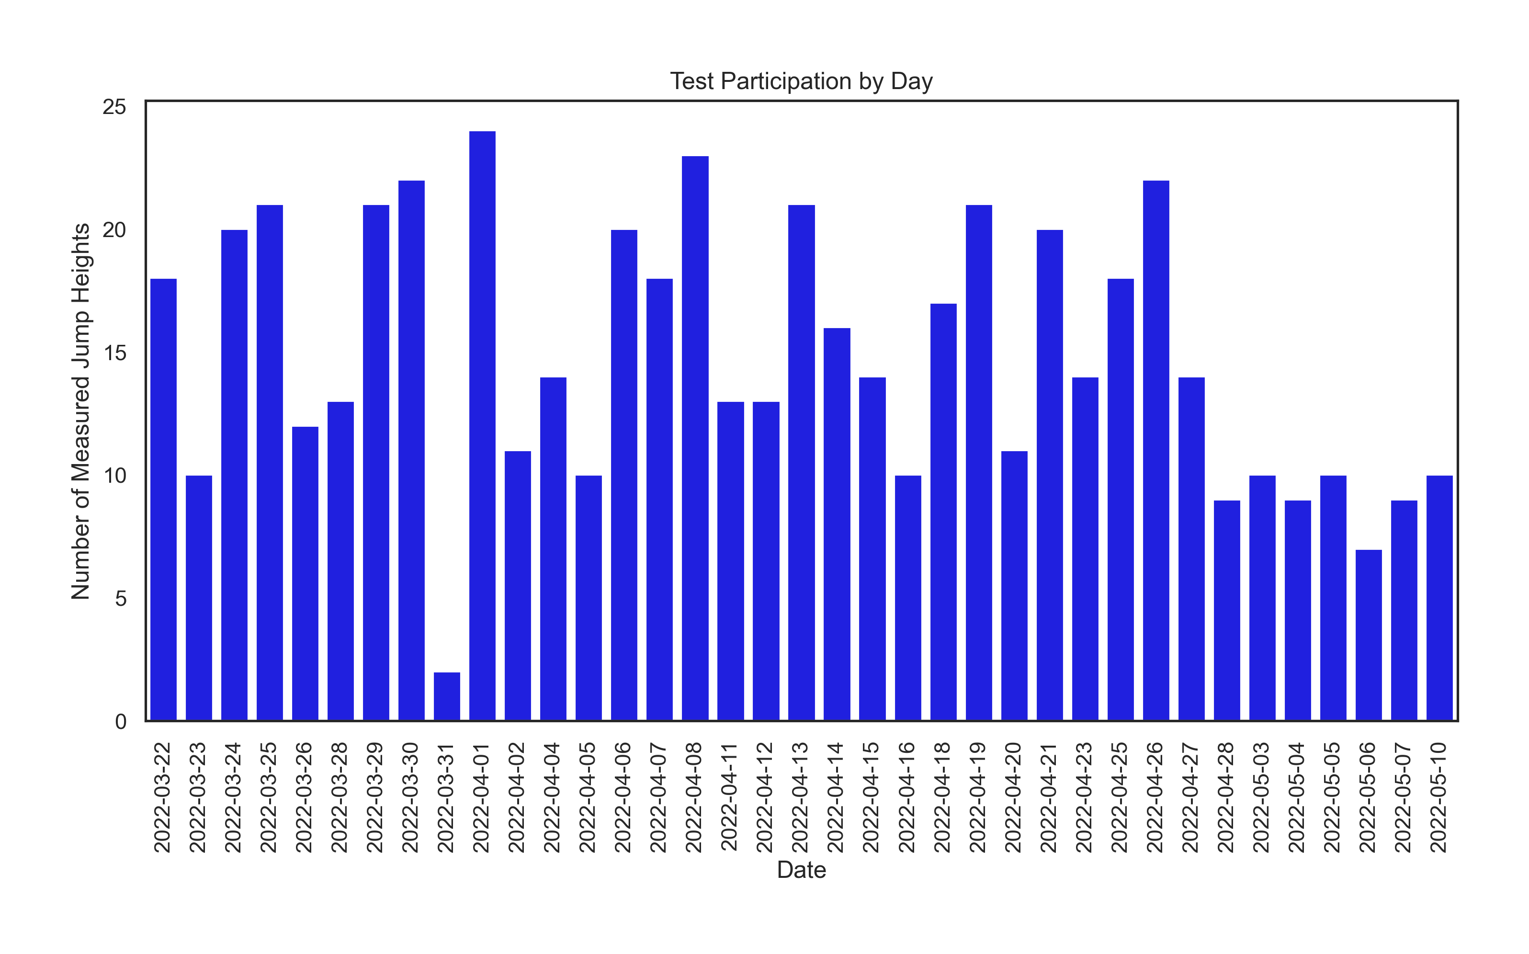

Figure 2

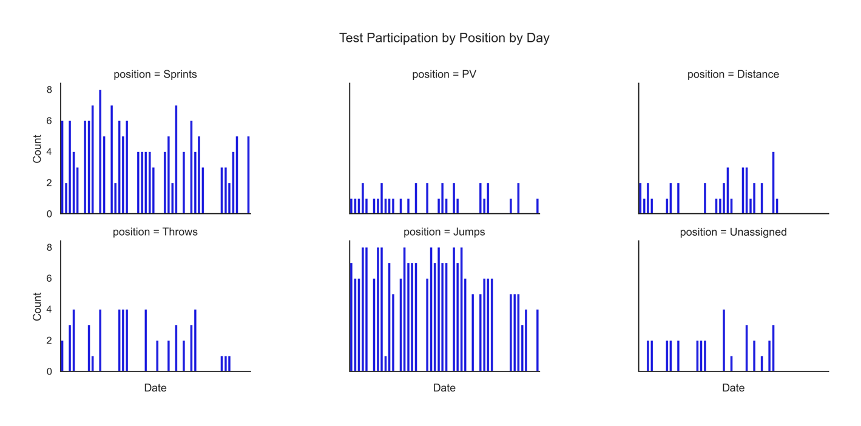

Figure 3

* Based on correlation analysis, 99.8% of jump height variation can be explained by takeoff velocity (Figure 4)
* Jump height and takeoff velocity exhibited similar trends over time due to the very strong relationship between variables (Figures 5 & 6)
* Based on daily average and daily variation trends, neither the jump heights nor takeoff velocities exhibited neurological fatigue signals (Figures 5 & 6)

Figure 4

Figure 5

Figure 6

* Based on Linear Regression and XGBoost machine learning models, peak propulsive power was the most important numeric variable for explaining takeoff velocities with position category also considered important
  + For every 1 W increase in peak propulsive power, take off velocity increased by 0.322 m/s
  + By comparison, the second most important numeric variable was system weight; for every 1 N increase in system weight, takeoff velocity decreased by 0.318 m/s
  + Relative to the Distance position,
    - Jumps takeoff velocity was 0.035 m/s higher (greatest increase)
    - Throws takeoff velocity was 0.05 m/s lower (greatest decrease)
* Peak propulsive power did not exhibit neurological fatigue over the study timeframe at either the aggregate team or position levels (Figures 7 & 8)
* Data for 3/23/2022 is abnormally low, potentially due to recording or equipment error (Figures 7 & 8)
* Pole Vaulters and Throwers exhibited greater variation in daily average peak propulsive power than Distance, Sprint or Jump athletes (Figure 8)

Figure 7

Figure 8

**Recommendations**

The force plate data for the West Chester University track and field team did not reveal definitive signals that the athletes suffered from neuromuscular fatigue based on the trends related to jump height, takeoff velocity and peak propulsive power. When daily trends indicated less daily variation in performance (a potential signal of fatigue), they coincided with steady, consistent athlete participation from 8-10 athletes from 2-3 of the 6 possible positions.

The findings are confounded due to inconsistent athlete participation. Daily participation ranged from 2 athletes to 24. At the position level, there was unequal representation; not all positions provided the same number of athletes. Additionally, not all positions provided data on all days. Because of the unequal position representation and participation, models could not accurately assess the importance of position relative to peak propulsive force. Nor is the average daily and daily variation in jump height, takeoff velocity and peak propulsive power representative of the team’s overall performance due to inconsistencies of athlete and position participation.

To improve the analysis and determine potential neuromuscular fatigue using a force plate, the following actions are recommended:

* Ensure equal representation of positions
* Increase athlete participation both individually and positionally
* Incorporate internal biometric markers such resting heart rate and HRV
* Incorporate competition results/outcomes
* Incorporate pattern of life variables to account for daily stress

Having equal position representation will account for differences in physiology present in the team. There are stark differences in distance runners and sprinters. Having equal representation will help the models determine which category most contributes to peak propulsive power.

Also incorporating internal markers will provide greater context to how the body handles the training and competition loads it absorbs along with life stressors, all of which would affect power generation. Including competition results/outcomes will provide a context for how force plate data relates to competition outcomes.

**References**

McLean, Adam PhD. Assistance given to the author, verbal and email discussion. On Monday, 1 April 2024, Dr. McLean and I had a short meeting on Teams during which we discussed my efforts on this analysis and report. He suggested I narrow my focus describe a specific question/trend that I arrived at in my analysis, but in my description of it, hadn’t actually fleshed out in the report. As a result of the talk, I was able to better formulate what my findings were. Subsequently, I rewrote the report to fit what had crystalized in my mind during the discussion. During the discussion, Dr. McLean offered to read through a draft for proofreading and does-it-answer-the-rubric purposes. The feedback I received, via email on 5 April 2024, was that I needed to answer the rubric’s call for introducing the dataset and explaining the utility of the analysis to the sport ecosystem. I deleted a sentence from my report and added a couple more sentences to address why this analysis was important to the sport ecosystem.