Predicting College Football Game Winners Using Box Score Histories, Roster Values, and Varying Time Windows with Machine Learning Models

Christopher L. Izenour
Department of Industrial and Systems Engineering
Mississippi State University
Mississippi State, MS 39762

Abstract

This analysis asks which pregame features best predict college football winners using only information available before kickoff. Using 2014-2025 regular-season games[1] for upper-echelon FBS teams[2], recruiting rankings from 247Sports[3], season-to-date team performance data, and offense-vs.-defense matchup features, the analysis compares six feature tiers under an expanding-window design and then retests the two preferred regularized logistic models under fixed 3-season and fixed 5-season windows. Logistic L2 achieved the best held-out AUC on the full tier and Logistic ElasticNet was nearly tied. Season-to-date performance provided the largest predictive lift. Roster talent added a meaningful secondary value. Fixed-width windows did not improve upon expanding-windows.

Keywords: machine learning, predictive analytics, college football, power conferences, matchup winners

1. Introduction and Background

This analysis addresses a practical sports analytics problem: given only the information available at kickoff, which pregame features best predict the winner of a college football game? College football is one of the most popular[4], most watched[5], and most gambled-on sports in the United States[6]. creating strong interest in forecasting matchup outcomes. Methodologically, the analysis avoids random train-test splits that mix seasons together and instead uses walk-forward, season-aware evaluation. The modeling table is framed from the home-team perspective with home_win as the binary target, and the sample is restricted to circa-2025 Power 4 teams plus Notre Dame, Oregon State, and Washington State to create a more homogeneous competitive environment. This analysis contributes to college football analytics in several ways:
- Evaluates tiered feature sets that separate context, roster talent, to-date performance, and matchup structure
- Compares model families by utilizing several modeling evaluation criteria and train-test gaps
- Tests whether the ordering of feature-tier usefulness remains stable across window designs
- Tests whether restricting training data to the most recent seasons improves predictive capability

This analysis sits at the intersection of several threads found within existing literature. Like South and Egros, it used box score histories with recruiting priors[7]. Like Delen et al., it compares multiple model families and treats winner prediction as a machine learning task[8]. Like Leung and Joseph, it is interested in whether historical structure can be used as a practical predictive model[9]. Like Coleman, it evaluates forecasting quality[10]. This analysis sought to integrate these ideas into a pipeline that compares context, talent, and performance under expanding and fixed-width season windows.

2. Literature Review

South and Egros are especially relevant to this analysis because they combined college football box scores with recruiting data, transformed game histories into season-long moving averages, engineered offense-vs-defense features, and compared multiple models. They used three seasons (2011-2014) for training and 2015 for testing. They found that lasso regression was the most accurate at predicting game outcomes[7]. Their design anticipated core ideas in this analysis, particularly the use of rolling pregame summaries and recruiting priors, but it remained centered on a single future test season rather than a sequence of walk-forward evaluation windows.

Delen et al. used 8 seasons of bowl game data and compared neural networks, decision trees, and support vector machines in both classification and regression-based classification settings. They found that direct classification outperformed regression-based classification and that decision trees achieved the strongest reported bowl game accuracy. They also reported that non-conference winning percentage and average margin of victory emerged as important variables[8].

Leung and Joseph took a different approach to using box scores or team summary predictors. They used a sports data mining approach where each team was represented in a four-dimensional space. They matched each team to similar teams and used historical results among those similar teams to infer the likely outcome. They reported high accuracy for selected seasons and substantially exceeded several benchmark methods in their comparisons[9].

Coleman’s approach focused on model aggregation. He developed a predictive metamodel by combining projected victory margins from 29 rating systems across 5,925 games from 2016-2024. Coleman identified a five-system ensemble that performed strongly relative to various betting lines[10].

Taken together, these studies show that college football forecasting has been assessed through box score modeling, similarity-based methods, and ensemble frameworks. These studies demonstrate that college football outcomes can be forecasted from multiple analytical perspectives, but they also leave gaps. The literature emphasizes bowl games, single test seasons, or conventional cross-validation rather than regular-season prediction with repeated future-season evaluation. The present study addresses those gaps.

3. Proposed Model

The analysis accessed 19,843 raw box scores[1], recruiting data[3], and present-day conference affiliations[2]. Team names are normalized, game dates aligned to football seasons, and January games are assigned to the prior season so that postseason timing does not affect season labeling. Each team’s pregame state is summarized consistently from prior games only. Team-level summaries are merged back into a one-row-per-game table, and most engineered features are expressed as home-minus-away differences, so that positive values indicate a home-team advantage. The final dataset contains 3,304 box scores and 69 teams.

This dataset is layered (see Table 1). These layers were evaluated both separately and cumulatively through six feature tiers (see Table 1). Figure 2 summarizes the end-to-end workflow from raw data through lagged feature engineering, tuning, and future season evaluation.

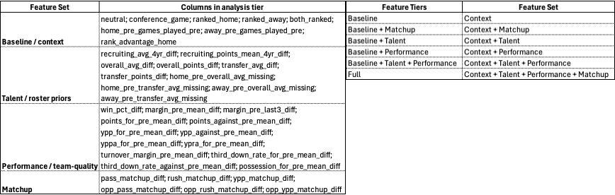

Table 1: Graphical depiction of tiered feature sets.

Figure 2: Flowchart depicting methodology used for conducting analysis.

4. Experimental Results

4.1 The Data

A descriptive look at the final modeling table provides context for the prediction problem. Home teams won 55.7% of games overall, confirming a modest home-field edge (see Table 2). Table 2 shows the home win rate stayed generally in the mid-50% range by season, but rank status sharpened the pattern: when the home team was higher ranked, the home win rate was roughly 74%–89%, whereas it dropped to roughly 22%–41% when the away team was higher ranked. Conference-game status mattered much less in aggregate. Regardless of conference-game status, home team win rates average 56%.

Table 2: Home team win rates aggregated by season and by Rank Context

A key aspect of the analysis is that every rolling predictor is built from prior games only. The final modeling table is one row per game with columns representing aspects of context, roster-talent, season-to-date performance summaries, matchup variables, and home-minus-away differentials. The target variable is home_win.

4.2 Experimental Design

The primary experiment used a walk-forward, expanding season-rollover design (see Figure 3a). In each iteration, earlier seasons formed the outer training block and the next season served as the outer test season. Within each outer training block, the most recent season was used as an inner validation season for hyperparameter tuning, while all earlier seasons formed the inner training subset. The selected model was then refit on the full outer training block and evaluated once on the untouched outer test season.

A second experiment served as a robustness check. After the expanding-window analysis identified the preferred models, those models were rerun under fixed-width rolling season windows (see Figures 3b & 3c). The goal was to test whether recency-only training improved on the broader historical memory of the expanding-window design

Figure 3: Graphical depiction of the three season window designs. a) expanding windows, b) fixed 3-season windows, c) fixed 5-season windows.

4.3 Candidate Models and Metrics

The primary experiment compared six candidate models: Logistic L1, Logistic L2, Logistic Elastic Net, Support Vector Classifier, Random Forest, and Gradient Boosted Classifier. Models were evaluated by ranking quality (AUC), probability quality (log loss, Brier score, calibration), threshold behavior (accuracy, precision, recall, F1, specificity, and balanced accuracy), and train-test gaps as an overfitting check. All six model families were evaluated across all six feature tiers under expanding windows, and the two preferred regularized logistic models were then re-evaluated across the same tiers under fixed 3-season and fixed 5-season windows.

4.4 Results

Across the expanding-window analysis, the regularized logistic models formed the strongest overall group. Logistic L2 had theThe best held-out discrimination on the full feature set (mean test AUC = 0.788), with Logistic L1, Logistic Elastic Net, and the support vector classifier close behind. Random forest and gradient boosted classifier exhibited much larger train-test gaps, indicating greater overfitting.

For the tiered results predictive performance improved in a highly consistent manner: baseline was weakest, matchup added only a small gain, talent added a clearer gain, performance produced the largest jump, baseline_talent_performance came close to the top, and the full tier performed best overall (see Figure 4). The full tier only slightly exceeded baseline_talent_performance, indicating that most of the predictive value came from context, talent, and especially season-to-date performance rather than matchup features alone. This ordering held across the expanding-window comparison, suggesting it reflects a real property of the data.

The consistency of the tier ordering across expanding, fixed 3-season, and fixed 5-season designs is one of the central results of the study. Together, Figures 4 and 5 show that older seasons continued to contribute useful predictive structure rather than simply diluting the signal.

The fixed-width analyses reinforced the same conclusions. Under both fixed 3-season and fixed 5-season windows, the same tier ordering reappeared and the full tier again performed best overall. Under fixed 3, the best result came from full + Logistic L2 (mean test AUC = 0.782), closely followed by Elastic Net; under fixed 5, the same pattern held. Figure 4 compares the best full-tier results across the three window designs and shows that expanding windows remained best overall, fixed 5 stayed close, and fixed 3 was generally weakest.

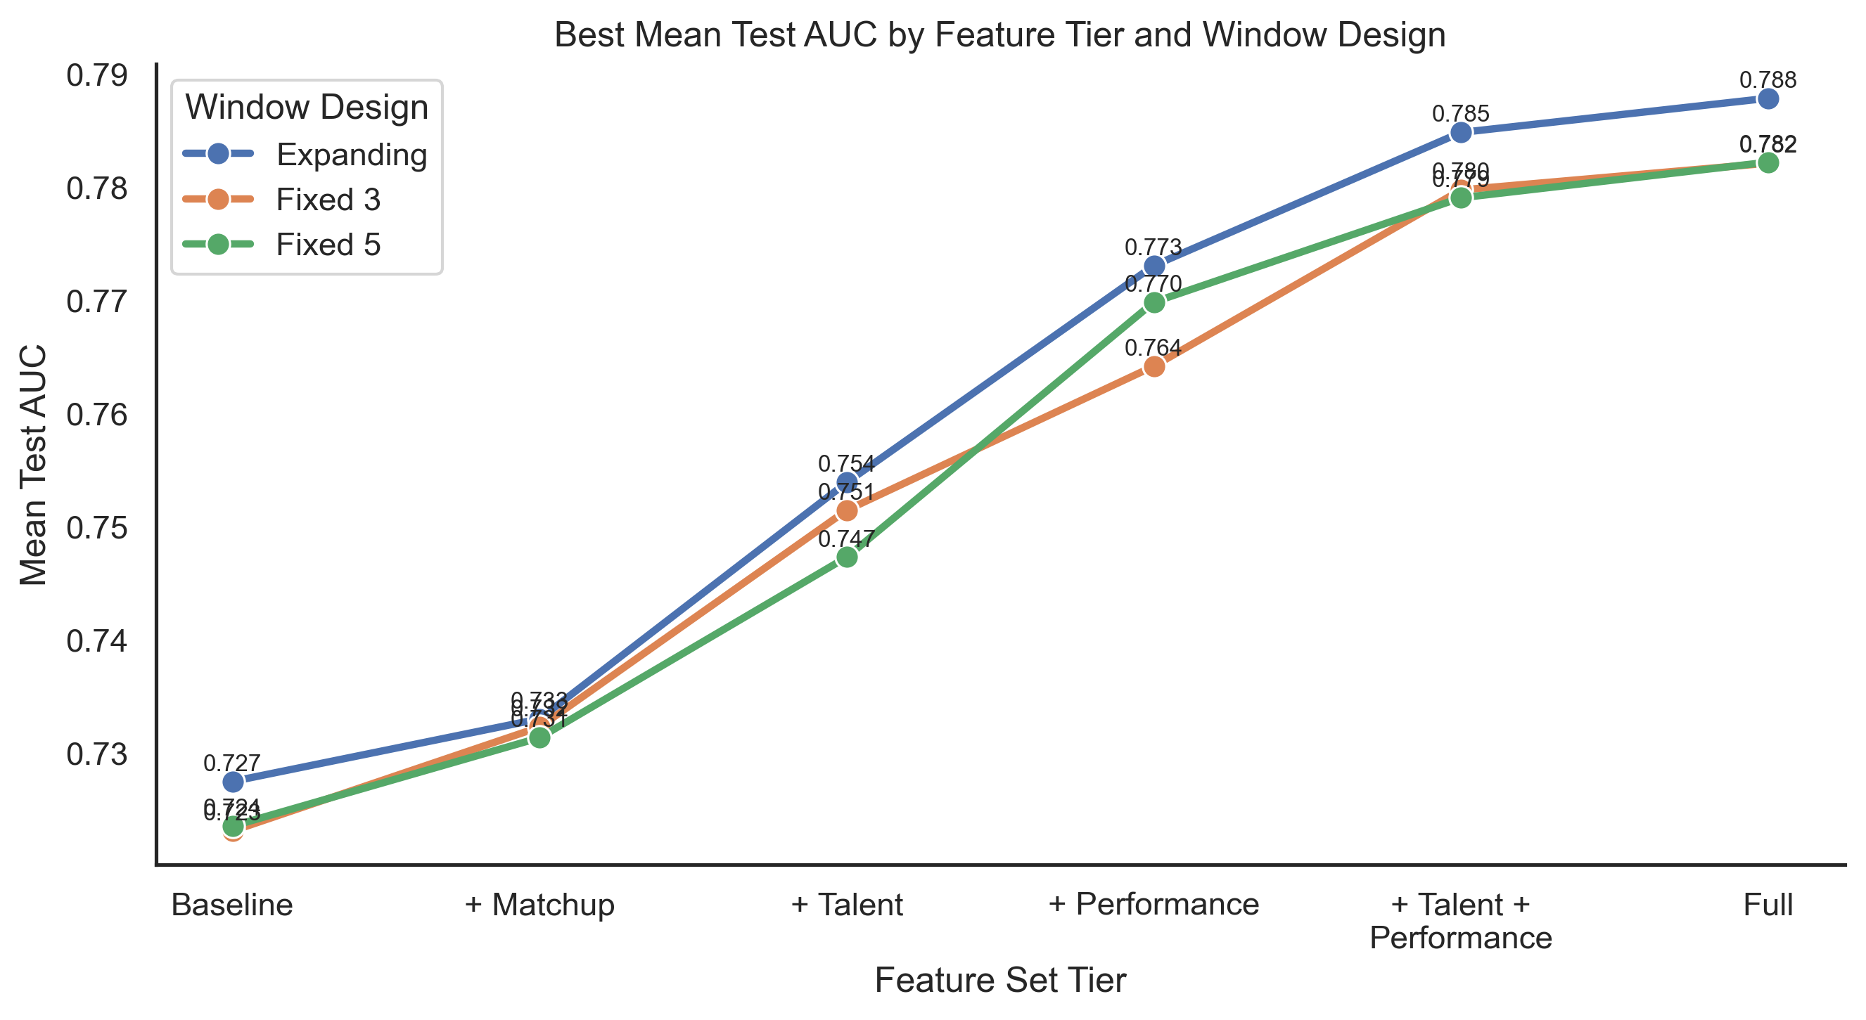

Figure 4: Line chart depicting Best Mean Test AUC by Feature Tier and Window Design. Expanding performed best and each window design followed the same pattern regarding feature tier set.

Evaluating the preferred models (Logistic L2 and Logistic ElasticNet) across the windows, the expanding window yielded superior performance. This indicates that predictive power is enhanced with greater historical context.

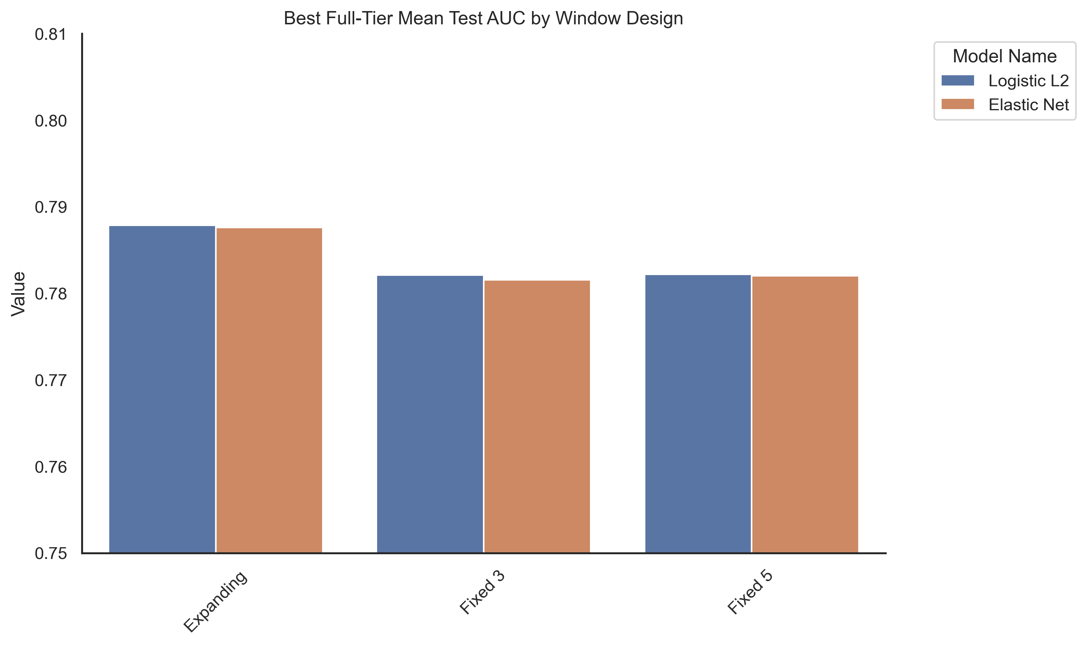

Figure 5: Bar chart depicting the best Full Tier Mean Test AUC by Window Design. Expanding performed best

4.5 Features

It was important to determine which pregame features were most useful. Across the expanding-window results, season-to-date performance provided the strongest predictive signal. The strongest and most stable predictors clustered around rank advantage, scoring-margin differentials, recent-form margin, points-for production, and recruiting-based talent differences (see Table 3).

Table 3: Useful features across analyses, what they represent in football terms and how they are interpreted

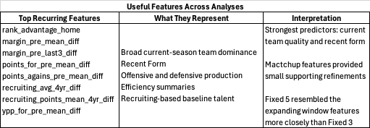

Rank advantage was one of the strongest predictors in every preferred model, indicating that ranking status continued to carry real information after controlling for roster quality and season-to-date performance. A stronger ranking profile for the home team generally increased the estimated probability of a home win.

Season-to-date scoring margin was one of the most valuable compact summaries of team strength. Both margin_pre_mean_diff and margin_pre_last3_diff remained influential, implying that decisive current-season performance was more informative than win-loss record alone.

Offensive production and efficiency variables were important supporting predictors. Teams entering a matchup with stronger points-for and efficiency profiles were more likely to win, while variables reflecting opponent production allowed moved in the opposite direction. Together, these features suggest the preferred models were learning broad current offensive and defensive quality rather than relying only on static roster information.

Talent variables added meaningful value, but less than realized in-season performance. Recruiting-based priors captured a team’s longer-run ceiling or baseline strength, while season-to-date box score histories better captured who that team had actually been in the current season.

Coefficient interpretation should be treated as conditional rather than causal because many predictors are correlated by construction. Tables 4 and 5 report the preferred-model coefficients and model-family performance summaries. The fixed-width analyses reinforced the same substantive conclusions.

Overall, the feature interpretation results support a coherent football conclusion: teams that entered a game with stronger ranking profiles, recruiting-based talent profiles, scoring-margin advantages, and offensive production summaries were systematically more likely to win.

Table 4: Feature coefficients for the two preferred models by window designs

Table 5: Feature set and model family performance by window designs

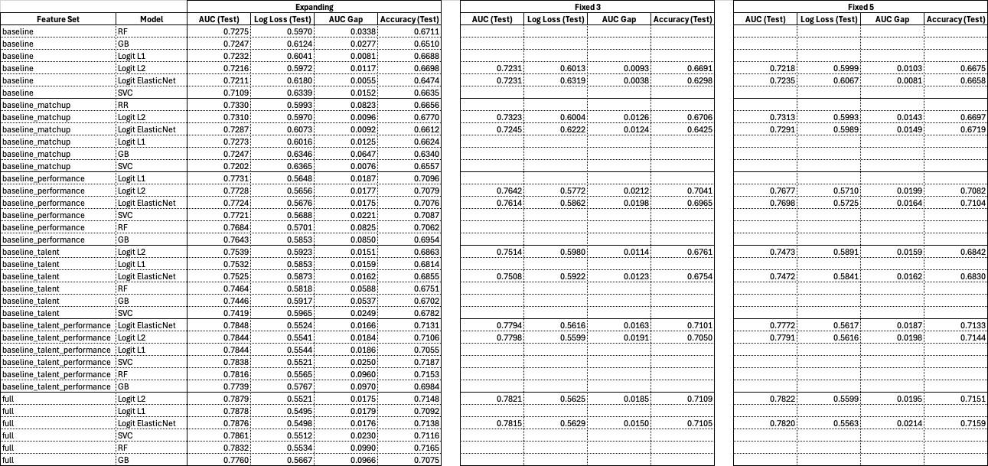

5. Conclusion and Future Work

This analysis examined which pregame features most consistently predict college football winners. Three conclusions stand out:
- Season-to-date performance was the dominant source of predictive lift
- Recruiting-based talent added meaningful secondary value
- Regularized logistic models outperformed more flexible nonlinear alternatives

Logistic L2 was the strongest overall model because it repeatedly achieved the best or near-best held-out discrimination, maintained relatively small train-test gaps, and remained stable across feature-tier and window-design comparisons. The fixed-width analyses reinforced the case for the expanding-window design.

Future work should focus on:
- Refining the regularized framework through further hyperparameter tuning
- Adding opponent-strength adjustments, injury status priors, phase-of-season comparisons
- Refining team inclusion criteria due to conference realignments
- Augment team roster talent data with transfer player ratings

References
[1] CVIAXMIWNPTR, “College Football Game Stats | 2022 to January 2026.” Accessed: Mar. 07, 2026. [Online]. Available: https://www.kaggle.com/datasets/cviaxmiwnptr/college-football-team-stats-2002-to-january-2024?resource=download
[2] “College Football Teams.” Accessed: Mar. 07, 2026. [Online]. Available: https://www.espn.com/college-football/teams
[3] “Recruit Football Composite Team Rankings.” Accessed: Mar. 05, 2026. [Online]. Available: https://247sports.com/season/{year}-football/compositeteamranki
[4] “College Football Continues to Build Unprecedented Interest with Record Attendance and Stellar Ratings | Military Bowl.” Accessed: Apr. 10, 2026. [Online]. Available: https://militarybowl.org/college-football-continues-to-build-unprecedented-interest-with-record-attendance-and-stellar-ratings/
[5] A. Karp, “College football rides wave to new audience records for the sport,” Sports Business Journal. Accessed: Apr. 10, 2026. [Online]. Available: https://www.sportsbusinessjournal.com/Articles/2025/12/08/college-football-rides-wave-to-new-audience-records-for-the-sport/
[6] bcsguestwriter, “College Sports Betting Data Is Increasingly Influencing Media and Sponsorship Valuations,” Business of College Sports®. Accessed: Apr. 10, 2026. [Online]. Available: https://businessofcollegesports.com/sports-betting/college-sports-betting-data-is-increasingly-influencing-media-and-sponsorship-valuations/
[7] C. South and E. Egros, “Forecasting college football game outcomes using modern modeling techniques,” J. Sports Anal., vol. 6, no. 1, pp. 25–33, Feb. 2020, doi: 10.3233/JSA-190314.
[8] D. Delen, D. Cogdell, and N. Kasap, “A comparative analysis of data mining methods in predicting NCAA bowl outcomes,” Int. J. Forecast., vol. 28, no. 2, pp. 543–552, Apr. 2012, doi: 10.1016/j.ijforecast.2011.05.002.
[9] C. K. Leung and K. W. Joseph, “Sports Data Mining: Predicting Results for the College Football Games,” Procedia Comput. Sci., vol. 35, pp. 710–719, 2014, doi: 10.1016/j.procs.2014.08.153.
[10] B. J. Coleman, “A predictive metamodel for college football,” J. Sports Anal., vol. 11, p. 22150218251365223, Oct. 2025, doi: 10.1177/22150218251365223.

