**BM508 Managerial Statistics Assignment 1 Spring 2024**

* Please specify the software you used for the questions. Python
* Please write down and submit your answers using Word document and attach the outputs generated from your software.
* Do not simply submit the output from the statistical tool as your homework without organizing it in a Word document.
* If you are using R, STATA, or python, please also submit your codes.

In the data, “Items” indicates the total number of items purchased, while “Net Sales” is the total amount ($) charged to the credit card.

Pelican's management would like to use this sample data to learn about its customer base and to evaluate the promotion involving discount coupons.

Managerial Report

Use the methods of descriptive statistics to summarize the data and comment on your findings.

1. Provide number of observations, mean, standard deviation, median, and range for the variable of “net sales” (1) by type of customer, (2) by whether customers used “Proprietary Card” for payment or not, (3) for those Age>=45 only. (50 pts)

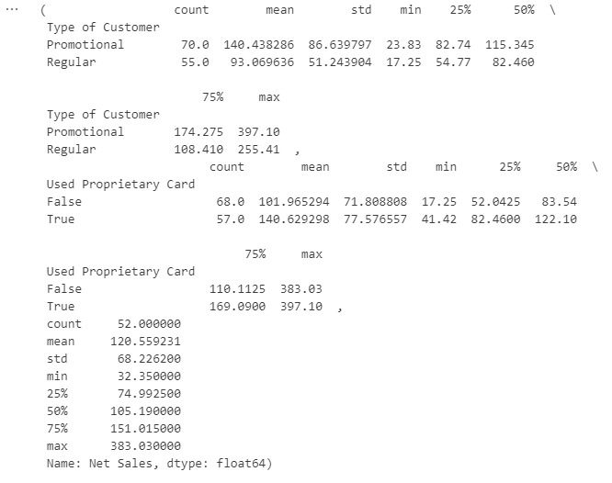

圖表1 Descriptive Statistics

**By Type of Customer:**

* Promotional Customers:

Count: 70

Mean: $140.44

Standard Deviation: $86.64

Median: $115.35

Range: $23.83 to $397.10

* Regular Customers:

Count: 55

Mean: $93.07

Standard Deviation: $51.24

Median: $82.46

Range: $17.25 to $255.41

**By Method of Payment (Proprietary Card or Not):**

* Used Proprietary Card:

Count: 57

Mean: $140.63

Standard Deviation: $77.58

Median: $122.10

Range: $41.42 to $397.10

* Did Not Use Proprietary Card:

Count: 68

Mean: $101.97

Standard Deviation: $71.81

Median: $83.54

Range: $17.25 to $383.03

**For Customers Aged 45 and Above:**

Count: 52

Mean: $120.56

Standard Deviation: $68.23

Median: $105.19

Range: $32.35 to $383.03

1. Use the formula introduced in the class or so called “exclusive” approach to obtain the following information on age: (1) the 30th percentile; (2) the first quartile; (3) the 95th percentile; (4) the third quartile; (5) IQR. (10 pts) (If your software does not support exclusive approach, please specify your programming codes for the results.)

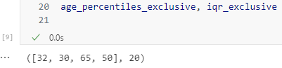

圖表2 Percentile & IQR

* 30th Percentile:

32 years-old

* First Quartile (25th Percentile):

30 years-old

* 95th Percentile:

65 years-old

* Third Quartile (75th Percentile):

50 years-old

* Interquartile Range (IQR):

20 years-old

1. From 1-(2), provide a figure containing two box plots of the net sales by the classification. Don’t forget the title of figure, and the axis titles. (10 pts)

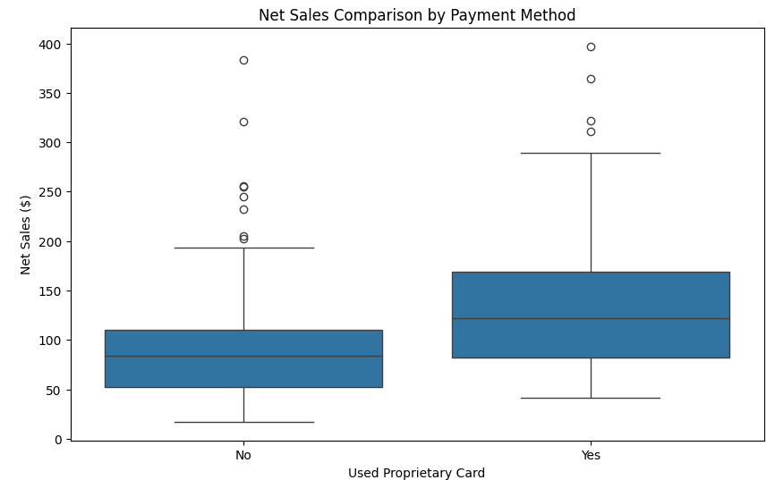

圖表3 Box Plots

Yes = used “Proprietary Card” for payment：

Q1 = 82.46 , Q2 = 122.10 , Q3 = 169.09 , max = 397.10 , min = 41.42

NO = Did not used “Proprietary Card” for payment：

Q1 = 52.0425 , Q2 = 83.54 , Q3 = 110.1125 , max = 383.03 , min = 17.25

1. Descriptive statistics concerning the relationship between age and net sales, including the measure of correlation coefficient (2 pts), a scatter diagram with a trendline. (8 pts)

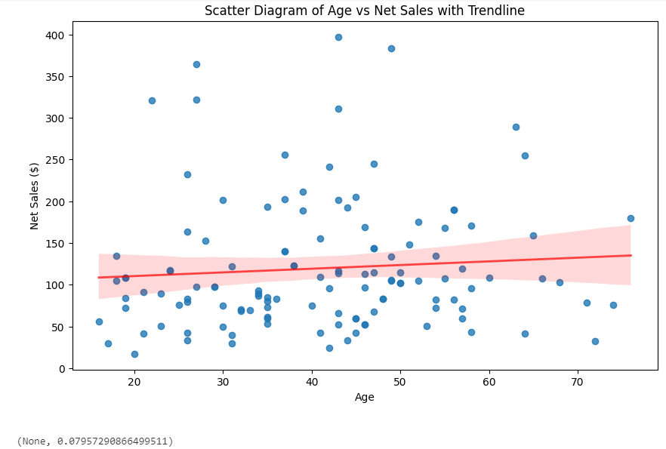

圖表4 Scatter Diagram

The scatter diagram above illustrates the relationship between age and net sales, including a red trendline to highlight the overall direction of this relationship. The correlation coefficient between age and net sales is approximately 0.08, indicating a very weak positive relationship between these two variables. This suggests that age does not strongly influence net sales in this dataset.

1. Develop a contingency table presenting the relationship between marital status and type of customer, where type of customer is the row variable. Please provide the count and the row percent for each cell as “n(%)”. (10 pts)

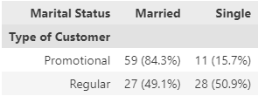

圖表5 Contingency Table

This table shows the distribution of marital status among promotional and regular customers. Promotional customers are predominantly married (84.3%), while the distribution between married and single is more balanced among regular customers, with a slight majority being single (50.9%).

1. Provide one paragraph (no more than 1/3 page) to summarize the findings from 1-5. (10 pts)

From the data analysis of Pelican Stores, we observed that promotional customers tend to spend significantly more on average compared to regular customers, with those using the Proprietary Card also showing higher expenditure. The correlation between age and net sales is weak, suggesting that age may not be a primary determinant of spending levels. Box plot analysis of net sales highlighted the disparities in spending distribution among promotional customers and those who pay with the Proprietary Card. Furthermore, the relationship between marital status and customer type reveals that the promotion was particularly effective among married customers, with a majority of promotional customers being married. These findings suggest that Pelican Stores' promotional strategy successfully attracted a higher-spending customer segment, especially married individuals, and enhanced customer loyalty and spending through the Proprietary Card. These insights can assist in the design of future marketing strategies and promotional activities aimed at further enhancing customer satisfaction and sales performance.