LEADERSHIP ROADMAP
& WORKSHOP GUIDE

Know Yourself. . Read the Room . Pivot with Intention . Sustain Momentum
{{NAME}}

Turning Leadership Insight into Visible Behavior, Intentional Action, and Sustained Impact

Confidential Leadership Development Use

TABLE OF CONTENTS

Welcome to Your Leadership Roadmap 3

Section 1: DISC 8

Section 2: EQ 15

Section 3: FLYWHEEL 23

Section 4: LEADERSHIP SIGNATURE 30

Section 5: COACHING PLAN 36

Welcome to Your Leadership Roadmap

Your leadership is not defined by what you know about yourself. It is defined by your ability to read the moment, choose your response, and create the momentum others need to move forward.

You have spent time exploring the SDG Leadership Framework and examining leadership through multiple lenses: how you naturally show up, how emotional intelligence influences your effectiveness, when the moment requires you to pivot, and the leadership experience you intentionally want to create for others.
Now the work becomes personal.
Your Leadership Roadmap brings those individual insights together. It is not another assessment, nor is it intended to change who you are as a leader. It is a personal leadership framework designed to help you determine what is most true about how you lead, where your strengths create value, where greater leadership range may be required, and what you will intentionally do differently.
The Leadership Roadmap and the worksheets that follow will help you integrate what you have learned through the SDG Leadership Practice Model:

Know Yourself . Read the Room . Pivot with Intention . Sustain Momentum

As you work through your Leadership Roadmap, the goal is not to focus on every possible development opportunity. The goal is to identify the patterns that matter most, recognize the leadership moments that may require a different response, and intentionally choose the leadership behavior to strengthen.

That intentional behavior shift becomes the focus of your 30-60-90 Coaching Plan. Through practice, coaching, reflection, and accountability, you will have the opportunity to move from insight to intentional behavior, and from intentional behavior to sustained leadership impact.
Ultimately, the measure of this work is not what you learn about yourself. It is what changes for the people you lead because of what you now understand, and what you choose to do differently.

 | LEADERSHIP FRAMEWORK OVERVIEW  One integrated leadership system | SDG  Leadership  Framework

The SDG Leadership Framework is an integrated leadership system designed to move insight into intentional behavior, consistent execution, and sustained organizational impact.
Each component provides a different lens into leadership. Together, they move the leader from self-awareness to system awareness, and from intention to observable leadership practice.
The framework answers four essential leadership questions:
Leadership Practice | Framework Lens | The Question It Helps You Answer
Know Yourself | DISC | How do I naturally lead?
Read the Room | EQ-i | What is happening within me, with others, and in this moment?
Pivot with Intention | Leadership Pivot + Leadership Signature | What does effective leadership require from me now?
Sustain Momentum | Flywheel | What impact is my leadership creating over time?

The power of the framework is not in any one component. It is in your ability to use them together. Knowing yourself creates awareness. Reading the room adds context. The Leadership Pivot turns awareness and context into intentional choice. Your Leadership Signature gives that choice consistency. The Flywheel helps you understand whether those choices create the direction, culture, learning, execution, and accountability needed to sustain momentum.

How to Use Your Leadership Roadmap

Step | Purpose | What You Will Do
- Reconnect | Bring together the leadership concepts you have explored. | Review the framework through the lens of your own leadership.
- Reflect | Determine what the combined insights reveal. | Use the Roadmap worksheets to examine your DISC, EQ-i, Flywheel and Leadership Signature insights.
- Integrate | Identify the patterns that matter most. | Confirm what is most true about your leadership and where greater range may be required.
- Focus | Move from multiple insights to intentional priority. | Select leadership behavior(s) to intentionally strengthen.
- Practice & Sustain | Translate your priority into behavior. | Use your 30-60-90 Coaching Plan and coaching conversations to practice, assess, adjust, and sustain the behavior.

 | LEADERSHIP ROADMAP INTEGRATION SUMMARY  Your Leadership Roadmap | SDG  Leadership  Framework

Your Leadership Roadmap reflects an integrated DISC, EQ-i, and Flywheel profile. DISC helps you know yourself. EQ-i helps you read the Room. Leadership Signature helps you pivot with intention. Flywheel helps you Sustain Momentum. The Leadership Roadmap helps you bring it all together and apply it to how you LEAD.

{{SUMMARY_DISC}}

{{SUMMARY_EQI}}
{{SUMMARY_EQI_DEV}}

{{SUMMARY_FLYWHEEL}}

Roadmap Focus
{{ROADMAP_FOCUS}}

Leadership Signature

{{LEADERSHIP_SIGNATURE}}

 | LEADERSHIP ROADMAP SNAPSHOT  Quick reference for personal integration | SDG  Leadership  Framework

Roadmap Element | Your Profile | What It Means for Workshop Application
Natural Leadership Pattern | {{SNAP_PATTERN}} | {{SNAP_PATTERN_MEANS}}
DISC Mirror Scores | {{MIRROR_LINE}} | {{SNAP_MIRROR_MEANS}}
DISC Stress Scores | {{STRESS_LINE}} | {{SNAP_STRESS_MEANS}}
EQ Strengths | {{SNAP_EQ_STRENGTHS}} | {{SNAP_EQ_STRENGTHS_MEANS}}
EQ Development Stretch | {{SNAP_EQ_DEV}} | {{SNAP_EQ_DEV_MEANS}}
Primary Flywheel Strength | {{SNAP_FLY_PRIMARY}} | {{SNAP_FLY_PRIMARY_MEANS}}
Secondary Flywheel Strength | {{SNAP_FLY_SECOND}} | {{SNAP_FLY_SECOND_MEANS}}
Leadership Risk Under Pressure | {{SNAP_RISK}} | {{SNAP_RISK_MEANS}}
Coaching Opportunity | {{SNAP_COACHING}} | {{SNAP_COACHING_MEANS}}
SECTION 1
DISC

Behavior, Communication, and Pressure Shifts
SDG LEADERSHIP FRAMEWORK
 | DISC LEADERSHIP ROADMAP CONNECTION  Behavior Pattern and Pressure Shift | SDG  Leadership  Framework

{{DISC_CONNECTION_INTRO}}

MIRROR SCORES — HOW YOU INTERNALLY PROCESS LEADERSHIP EXPECTATIONS
D | I | S | C
{{M_D}} | {{M_I}} | {{M_S}} | {{M_C}}

PRESSURE SCORES — BEHAVIORAL SHIFT UNDER STRESS
D | I | S | C
{{P_D}} | {{P_I}} | {{P_S}} | {{P_C}}
RADAR SHIFTS
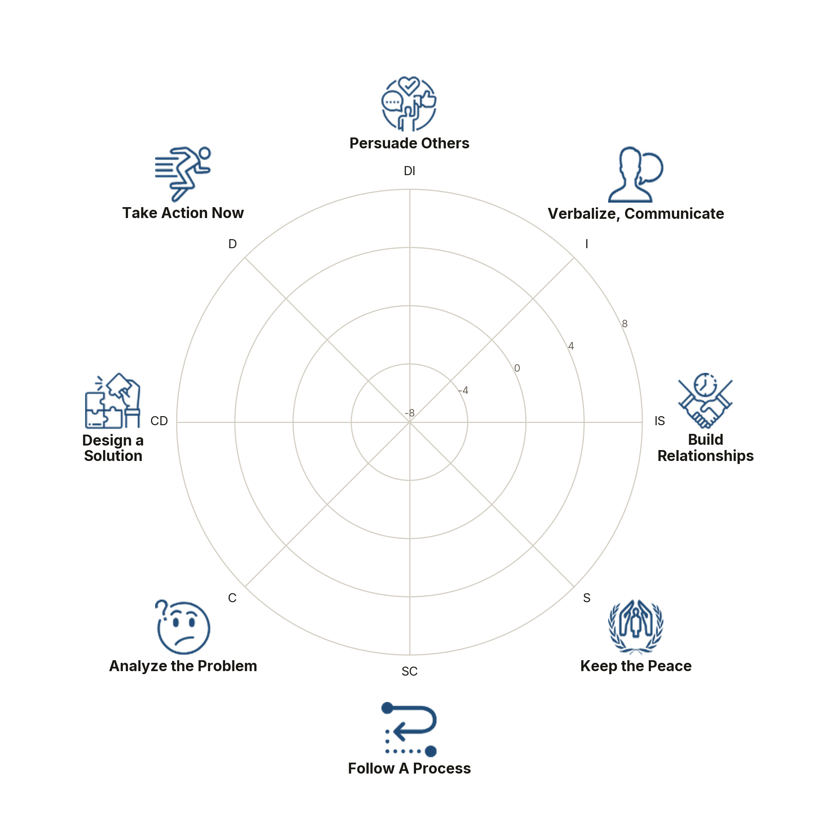
Profile Element | Leadership Interpretation
Primary Style | {{STYLE_LABEL}}
Mirror Profile | {{MIRROR_LINE}}
Natural Strengths | {{DISC_NATURAL_STRENGTHS}}
How Staff May Experience You | {{DISC_STAFF_EXPERIENCE}}
Potential Blind Spot | {{DISC_BLIND_SPOT}}
Pressure Risk | {{DISC_PRESSURE_RISK}}
DISC Coaching Adjustment | {{DISC_COACHING_ADJUSTMENT}}

Practice Language
Here is what I am seeing. Here is why it matters. Here is what I believe we need to do next.

 | SECTION 1: DISC  Mirror Profile, Pressure Shifts, and Coaching Adjustments | SDG  Leadership  Framework

Use your DISC Mirror Profile to identify how you naturally lead and what shifts when pressure rises. The goal is to recognize the behavior, name the leadership risk, and choose an intentional coaching adjustment.
A. MY DISC MIRROR PROFILE
Prompt | Reflection / Notes
My highest DISC Mirror style(s):
My natural leadership strengths:
How staff likely experience me when things are calm:
My natural coaching and accountability tendency:
B. MY STRESS / PRESSURE SHIFT
Prompt | Reflection / Notes
Under pressure, my profile shifts toward:
My communication becomes more:
My decision-making becomes more:
Staff may experience this pressure shift as:

The leadership risk I need to manage:

C. INTENTIONAL ADJUSTMENT
Pressure Pattern | Leadership Risk | Adjustment I Will Practice
Move too fast / become forceful | Compliance without ownership
Over-explain / become scattered | Energy without clarity
Avoid conflict / become quiet | Delayed accountability
Over-focus on details / become rigid | Fear of mistakes or slow action

30-day commitment: When pressure rises, I will pause, name the pattern, coach the shift, and confirm accountability.

 | DISC NOTES  Reflection, Insights, and Coaching Application | SDG  Leadership  Framework

Guided Reflection
- What did I learn about my natural leadership pattern?
- What pressure behavior must I manage?
- What coaching adjustments will staff notice?

SECTION 2
EQ

Leadership Presence and Coaching Capacity
SDG LEADERSHIP FRAMEWORK
 | EQ ROADMAP CONNECTION  Leadership presence and coaching capacity | SDG  Leadership  Framework

{{EQI_STRENGTH_NOTE}}

CORE EQ-I STRENGTHS

{{TABLE:EQ_STRENGTH_BARS}} |  | {{CELL}}

Two types of scores appear on this page: scores that fall just below the mid-range, and scores that may be above the mid-range but remain below the range typically expected of senior leaders. The scores highlighted with a green bar are above the mid-range but fall outside the range we would like to see for most leaders.
These scores do not define your leadership effectiveness. Rather, they highlight areas where greater intention, consistency, and practice can strengthen how you respond to different people, pressures, and situations. Your existing leadership assets provide a strong foundation for that continued growth.
{{EQI_DEV_NOTE}}

LEADERSHIP CAPACITIES TO STRENGTHEN
{{TABLE:EQ_DEVELOPMENT_BARS}} |  | {{CELL}}

{{EQI_INTRO}}
The Goal is not to lead from a score. The goal is to expand the leadership you can access when the moment requires it.

If scores appear in this section, Leadership Derailment Risk, they indicate an opportunity to strengthen one or more of the four EQ-i subscales associated with leadership effectiveness under pressure: Impulse Control, Stress Tolerance, Problem Solving, and Independence.
Scores below the mid-range of 100 may signal a greater likelihood that, during periods of stress, complexity, or uncertainty, a leader may become more cautious, reactive, passive, or avoidant. These shifts can affect decision-making, communication, confidence, and the ability to provide clear direction when the team needs it most.
The impact may be especially noticeable when leading a diverse DISC team, where different behavioral styles require the leader to adapt communication, pace, decision-making, and engagement while maintaining consistency and clarity.
These scores should not be viewed as limitations. Instead, they identify specific emotional intelligence capacities you can intentionally strengthen. Developing these areas can increase leadership resilience, expand behavioral flexibility, and help ensure that your leadership remains effective and aligned, even under pressure.
If any score in this section is 100 or above, your results indicate a low or minimal current risk of leadership derailment across these four EQ-i dimensions.

LEADERSHIP DERAILMENT RISK
Impulse Control |  | {{CELL}}
Stress Tolerance |  | {{CELL}}
Problem Solving |  | {{CELL}}
Independence |  | {{CELL}}

{{TABLE:EQ_DIMENSIONS}} | Score / Theme | Leadership Meaning
{{CELL}} | {{CELL}} | {{CELL}}
{{CELL}} | {{CELL}} | {{CELL}}
EQ Practice
Before responding, ask: What am I noticing? What needs to be named? What does this person need from me - direction, support, or a sounding board?

 | PARTICIPANT WORKSHEET 2: EQ  Leadership presence, self-management, and coaching capacity | SDG  Leadership  Framework

Use this worksheet to connect emotional intelligence to everyday leadership. EQ is the capacity that helps you manage yourself, read the moment, build trust, and coach staff through pressure without becoming reactive.

A. EQ LEADERSHIP ANCHORS
EQ Anchor | What It Requires of Me | My Current Reflection
Authenticity | Be clear, fair, steady, and consistent.
Coaching | Develop the staff instead of only correcting the issue.
Insight | Connect expectations to purpose, impact, and direction.
Innovation | Create space for ownership, problem-solving, and learning.

B. MY EQ PRACTICE UNDER PRESSURE
Prompt | Reflection / Notes
A situation that tests my emotional intelligence:

My usual reaction under pressure:

What I need to regulate before responding:

The EQ anchor I most need to strengthen:

The leadership response I want supervisors to experience:

C. COACHING QUESTION I WILL USE
Prompt | Reflection / Notes
My first coaching question will be:

The ownership question I will ask:

The follow-up accountability question I will ask:

EQ commitment: I will manage my response before I manage the conversation.
 | EQ NOTES  Reflection, insights, and coaching application | SDG  Leadership  Framework

Guided Reflection
- What situation tests my emotional intelligence?
- What do I need to regulate before responding?
- What coaching question will I use first?

SECTION 3
FLYWHEEL

Momentum, Drag, and Staff Coaching Priorities
SDG LEADERSHIP FRAMEWORK
 | FLYWHEEL LEADERSHIP ROADMAP CONNECTION  Where you Create and Sustain Momentum | SDG  Leadership  Framework

PURPOSE
The SDG Flywheel helps leaders see how their behavioral style and emotional intelligence patterns shape organizational momentum. It translates DISC and EQ-i insight into four essential leadership capacities: setting direction, shaping culture, executing with accountability, and learning through feedback and adaptation.

{{FLYWHEEL_FOR_YOU}}

Primary Strength  {{FLY_PRIMARY_LABEL}}  {{FLY_PRIMARY_BOX}} | Secondary Strength  {{FLY_SECONDARY_LABEL}}  {{FLY_SECONDARY_BOX}}

{{FLY_DEV_RISK}}

Flywheel Quadrant | Current Strength | Development Stretch
Direction & Strategic Intent | {{FLY_DIRECTION_NOW}} | {{FLY_DIRECTION_FROM}}  {{FLY_DIRECTION_NEXT}}
Leadership Behavior & Culture | {{FLY_CULTURE_NOW}} | {{FLY_CULTURE_FROM}}  {{FLY_CULTURE_NEXT}}
Learning, Feedback & Adaptation | {{FLY_LEARNING_NOW}} | {{FLY_LEARNING_FROM}}  {{FLY_LEARNING_NEXT}}
Execution & Accountability | {{FLY_EXECUTION_NOW}} | {{FLY_EXECUTION_FROM}}  {{FLY_EXECUTION_NEXT}}

Coaching Goal
{{FLY_COACHING_GOAL}}

When leadership derailment indicators are present, they identify where pressure may create drag in your leadership and disrupt the behaviors, decisions, and relationships that sustain Flywheel momentum.

Leadership Derailment Risk | Flywheel Impact
Impulse Control | Can disrupt Leadership Behavior & Culture through reactive communication, reduced patience, or inconsistent responses under pressure.
Stress Tolerance | Can weaken Execution & Accountability when pressure causes avoidance, delayed decisions, or difficulty sustaining performance expectations.
Problem Solving | Can slow Learning, Feedback & Adaptation by reducing the leader’s ability to evaluate options, work through ambiguity, and adjust effectively.
Independence | Can affect Direction & Strategic Intent when leaders hesitate to make decisions, rely too heavily on consensus, or struggle to provide clear direction.

 | PARTICIPANT WORKSHEET 3: FLYWHEEL  Momentum, Drag, and Coaching Priorities | SDG  Leadership  Framework

Use the Flywheel to diagnose whether your leadership and your staffs' leadership are creating momentum or drag. The Flywheel turns when direction, leadership behavior and culture, learning feedback, adaptation, and execution, and accountability are aligned.

A. MOMENTUM or DRAG SCAN
Flywheel Quadrant | Where We Have Momentum | Where We May Have Drag
Direction & Strategic Intent
Leadership Behavior & Culture

Learning, Feedback & Adaptation

Execution & Accountability

B. MY LEADERSHIP ROLE IN THE FLYWHEEL
Prompt | Reflection / Notes
The quadrant most affected by my leadership right now:

The quadrant most affected by my pressure behavior:

One staff behavior that is slowing momentum:

One leadership behavior that would strengthen momentum:

The accountability conversation I need to initiate:

C. FLYWHEEL COACHING PROMPT
Prompt | Reflection / Notes
When coaching staff, I will ask:

The expected shift I want to see in 30 days:

Flywheel commitment: I will identify what creates momentum, name what creates drag, and coach the next shift.
 | FLYWHEEL NOTES  Reflection, Insights, and Coaching Application | SDG  Leadership  Framework

Guided Reflection
- Where do we have momentum?
- Where are we experiencing drag?
- What conversation needs to happen to move the Flywheel?

SECTION 4
LEADERSHIP SIGNATURE

The Consistent Leadership Experience I Want to Create
SDG LEADERSHIP FRAMEWORK
 | LEADERSHIP SIGNATURE CONNECTION  Making your Leadership Impact Observable | SDG  Leadership  Framework

PURPOSE
The Leadership Signature is the integration point of the Leadership Roadmap. It brings together your DISC behavioral style, EQ leadership capacity, and Flywheel momentum pattern into a clear and intentional leadership commitment.
Every leader has a signature. Whether intentional or unintentional, people experience patterns in how a leader communicates, makes decisions, responds to pressure, builds trust, holds accountability, and creates momentum. The purpose of the Leadership Signature is to make that pattern conscious, mature, and aligned with the impact the leader intends to have.

It answers the question:
What should others consistently experience when they are led by you?
Your Leadership Signature translates self-awareness into visible leadership behavior. It defines how you will lead with intention, maturity, accountability, and sustained impact in a way that staff, peers, and partners can recognize, rely on, and experience consistently.
In this section, your Leadership Signature becomes more than a statement of intent. It becomes a behavioral promise of the leadership experience you commit to creating with consistency, maturity, and purpose.

Your Leadership Signature (created by SDG)

{{LEADERSHIP_SIGNATURE}}

Make the Signature Observable

Signature Element | Observable Behavior
{{SIG_EL_1}} | {{SIG_OBS_1}}
{{SIG_EL_2}} | {{SIG_OBS_2}}
{{SIG_EL_3}} | {{SIG_OBS_3}}
{{SIG_EL_4}} | {{SIG_OBS_4}}
{{SIG_EL_5}} | {{SIG_OBS_5}}

Reflection
What part of this signature is already visible, and what part needs to become more consistent under pressure?

 | PARTICIPANT WORKSHEET 4: LEADERSHIP SIGNATURE  The Consistent Leadership Experience I want to Create | SDG  Leadership  Framework

Your Leadership Signature is the observable pattern of leadership others should consistently experience from you. It should describe how you lead, coach, communicate, and hold accountability, especially when pressure rises.

A. LEADERSHIP SIGNATURE INPUTS
 | Prompt | Reflection / Notes
The leadership experience I want staff to consistently have:

 | The strengths from my DISC Mirror Profile that support this:
 | The EQ anchor that will make this more credible:
 | The Flywheel quadrant my signature must strengthen:
 | The pressure behavior that could weaken my signature:

B. DRAFT MY LEADERSHIP SIGNATURE
My Leadership Signature is to lead with _________________________________________,

create ___________________________________________________________________,

coach staff toward ___________________________________________________________,

and hold me and others accountable for _________________________________________

__________________________________________________________________________.

C. MAKE IT OBSERVABLE
Behavior Staff will See | What I Will Stop / Manage | How Peers Can Hold Me Accountable

D. 30-DAY COMMITMENT
Prompt | Reflection / Notes
One leadership behavior I will practice consistently:

One staff coaching conversation I will initiate:

One accountability request I am making of my peers:

Leadership Signature commitment: My leadership impact must be visible, repeatable, and aligned to {{ORG}} momentum.
 | LEADERSHIP SIGNATURE NOTES  Reflection, Insights, and Coaching Application | SDG  Leadership  Framework

Guided Reflection
- What do I want staff to consistently experience?
- What will I stop or manage under pressure?
- What peer accountability request will I make?

SECTION 5
30-60-90 COACHING PLAN

Takeaway Implementation Guide
SDG LEADERSHIP FRAMEWORK
COACHING PURPOSE

Coaching moves the Leadership Roadmap from insight to intentional practice. The DISC, EQ-i, Flywheel, and Leadership Signature each provide a different layer of leadership awareness; coaching integrates those layers into focused behavior change, real-time application, and sustained leadership impact.
DISC identifies your natural behavioral pattern: how you tend to communicate, decide, respond to pressure, and engage others.

EQ-i deepens that awareness by revealing the emotional intelligence capacities that support or limit your ability to manage yourself, read the room, and pivot with intention.

The Flywheel then translates those individual patterns into organizational impact by showing how leadership behaviors create momentum, clarity, culture, accountability, learning, and adaptation across the system.

The Leadership Signature brings these insights together into a clear behavioral commitment: the leadership experience others should consistently have with the leader.

The 30/60/90 Coaching Plan makes that commitment actionable. It provides a structured pathway for you to practice the necessary leadership pivots, strengthen emotional capacity, apply your Signature in real leadership moments, and build the consistency required for others to experience the intended impact.

The Roadmap creates awareness. The Signature defines the commitment. Coaching builds the discipline that makes the commitment visible, repeatable, and real.

Timeline | Primary Coaching Focus | DISC Component | EQ Component | Flywheel Component
30 Days | {{PLAN_30_FOCUS}} | {{PLAN_30_DISC}} | {{PLAN_30_EQ}} | {{PLAN_30_FLY}}
60 Days | {{PLAN_60_FOCUS}} | {{PLAN_60_DISC}} | {{PLAN_60_EQ}} | {{PLAN_60_FLY}}
90 Days | {{PLAN_90_FOCUS}} | {{PLAN_90_DISC}} | {{PLAN_90_EQ}} | {{PLAN_90_FLY}}

30-Day Action Commitments

Action | Your Commitment
Visible Leadership Conversation | Use one clear leadership frame each week: Here is what I am seeing; here is why it matters; here is what I recommend.
EQ Practice | Identify what needs to be expressed before key conversations: appreciation, concern, urgency, confidence, or direction.
Flywheel Scan | Name one place where unclear direction or low visibility is slowing momentum.
Staff Coaching Step | Complete one coaching conversation that ends with owner, action, timeline, and follow-up.

60-Day Action Commitments

Action | Your Commitment
Ownership Coaching | Use the question: What do you think the next step should be, and what will you own before our next check-in?
Transfer Standards | Identify one recurring quality or follow-through issue and coach the staff to own the standard.
EQ Practice | Ask before solving: What do you need from me right now - direction, support, or a sounding board?
Flywheel Review | Map one staff pattern across Direction, Culture, Learning, and Execution to identify where coaching is needed.
90-Day Action Commitments

Action | Your Commitment
Pressure Check | Ask: Am I solving this because it is mine to solve, or because I have not coached ownership clearly enough?
Leadership Signature Review | Identify which part of the Leadership Signature has become more visible and which part still needs practice.
Accountability Rhythm | Review three coaching conversations and confirm what changed, what repeated, and what needs follow-up.
Flywheel Momentum Review | Identify momentum gained, drag remaining, and the next leadership behavior that must become consistent.

90-Day Success Indicator
{{SUCCESS_INDICATOR}}

 | MY LEADERSHIP MOMENTUM COMMITMENT  Final Reflection and Accountability Statement | SDG  Leadership  Framework
Over the next 90 days, I commit to using my Leadership Roadmap as an active leadership practice, not simply a reflection tool, to strengthen how I lead, coach, and develop staff, make intentional leadership pivots, and contribute to sustained momentum across {{ORG}}.
My Accountability Partner will help translate that commitment into consistent practice by providing the support, constructive challenge, and follow-through needed to close the gap between leadership intention and leadership impact. Together, we will use the insights from DISC, EQ, the Flywheel, and my Leadership Signature to reinforce what is working, address behaviors that may create drag, and hold one another accountable for visible leadership growth over the next 90 days.
Commitment Prompt | My Response
One leadership behavior I will practice consistently:
One staff coaching conversation I will initiate:
One accountability commitment I am making to my peers:
One Flywheel quadrant I will intentionally strengthen:
One way I will make my Leadership Signature more visible:

Closing Commitment
We commit to keeping this work active, candid, and visible, because leadership growth is demonstrated not by what we know, but by what becomes different in how we lead.

Participant Signature: _______________________________________

Date: ________________
Peer Accountability Partner: _____________________________________

Date: _________________

