# PythonAPI_Homework

Observable Trends of Global Cities on 06/27/2019 ~1500 UTC.

1. The City Latitude vs. Max Temperature plot map supports general notion temperatures increase closer to the equator and decrease farther from the equator.

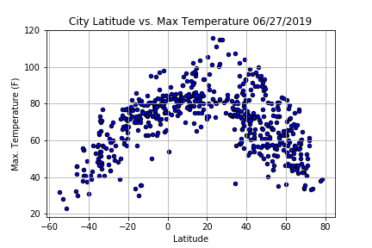

1. The City Latitude vs. Wind Speed plot map indicates the current wind speed for majority of global cities is low, between 5-10 mph.

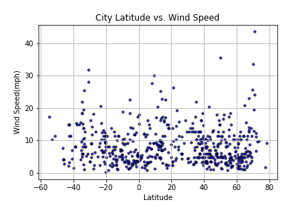

1. The City Latitude vs. Humidity plot map indicates higher levels of humidity from -40 to 60 degrees latitude. Relatively speaking this area encompasses Australia to Northern Europe. This could be a strong indicator of the greenhouse effect.

