ELC 348

Project 2: Conceptual Design and Top-Level System Architecture

Brian Worts (348-01), Chris Jenson (348-01), Shannon Chapter (348-02)

04/16/2020



Project: Handheld Oscilloscope

**a. (2) Statements of the Problem Definition and Need Identification.**

In an ideal world, students would not need to go to labs in order to test circuits and would instead be able to have their own oscilloscope readily available. This oscilloscope should be of comparable size and weight to a modern smartphone. This oscilloscope should also not be cost prohibitive to acquire and a comparable price to similar oscilloscopes, which range from about $30 to $80. The oscilloscope also needs to be practical, so it must be able to measure signals between 0 and 10 MHz and 10V amplitudes with accuracy margins of plus or minus 2%. These signals should be displayed on an attached screen that is able to show the voltage and time divisions as well as able to have a trigger set to trigger on the rising or falling edge. One of these oscilloscopes must be finalized and built by the Spring of 2021.

**b. (1) Documentation of the System Feasibility Analysis.**

There are many approaches to consider in the design of the system. The sampling rate of the ADC, the number of channels, the range of acceptable signals, the ability to generate signals, the display parameters, and the boards to be used. To make these decisions, multiple factors have to be considered. These factors are the cost of the parts and implementation, the power requirements of components, and availability. It is required that at least one channel is successfully implemented, two channels are a reach goal that may land outside the range of feasibility. The sampling rate of the ADC needs to accurately sample signals, so in order to do so the sampling rate must be at least twice the highest input signal frequency so the option we choose will be between 20MHz to meet the minimum system requirements. The display and system will have variable gains that can be set by the user. The display itself will need to have a high enough refresh rate to display accurate signals, so options range from 15 to 60Hz at 240p or 480p. Given the system requirements, we will choose a display on the lower end of this range. The entire system needs to be powerable by a portable power supply as opposed to wired to maintain the goal of the project.

**c. (1) Documentation of the System Operational Requirements.**

The primary mission of the system is to display an inputted electrical waveform onto a display. This input waveform will have a max frequency of 10MHz and will be done by utilizing an FPGA board to serve as the interface between the ADC and the microcontroller that controls the display. The input signal will go through a gain set by the user and then sampled by the ADC. The FPGA will perform the necessary calculations and pass the information to the microcontroller, which will then command the display.

The proposed oscilloscope will be transportable by hand and sturdy enough to handle typical stresses from transportation that will be determined through studies on the strengths of materials. It should be no bigger than 200g with max dimensions of 150x 80 x 50 mm (specs based on Iphone X).

The proposed oscilloscope will be fully operational by May of 2021, one year from the current date. The operational life cycle shall be 4 years.

The operational availability of the system should be 100% while on, with a startup time of no less than 5 seconds.

The proposed oscilloscope should be fully operational inside a typical household, between 50°F and 90°F with humidity ranges of 15% to 70%. It should withstand drops of 3 feet and transportation by hand about twice per day.

All electrical connections and components should not degrade within the operational life cycle. The system should remain unchanged by any environmental factors and there should be no measurable effects from degradation due to use within the operational life cycle.

The oscilloscope life-cycle cost should not exceed $65 with the only maintenance being to faulty components.

**d. (1) Documentation of the development of the Maintenance and Support Concept for the system.**

The main components of the system are the ADC, the FPGA, the display, and the power supply. The power supply will be easily maintainable, most likely a USB connection to the power source. AC power to USB plugs and USB to USB cords are very easily and cheaply acquirable so these components can be replaced by the user without putting the device at risk. Though the FPGA has an on-board ADC, this system will use an external ADC with a higher sampling rate. The ADC may degrade over extended periods of time but due to the number of electrical connections this component should not be repaired by the organization. The FPGA should not be replaced by the user due to the electrical connections as well. If the repair is done improperly by the user, the system could be jeopardized. The same goes for the display. As a result, the FPGA and the display will utilize intermediate or manufacturer maintenance.

To prevent breaking, a casing may be designed to protect and house the system. The display should be replaceable in the event of a break, but should withstand the expected tribulations of a handheld device such as small drops and frequent motion. The system whole is also not meant to be exposed to unideal environments such as high humidity or extreme temperatures since such conditions could cause the device irreparable harm.

|  |  |  |  |
| --- | --- | --- | --- |
| Criteria | Org Maintenance | Intermediate Maintenance | Supplier Maintenance |
| Where? | At operational site or wherever the prime elements of the system are located | | At designated work station with the needed equipment |
| By Whom? | Those with no experience of similar tools (low-maintenance skills) | Experienced users of similar tools (intermediate-maintenance skills) | The designers/builders of the system (high-maintenance skills) |
| Whose Equipement? | User Equipment | | Supplier Equipment |
| Work Accomplished? | Visual inspection, external adjustments, restarts, and change of inputs | Part replacement, medium adjustments, and overload from low maintenance | Overhaul and rebuild, complex repairs, and overload from intermediate |

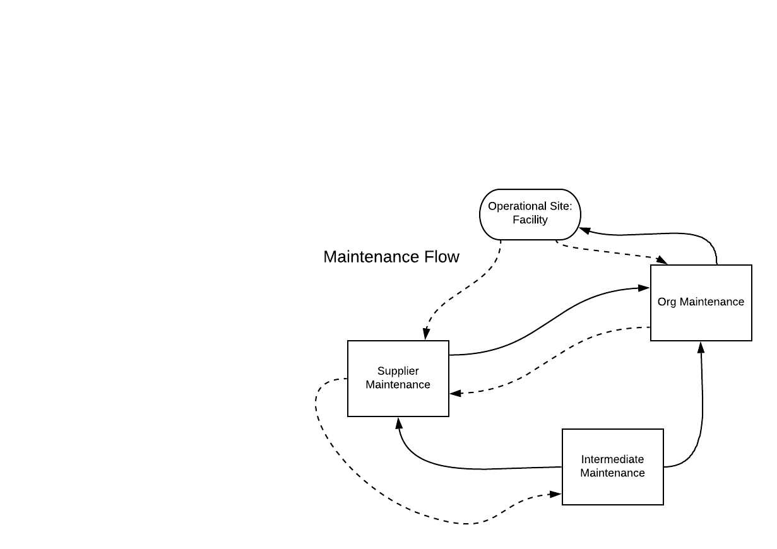

**e. (2) Documentation of the Technical Performance Measures of the system using a Modified House of Quality.**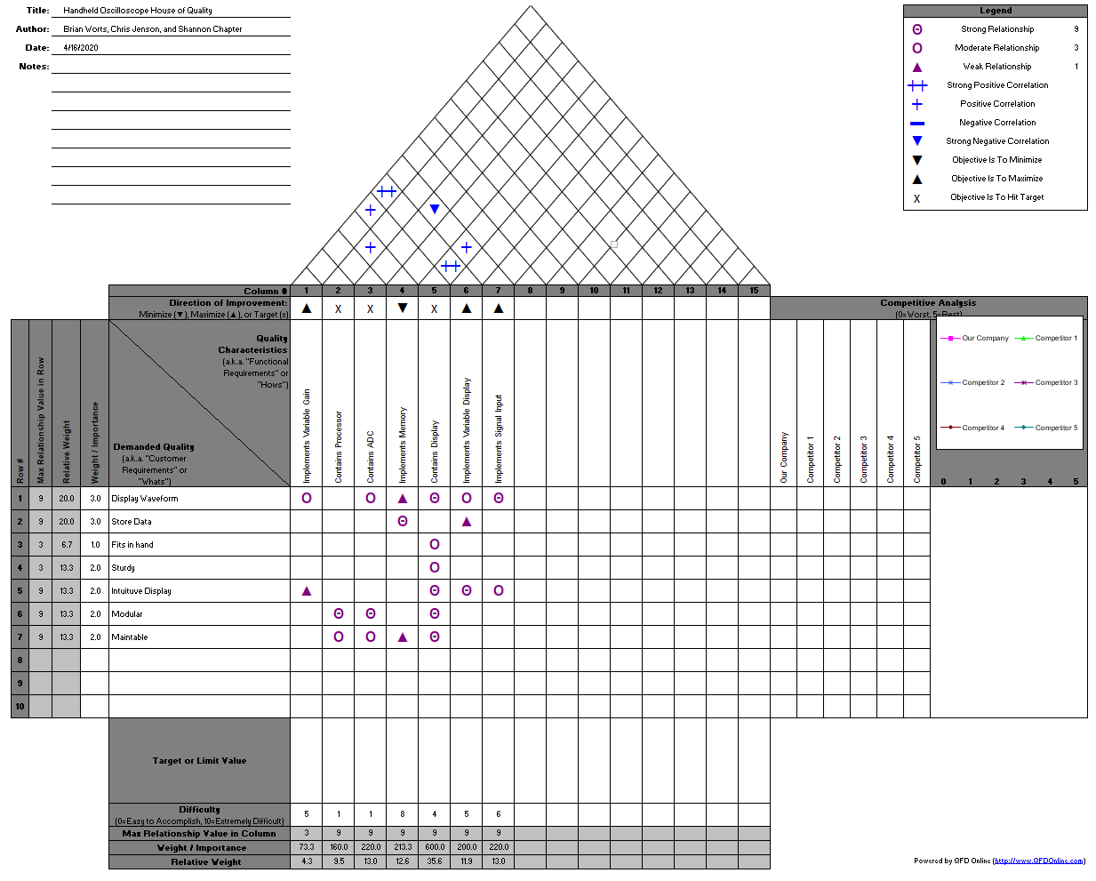

**f. (2) Documentation of the Functional Analysis and Allocation for the system.**

The functional description of the overall system is to display an electrical signal on a screen. This involves multiple sub functions and components.

The first function is to sample the input signal and pass that signal to the FPGA. This sampling speed will determine the max frequency able to be properly displayed on the screen and will this be two times that requirement.

The FPGA then prepares that signal for the display and passes it to the microcontroller. These operations will include storing the data, triggering based on the desired trigger type, and calculating values like the amplitude and frequency of the waveform as explained in the requirements.

The microcontroller then interprets the data that the FPGA passes and passes it to the display where it can be seen. Using on board buttons, the user will be able to change the voltage and time per division which will be done by the microcontroller and will be able to change the trigger information which will be passed to the FPGA.

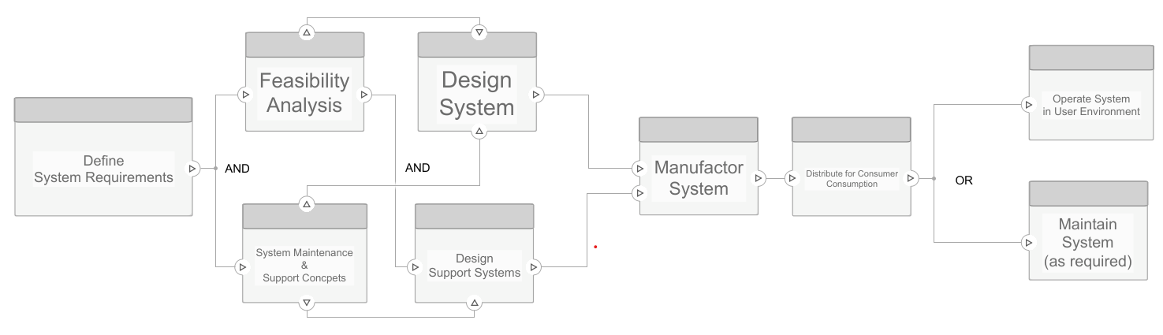

**g. (2) Documentation of the usage of MATLAB to draw a Functional Block Diagram for the system and simulate the top level architectural behavior of the system.** 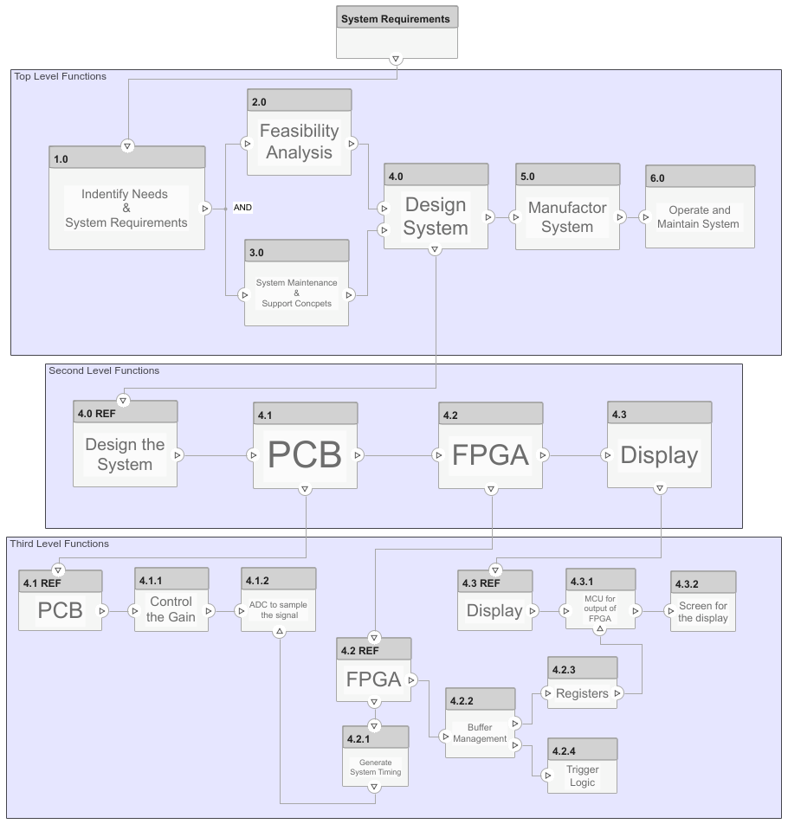

MATLAB Simulink System Composer was used to create the above Functional Block Diagram. The diagram includes the top level, second level, and third level functions of the project. System requirements are first fed into the top level where they are analysed and used to create the conceptual aspects of the system and then to actually design, manufacture, and maintain the system. The second level looks at the broader components of the system itself that as a whole create the project. The third level contains the specifics of what the functions are of each component.