ELC 348

Project #3

**Preliminary System Design of the “Handheld” and Detailed System Architecture with MATLAB**

Brian Worts (348-01), Chris Jenson (348-01), Shannon Chapter (348-02)

05/07/2020



**a.(1) Development Specification (Type B).**

ADC:

Performance: This device should be able to convert analog signals from 0 to 10Mhz into digital signals. Thus, the sampling frequency should be twice the max frequency.

Effectiveness: This device should convert signals in the required range with worst case accuracy of 97%.

Support Characteristics: The ADC should be removable and replaceable in the event of failures. The ADC may degrade over extended periods of time but due to the number of electrical connections this component should not be repaired by the organization.

FPGA:

Performance: The FPGA should have enough memory to store 256 MB of data and have a data transfer (input of FPGA to output of FPGA) rate of no more than 1 second. This means the data will need to be read from input or from storage, have operations performed on it, and output to the controller in that time.

Effectiveness: The FPGA should be able to accurately read data up to the maximum specified frequency. It should output this data correctly as well.

Support Characteristics: The FPGA should not be replaced by the user due to the electrical connections. If the repair is done improperly by the user, the system could be jeopardized. Only the manufacturer should replace the FPGA.

Display:

Performance: Should display data with <0.5s delay from time inputted to display. Brightness should be variable and resolution should be no less than 512x512 with a minimum refresh rate of 20 Hz.

Effectiveness: Waveforms should have a minimum accuracy of 97%. Waveforms should be readable for the average person within the given range under normal use conditions.

Support Characteristics: The Display will be heavily integrated with the FPGA so maintenance to either will require major disassembly. The Display will have a significant number of electrical connections that will make maintenance by the user put the system at risk. Thus, maintenance to the display should be done only by the manufacturer.

**b.(1) Documentation of the Identification of Resource Requirements.**

|  |  |
| --- | --- |
| Human Resources | In order to use, an operator will be needed to record information and use since there is no permanent storage of data. Humans will also be needed in the maintenance and support |
| Electrical Resources | The system will be USB powered, and the typical USB port outputs 5 volts, so the system should need no more than 5V. |
| Software Resources | The FPGA and display controller will need to be calibrated and programmed during manufacturing with the developed softwares. |
| Maintenance and Support Resources | Each component should be separable from the rest of the system and replaceable, so extra components will need to be in storage for replacement. Trained humans will also be necessary to perform the maintenance and support and the system. |

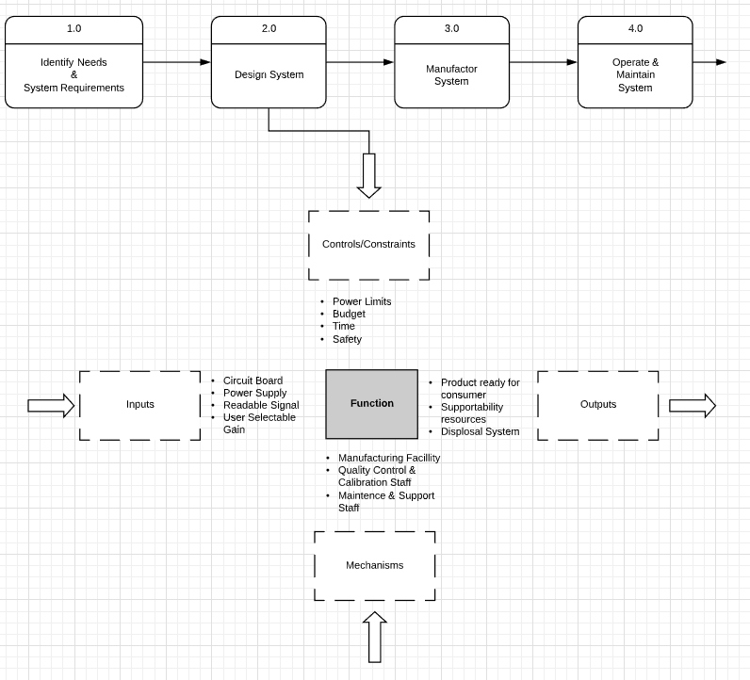

**c.(1) Documentation of the Functional Packaging into Major Elements.**

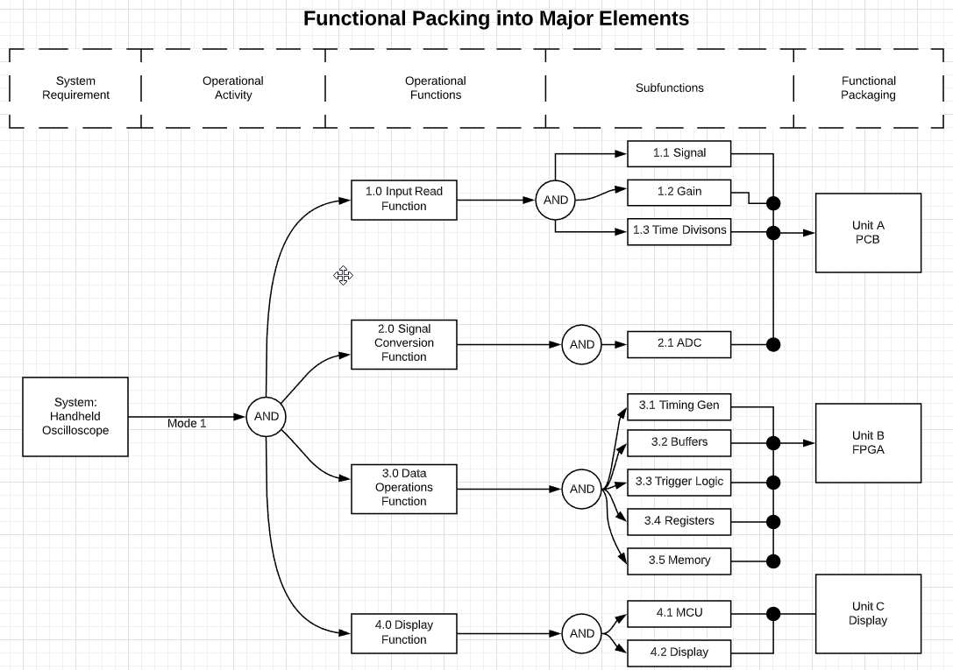

**d.(1) Documentation of the Requirements Allocation.**

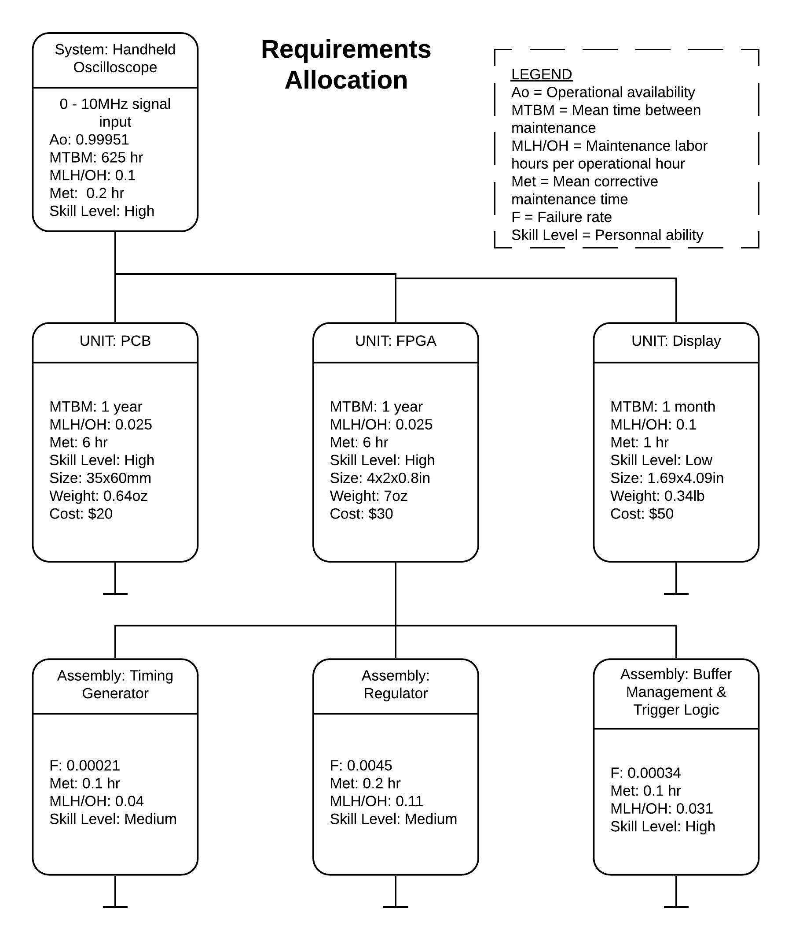

**e.(1) Documentation of the Systems Analysis.**

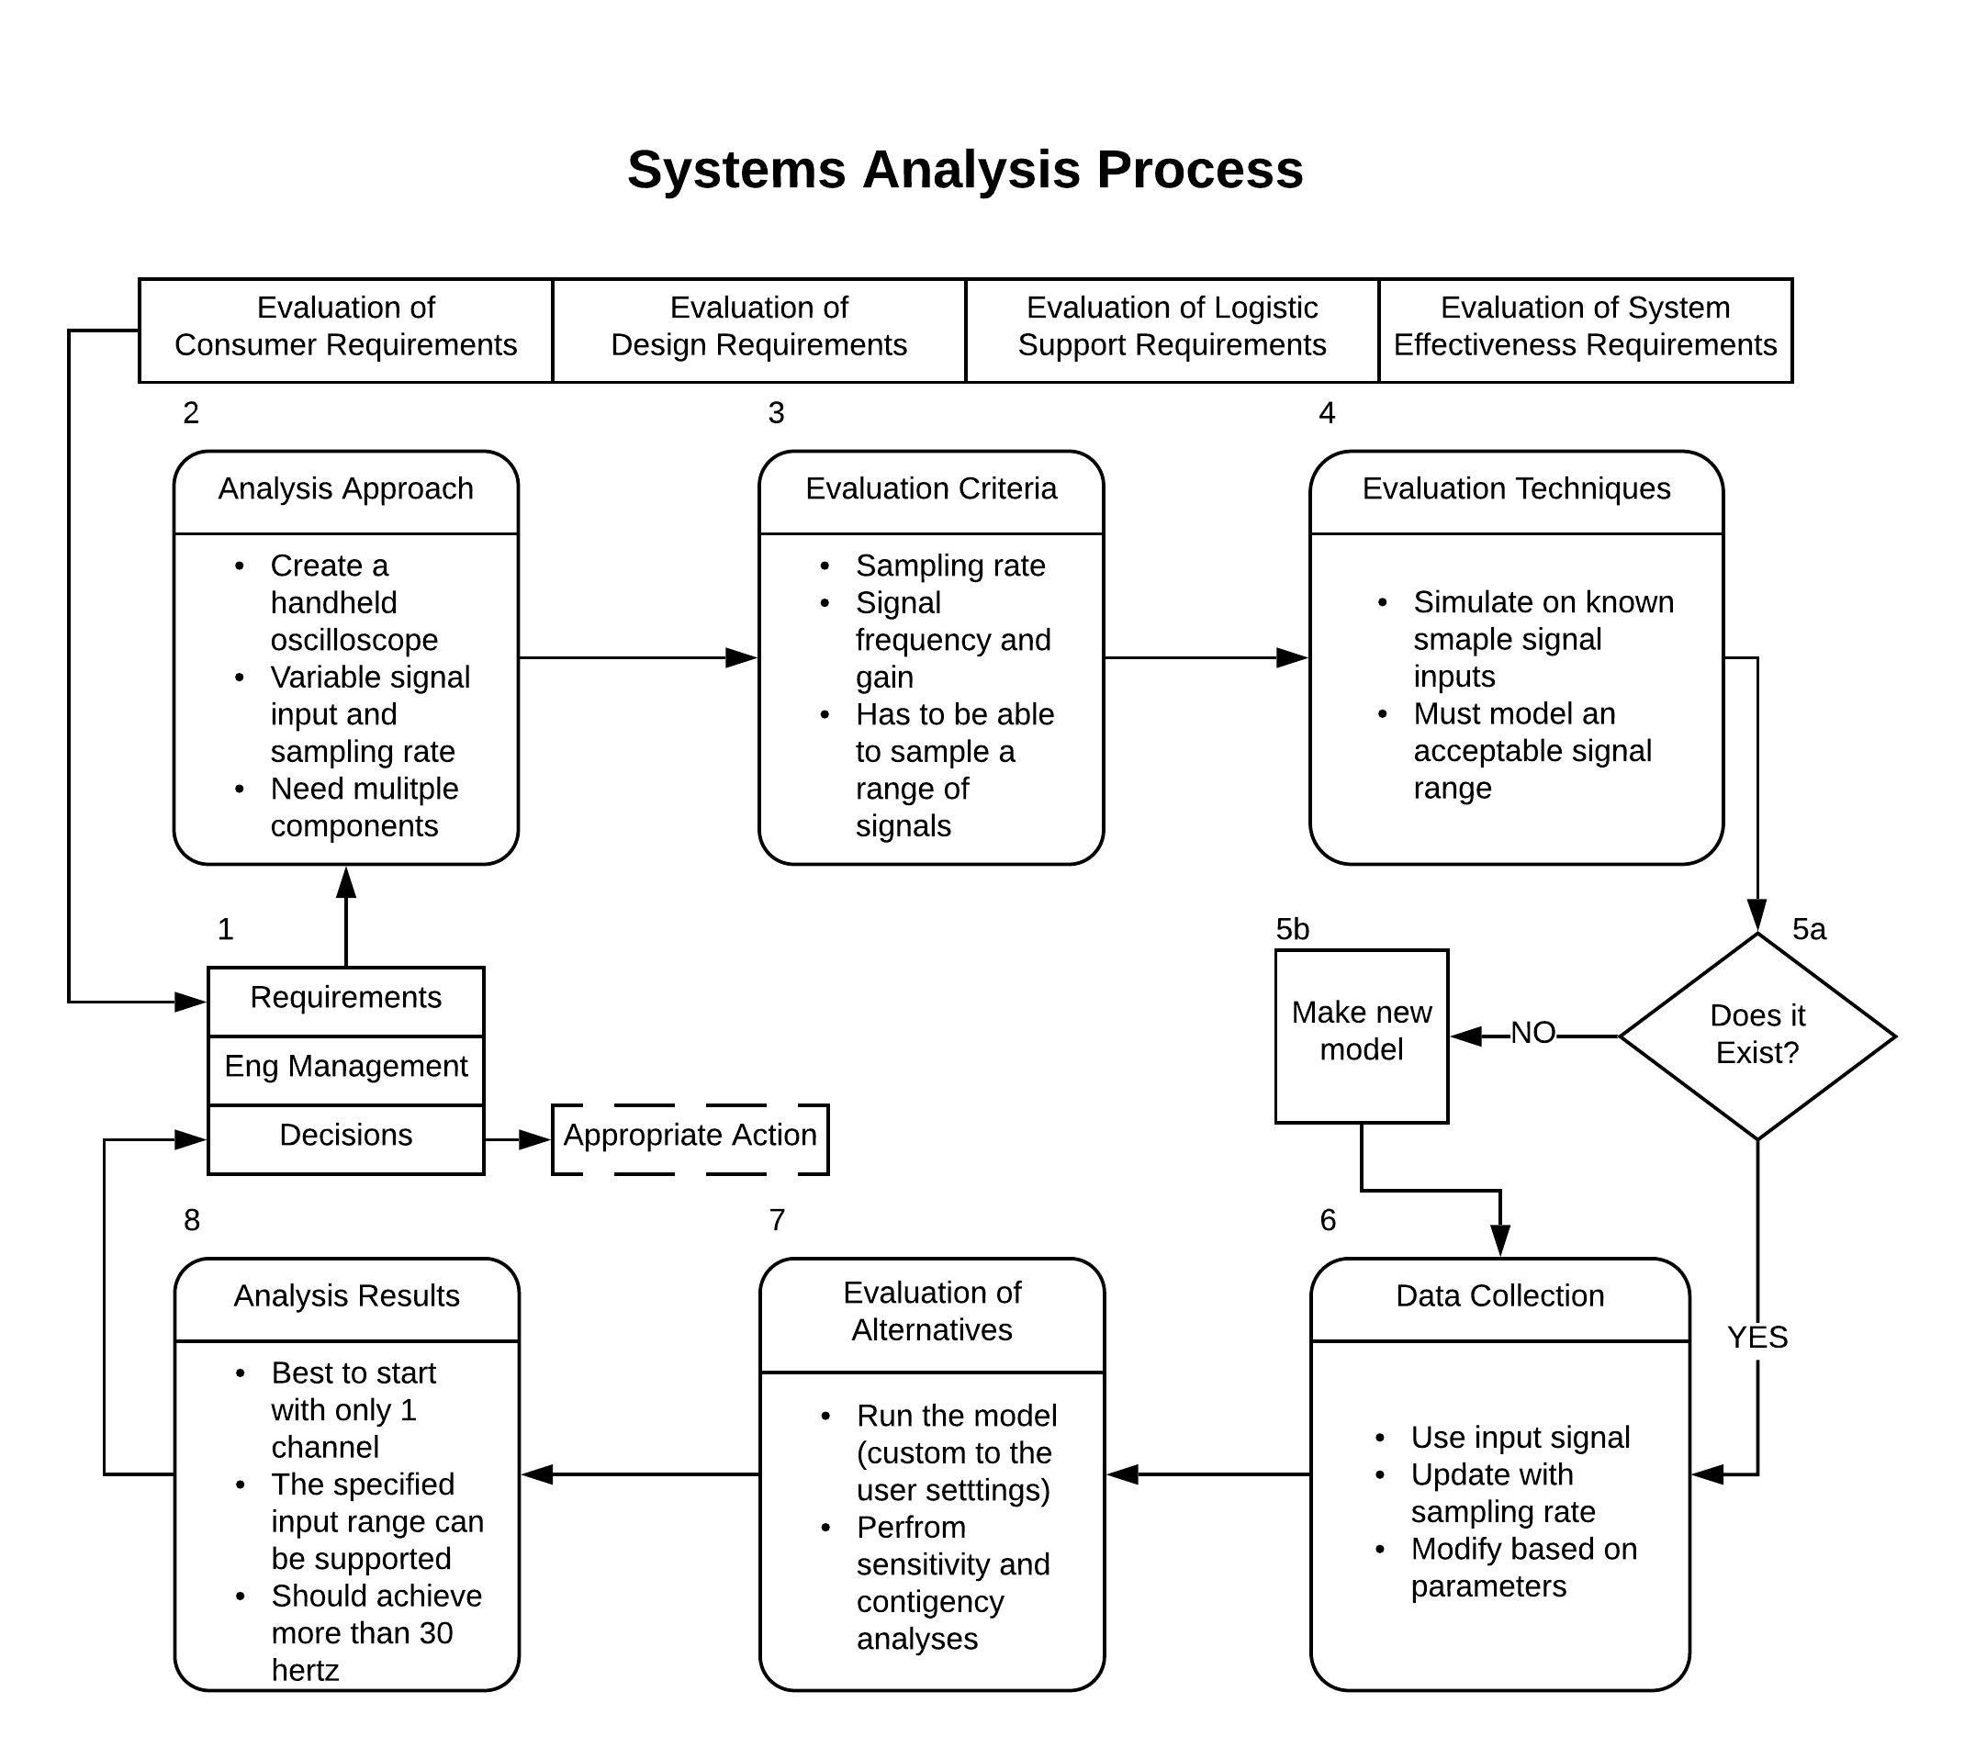

**f.(4) Documentation of the usage of MATLAB to draw a Functional Block Diagram for the**

**system and subsystems.**

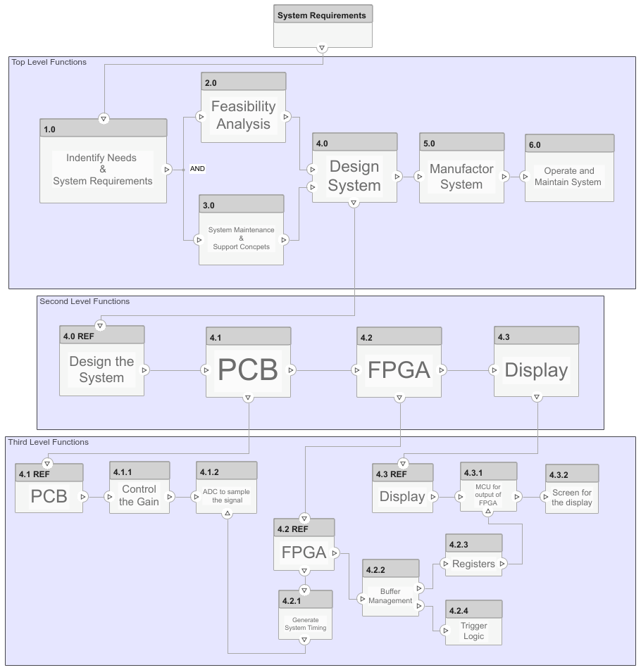

MATLAB Simulink System Composer was used to create the above Functional Block Diagram. The diagram includes the top level, second level, and third level functions of the project. System requirements are first fed into the top level where they are analysed and used to create the conceptual aspects of the system and then to actually design, manufacture, and maintain the system. The second level looks at the broader components of the system itself that as a whole create the project. The third level contains the specifics of what the functions are of each component.