PENETRATION TESTING REPORT
FOOTPRINTING & NETWORK SCANNING PHASES
W2-PM-FINAL | CYBERSECURITY | NETWORKWALKS

Pentester Name  (Cybersecurity Professional) | Chris Jeon
Program/Batch | [Your batch]-Networkwalks
Date | 11 November 2026
Modules completed | W2-PM1 (Multiple Kali Tools)  W2-PM5 (Zenmap Scanning)
Client/Target | 1. Networkwalks (secured written permission already)  2. My own local LAN Network
Permission secured from client? | Yes
Phases covered | Phase 1: Reconnaissance & Footprinting  Phase 2: Scanning & Network Discovery  Phase 3-5: In Progress

1. Liability Disclaimer
I have performed these activities only on the systems & devices where I had secured written permission or the devices/systems that I own myself. All these materials are for education and research purpose only. Do not use anything from here to break the law. The instructor, the authors and Networkwalks are not responsible for what you do with this knowledge. Every action you take is your own responsibility. Misuse can lead to criminal charges, heavy fines, loss of your job and a permanent record. In most countries unauthorised access is a crime even when nothing is damaged.

2. Introduction
This report covers footprinting the networkwalks.com domain using six Kali Linux tools (W2-PM1) and scanning my own home LAN with Zenmap (W2-PM5). The first module covers the footprinting phase and the second covers the scanning phase, so together they show how an attacker moves from gathering public information about an organisation to mapping the live hosts on a network. It is the Week 2 part of my ongoing internship program at Networkwalks.
The footprinting commands were run from a Kali Linux virtual machine on 10 November 2026. The network scan was run from my Windows 11 PC with Zenmap (Nmap 7.993) on the same day, together with the Windows ipconfig /all and arp -a commands. Each step below gives the command used and the result I observed; the matching screenshots are in Section 8, and Section 5 explains why each finding matters from an attacker’s point of view.

3. Tools Used
The table below lists each tool used in this report and its purpose.
Tool | Purpose
Kali Linux & Windows 11 | Operating systems used for the footprinting (Kali VM) and scanning (Windows PC) activities.
WHOIS | Find domain registration details (owner, dates, name servers).
whatweb | Fingerprint web technologies (server, CMS, plugins, IP).
nslookup | Resolve the domain name to its IP address using DNS.
curl -I | Read the HTTP response headers of the website.
wafw00f | Detect whether a Web Application Firewall protects the site.
dnsrecon | Enumerate all DNS records (NS, MX, SPF, TXT, SRV).
Zenmap (Nmap GUI) | Ping scan (nmap -sn) of the local subnet to find live hosts, IPs and MAC addresses, and draw the topology.
Windows CMD | ipconfig /all (local IP, subnet, gateway, own MAC) and arp -a (IP-to-MAC table of nearby hosts).

4. Activities Performed

4.1 Footprinting & Reconnaissance

I performed reconnaissance against the networkwalks.com domain using six Kali Linux tools: WHOIS, WhatWeb, Nslookup, Curl, Wafw00f and DNSRecon. Each tool collected a different type of information about the target.
First, I used WHOIS (whois networkwalks.com) to obtain the domain registration record. The domain is registered with GoDaddy.com, LLC, was created on 6 November 2019 and expires on 6 November 2027. Registrant and technical contact details are hidden behind the privacy service Domains By Proxy, LLC, so no personal contact information was exposed. The record lists the name servers NS6135.HOSTGATOR.COM and NS6136.HOSTGATOR.COM (the registrar record also lists NS29/NS30.DOMAINCONTROL.COM), shows that the domain is locked against unauthorised transfer, update and deletion, and states DNSSEC: unsigned.
I then used WhatWeb (whatweb networkwalks.com) to fingerprint the website. Plain HTTP returns a 301 redirect to HTTPS. The site runs on an Apache web server at 192.232.216.135 and is built with WordPress 7.1.4, the WordPress Download Manager 3.3.76 plugin, jQuery 3.7.1, Bootstrap and Google Tag Manager. WhatWeb also picked up the page title (Networkwalks Academy), the public contact email address and the __wpdm_client cookie, which is set with the HttpOnly flag.
Using Nslookup (nslookup networkwalks.com), I resolved the domain name through my router’s DNS resolver (192.168.1.1). The non-authoritative answer returned the IP address 192.232.216.135, matching the WhatWeb result.
I used Curl with the -I option (curl -I https://networkwalks.com) to read only the HTTP response headers. The server answered HTTP/2 200 with server: Apache and x-nginx-cache: WordPress. The link header exposes the WordPress REST API endpoints /wp-json/ and /wp-json/wp/v2/pages/53, and the session cookie is set with the secure and HttpOnly flags. Common security headers such as Strict-Transport-Security, Content-Security-Policy, X-Frame-Options and X-Content-Type-Options were not present in this response.
Next, I used Wafw00f (wafw00f networkwalks.com) to check whether a Web Application Firewall protects the site. After two requests it reported that the site is behind ModSecurity (SpiderLabs).
Finally, I used DNSRecon (dnsrecon -d networkwalks.com) for a standard DNS enumeration. It found 8 records: the SOA and name servers on HostGator (ns6135.hostgator.com, 50.87.144.87 and ns6136.hostgator.com, 192.232.216.131), which both disclosed their DNS software version as BIND 9.16.23-RH; an MX record (mail.networkwalks.com) pointing to the same IP as the website, 192.232.216.135; a Google site-verification TXT record; an SPF record (v=spf1 +a +mx +ip4:50.87.144.87 +include:websitewelcome.com ~all); and eight _autodiscover._tcp SRV records pointing to cpanelemaildiscovery.cpanel.net, which shows the site uses cPanel hosting. The DNSSEC query returned no answer.

4.2 Network Scanning with Zenmap
For the second activity, I used Zenmap to perform network discovery on my own home network. The practical required me to identify my local IP address and subnet, discover live hosts, identify their IP and MAC addresses, and generate a network topology.
I first ran ipconfig /all in Windows Command Prompt. My PC’s wired adapter has the IP address 192.168.1.154 with subnet mask 255.255.255.0, so my LAN subnet is 192.168.1.0/24. The default gateway, DHCP server and DNS server are all the router at 192.168.1.1, and the adapter’s physical (MAC) address is 70:85:C2:XX:XX:XX. A second adapter, 192.168.56.1, is the VirtualBox host-only network used by my Kali VM, so I left it out of scope.
I then entered 192.168.1.0/24 as the target in Zenmap and selected the Ping scan profile (nmap -sn 192.168.1.0/24). The scan checked 256 addresses in 7.54 seconds and found 12 live hosts:
- 192.168.1.1 – Router / default gateway (mynetworksettings.com) – MAC: 04:B3:C9:XX:XX:XX
- 192.168.1.3 – Tuya Smart IoT device – MAC: 00:33:7A:XX:XX:XX
- 192.168.1.5 – “desktop” (Intel) – MAC: F4:46:37:XX:XX:XX
- 192.168.1.6 – Personal device, hostname redacted (ASUSTek) – MAC: 10:7C:61:XX:XX:XX
- 192.168.1.7 – “thinkpad” (Intel) – MAC: DC:46:28:XX:XX:XX
- 192.168.1.9 – Unknown (randomised MAC) – MAC: 66:DF:FD:XX:XX:XX
- 192.168.1.10 – “PF4DJP34” (Intel) – MAC: 60:45:2E:XX:XX:XX
- 192.168.1.11 – Unknown (randomised MAC) – MAC: 46:69:BB:XX:XX:XX
- 192.168.1.20 – Raspberry Pi – MAC: B8:27:EB:XX:XX:XX
- 192.168.1.153 – Unidentified, no MAC reported – MAC: none
- 192.168.1.154 – My PC, the scanning host (from ipconfig) – MAC: 70:85:C2:XX:XX:XX
- 192.168.1.165 – Unknown (randomised MAC) – MAC: 96:7E:2C:XX:XX:XX
Nmap lists a MAC address for every host except two. 192.168.1.154 is my own PC (Nmap does not report the scanning machine’s own MAC), so I took its MAC from ipconfig /all. 192.168.1.153 also returned no MAC and no latency, which suggests it is a virtual interface on my PC rather than a separate device; arp -a had no entry for it, so this is not yet confirmed. Four hosts use randomised (locally administered) MAC addresses, which is typical of phones and tablets with MAC privacy turned on. I also noticed the number of live hosts changed between scans (11, 13, then 12) as devices joined and left the network, so all answers in this report use the single scan from 10 November 2026 at 23:38.
After completing the scan, I opened the Topology tab in Zenmap, enabled the legend and saved the network topology with Save Graphic in PDF format as required by the practical task. The map shows my PC (localhost) in the centre with all live hosts on one ring, which means every device is one hop away on a single flat network. All hosts appear as green circles because a ping scan does not check ports. The Topology view was blank at first and needed the window resized before it displayed. The saved map also shows 192.168.1.158, because Zenmap keeps hosts from earlier scans in the same session.

5. Risk Analysis / Impact
Based on the information collected during the footprinting and network scanning activities, I identified the following potential risks. Positive controls were also observed: WHOIS privacy protection, registrar locks on the domain, HTTPS redirection, Secure/HttpOnly cookie flags and an active WAF.
# | Risk / Finding | Evidence / Observation | Potential Impact | Risk Level
1 | WordPress core and plugin versions exposed | WhatWeb: WordPress 7.1.4, WordPress Download Manager 3.3.76, jQuery 3.7.1 | Exact versions let an attacker match the site against published vulnerabilities for WordPress and the plugin | ● Medium
2 | DNS server software version disclosed | DNSRecon: both name servers report BIND “9.16.23-RH” | A version banner helps target known BIND vulnerabilities; the upstream BIND 9.16 branch is end-of-life (vendor builds may include backported fixes) | ● Medium
3 | Home network: IoT and unidentified devices on one flat LAN | Zenmap: 12 live hosts incl. a Tuya smart device, a Raspberry Pi, 4 randomised MACs and 1 host with no MAC | IoT devices share a network with PCs, so one compromised device could reach the others; unknown hosts are hard to inventory | ● Medium
4 | HTTP security headers not observed | curl -I: no HSTS, CSP, X-Frame-Options or X-Content-Type-Options; “server: Apache” shown | Weaker browser-side protection against clickjacking, MIME sniffing and downgrade; the Server header helps fingerprinting | ● Low
5 | WordPress REST API endpoint exposed | curl -I Link header: /wp-json/ and /wp-json/wp/v2/pages/53 | The REST API can be used to enumerate site content and, if not restricted, user accounts | ● Low
6 | Hosting and mail infrastructure identifiable | Nslookup/DNSRecon: website and MX both on 192.232.216.135; HostGator name servers; cPanel SRV records | Shows the hosting provider and control panel, and that web and mail run on the same server | ● Low
7 | DNSSEC not enabled | WHOIS: “DNSSEC: unsigned”; DNSRecon: no DNSSEC answer | DNS answers cannot be cryptographically validated, leaving room for spoofing or cache poisoning | ● Low
8 | WAF product identifiable | Wafw00f: ModSecurity (SpiderLabs) | Knowing the WAF helps an attacker choose bypass techniques, although having a WAF is itself a positive control | ● Low

Risk level key: ● Critical ● Medium ● Low
The risks above are observations from the footprinting and scanning exercises, not confirmed vulnerabilities.
The practical exercises involved only information gathering and host discovery. No exploitation or vulnerability validation was performed as part of these two modules.
Therefore, the presence of information such as a software version, IP address or DNS record does not by itself mean that the system is vulnerable. Further authorized security testing would be required to confirm any actual vulnerability.

6. Recommendations
Based on the observations from these activities, I recommend the following security improvements:
- Hide version information
Remove the WordPress generator meta tag and plugin version strings so exact versions are not publicly visible.
- Keep WordPress core and plugins updated
Regularly update WordPress, WordPress Download Manager and other plugins, and check them against current security advisories.
- Add HTTP security headers
Configure Strict-Transport-Security, Content-Security-Policy, X-Frame-Options and X-Content-Type-Options, and reduce the detail in the Server header.
- Restrict the WordPress REST API
Limit unauthenticated access to sensitive REST endpoints such as /wp-json/wp/v2/users.
- Hide the DNS server version and keep BIND current
Ask the hosting provider to suppress the BIND version banner and confirm the DNS servers run a supported, patched release.
- Enable DNSSEC
Sign the zone with DNSSEC through the registrar and DNS host so DNS answers can be validated.
- Keep the WAF enabled and monitored
Keep ModSecurity enabled with an up-to-date rule set and review its logs, since it already blocks basic attacks.
- Separate IoT devices on the home network
Move smart-home devices such as the Tuya device onto a guest or IoT network, away from PCs, and keep the router firmware updated.
- Maintain a device inventory and investigate unknown hosts
Rescan the network periodically, identify the unknown hosts (including 192.168.1.153) and only scan networks where authorisation has been given.

7. Conclusion
During Week 2 of my Cybersecurity & Ethical Hacking internship, I completed practical activities covering footprinting, reconnaissance and network scanning.
In the footprinting activity, I used six Kali Linux tools against networkwalks.com. WHOIS showed the registrar, privacy-protected contacts and HostGator name servers; WhatWeb identified Apache, WordPress 7.1.4 and its plugins; Nslookup resolved the site to 192.232.216.135; Curl showed the HTTP headers and the REST API endpoint; Wafw00f detected ModSecurity; and DNSRecon mapped the DNS, mail, SPF and SRV records and revealed the BIND version.
In the network scanning activity, I used ipconfig to find my IP (192.168.1.154) and subnet (192.168.1.0/24), then used Zenmap to discover 12 live hosts with their IP and MAC addresses and saved the network topology. I also learned why some hosts show no MAC address, how randomised MACs look, and how to cross-check results with arp -a.
The exercises showed me how much can be learned about an organisation and a network before any attack is attempted, using only public records and normal network responses.
I also learned that findings must be documented clearly and handled carefully: a good report explains what was performed, what was found, what it means and how to reduce the risk, and sensitive details such as MAC addresses and personal hostnames should be redacted before anything is shared publicly.
Finally, I learned that reconnaissance and scanning must always be performed within an authorized scope. These activities were completed as part of the assigned educational cybersecurity lab.

8. Evidences Collected
Figure 1 – whois networkwalks.com (registry record)
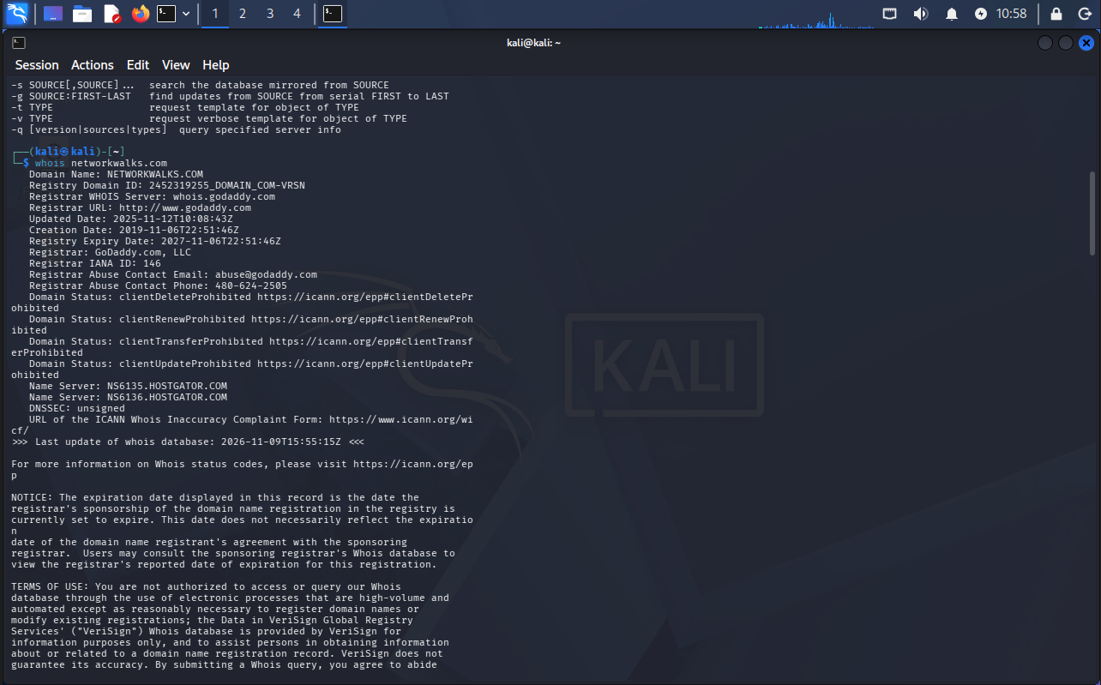
Figure 2 – whois networkwalks.com (registrar record)
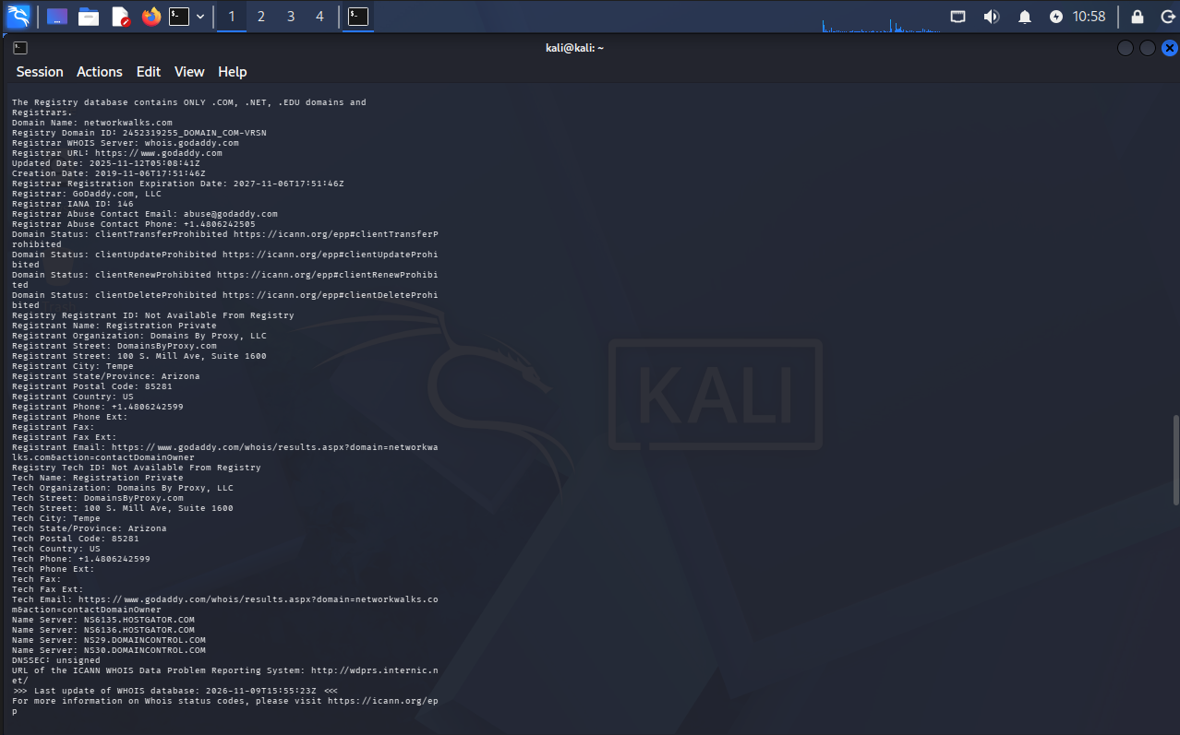
Figure 3 – whatweb networkwalks.com
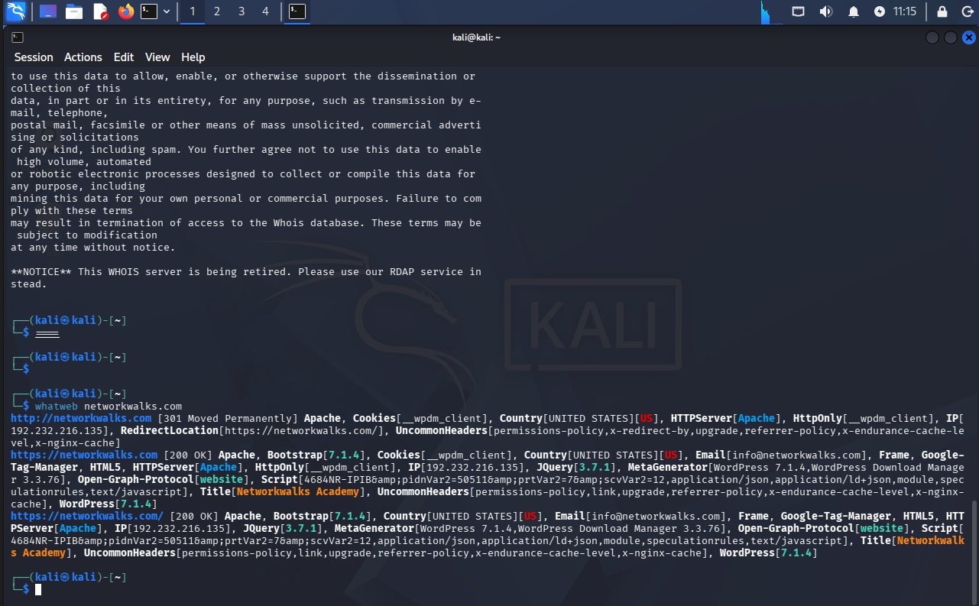
Figure 4 – nslookup networkwalks.com
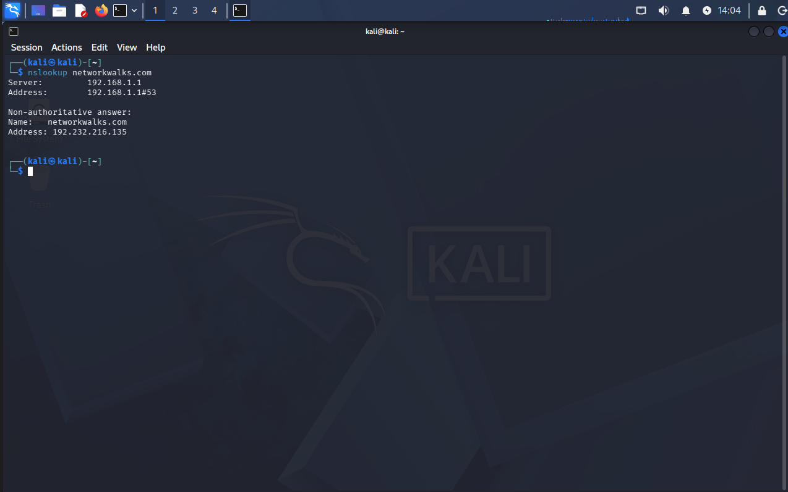
Figure 5 – curl -I https://networkwalks.com
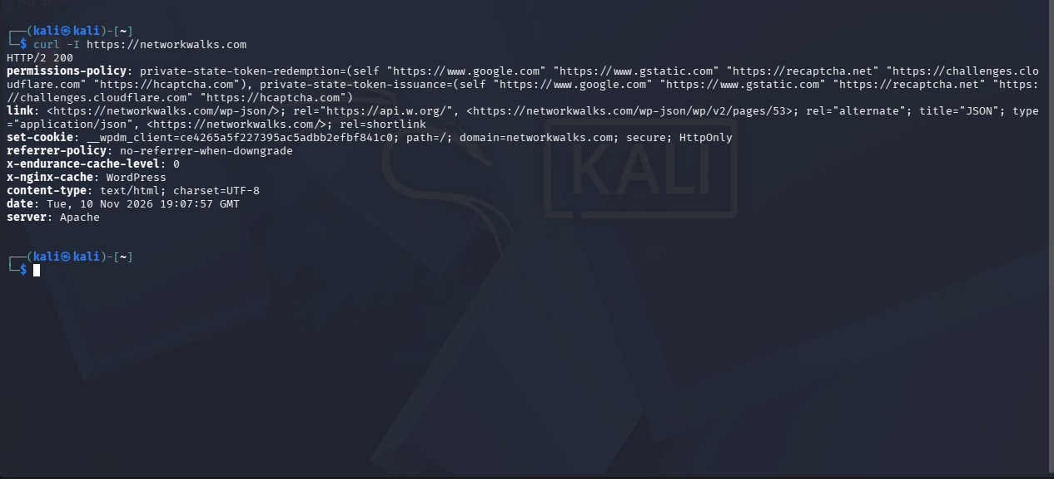
Figure 6 – wafw00f networkwalks.com
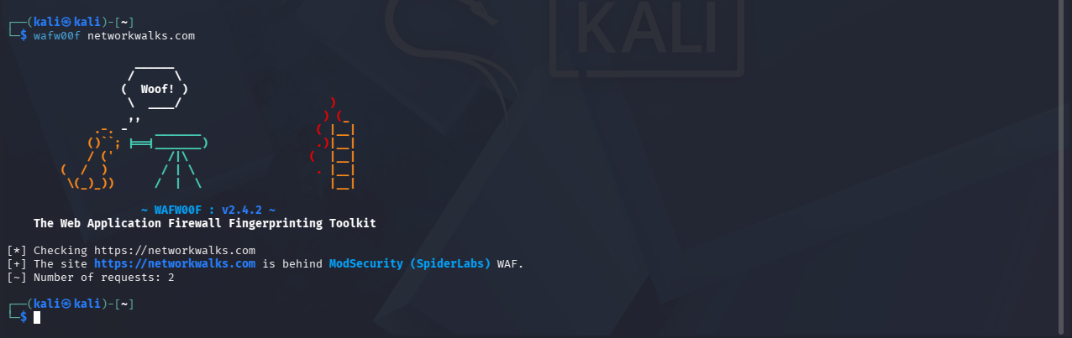
Figure 7 – dnsrecon -d networkwalks.com
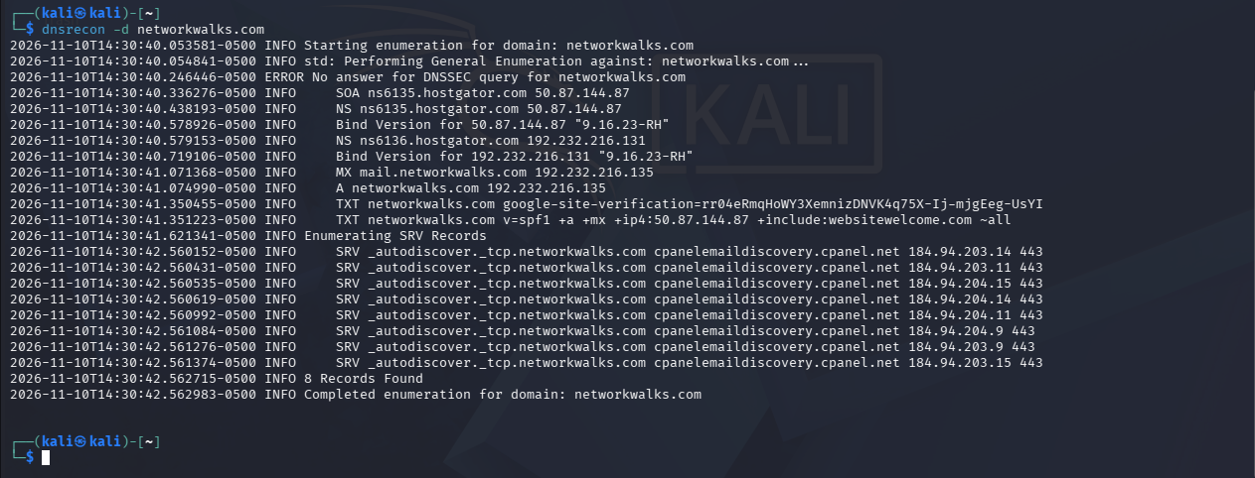
Figure 8 – ipconfig /all (local IP, subnet and MAC)
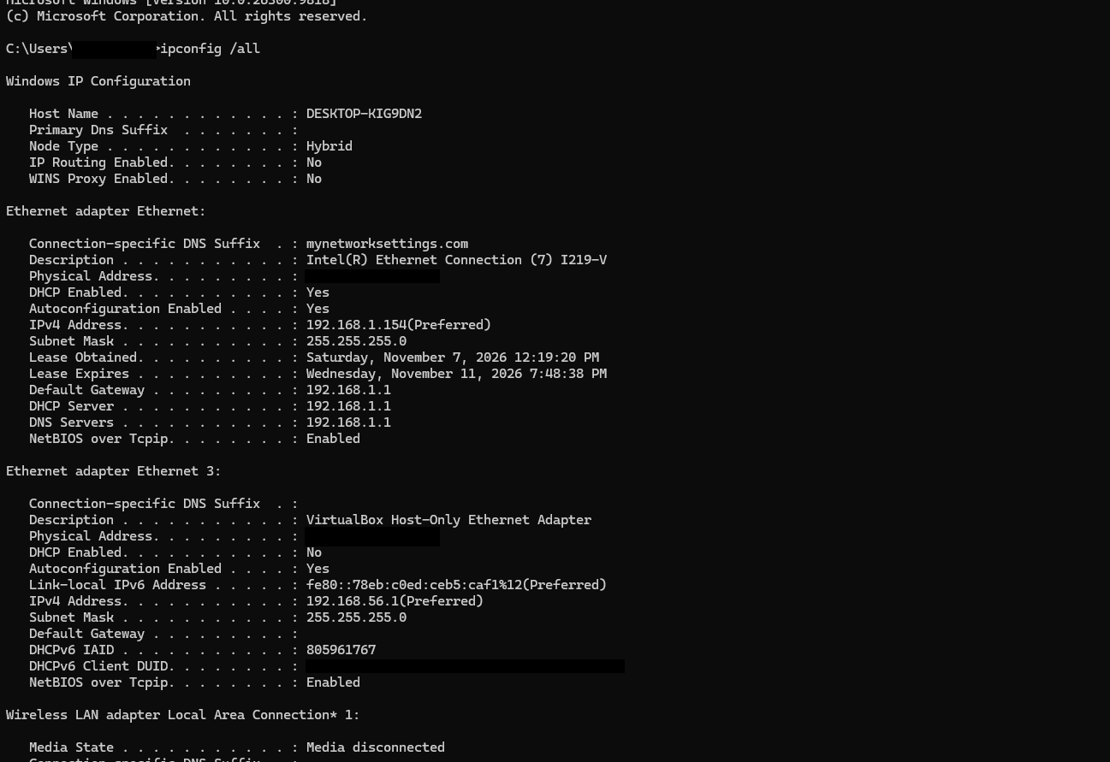
Figure 9 – Zenmap ping scan of 192.168.1.0/24 (12 hosts up)
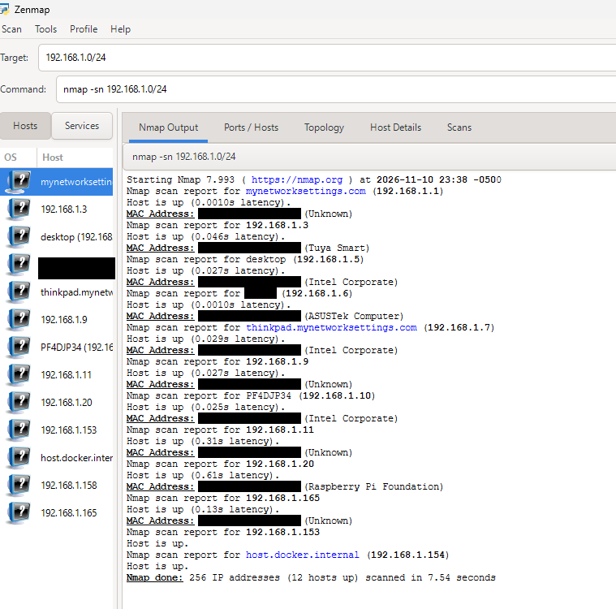
Figure 10 – arp -a (IP-to-MAC table)
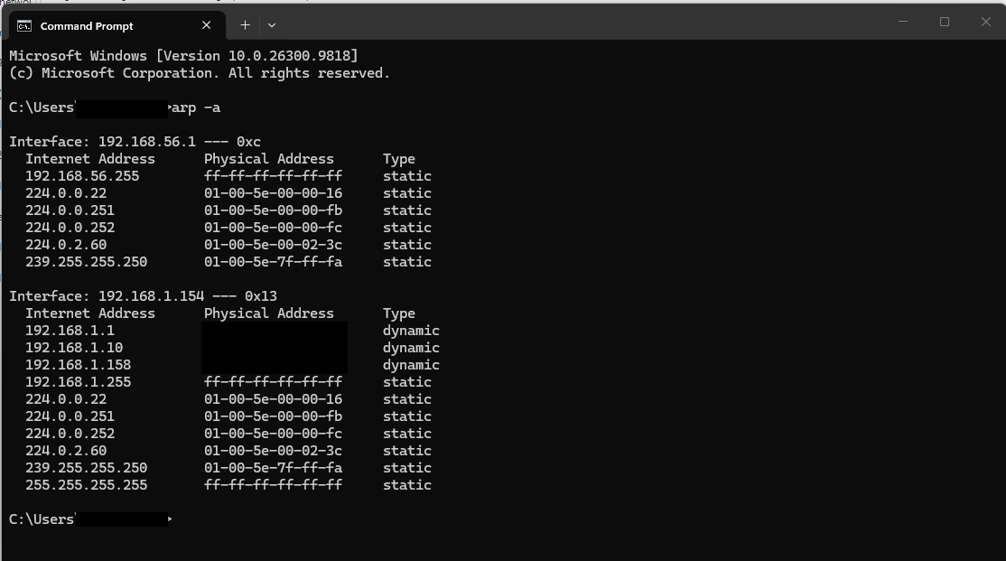
Figure 11 – Zenmap network topology (also shows 192.168.1.158 from an earlier scan in the same session)
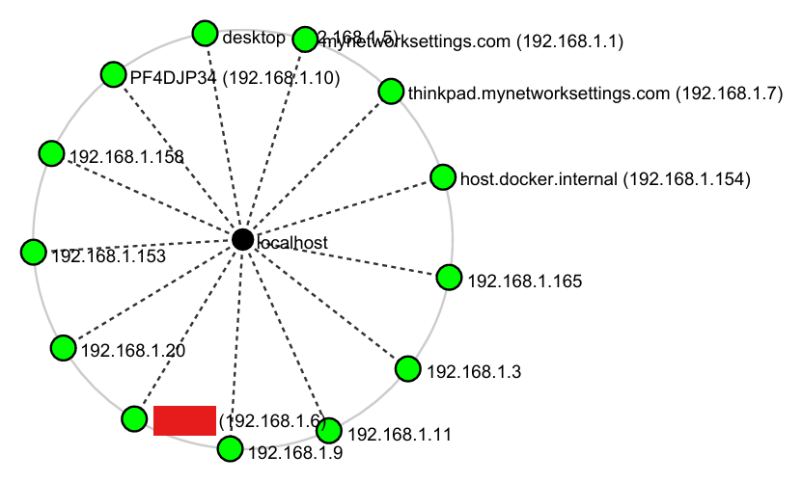

-End-

👤 Author
Chris Jeon
Cybersecurity Intern, Networkwalks

📌 Project Information
Program Name: Cybersecurity program at Networkwalks | Week: 02 | Repository: GitHub

