INTRODUCTION TO ECONOMICS

1. Vocabulary

|  |
| --- |
| economics transaction scarce finite ultimate invest shelter budget infrastructure goods specialize poverty critical |

|  |  |
| --- | --- |
| 1. __________________ | to concentrate one's efforts in a special activity, field, or practice |
| 1. __________________ | having a limited nature or existence; not endless |
| 1. __________________ | an exchange or transfer of goods, services, or funds |
| 1. __________________ | the best or most extreme |
| 1. __________________ | to make use of for future benefits or advantages |
| 1. __________________ | deficient in quantity or number; not plentiful or abundant |
| 1. __________________ | the amount of money that is available for, required for, or assigned to a particular purpose |
| 1. __________________ | exercising or involving careful judgment |
| 1. __________________ | something that covers or affords protection |
| 1. __________________ | something manufactured or produced for sale |
| 1. __________________ | the state of lacking money or material possessions |
| 1. __________________ | a social science concerned with the production, distribution, and consumption of goods and services |
| 1. __________________ | the system of public works of a country, state, or region |

2. Introduction to Economics



What is economics? Economics is about more than just money and financial transactions. More accurately, economics is a study that helps us understand how people make choices in the face of scarcity. "Scarcity" means that there are not enough resources for people who want them. Such resources are finite, meaning they have a limit, and include money, land, labor, and materials. Time is considered the ultimate finite resource, as every person has the same number of hours in a day.

When resources are limited, people must make certain decisions. What should I buy? What can I sell? What should I invest my time into? These decisions can be made by individuals, families, or businesses. Governments and societies are also faced with these decisions. When certain people don't have access to food, shelter, or healthcare, this is a result of the scarcity of resources. Just as people have to choose whether to spend their money on a car or a vacation, governments must also decide how to divide their budget between schools, emergency services, and other infrastructure. Meanwhile, countries must choose how much to fund the military as opposed to protecting the environment. These decisions are not always easy to make.

One of the most important people in the history of economics is Adam Smith, an economist and philosopher from the 18th century. He explained how producing goods can be made more efficient by dividing the work into smaller tasks. This is known as the "division of labor." For example, running a bakery involves many different tasks, including buying ingredients, mixing the dough, baking it, selling the bread, and managing the store. It would be difficult for one person to become an expert in all these different tasks. Instead, it would be smarter to have different people specialize, or become experts in, different tasks. This way, people could carry out tasks more quickly, and the bakery would be able to sell more bread. This is an example of the power and efficiency of the division of labor.

Specialization allows workers to become really good at one task, which makes production faster and better. This is true not just for bakeries but for many different kinds of businesses. Oftentimes, it is a better decision for a business to focus on specializing in a few products than many different ones. This is one area that economists have been interested in, but economics is not limited to just that. Economics also helps us understand and solve issues like poverty, education, and climate change. Learning economics can help you become a better decision-maker in your personal life, as well as a more critical thinker about current events and politics.

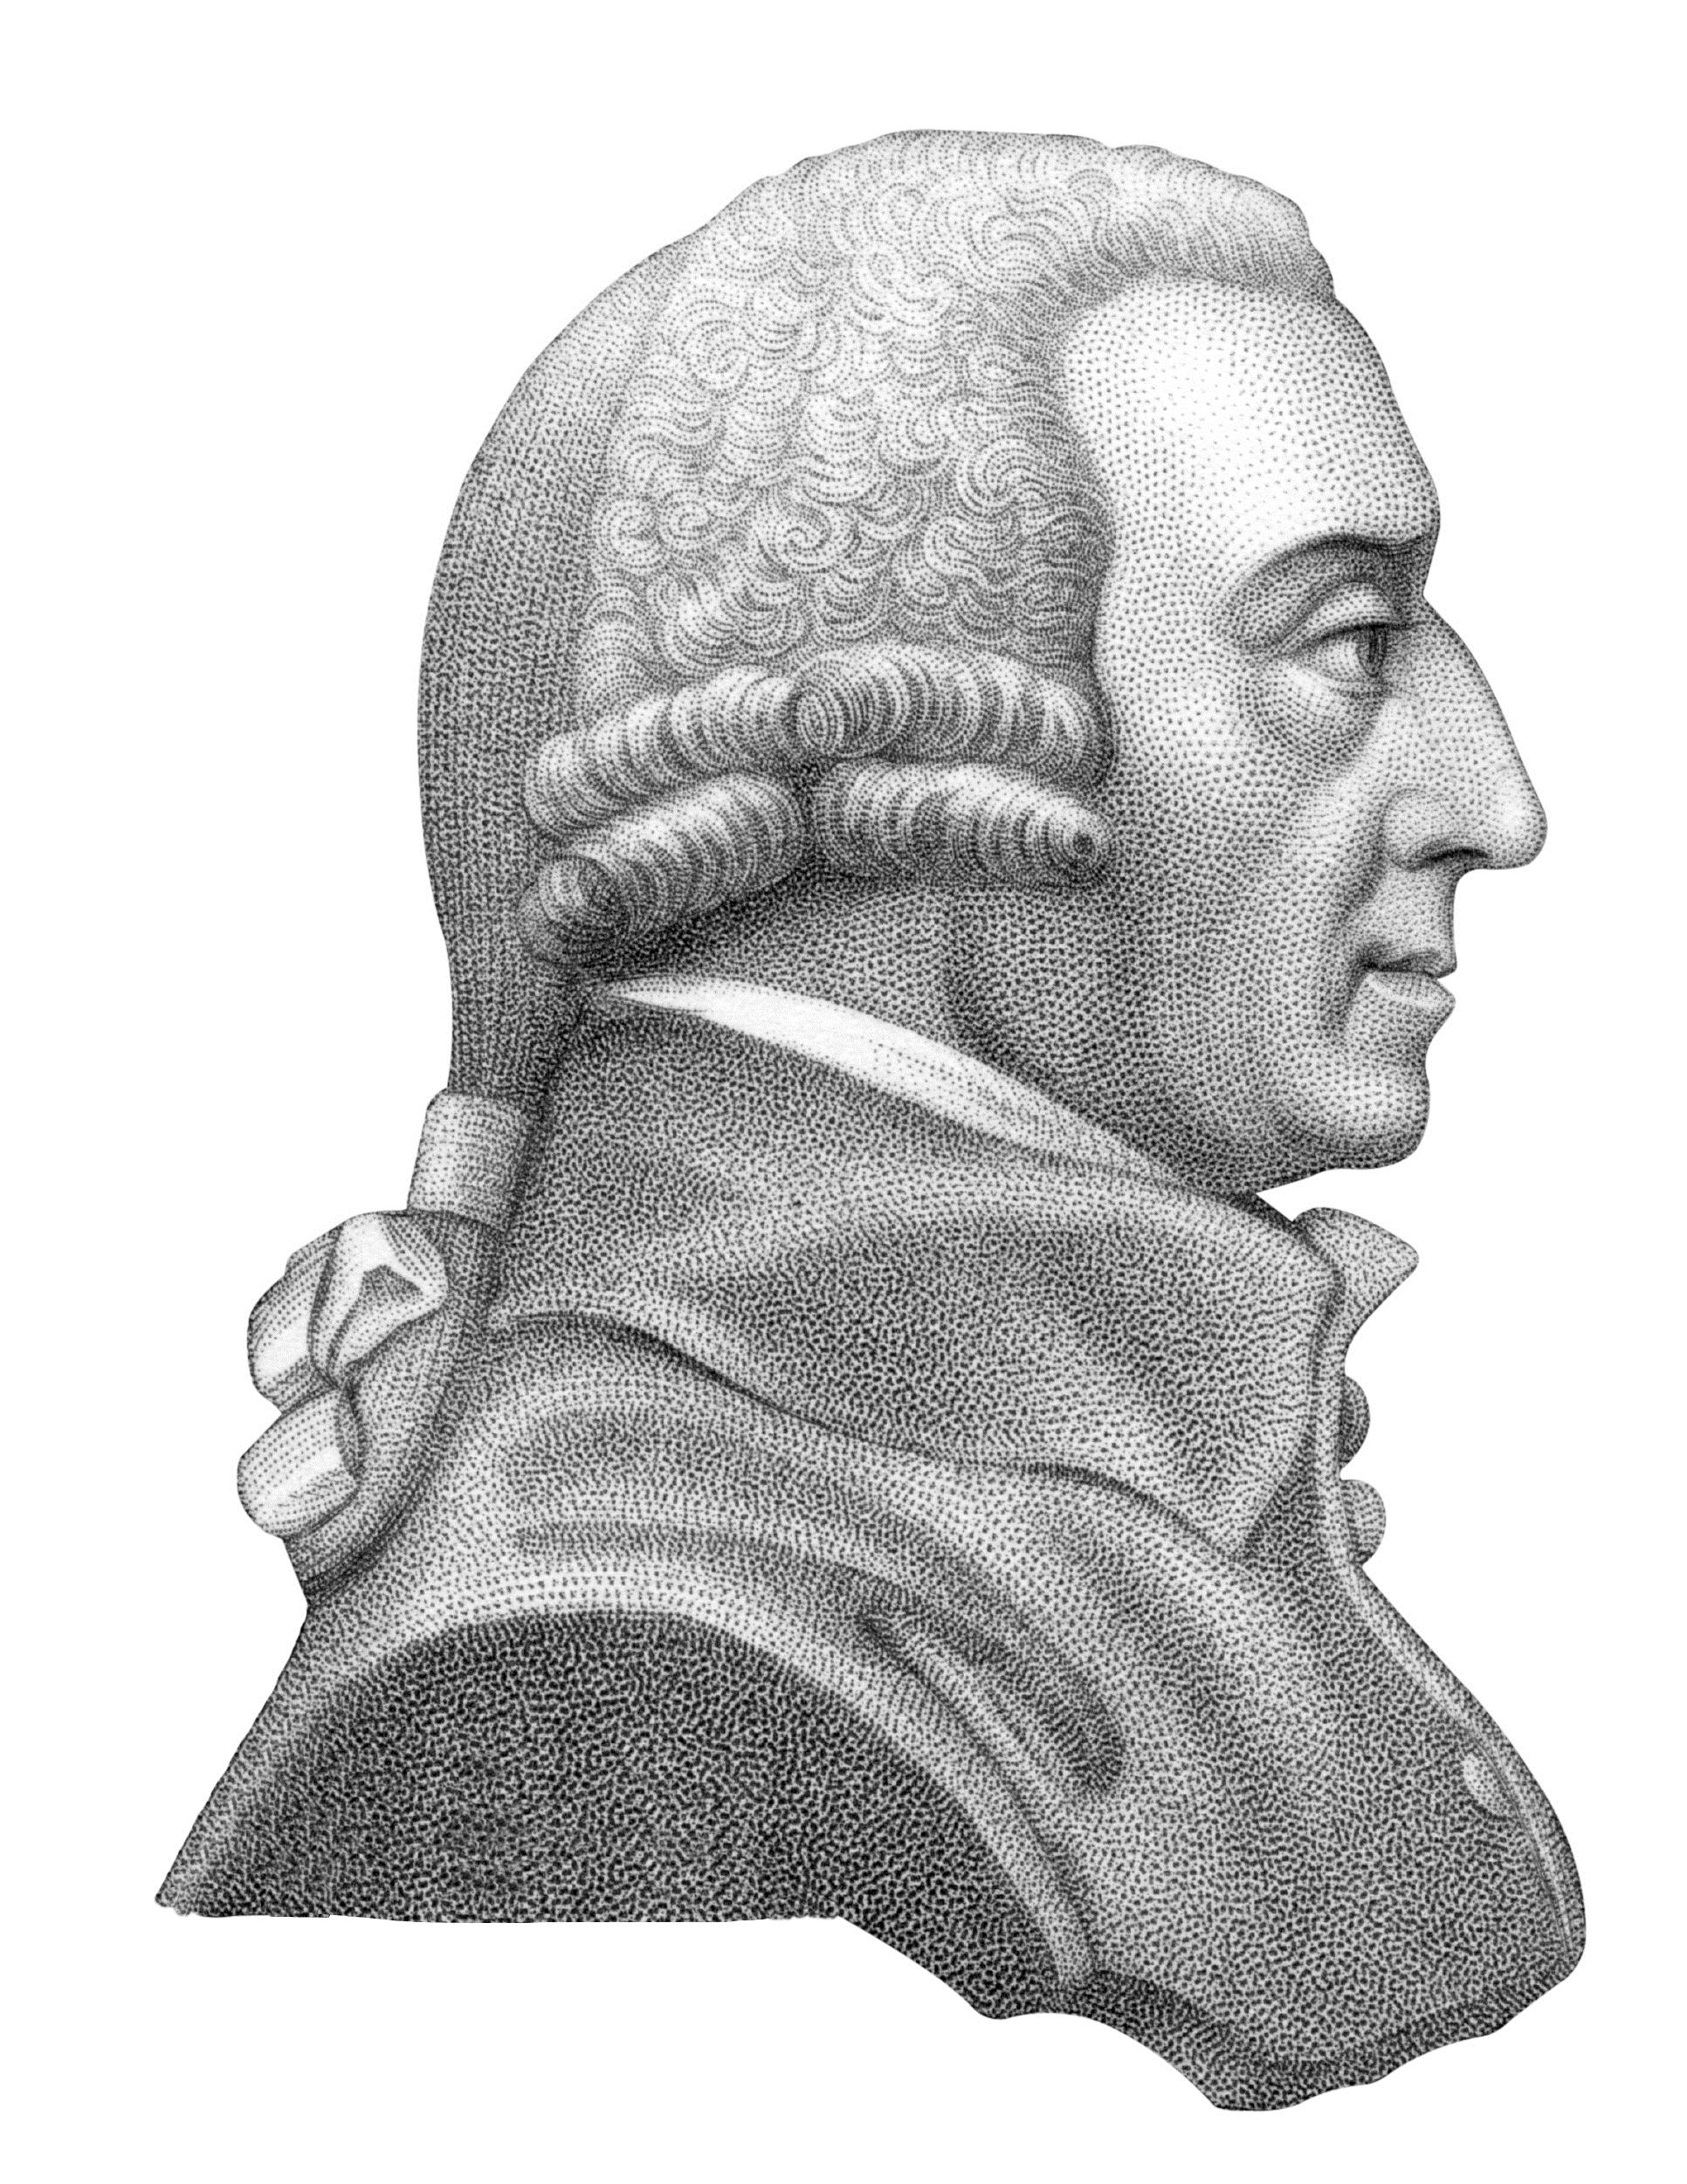

3. Comprehension Questions

Circle "T" for True or "F" for False for the following statements:

|  |  |  |
| --- | --- | --- |
| 1. The division of labor can make production more efficient. | T | F |
| 1. Specialization can make workers slower and less productive. | T | F |
| 1. Learning economics can help you in multiple areas in life. | T | F |

Choose the correct answer for each of the following questions:

1. Who out of the following is a famous economist?

1. Adam Smith
2. George Washington
3. Marie Curie
4. Immanuel Kant

2. What is an example of division of labor?

1. Having a group of people all work on the same task
2. Having different people specialize in different tasks
3. Outsourcing a task from one person to another
4. Controlling all steps in the process of making a product

3. Why might a business choose to specialize in only a few products?

1. To lower competition
2. To increase competition
3. To improve efficiency and quality in making those products
4. To find customers in new markets

4. Which of the following is not a scarce resource?

1. Time
2. Human wants
3. Money
4. Labor

5. Who makes economic decisions?

1. Governments
2. People
3. Businesses
4. All of the above

ANSWER KEY

1. VOCABULARY

1. specialize
2. finite
3. transaction
4. ultimate
5. invest
6. scarce
7. budget
8. critical
9. shelter
10. goods
11. poverty
12. economics
13. infrastructure

3. VOCABULARY

1. T
2. F
3. T