Social Network Sites and Social Media:
A New Research Paradigm for Strategic Communication?

Abstract
This article uses citation, co-citation, and social network analyses to examine the current state of strategic communication research related to social network sites (SNSs), aka social media. Analysis of more than 100,000 co-citations reveals five primary clusters of research: (1) word of mouth / diffusion, (2) uses and gratifications, (3) networks and networking, (4) marketing / advertising / promotion, and (5) methodology / statistics. Research is distributed across 289 different journals, well beyond the typical “core” journals in communication, marketing, advertising, and public relations. Four journals (Journal of Advertising Research, Journal of Interactive Advertising, Journal of Interactive Marketing, and Public Relations Review) are identified as leading contenders as core journals in SNSs/social media research for strategic communication.

Social Network Sites and Social Media:
A New Research Paradigm for Strategic Communication?

The purpose of this research is to examine the current state of scholarly research on the use of social network sites/social media in the fields of marketing, advertising and public relations, hereafter referred to as strategic communication. Kuhn (1970) argued that the investigation of a given specialty at a given time may be used to identify its paradigms as revealed in the specialty’s dissemination of scientific knowledge. This study of scholarly research in a field may identify not only which authors, journals, and publications have the most influence in a discipline, but also the “recurrent and quasi-standard illustrations of various theories in their conceptual, observational, and instrumental applications” (Kuhn 1970, p. 43). In this instance, evaluating the relatively young status of social media research in strategic communication not only provides a glimpse of its historical development and current status of its paradigms, but may also provide future scholars with a point of comparison for examining the field as it develops over time.

Literature
Boyd & Ellison (2007) defined social network sites (SNSs) as “web-based services that allow individuals to (1) construct a public or semi-public profile within a bounded system, (2) articulate a list of other users with whom they share a connection, and (3) view and traverse their list of connections and those made by others within the system.” For many, especially in popular discourse, the term “social media” is used interchangeably with SNSs. Regardless of which term is used, the rapid growth of use of SNSs/social media cannot be ignored. Although originally developed for use by individuals, companies have increasingly begun to use SNSs/social media for marketing, advertising and public relations purposes. Not surprisingly, the adoption of these new technologies also leads to the development of new research streams (Pasadeos, Phelps & Edison 2008).

Bibliometrics
Bibliometric techniques such as citation analysis and co-citation analysis are often used to conduct what Kim & McMillan (2008) called a “meta-review” of the literature. Using the citation as the basic unit of analysis, citation analysis uses frequency of citation to assess which author, journals, and/or articles have the most value to other scholars (Pasadeos, Phelps & Kim 1998; Kim & McMillan 2008). To obtain data for a citation analysis, scholars typically collect articles from core journals in a particular discipline and record author and journal information from the citations within each of the articles.
Once the citation analysis data are obtained, it becomes possible to list all possible pairs of citations, or co-citations, in each article. Co-citation frequencies tell researchers how often particular documents have been cited together by other researchers. When multiple scholars have cited two particular documents together, it may identify a particular research area, especially if multiple co-cited documents are themselves related and form a cluster of research. The process of examining such clusters by creating co-citation networks can identify schools of thought and so-called “invisible colleges” (Lievrouw 1989).
There is an established history of using these bibliometric techniques in the communication (Greenberg & Schweitzer 1989; Tsan-Kuo & Zixue 2005), marketing (Goldman 1979; Cote, Leong & Cote 1991; Cote, Siew Meng & Cote 1992), advertising (Pasadeos 1985; Henthorne, LaTour & Loraas 1998; Ford & Merchant 2008), and public relations (Russell & Martin 1976; Pasadeos, Renfro & Hanily 1999) literature.
Piotrowski (2012) argued that the type of methodology used in the analysis tends to influence the results, along with the objective(s) of the researcher(s). Most citation and co-citation analyses traditionally focus on research in a core set of journals and justify the selection process as part of a desire to examine publications in the most frequently cited or leading journals. Another reason is simply one of access; it is relatively easy to go to the university library (or library web site) and simply select the volumes you want to examine. However, the various components of strategic communication have always borrowed heavily from other research traditions, and other research traditions have often studied strategic communication concepts within their own disciplines. To address the possibility of citations occurring outside of the traditional core journals, some researchers have turned to database searching to identify articles for use their analyses (Tai 2009) rather than limiting themselves to core journals.

Social Network Analysis
Co-citation analysis is actually a specific form of social network analysis, a widely accepted scientific method that attempts to investigate how points of data are related to each other. Social network analysis does this by visualizing the relationships in networked data. Though the desire to describe relational data has been discovered in the writings of scholars dating back to ancient Greeks, modern approaches began in the 1930s (Scott 1996). In perhaps its first famous application, the method was used to depict the social interactions between students in classrooms. Graphical depictions clearly showed that certain people clustered into different social groups based on that individual’s role in that community (Moreno 1934). Since its inception, the method has been embraced in psychology, anthropology and mathematics. Whenever relational data is recorded, connections can be better understood with a social network analysis.
Journal articles themselves can be thought of as related to each other inside a community or communities. If one article cites another article, they are related unilaterally. Lin & Liao (2008) created a social network around 69 articles that shared the topic of “word of mouth.” The researchers looked at the reference section for each article. If any of the entries matched one of the other 68 articles in their study, they recorded a relationship. The result was a network that visualized how those 69 articles were related to each other. The researchers found that articles seemed to cluster by research field. The most popular fields were consumer, marketing, management and economics. Moreover, a handful of articles were high in centrality, meaning that only a few articles had most of the unilateral connections. Conversely, many of the articles only had one or two unilateral connections. The network had a small core of articles, which were cited often, while many articles were not central to the network, and were not cited often. In this particular research, the authors did not perform a co-citation analysis.
Tai (2009) searched two commercial research databases, Academic Search Primer and Communication and Mass Media Complete, both available through EBSCO, to identify a corpus of agenda-setting literature for analysis, and used social network analysis to investigate the co-citations. The researcher found that there were related areas outside of agenda setting occurring frequently in the citations. And, despite agenda setting’s journalism and communication roots, a healthy percentage of citations included journals outside of the mass communication field. Once again, as in the word of mouth study, the level of centrality was very high. The top five most cited articles accounted for the majority of the citations. This is probably not surprising for a field of research that was coined from one seminal article by McCombs & Shaw (1972).

Research Questions
This study answers three primary research questions:
RQ1: How has the study of SNSs/social media in strategic communication developed and grown in recent years? Who are the most frequent authors and where do they publish?
RQ2: What are the most frequently cited articles in this field? Where are they published? Who are the authors?
RQ3: What is the network of co-citation among articles in this area? Can we identify common schools of thought in the network?

Method
Data for this project were obtained by searching the entire set of 78 databases available through EBSCO. While many previous bibliometric studies have limited their searches to “core” journals in a particular field or to a specific but small set of databases, this project examines a wide range of journals to account for the anticipated interdisciplinary nature of research connecting social networking sites / social media with strategic communication.
In May 2012, the authors conducted a search for either one of the terms “social media” or “social network” used along with either “advertising” or “public relations” or “marketing” in the subject term field of the databases. Results were limited to scholarly (peer reviewed) journals. Once duplicates were removed, this original search yielded 1154 results dating from 2003 to 2012. Citation information and abstracts for these search results were downloaded to a spreadsheet. Despite limiting the results to scholarly journals, some non-research publications such as Public Relations Tactics were returned in the results. These were eliminated and each author read the remaining abstracts to determine whether each article reported research results or could be classified as non-research (book reviews, tips, editorials, commentaries, etc.). This first sample was comprised of 620 research articles from 289 different journals dating from 2003 to 2012.
A second sample was constructed from the first by using all journals with at least 2 articles identified in the most recent full year (2011). Each article was examined to determine if it included citations, resulting in a sample of 95 sets of citations. Each unique citation from each article was downloaded using EBSCO when available. In other instances, citations were copied and pasted from article PDFs. Four articles were not available. This process resulted in 3,672 citations, 3,090 of which were unique. Using a spreadsheet, all possible pairs of citations for each article were listed, generating 101,722 co-citations for analysis. To visualize this rather large corpus of social networking articles, a co-citation matrix was built using UCINET while NetDraw and Gephi were used to visualize the network (Borgatti, Everett & Freeman 2002).

Results
Citation Analysis for 2003-2012
Table 1 shows the total number of different articles and journals containing social network/media articles related to strategic communication from 2003 until 2012. As an area of strategic communication research, social network/media research has grown dramatically, especially since 2008. The number of articles as well as the number of journals increased almost 7-fold from 2008 until 2011, and 2012 was on pace to exceed the numbers from 2011.

Table 1. Distribution of articles and journals by year.

Year | Articles | Journals
2012* | 119 | 76
2011 | 244 | 141
2010 | 138 | 94
2009 | 73 | 48
2008 | 35 | 21
2007 | 8 | 7
2006 | 1 | 1
2005 | 1 | 1
2004 | 0 | 0
2003 | 1 | 0

Note: 2012 totals include only those articles indexed as of May, 2012.

There were 1,314 different authors contributing to these 620 articles. Without distinguishing among first, second, or third (or higher) authorship, 38 authors were associated with at least 3 articles, as shown in Table 2.

Table 2. Authors with 3 or more articles.

Author | Articles |  | Author | Articles
Pitt, L. | 8 |  | Choi, S. | 3
Sweetser, K. | 8 |  | Constantinides, E. | 3
Kim, Y. | 7 |  | Cooke, M. | 3
Barnes, N. | 6 |  | Ewing, M. | 3
Berthon, P. | 6 |  | Ghose, A. | 3
Lariscy, R. | 5 |  | Hackworth, B. | 3
Liu, B. | 5 |  | Hardey, M. | 3
Mancuso, J. | 5 |  | Hove, T. | 3
Chu, S | 5 |  | Huang, L. | 3
Stuth, K. | 5 |  | Jin, Y. | 3
Waters, R. | 5 |  | Kunz, M. | 3
Kelleher, T. | 4 |  | Lorenzo-Romero, C. | 3
Neiger, B. | 4 |  | Mattson, E. | 3
Steyn, P. | 4 |  | Parent, M. | 3
Sung, Y. | 4 |  | Sejung, M. | 3
Thackeray, R. | 4 |  | Smith, B. | 3
Alarcón-del-Amo, M. | 3 |  | Sohn, D. | 3
Avery, E. | 3 |  | Wigley, S. | 3
Liu, C. | 3 |  | Zhang, J. | 3

Of the 289 different journals in the sample, Public Relations Review contained the most articles, followed by the American Academy of Advertising Conference Proceedings and Marketing Research. Table 3 lists the 34 journals in the first sample with at least 2 articles in 2011, along with article totals for 2003-2012. These 34 journals account for 43.9% of the articles published from 2003-2012. According to Bradford’s Law (Bensman 2001; Bradford 1934), a relatively small set of core journals publishes approximately one-third of all articles on a subject, while a second larger set of journals publishes a second third of the articles, and a third and larger set of journals publishes the remaining third. This is the case for the journals listed in Table 3. The first 14 journals published 33.5% of the articles; the next 85 journals in the sample published 33.1% of the articles; the remaining 190 journals published the final 33.4% of the articles.

Table 3. Journals containing 2 or more articles in 2011.

Journal | 2003-12  Total* | 2011
Public Relations Review | 47 | 10
American Academy of Advertising Conference Proceedings | 30 | 17
Marketing Research | 20 | 15
Journal of Advertising Research | 18 | 11
International Journal of Market Research | 18 | 3
Journal of Interactive Advertising | 13 | 6
Journal of Marketing Management | 12 | 4
Journal of Interactive Marketing (Mergent, Inc.) | 10 | 2
International Journal of Advertising | 8 | 7
Journal of Database Marketing & Customer Strategy Management | 8 | 5
Computers in Human Behavior | 8 | 3
Marketing Science | 6 | 3
International Journal of Integrated Marketing Communications | 5 | 3
Journal of Medical Marketing | 5 | 2
Vikalpa: The Journal for Decision Makers | 5 | 2
Journal of Marketing Research (JMR) | 5 | 2
Journal of Marketing Education | 4 | 4
Journal of Brand Management | 4 | 3
CyberPsychology, Behavior & Social Networking (formerly  CyberPsychology & Behavior) | 4 | 3
Journal of Internet Commerce | 4 | 2
Social Marketing Quarterly | 4 | 2
Interdisciplinary Journal of Contemporary Research in Business | 3 | 3
Journal of Consumer Behaviour | 3 | 3
Journal of Advertising | 3 | 2
Academy of Marketing Studies Journal | 3 | 2
Psychology & Marketing | 3 | 2
Information, Communication & Society | 3 | 2
International Journal of Mobile Marketing | 3 | 2
Journal of Political Marketing | 3 | 2
AMWA Journal: American Medical Writers Association Journal | 2 | 2
Computer Law & Security Review | 2 | 2
International Journal of Business & Social Science | 2 | 2
International Journal of Management Cases | 2 | 2
Journal of Airport Management | 2 | 2

Note: 2012 totals include only those articles indexed as of May, 2012.

Citation Analysis for 2011
There were 31 sources cited 5 or more times in 2011 articles as shown in Table 4. Four of the sources were books, 1 was a web article, and the remaining 26 were journal articles.

Table 4. Most cited articles in articles in 2011.

Cites | Source
15 | Boyd, D. M., & Ellison, N. B. (2007). Social Network Sites: Definition, History, and Scholarship. Journal Of Computer-Mediated Communication, 13(1), 210-230.
13 | Thorsten Hennig-Thurau, F., Gwinner, K. P., Walsh, G., & Gremler, D. D. (2004). Electronic Word-of-Mouth via Consumer-Opinion Platforms: What Motivates Consumers to Articulate Themselves on the Internet?. Journal Of Interactive Marketing (John Wiley & Sons), 18(1), 38-52.
9 | Hair, J. F. (1998). Multivariate data analysis. Upper Saddle River, N.J.: Prentice Hall.
9 | Kaplan, A. M., & Haenlein, M. (2010). Users of the world, unite! The challenges and opportunities of Social Media. Business Horizons, 53(1), 59-68.
8 | Smith, T., Coyle, J. R., Lightfoot, E., & Scott, A. (2007). Reconsidering Models of Influence: The Relationship between Consumer Social Networks and Word-of-Mouth Effectiveness. Journal Of Advertising Research, 47(4), 387-397.
8 | Muñiz, A. M., & Schau, H. (2007). Vigilante Marketing and Consumer-Created Communication. Journal Of Advertising, 36(3), 35-50.
7 | Berthon, P., Pitt, L., & Campbell, C. (2008). Ad Lib: When Customers Create the Ad. California Management Review, 50(4), 6-30.
7 | Rogers, E. M. (2003). Diffusion of innovations (5th ed., Free Press trade pbk. ed.). New York: Free Press.
7 | Raacke, J., & Bonds-Raacke, J. (2008). MySpace and Facebook: Applying the Uses and Gratifications Theory to Exploring Friend-Networking Sites. Cyberpsychology & Behavior, 11(2), 169-174.
7 | Mangold, W., & Faulds, D. J. (2009). Social media: The new hybrid element of the promotion mix. Business Horizons, 52(4), 357-365.
7 | Ellison, N. B., Steinfield, C., & Lampe, C. (2007). The Benefits of Facebook “Friends:” Social Capital and College Students’ Use of Online Social Network Sites. Journal Of Computer-Mediated Communication, 12(4), 1143-1168.
7 | CHEVALIER, J. A., & MAYZLIN, D. (2006). The Effect of Word of Mouth on Sales: Online Book Reviews. Journal Of Marketing Research (JMR), 43(3), 345-354.
7 | Hung, K. H., & Yiyan Li, S. (2007). The Influence of eWOM on Virtual Consumer Communities: Social Capital, Consumer Learning, and Behavioral Outcomes. Journal Of Advertising Research, 47(4), 485-495.
7 | Boyd, D.M. (2007). Why Youth (heart) Social Network Sites: The Role of Networked Publics in Teenage Social Life; McArthur Foundation Series on Digital Learning--Youth, Identity, and Digital Media. Cambridge, MA: MIT Press.
6 | Dholakia, U. M., Bagozzi, R. P., & Pearo, L. (2004). A social influence model of consumer participation in network- and small-group-based virtual communities. International Journal Of Research In Marketing, 21(3), 241-263.
6 | Fornell, C., & Larcker, D. F. (1981). Evaluating Structural Equation Models with Unobservable Variables and Measurement Error. Journal Of Marketing Research (JMR), 18(1), 39-50.
6 | Li, C. (2008). Groundswell : winning in a world transformed by social technologies. Boston, Mass.: Harvard Business Press.
6 | Davis, F. D. (1989). Perceived Usefulness, Perceived Ease of Use, and User Acceptance of Information Technology. MIS Quarterly, 13(3), 319-340.
6 | Brown, J., & Reingen, P. H. (1987). Social Ties and Word-of-Mouth Referral Behavior*. Journal Of Consumer Research, 14(3), 350-362.
6 | Trusov, M., Bucklin, R., & Pauwels, K. (2009). Effects of Word-of-Mouth Versus Traditional Marketing: Findings from an Internet Social Networking Site. Journal Of Marketing, 73(5), 90-102.
5 | Gilly, M. C., Graham, J. L., Wolfinbarger, M., & Yale, L. J. (1998). A Dyadic Study of Interpersonal Information Search. Journal Of The Academy Of Marketing Science, 26(2), 83-100.
5 | Park, N., Kee, K. F., & Valenzuela, S. (2009). Being Immersed in Social Networking Environment: Facebook Groups, Uses and Gratifications, and Social Outcomes. Cyberpsychology & Behavior, 12(6), 729-733.
5 | Stafford, T. F., Stafford, M., & Schkade, L. L. (2004). Determining Uses and Gratifications for the Internet. Decision Sciences, 35(2), 259-288.
5 | Lee, M., & Youn, S. (2009). Electronic word of mouth (eWOM): How eWOM platforms influence consumer product judgement. International Journal of Advertising: The Quarterly Review Of Marketing Communications, 28(3), 473-499.
5 | Dichter, E. E. (1966). How word-of-mouth advertising works. Harvard Business Review, 44(6), 147-166.
5 | Hoffman, D. L., & Novak, T. P. (1996). Marketing in hypermedia computer-mediated environments: Conceptual foundations. Journal Of Marketing, 60(3), 50.
5 | Donath, J.; Boyd, D.M. (2004). Public Displays of Connection. BT Technology Journal, 22(4), 71-82.
5 | Godes, D., & Mayzlin, D. (2004). Using Online Conversations to Study Word-of-Mouth Communication. Marketing Science, 23(4), 545-560.
5 | Phelps, J. E., Lewis, R., Mobilio, L., Perry, D., & Raman, N. (2004). Viral Marketing or Electronic Word-of-Mouth Advertising: Examining Consumer Responses and Motivations to Pass Along Email. Journal Of Advertising Research, 44(4), 333-348.
5 | What is Web 2.0? Design Patterns and Business Models for the Next Generation of Software. online at http://oreilly.com/web2/archive/what-is-web-20.html
5 | Brown, J., Broderick, A. J., & Lee, N. (2007). Word of mouth communication within online communities: Conceptualizing the online social network. Journal Of Interactive Marketing, 21(3), 2-20.

There were 71 different publications cited, including 14 books. Table 5 shows the most commonly cited journals, those cited five or more times. Just under one-half (10 of 21) of these journals are also listed in Table 3 as journals with more than two articles in 2011. Only four journals were in the top ten for both lists: Journal of Advertising Research, Journal of Interactive Advertising, Journal of Interactive Marketing, and Public Relations Review.

Table 5. Journals Cited 5 or More Times in articles from 2011.

Journal | Cites
Journal of Computer-Mediated Communication | 36
*Journal of Interactive Marketing | 32
*Journal of Advertising Research | 29
Business Horizons | 26
Journal of Marketing | 25
*Journal of Marketing Research | 16
*Journal of Interactive Advertising | 15
Journal of Consumer Research | 13
*Public Relations Review | 13
*Cyberpsychology & Behavior | 12
*International Journal of Advertising | 12
International Journal of Research in Marketing | 10
*Journal of Advertising | 8
California Management Review | 7
*Marketing Research | 7
MIS Quarterly | 6
BT Technology Journal | 5
Decision Sciences | 5
Harvard Business Review | 5
Journal of the Academy of Marketing Science | 5
*Marketing Science | 5
*also appeared on list of journals with multiple articles for 2011 (Table 3).

Without distinguishing among first, second, or third (or higher) authorship, authors associated with 5 or more citations are presented in Table 6. Only 2 of these authors are also listed in Table 2 as authors with 3 or more articles related to SNSs/social media and strategic communication.

Table 6. Authors Cited 5 or More Times in articles from 2011.

Author | Cites |  | Author | Cites
Boyd, D.M. | 27 |  | Raacke, J. | 7
Ellison, N.B. | 22 |  | Rogers, E.M. | 7
Gremler, D.D. | 15 |  | Steinfield, C. | 7
Gwinner, K.P. | 15 |  | Sweetser K.D. | 7
Hennig-thurau, T. | 15 |  | Bernoff, J. | 6
Mayzlin, D.J. | 15 |  | Bickart, B. | 6
Walsh, G. | 15 |  | Davis, F.D. | 6
Brown, J. | 11 |  | Dellarocas, C. | 6
Bagozzi, R.P. | 10 |  | Fornell, C. | 6
*Berthon, P.R. | 10 |  | Granovetter, M.S. | 6
Dholakia, U.M. | 10 |  | Larcker, D.F. | 6
Kozinets R.V. | 10 |  | Li, C. | 6
*Pitt, L.F. | 10 |  | Libai, B. | 6
Reingen, P.H. | 10 |  | Mackenzie, S.B. | 6
Anderson, R.E. | 9 |  | Pearo, L.K. | 6
Black, W.C. | 9 |  | Riegner, C. | 6
Bucklin, R.E. | 9 |  | Schindler, R.M. | 6
Haenlein, M. | 9 |  | Trusov, M. | 6
Hair Jr., J.F. | 9 |  | Broderick, A. | 5
Kaplan, A.M. | 9 |  | Dichter, E. | 5
Pauwels, K. | 9 |  | Donath, J | 5
Tatham, R.L. | 9 |  | Gilly, M. | 5
Coyle, J. | 8 |  | Graham, J. | 5
Godes, D. | 8 |  | Hoffman, D. | 5
Lee, M. | 8 |  | Kee, K.F. | 5
Lightfoot, E. | 8 |  | Lee, N.J. | 5
Muñiz, Jr., A.M. | 8 |  | Lewis, R. | 5
Schau, H.J. | 8 |  | Mobilio, L. | 5
Scott, A. | 8 |  | Novak, T. | 5
Smith, T. | 8 |  | Park, N. | 5
Youn, S. | 8 |  | Perry, D. | 5
Beverland, M. | 7 |  | Phelps, J. | 5
Bonds-raacke, J. | 7 |  | Raman, N. | 5
Campbell, C. | 7 |  | Schkade, L.L. | 5
Chevalier, J. | 7 |  | Stafford, T.F. | 5
Dobele, A. | 7 |  | Stafford, M.R. | 5
Faulds, D.J. | 7 |  | O'Reilly, T. | 5
Hung, K.H. | 7 |  | Valenzuela, S. | 5
Lampe, C. | 7 |  | Wolfinbarger, M. | 5
Li, S.Y. | 7 |  | Yale, L. | 5
Mangold, W.G. | 7
*also appeared on most-cited list for 2003-2012 (Table 2).

Co-Citation / Social Networking Analysis - 2011
The initial social networking graph was too complex to address the research questions. The network had too many ties to reveal any significant detail, as shown in Figure 1.

Figure 1. Initial Network of Co-Citations.
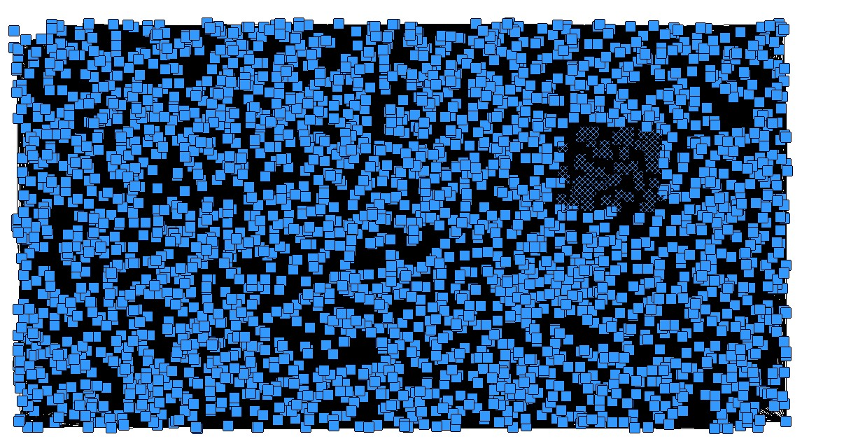
This initial view suggests that the network consisted of only one large component. A particularly dense network appears in the upper right corner. Initial analyses of the nodes reveal very little detail about the dense network. It does not appear to contain articles that mention a particular topic, or that are in a particular journal. Because this picture is too complex to reveal any great understanding, the link strength was increased to only show links with three or more co-citations. In other words, if any article was cited together more than three times, a connection was drawn. Isolates, articles with no connections, and pendants, articles with only one connection, were removed. A network visualization produced by an algorithm designed to detect naturally occurring clusters of items is shown in Figure 2. Individual articles are shown as circles. The numbers inside the circles are identification numbers. The size of the circle indicates how many times that article was cited (larger circles indicate a greater number of citations). Articles that were cited together (co-citations) are linked and heavier lines indicate a greater number of co-citations.

Figure 2. Network with tie strength 3+ and no isolates or pendants
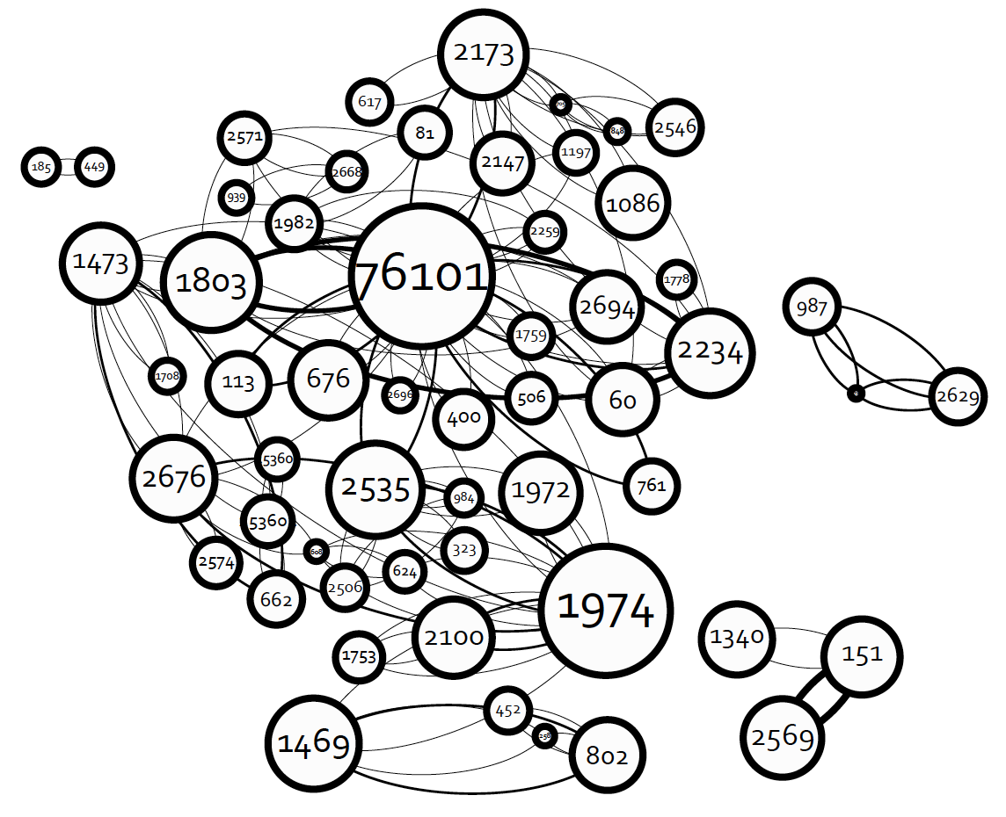

While Figure 2 provides a clearer picture of the main components, it is produced by a computer program with no understanding of the context of the connections. What did these articles have in common? Are they about similar topics? Are they published in similar journals?
To better understand the patterns of co-citations, each article in the co-citation list was coded based on its topic:
- word of mouth and/or diffusion (22)
- uses and gratifications (8)
- networks or networking (9)
- marketing, advertising, promotion (9)
- methodology and/or statistics(3)
- other (6)
The computer algorithm used the topic codes to rearrange the network shown in Figure 2 so that articles are also clustered visually by topic. The resulting visualization is shown in Figure 3, and Table 7 identifies the most cited article in each cluster.

Figure 3. Final Network Structure
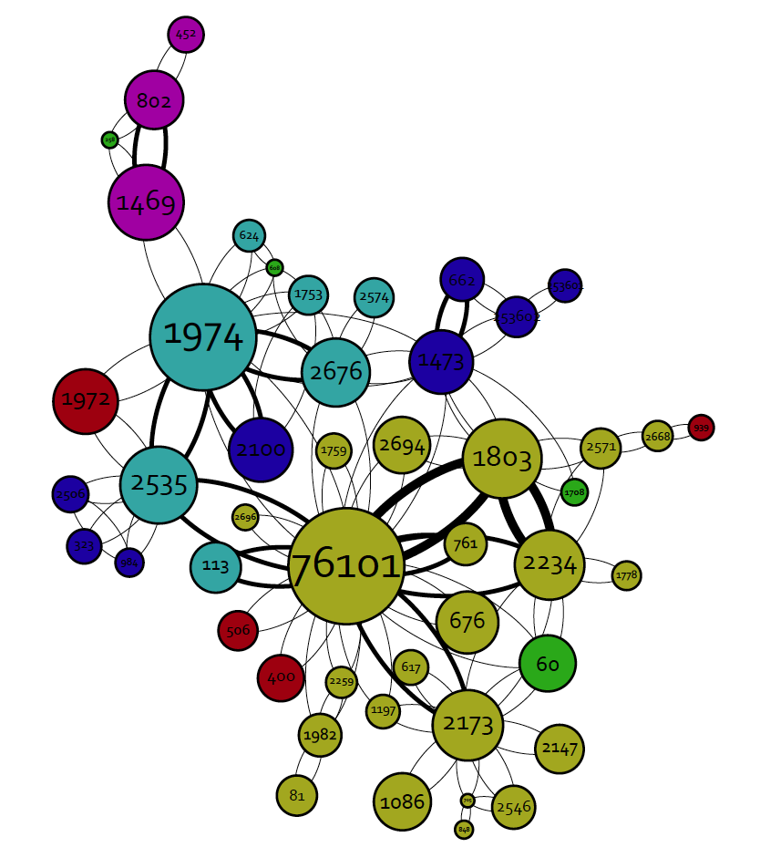

Table 7.
Most Cited Article in Each Network Clusters
Word Of Mouth / Diffusion
Electronic word‐of‐mouth via consumer‐opinion platforms: What motivates consumers to articulate themselves on the Internet? (2004) ID # 76101 | Hennig-Thurau, T., Gwinner, K.P., Walsh, G. & Gremler, D. D. | Journal of Interactive Marketing
Uses & Gratifications
MySpace and Facebook: Applying the Uses and Gratifications Theory to Exploring Friend Networking Sites (2008) ID# 1473 | Raacke, J. & Bonds-Raacke, J. | Cyberpsychology & Behavior
Networks / Networking
Social network sites: Definition, history, and scholarship (2007) ID# 1974 | Boyd, D. M., & Ellison, N. B. | Journal of Computer‐Mediated Communication
Marketing / Advertising / Promotion
Social media: The new hybrid element of the promotion mix (2009) ID# 1972 | Mangold, W. G. & Faulds, D. J. | Business Horizons
Methodology / Statistics  Multivariate Data Analysis, 7th Edition. (2010) ID# 1469 | Hair, J.F. | Prentice Hall
Other  A Dyadic Study of Interpersonal Information Search (1998) ID# 60 | Gilly, M., Graham, J., Wolfinbarger, M., & Yale, I. | Journal of the Academy of Marketing Science

Discussion
The data from this study reveal that the study of SNSs/social media in the area of strategic communication is a fast growing research paradigm. Research is conducted by a significant number of scholars who publish in a wide variety of journals. However, a small number of publications appear to be developing as “core” journals for this type of research Only 4 journals ranked in the top ten for both citations and publication of strategic communication articles in 2011: Journal of Advertising Research, Journal of Interactive Advertising, Journal of Interactive Marketing, and Public Relations Review. During the same year, there were another 30 journals with 2 or more published articles. In addition, many of the journals were outside the traditional communication, marketing, advertising, and public relations journals typically thought of for strategic communication research.
In terms of most-cited articles, there does not appear to be a single seminal article that is highly cited. Of the 31 most-cited sources in 2011, only 7 were published prior to 2000. This focus on more recent research is not surprising on the one hand since social media is a relatively new field; however, this focus might also reflect the findings by Khang, Ki & Ye (2012) that the majority of social media research does not explicitly employ a theoretical framework. Articles in the Marketing / Advertising / Promotion cluster from the co-citation network analysis appear to be primarily descriptive studies and not theoretically focused.
Khang, Ki & Ye (2012) also noted that when social media researchers used a particular theoretical approach, the research tended to use existing theoretical frameworks rather than suggesting alternative frameworks. The results of the social network analysis presented here also support this view. Two of the primary clusters in the citation network involved established theoretical frameworks in marketing and communication: word-of-mouth and uses and gratifications.
The number of different authors who were cited was quite large, however, only two of the authors cited 5 or more times in 2011 were also on the list of authors publishing in this area. This finding could indicate the degree to which interdisciplinary research is being conducting with authors going outside of their established paradigms to help understand social media phenomena.
This study also has implications for future study of scholarly research using co-citation and/or social network analysis. SNSs/social media research appeared in 289 different journals, a much larger number than typically studied by researchers employing a “core journal” strategy. Additional research is needed to determine the degree to which using only “core” journals in a citation analysis might bias the results.

References
Bensman, S.J. (2001). Bradford’s Law and Fuzzy Sets: Statistical Implications for Library Analysis. IFLA Journal, 27(4), 238-246.
Bradford, S.C. (1934). Sources of Information on Specific Subjects. Engineering, 137, 85-86.
Borgatti, S.P., Everett, M.G. & Freeman, L.C. (2002). UCINET for Windows: Software for Social Network Analysis. Harvard, MA: Analytic Technologies.
Boyd, D. M., & Ellison, N. B. (2007). Social Network Sites: Definition, History, and Scholarship. Journal Of Computer-Mediated Communication, 13(1), 210-230.
Cote, J. A., Leong, S., & Cote, J. (1991). Assessing the Influence of Journal of Consumer Research: A Citation Analysis. Journal Of Consumer Research, 18(3), 402-410.
Cote, J. A., Siew Meng, L., & Cote, J. (1992). Assessing the Influence of Marketing Research on the Social Science Literature. Marketing Letters, 3(3), 251-258.
Ford, J. B., & Merchant, A. (2008). A Ten-Year Retrospective of Advertising Research Productivity, 1997--2006. Journal Of Advertising, 37(3), 69-94.
Goldman, A. (1979). Publishing Activity in Marketing as an Indicator of Its Structure and Disciplinary Boundaries. Journal Of Marketing Research (JMR), 16(4), 485-494.
Greenberg, B. S., & Schweitzer, J. C. (1989). 'Mass Communication Scholars' Revisited and Revised. Journalism Quarterly, 66(2), 473-475.
Henthorne, T. L., LaTour, M. S., & Loraas, T. (1998). Publication Productivity in the Three Leading U.S. Advertising Journals: 1989 through 1996. Journal Of Advertising, 27(2), 53-63.
Khang, H., Ki, E., & Ye, L. (2012). Social Media Research in Advertising, Communication, Marketing, and Public Relations, 1997-2010. Journalism & Mass Communication Quarterly, 89(2), 279-298.
Kim, J., & McMillan, S. J. (2008). Evaluation of Internet Advertising Research. Journal Of Advertising, 37(1), 99-112.
Kuhn, T.S. (1970). The Structure of Scientific Revolutions (2nd ed.). The University of Chicago Press. Chicago.
Lievrouw, L. A. (1989). The Invisible College Reconsidered. Communication Research, 16(5), 615.
Lin, T. M. Y and Liao, C.W. (2008). Knowledge Dissemination of Word-of-Mouth Research: Citation Analysis and Social Network Analysis. Libri, (58) p. 212–223.
McCombs, M. E., & Shaw, D. L. (1972). The agenda-setting function of mass media. The Public Opinion Quarterly, 36(2), pp. 176-187.
Moreno, J. L. (1934). Who Shall Survive? Nervous and mental disease publishing co. Washington, DC.
Pasadeos, Y. (1985). A Bibliometric Study of Advertising Citations. Journal Of Advertising, 14(4), 52-68.
Pasadeos, Y., Phelps, J., & Edison, A. (2008). Searching for our “Own Theory” in Advertising: An Update of Research Networks. Journalism And Mass Communication Quarterly, 85(4), 785-806.
Pasadeos, Yorgo, Joseph Phelps, and Bong-Hyun Kim (1998), “Disciplinary Impact of Advertising Scholars: Temporal Comparisons of Influential Authors, Works and Research Networks,” Journal of Advertising, 27 (4), 53–70.
Pasadeos, Y., Renfro, R., & Hanily, M. (1999). Influential Authors and Works of the Public Relations Scholarly Literature: A Network of Recent Research. Journal Of Public Relations Research, 11(1), 29-52.
Piotrowski, C. (2012). Citation-based findings are (largely) a functionof the method of analysis: A comment on Black (2012). Psychological Reports: Mental & Physical Health, 111(3), 711-716.
Russell, J., & Martin, C. H. (1976). Sources of Scholarly Publications in Marketing, Advertising, and Public Relations. Journal Of Advertising, 5(3), 29-34.
Scott, J. (1996). Social Network Analysis: A Handbook. Sage Publications. New York. NY.
Tai, Z. (2009). The Structure of Knowledge and Dynamics of Scholarly Communication in Agenda Setting Research, 1996-2005. Journal of Communication. (59). pg. 481-513.
Tsan-Kuo, C., & Zixue, T. (2005). Mass Communication Research and the Invisible College Revisited: The Changing Landscape and Emerging Fronts in Journalism-Related Studies. Journalism & Mass Communication Quarterly, 82(3), 672-694.

