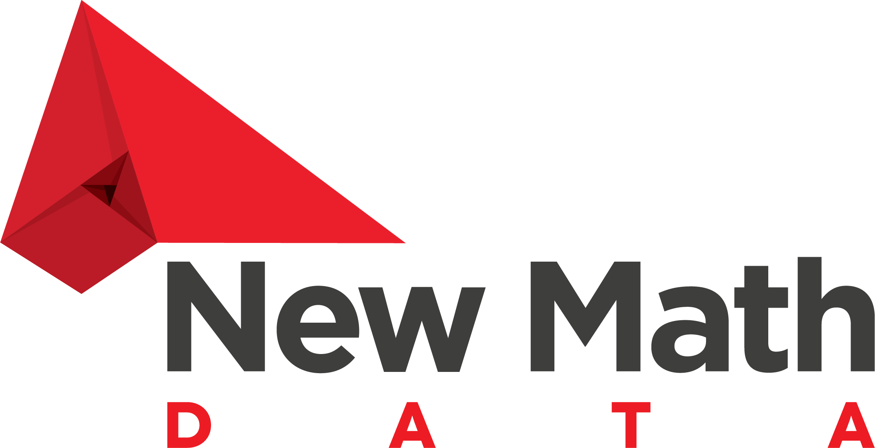

**CUSTOMER_NAME**

Statement of Work

PROJECT_NAME



Prepared by: New Math Data, LLC

Date: Feb 25, 2025

# Summary

This Statement of Work ("SOW") is between CUSTOMER_NAME ("Client") and New Math Data, LLC ("Contractor"), effective Mar 11, 2025 (the "Effective Date").

This SOW is entered into, as of the Effective Date, by and between the Client and Contractor, and is subject to the terms and conditions specified below. In the event of any inconsistency between the terms of this SOW and the Agreement, the terms of the SOW shall prevail.

# Overview

The New Math Data, will design and implement a SOLUTION_DESCRIPTION for CUSTOMER_NAME to <SOLVE A BUSINESS PROBLEM>.

ADD A SHORT 3-5 SENTENCE OVERVIEW OF THE SOLUTION.

Thorough testing and user acceptance testing (UAT) will ensure the functionality and performance of the system. The project will utilize AWS-based infrastructure with development, testing, and production environments to ensure seamless integration and deployment.

# Scope

## Activities

* 1. Planning
     1. Project outline and timelines
        1. Set up sprint cadence
        2. Determine discovery work necessary for delivery
           1. Create timeline for discovery sessions
           2. Schedule discovery sessions ensuring key stakeholders will be available and present
     2. Identify product owner, key stakeholders/contributors
     3. Define working backlog and milestones
     4. Identify collaboration tools and processes
  2. Discovery
     1. Prerequisites
        1. Access and login for NMD resources
        2. Review Network configuration/VPC setup
        3. Is VPN needed to access customer resources?
        4. Credential generation for developer access, infrastructure deployment
        5. Account structure
           1. Single vs. Multiple Accounts
  3. Design
  4. Build/Deploy
  5. Validation
  6. Documentation/Training/Knowledge

## Deliverables/Acceptance Criteria

* 1. The products or services provided by New Math Data, LLC will be considered complete by CUSTOMER_NAME as long as the following conditions or criteria are met:
     1. <PROJECT ACCEPTANCE CRITERIA>

## Assumptions

## Considerations

* 1. Infrastructure development and deployment will include development, test and production environment, but New Math Data will only be responsible for populating data into development and test environments. Customer will be responsible for enabling and executing data pipeline(s) within their production environment.
  2. Customer will make available subject matter experts, accessible via Teams or Slack for short requests (less than 15 mins).
  3. Customer will make available subject matter experts on a weekly basis for discovery and design sessions. Schedule to be determined during kick-off and discovery activities.

## Customer Responsibilities

* 1. Customer will provide access to underlying cloud environment, either directly or via an infrastructure/DevOps engineer, sufficient to conduct development and carry out delivery and feature release

# Pricing

Consulting and engineering services will be provided on a “resource usage” basis.

| Services | | Estimated Cost |
| --- | --- | --- |
| POC | 1 | $25,000.00 |
|  |  |  |
|  | Sub Total | $25,000.00 |
|  | Tax | $0.00 |
|  | AWS Funding | ($25,000.00) |
|  | Total | $0.00 |

# Period of Performance

The Services shall commence on Mar 11, 2025 and shall continue until the completion of services.

**IN WITNESS WHEREOF**, the parties hereto have executed this SOW to be effective as of the day, month and year first written above.

New Math Data, LLC

By: ___________________________________ Date: __________________

Bernard Hatch

Owner

CUSTOMER_NAME

By: ___________________________________ Date: __________________

CUSTOMER_SIGNER

CUSTOMER_SIGNER_TITLE