**Gun Deaths in America (2012-2014) - Data Analysis Report**

**Christopher Okoro**

**Introduction:**

This report presents an analysis of gun deaths in America from 2012 to 2014, using a dataset sourced from the Centers for Disease Control and Prevention (CDC). The objective is to uncover patterns, trends, and demographic factors associated with gun-related incidents during this period.

**Methodology:**

The dataset underwent thorough cleaning using Python (pandas, Numpy, Seaborn) to eliminate duplicates and blank spaces. Exploratory data analysis (EDA) was then conducted to reveal patterns and correlations. Visualizations were created using Tableau to enhance understanding and convey insight.

**Key Findings:**

* Total Recorded deaths between 2012-2014 is 98,015. This comes to 134 deaths per day.

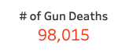

* Majority of gun deaths occurred at Home (60.83%)

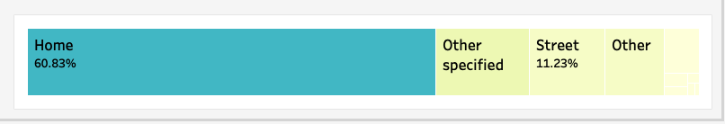

* Male recorded gun deaths were over 5x more than female gun deaths.

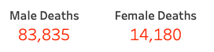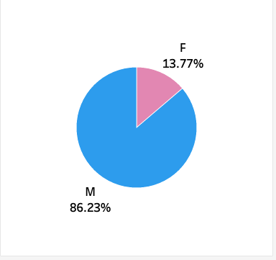

* The majority of gun deaths are categorized as suicides, followed by homicides.

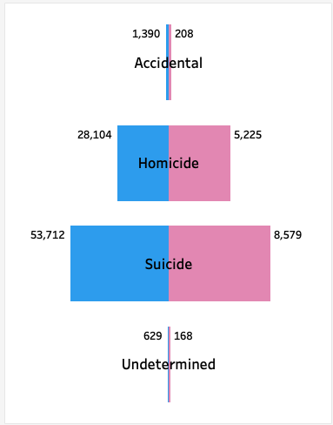

* Individuals in the ages 21-39 are more prone to gun-related incidents.

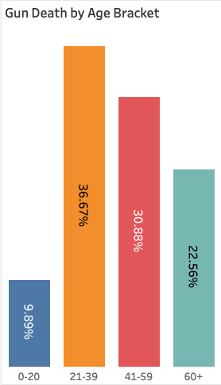

* Demographic disparities exist, with white descendants showing higher gun death percentage.

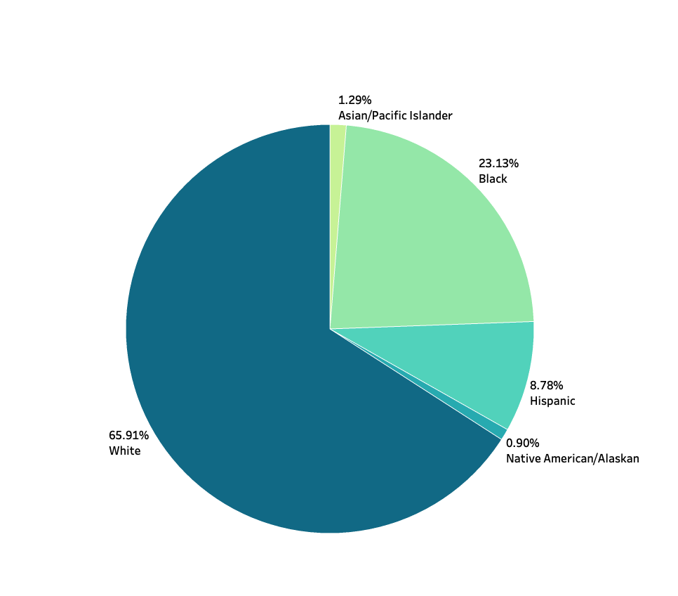

* Age brackets 41-59 and 60+ are more likely to commit suicide compared to other age brackets.

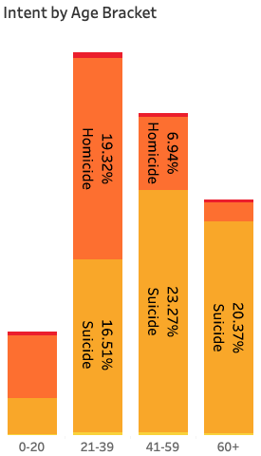

**Implications:**

Seasonal patterns could inform targeted interventions and awareness campaigns.

Understanding demographic trends can guide policy initiatives addressing mental health and community-specific concerns.

**Limitations:**

The dataset covers 2012-2014; trends may have evolved since then.

Lack of certain demographic factors limits a comprehensive analysis of disparities.

**Conclusion:**

This analysis provides insights into the complex dynamics of gun deaths in America, offering valuable information for policymakers, researchers, and the public. Addressing the identified trends and disparities could contribute to more targeted efforts to reduce the impact of gun-related incidents.

**Recommendations:**

Conduct further research to explore evolving patterns in recent years.

Implement targeted mental health initiatives to address the high incidence of suicides.

**References:**

* Centers for Disease Control and Prevention (CDC) Gun Deaths Dataset
* Masood Ahmed (Kaggle User)

**Links**

* [Tableau Public Dashboard](https://public.tableau.com/views/CDC-GunDeathDashboard/Dashboard1?:language=en-GB&:display_count=n&:origin=viz_share_link)
* [LinkedIn Profile](https://www.linkedin.com/in/chris-dataanalyst/)
* [GitHub Repo](https://github.com/chriskachiokoro/CDC-GunDeath-Analysis)
* [Kaggle Dataset](https://www.kaggle.com/datasets/maso0dahmed/gun-deaths-in-america-cdc/data)