Christopher Okoro – cookoro@iu.edu

Z639 Topic Modeling Project – Report

1. Introduction
This project uses a Movies Review Dataset, obtained from Kaggle, which contains user-written reviews of movies collected from the Internet Movie Database (IMDB). The dataset was originally created for binary sentiment classification and includes many detailed, opinion-based reviews written by viewers. Each review consists of free-form text in which users discuss various aspects of movies such as plot, acting, directing, pacing, and overall enjoyment. Due to its size, richness, and widespread use in natural language processing research, this dataset provides a strong foundation for exploratory text analysis.
For this study, the test portion of the dataset, consisting of 25,000 reviews, was used as the source data. From this set, a random sample of 2,500 reviews was selected to balance computational efficiency with sufficient textual diversity for topic modeling. Preliminary experimentation showed that using substantially larger samples (above 5,000 reviews) resulted in fewer discovered topics and a highly unbalanced topic frequency distribution. Based on this observation, a sample size of 2,500 reviews was selected as a better balance between topic diversity and interpretability.

The purpose of applying topic modeling to this dataset is to identify recurring themes and patterns in how audiences discuss movies, beyond simple positive or negative sentiment. While the dataset is often used for sentiment classification, topic modeling allows for a deeper exploration of what reviewers are talking about, such as storytelling quality, performances, emotional impact, or technical aspects of filmmaking. By using BERTopic, this project aims to discover thematic groupings within movie reviews and to understand the dominant topics that characterize audience feedback.

2. Methods
Prior to topic modeling, the movie reviews were preprocessed to reduce noise while preserving the semantic content necessary for meaningful topic discovery. An initial version of the analysis followed the minimal cleaning steps provided in the course starter notebook, which included converting text to lowercase and removing URLs. While this approach was sufficient to run BERTopic, preliminary results indicated that topics were few and very unbalanced, motivating further refinement of the preprocessing pipeline.

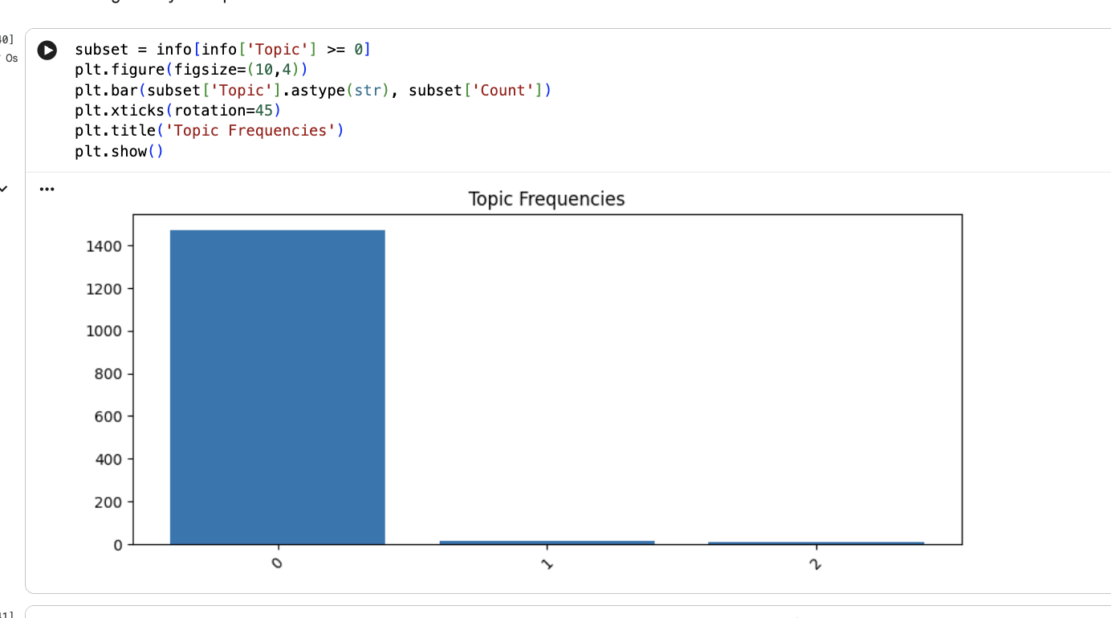
Figure 1: Topic Frequency distribution using minimal text processing

For the final analysis, an enhanced but still conservative cleaning strategy was adopted. This approach was designed to normalize the text without over-processing it, as aggressive preprocessing can remove contextual information that is important for transformer-based embeddings. Specifically, the following steps were applied:

- All text was converted to lowercase to ensure consistency across tokens.
- HTML tags, including common line break tags (e.g., <br />), were removed, as these frequently appear in IMDB reviews and do not contribute meaningful semantic information.
- URLs were removed to eliminate irrelevant tokens.
- Common English contractions were expanded (e.g., “don’t” to “do not”) to improve token consistency.
- Non-alphabetic characters were removed, retaining only letters and whitespace.
- Extra whitespace was normalized to produce clean, readable text.

This preprocessing strategy resulted in clearer and more stable topic distributions. When compared to the minimal cleaning approach, the refined preprocessing led to increased prominence of the most frequent topics, indicating improved topic coherence and reduced noise. Based on this comparison, the enhanced cleaning strategy was selected for the remainder of the project.

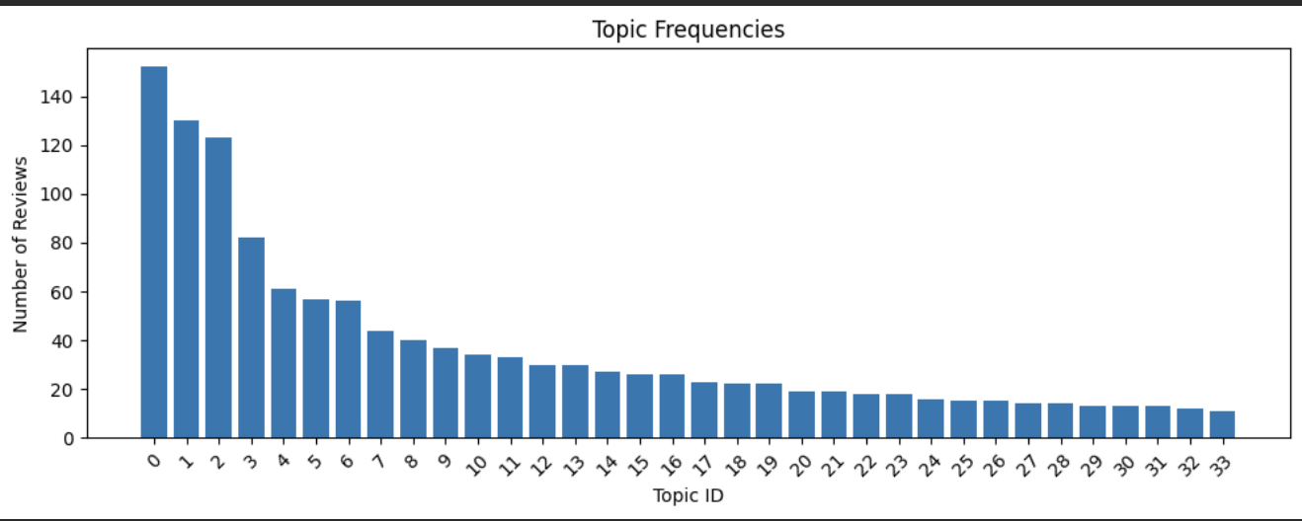
Figure 2: Topic Frequency distribution using improved text processing

Topic Modeling with BERTopic
After preprocessing, topic modeling was performed using BERTopic. Sentence embeddings were generated using the all-MiniLM-L6-v2 pre-trained transformer model. BERTopic was then applied to the cleaned review texts to automatically discover latent topics and assign each document to a topic cluster, with topic probabilities calculated to quantify the confidence of each document’s assignment.

During initial experimentation using the default BERTopic workflow provided in the starter notebook, many of the extracted topic representations were dominated by common stopwords, making the resulting topics difficult to interpret.

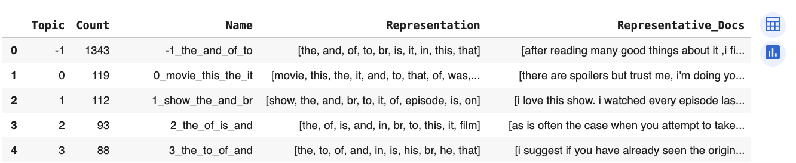
Figure 3: Topics Info using basic BERTopic script

To address this issue, AI assistance was used to modify the modeling pipeline by incorporating a CountVectorizer, which is a feature extraction method that converts text into numerical token counts while allowing control over stopword removal, n-gram usage, and minimum word frequency. By explicitly configuring the vectorizer to remove English stopwords and include meaningful word combinations, the topic representations became substantially more interpretable.
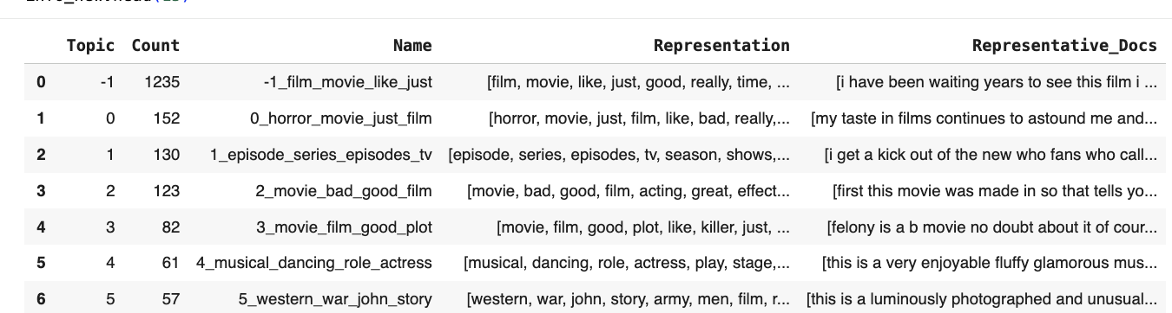
Figure 4: Topics Info using BERTopic & CountVectorizer script

3. Results: Topic Exploration
For this analysis, BERTopic identified a total of 34 topics from the 2,500 sampled reviews. Of these, 1,235 reviews were assigned to Topic -1, which represents documents that did not strongly align with a single topic. The following subsections focus on Topics 0, 1, 2, 3, and 4, as these were the most frequently occurring and interpretable topics identified by the model.

Topic 0
From the analysis, Topic 0 occurred 152 times, having its top words as ['horror', 'movie', 'just', 'film', 'like', 'bad', 'really', 'movies', 'people', 'does']. It was named “0_horror_movie_just_film”. An example of the sentence is below,

“…strange things happen to americans will greg evigan maura alexandra paul and their young daughter aubrey briana evigan greg is real life daughter when they move into a large newly inherited house in…”
“ …ireland crusty corpses are found in the cellar a turkey squirts blood furniture moves and the ghosts of a dead child and a cackling old lady show up to scare the little girl paranormal investigators…”

This topic appears to capture reviews that focus on horror movies, shown in the name given by BERTopic and top words such as horror and bad.

Topic 1
From the analysis, Topic 1 occurred 130 times, having its top words as ['episode', 'series', 'episodes', 'tv', 'season', 'shows', 'like', 'just', 'watching', 'people']. It was named “1_episode_series_episodes_tv”. An example of the sentence is below,

“…i love this show i watched every episode last year i bought the dvds and i tune into to watch tonight and i see for some reason you have retooled this great show…”
“…as i sat watching this episode i kept glancing at the clock waiting for something to happen as the hour wound…”

This topic appears to capture reviews that focus on contents that are broadcasted as series with episodes, shown in the name given by BERTopic and top words such as episode and series.

Topic 2
From the analysis, Topic 2 occurred 123 times, having its top words as ['movie', 'bad', 'good', 'film', 'acting', 'great', 'effects', 'just', 'time', 'quality']. It was named “2_movie_bad_good_film”. An example of the sentence is below,

“…i think this is the worst movie i have seen since mortal kombat the action including the effects is like in a cheap glen…”
“…honestly how hard can it be to make a good remake obviously pretty hard i was soooo excited to see this because …”

This topic appears to capture reviews that focus on comments about the quality of the content/movie, shown in the name given by BERTopic and top words such as quality, acting, great and effects.

Topic 3
From the analysis, Topic 3 occurred 82 times, having its top words as ['movie', 'film', 'good', 'plot', 'like', 'killer', 'just', 'story', 'police', 'cop']. It was named “3_movie_film_good_plot”. An example of the sentence is below,

“…i can envision the writers of this story thinking up this script let is make a serial killer movie like se en knight moves…”
“…fbi agents a cop feet away apparently cannot hit either one with a standard police issue pistol that can shoot several shots i hate movies that try to make you…”

This topic appears to capture reviews that focus on the plot, and story told in content/movie, and the plot being related to law enforcement agencies. This is shown in the name given by BERTopic and top words such as story, plot, and police.

Topic 4
From the analysis, Topic 4 occurred 61 times, having its top words as ['musical', 'dancing', 'role', 'actress', 'play', 'stage', 'little', 'film', 'good', 'production']. It was named “4_musical_dancing_role_actress”. An example of the sentence is below,

“…like most musicals of the era one must check reality at the door broadway melody of is not remotely believable…”
“…julie andrews satirically prods her own goody two shoes image in this overproduced musical comedy drama but if she approaches her role…”

This topic appears to capture reviews that focus on musicals that involve dancing, plays on a stage with a production crew. This is shown in the name given by BERTopic and top words such as musical and dancing.

Incoherent Topic (Topic -1)
From the analysis, Topic -1 occurred 1,235 times, having its top words as ['film', 'movie', 'like', 'just', 'good', 'really', 'time', 'story', 'did', 'does']. It was named “-1_film_movie_like_just”. An example of the sentence is below,

“…dubbed beyond comprehension the hbo version of lumumba is a disastrous rendering of what looks like what was once a decent film some scenes…”

From the results gotten, reviews have been put into Topic -1 due to them not strongly aligning into a single topic. They show multiple themes and topics. They are also called outliers.

4. Visualizations

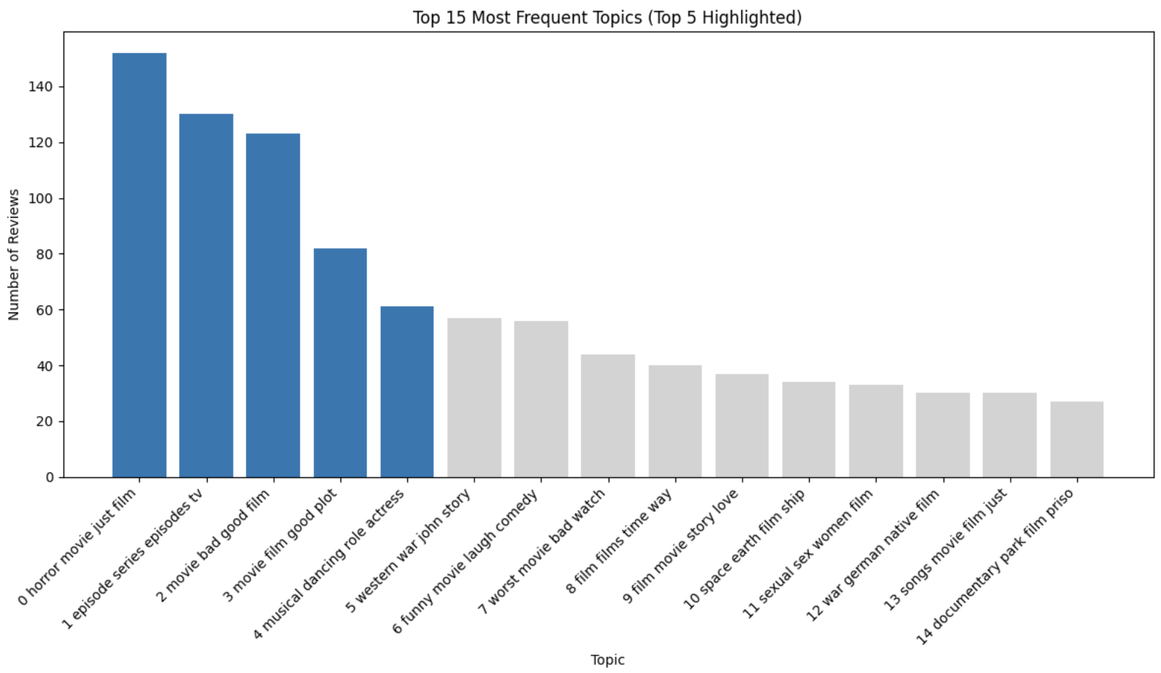
Figure 5: Topics Frequencies distribution with Topic names

This visualization shows the Top 15 most frequent topics categorized by BERTopic and the Top 5 highlighted also showing their respective topic names.

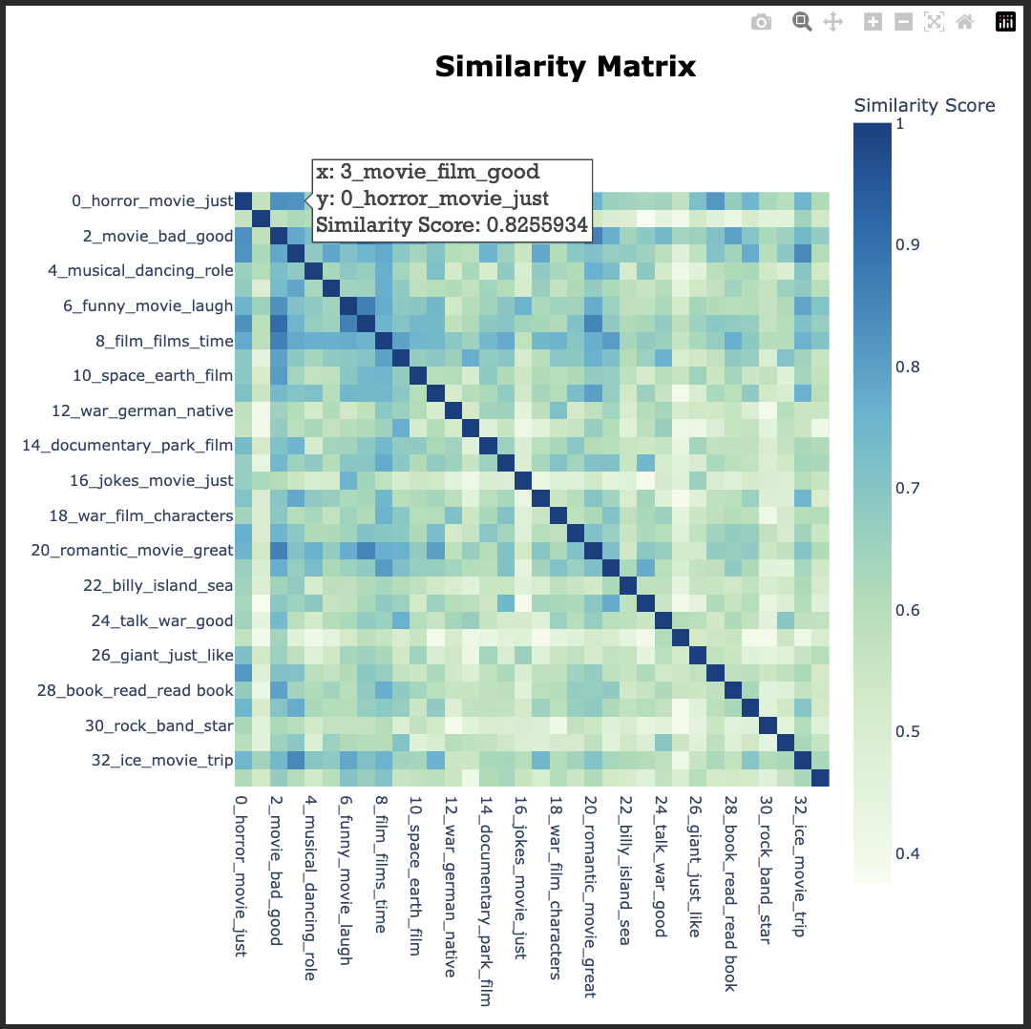
Figure 6: Topics similarity matrix

In the above visualization, Topic 0 and Topic 3 have a similarity score of 0.8255. Looking at the top words for the 2 topics, Topic 0 having ['horror', 'movie', 'just', 'film', 'like', 'bad', 'really', 'movies', 'people', 'does'] and Topic 3 having ['movie', 'film', 'good', 'plot', 'like', 'killer', 'just', 'story', 'police', 'cop'], This high similarity score reflects overlapping themes between the two topics, particularly discussions related to darker film content such as horror elements, violence, and negative evaluations of movie quality.

5. Conclusion

The topics in the IMDB Movies reviews dataset was correctly extracted by BERTopic. The preprocessing of the text plays a significant role in determining if Topic extraction will be successful or not. For future improvements, I would suggest pretrain/fine tune BERTopic using better custom embedding models that are familiar with movie review terminologies and semantics.

