Strengthening Fisheries Monitoring Capacity for Adaptive Management of the KAMAMKUKI Joint Co-Management Area

Implementation period | October 2024–November 2026
Funded by | Blue Ventures Conservation (BVC)
Implemented by | Oceans Alive Foundation (OA)
Key partners | Kenya Fisheries Service (KeFS); County Governments of Kilifi and Mombasa; and the KAMAMKUKI Joint Co-Management Area Committee

PROJECT OVERVIEW
Oceans Alive Foundation (OA), with funding support from Blue Ventures Conservation, is implementing a two-phase project to strengthen the fisheries monitoring and co-management capacity of five Beach Management Units (BMUs) within the KAMAMKUKI Joint Co-Management Area (JCMA). The project promotes the use of reliable fisheries and ecological information to support informed, adaptive management of shared coastal resources.
The KAMAMKUKI JCMA spans approximately 304 km² of coastal and marine waters within Kenya’s territorial sea. It brings together the Kuruwitu, Kanamai and Mtwapa BMUs in Kilifi County and the Marina and Kidongo BMUs in Mombasa County. These institutions work alongside the Kenya Fisheries Service (KeFS) and the respective county governments to manage shared fisheries resources under the framework established by the Fisheries Management and Development Act No. 35 of 2016.
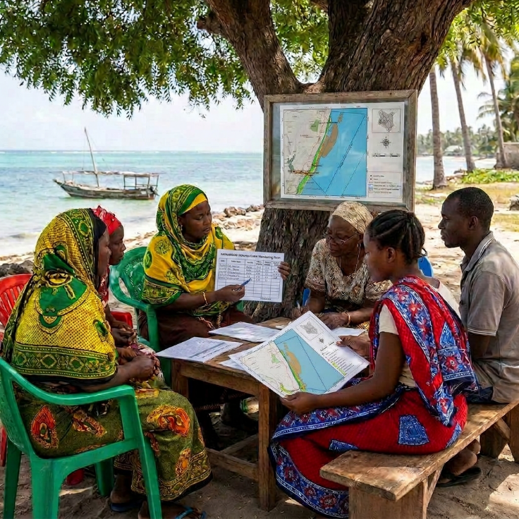
The project responds to a set of interrelated pressures on the JCMA’s fisheries: destructive and illegal fishing practices, declining fish stocks, habitat degradation, weak enforcement, limited institutional capacity within co-management bodies, and the growing economic vulnerability of coastal communities whose livelihoods depend on increasingly stressed resources.
The project’s approach is centred on building the capacity of BMUs and allied co-management institutions to implement fisheries regulations and management measures effectively and accountably. Interventions span governance and institutional development, fisheries catch and ecological monitoring, compliance strengthening, financial resilience for fisheries-dependent households, and community food security.
Phase 1 (October 2024 – September 2025) focused on diagnosing and addressing governance and institutional capacity gaps across the five BMUs and establishing a fisheries catch-monitoring system at ten landing sites within the JCMA.
Phase 2 (December 2025 – November 2026) builds on those foundations across four priority areas: strengthening BMU governance and compliance through a structured mentorship programme; promoting peer learning, knowledge exchange and collaboration among BMUs; improving the financial resilience of fisheries-dependent communities through Village Savings and Loan Associations (VSLAs); and deepening fisheries and ecological monitoring to support evidence-based management decisions.
Delivery draws on a combination of ongoing fisheries data collection, community resource surveys, data-feedback sessions, compliance assessments, exchange visits, stakeholder engagement and technical partnerships. Together, these activities are designed to establish functional, accountable and self-sustaining systems for fisheries co-management that endure beyond the project period.
Collaboration is central to implementation. OA and Blue Ventures work closely with the five BMUs, the KAMAMKUKI Joint Co-Management Area Committee, national and county government institutions, research organizations and other stakeholders.
The expected result is a stronger and better-coordinated co-management system, supported by capable BMUs, reliable fisheries information, improved compliance, greater community financial resilience and stronger partnerships for sustainable fisheries management.

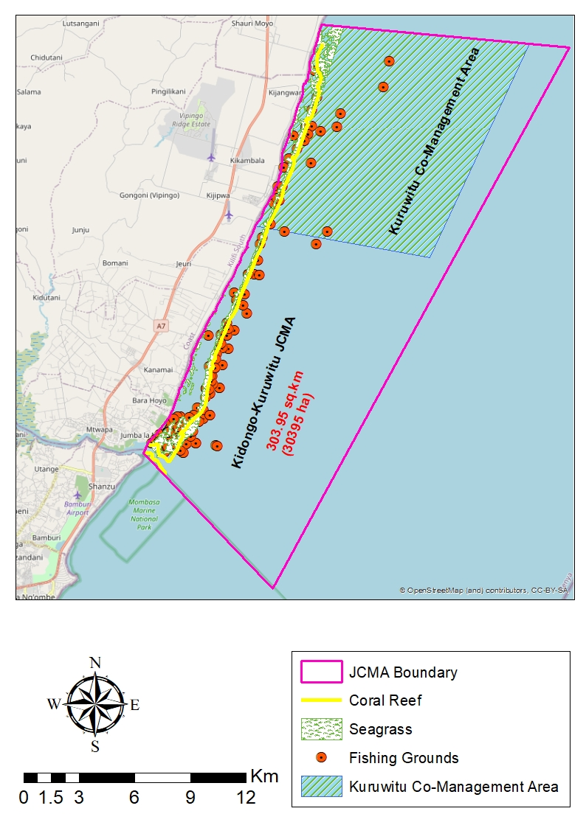
Figure 1: KAMAMKUKI JCMA

