Assignment 8

# question 1

Write the class Palindrome which first asks the user to enter a file name with a txt extension. You can assume the user will always enter a valid file name of a non-empty file which is located in the same folder as Palindrome.java.

Read in the contents of the file, and check whether or not the contents is a palindrome.

See section 5.5 of the text for an example which uses files.

Your code will be tested with the palindrome at: <http://norvig.com/pal17txt.html>

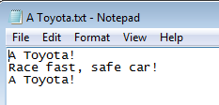

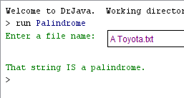

# question 2

Write the code for UnicodePanel.java which displays the following:

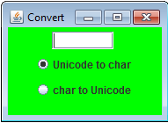

The GUI is used for converting between Unicode and char. I enter a Unicode in the text field, hit Enter, and its corresponding char is displayed beside the text field:

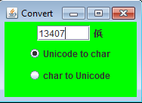

I can enter another Unicode and hit Enter:

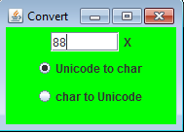

When I click on the other radio button, the text at the top is cleared:

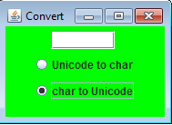

If I enter a char it will be converted to its Unicode after hitting the Enter key:

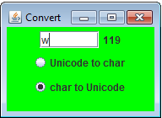

I can enter a different char and hit Enter:

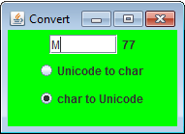

Clicking on the other radio button, clears the text:

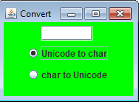

Assume the user will only enter valid input.

# what to submit

Submit Assignment8.zip which contains ONLY the following files:

* longPalindrome.txt
* Palindrome.java
* Unicode.java
* UnicodePanel.java