Derivation

*Locate Validation rules page*

i) In SAP easy Access search IMGMDG

ii) Open General settings à Data Quality and Search à Validations and Enrichments then click on Validation and Derivation rules (follow Highlighted blocks below)

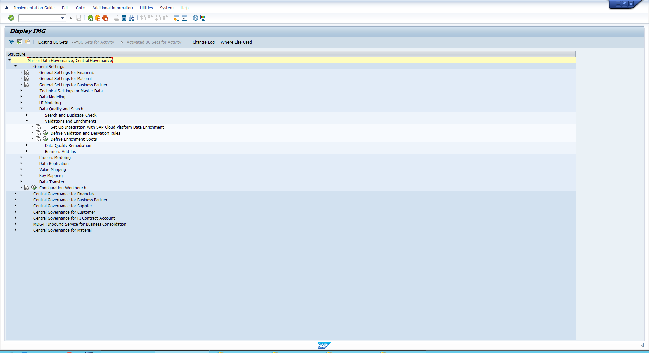

*A simpler way to find this is by inputting transaction code : usmd_rule*

iii) Enter MM into data model and click continue. If prompted click local object

*Business rule Framework*

i) Open Data Object you will see the framework. The list is all the fields from The MM model we opened

ii)Open Trigger Function à Derivation.

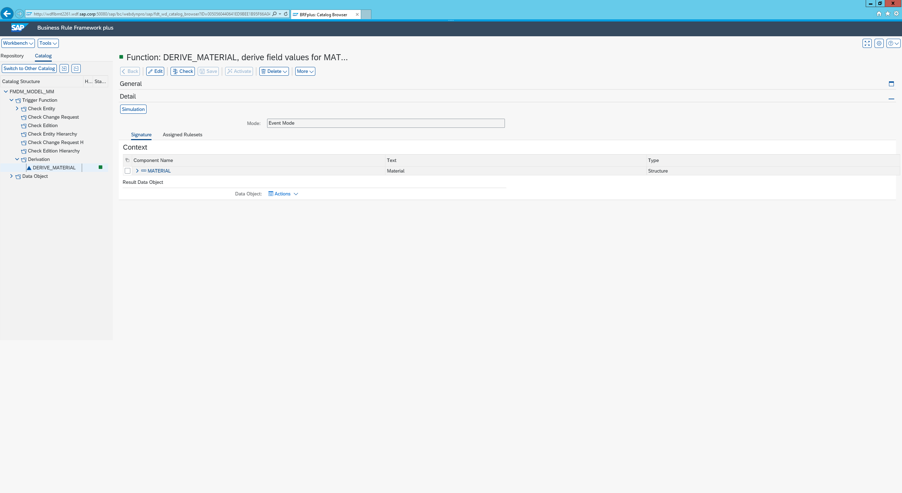

iii)Click the assigned ruleset tab 🡪 edit 🡪 create Rule set

iv) Enter The following in the box:

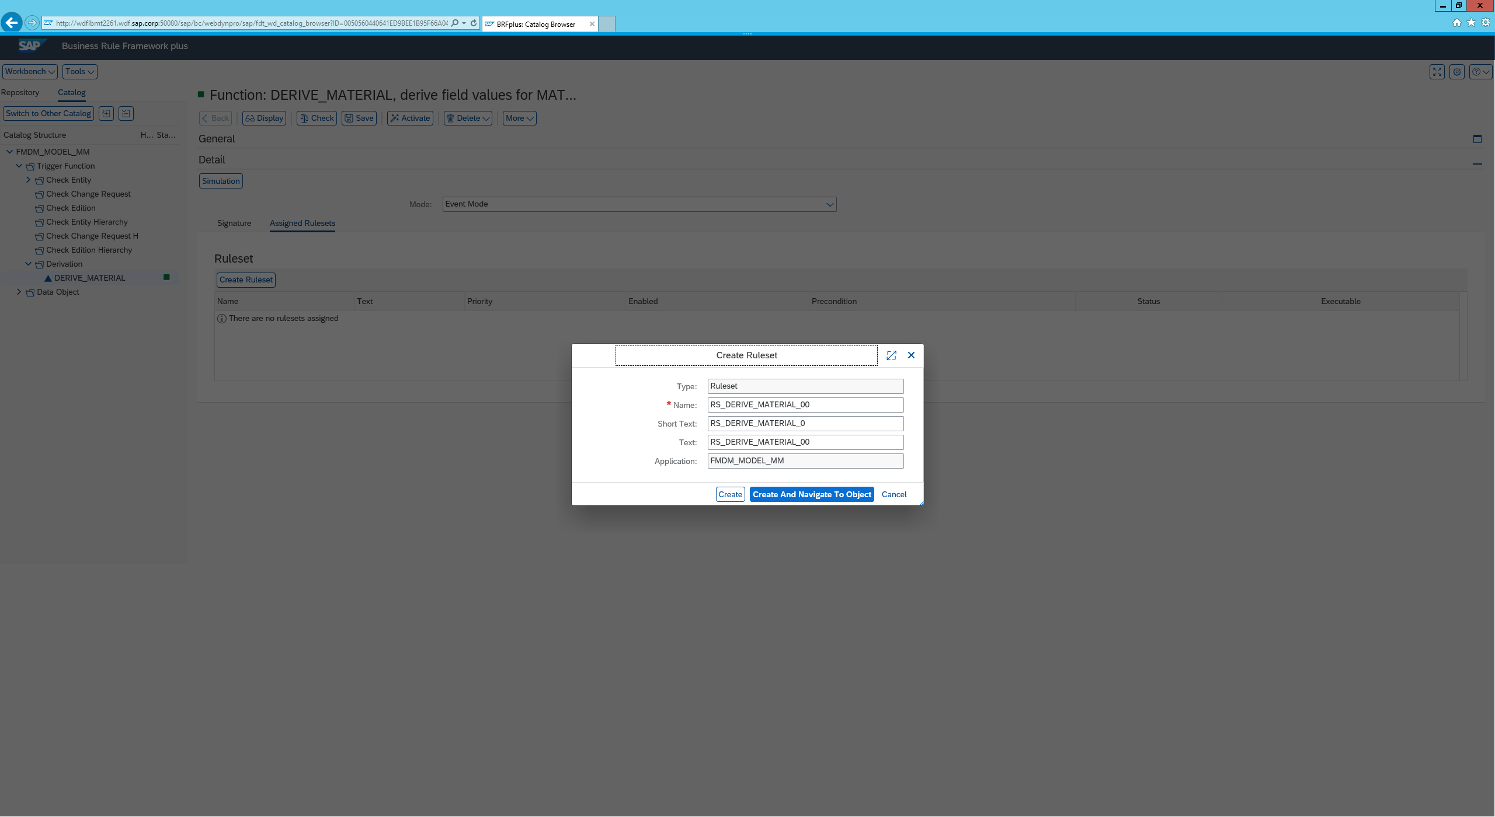

v) Click ‘create and navigate to object’

Creating a derivation

i) Click insert rule 🡪 create

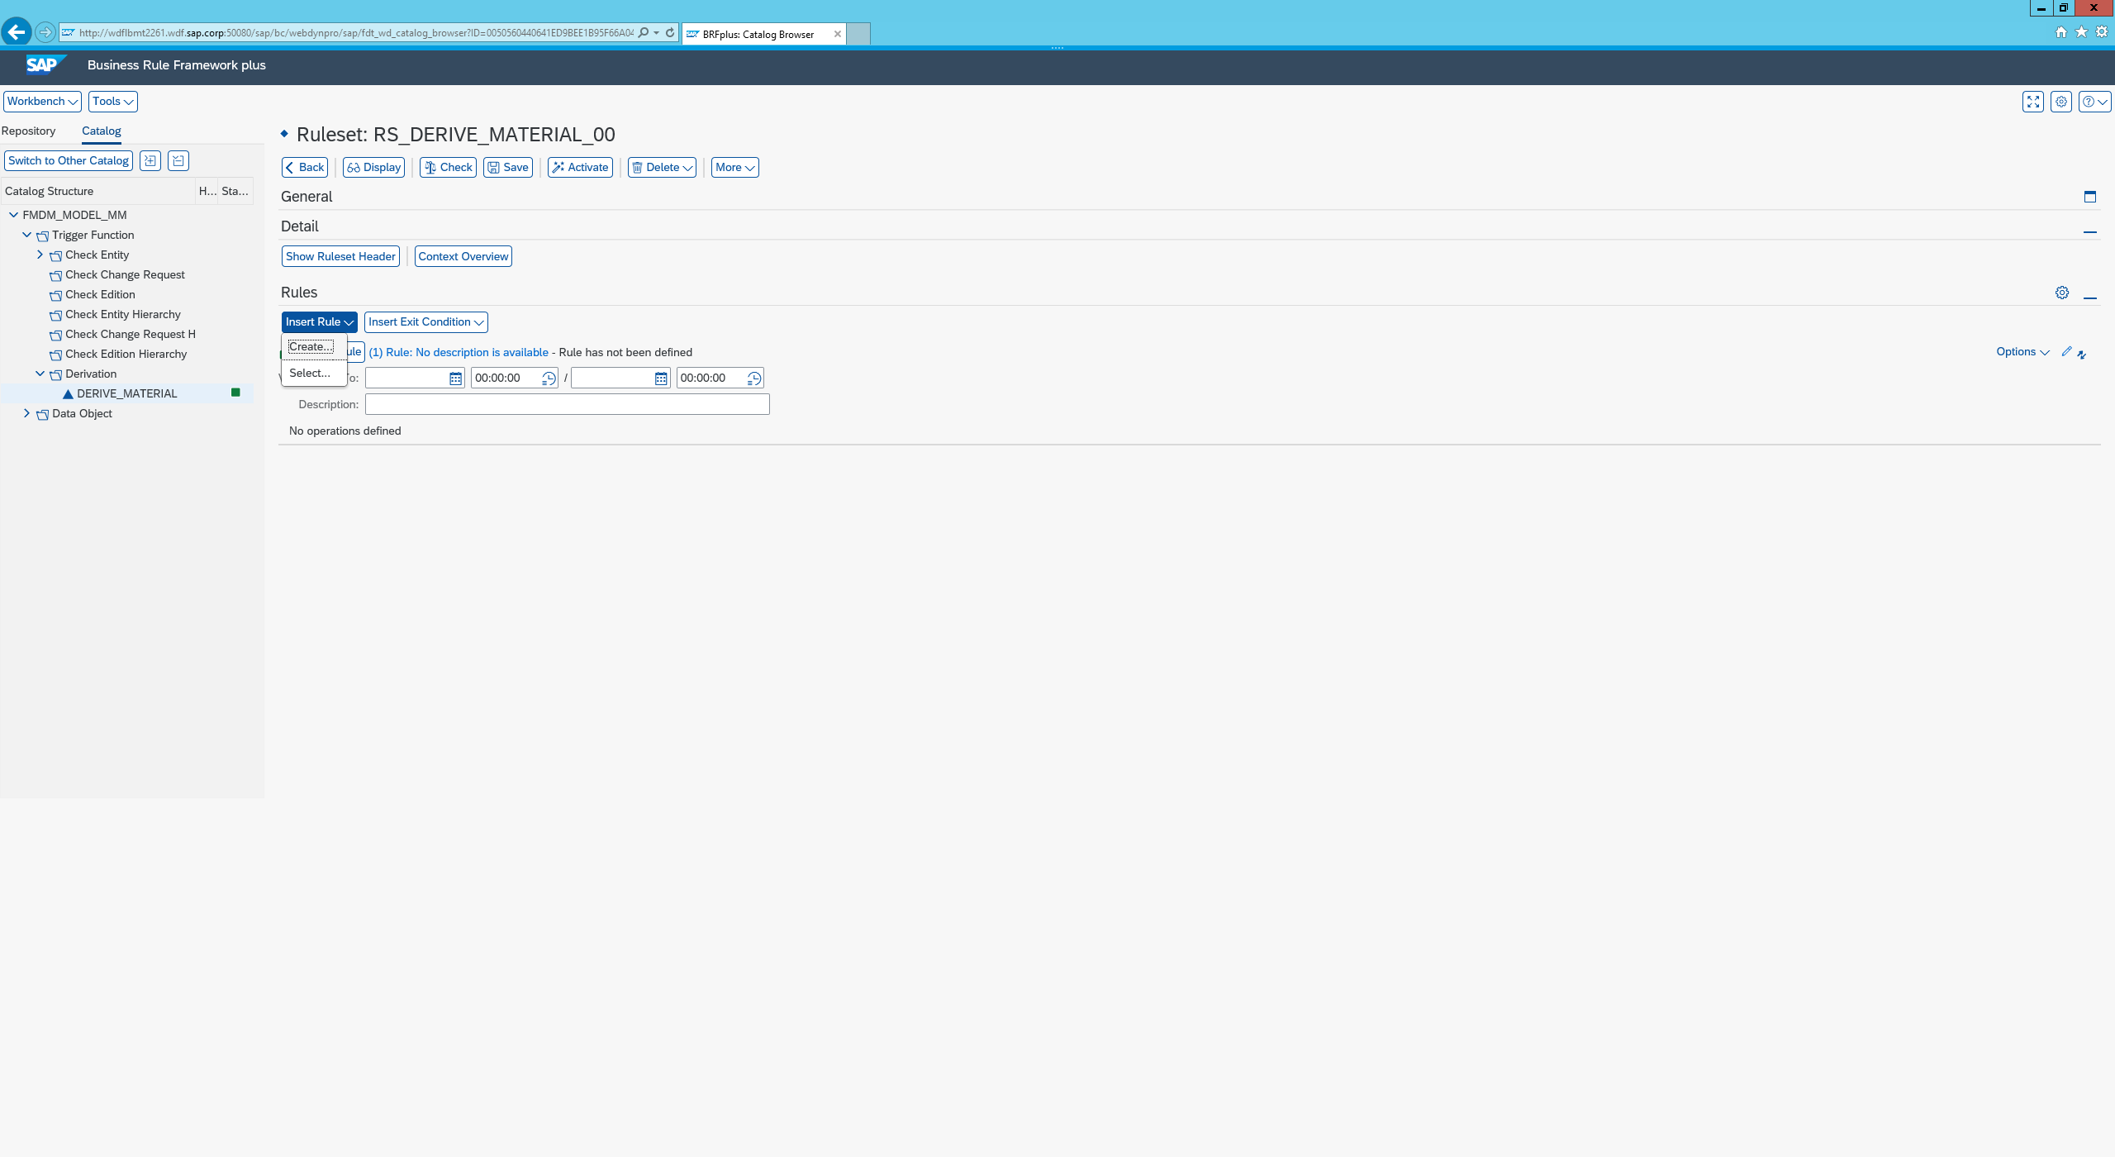

ii) Click on Assign condition 🡪 use Value Range From 🡪 Context 🡪 More

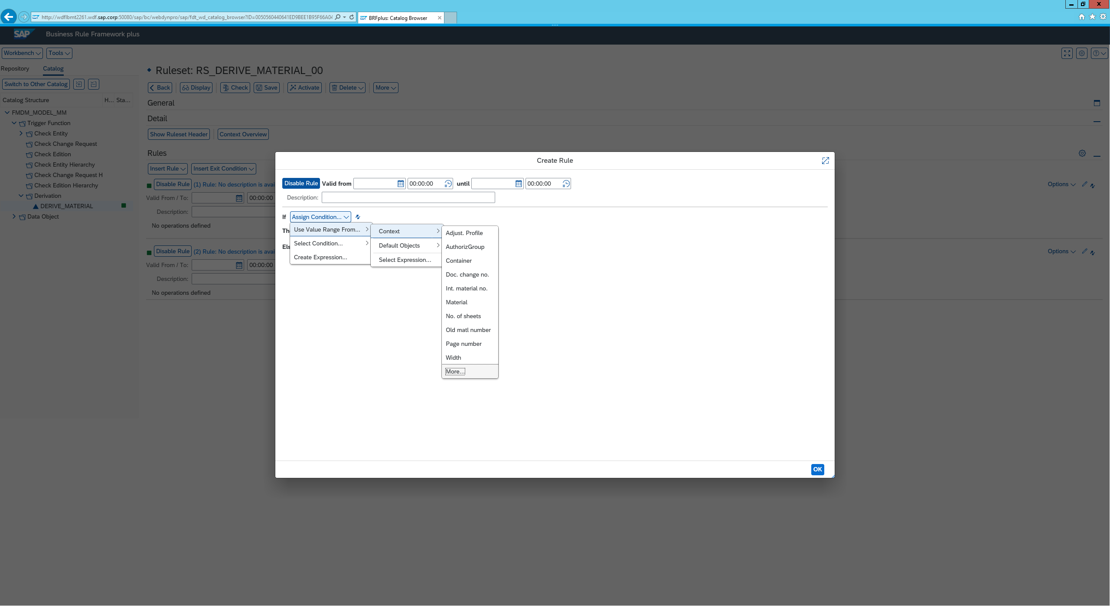

iii)We will be presented with a list of objects to chose from in this example we will be choosing Industry sector. You can simply scroll through the list till you find it or search as shown below. Once added you will want to change the industry sector from ‘is equal’ to ‘is initial’

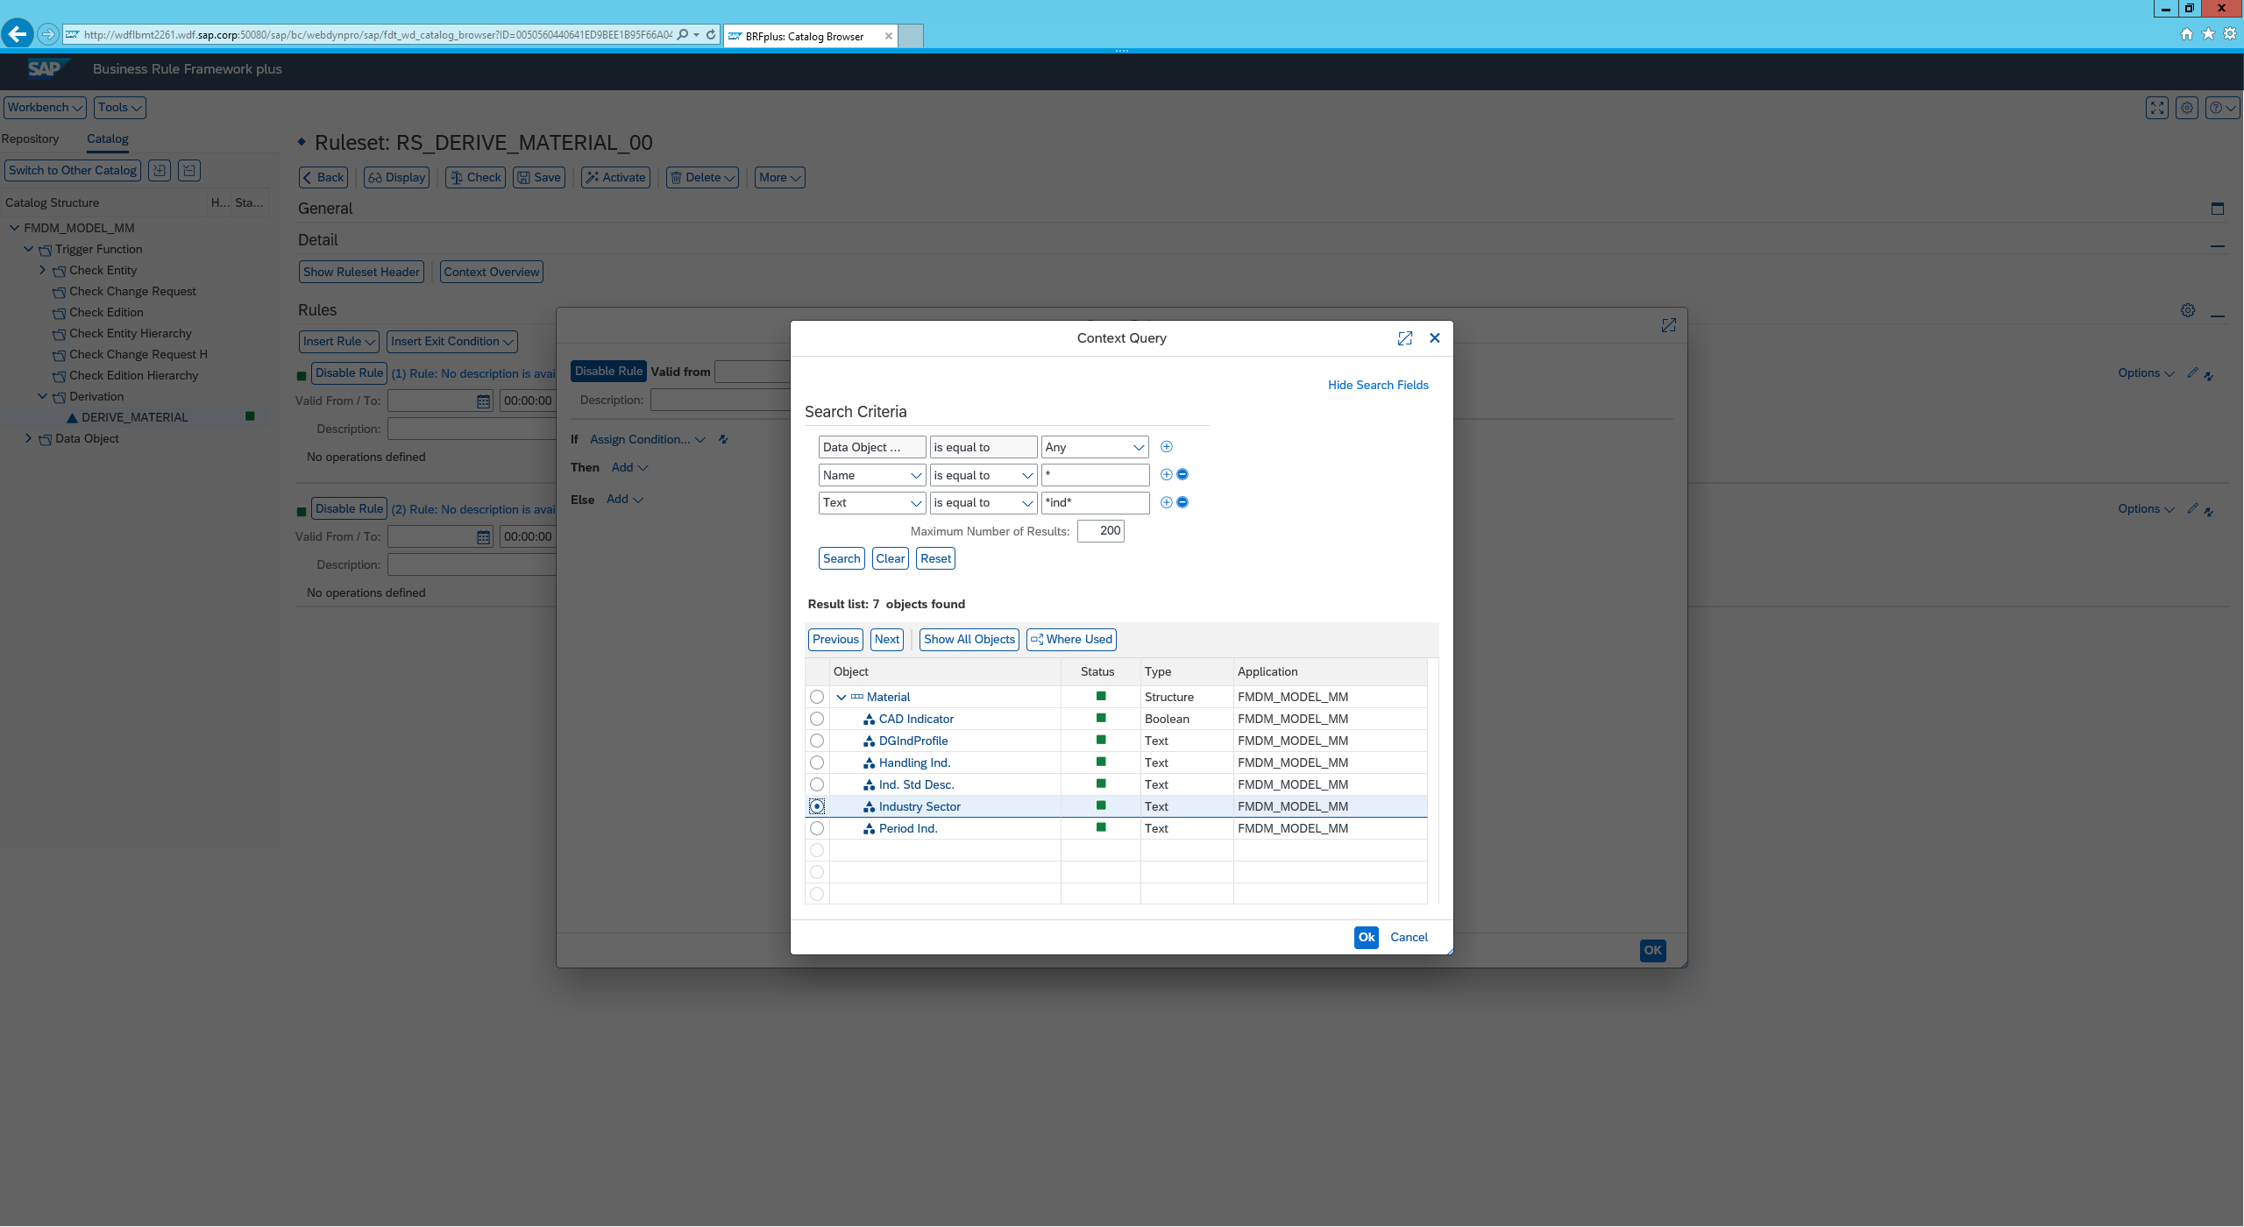

iv)Naturally we would want to add more conditions to do this click change condition 🡪 add more conditions. Once done it is important to change the or to an and

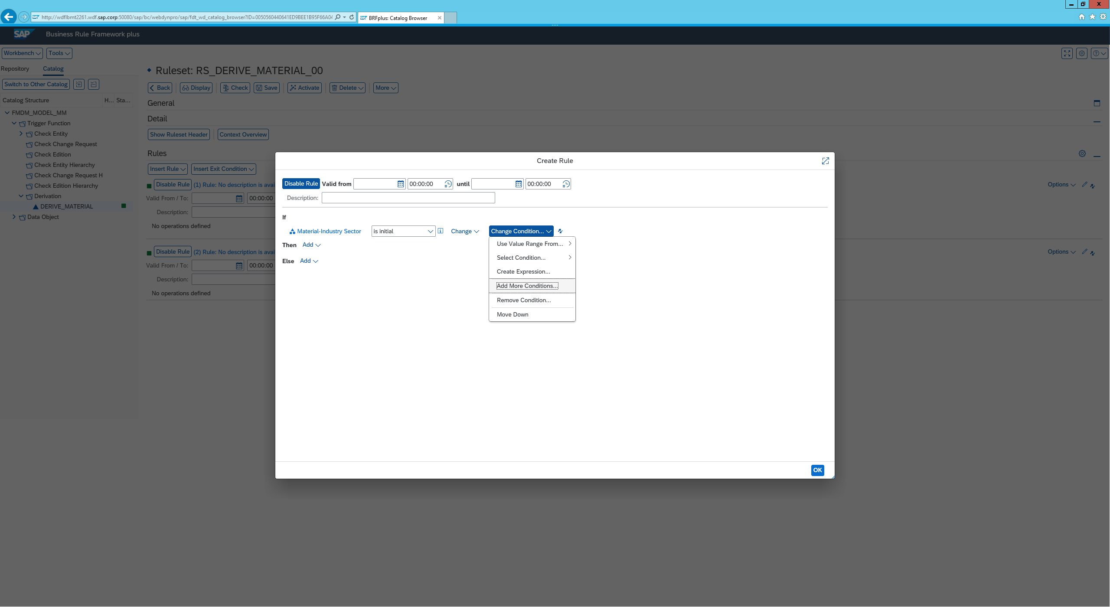

V)To make this rule specific to your user click use direct value range from 🡪 default objects 🡪 Current User

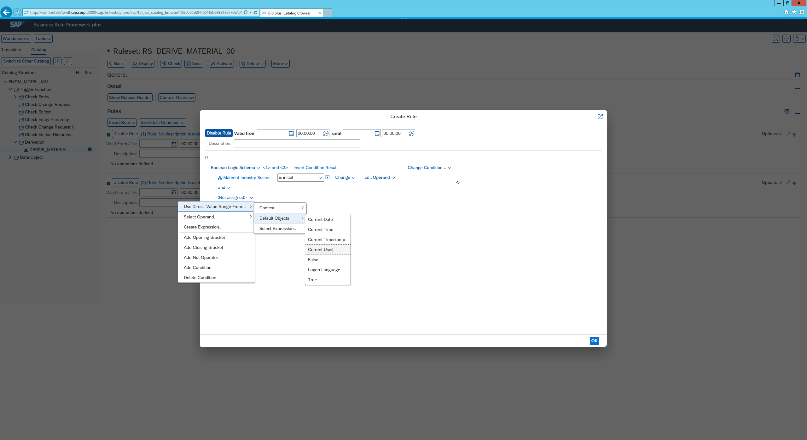

Vi) Lastly we will want to add a result if this statement is true.. So we click on Then 🡪 add 🡪 Assign value to Context 🡪 More

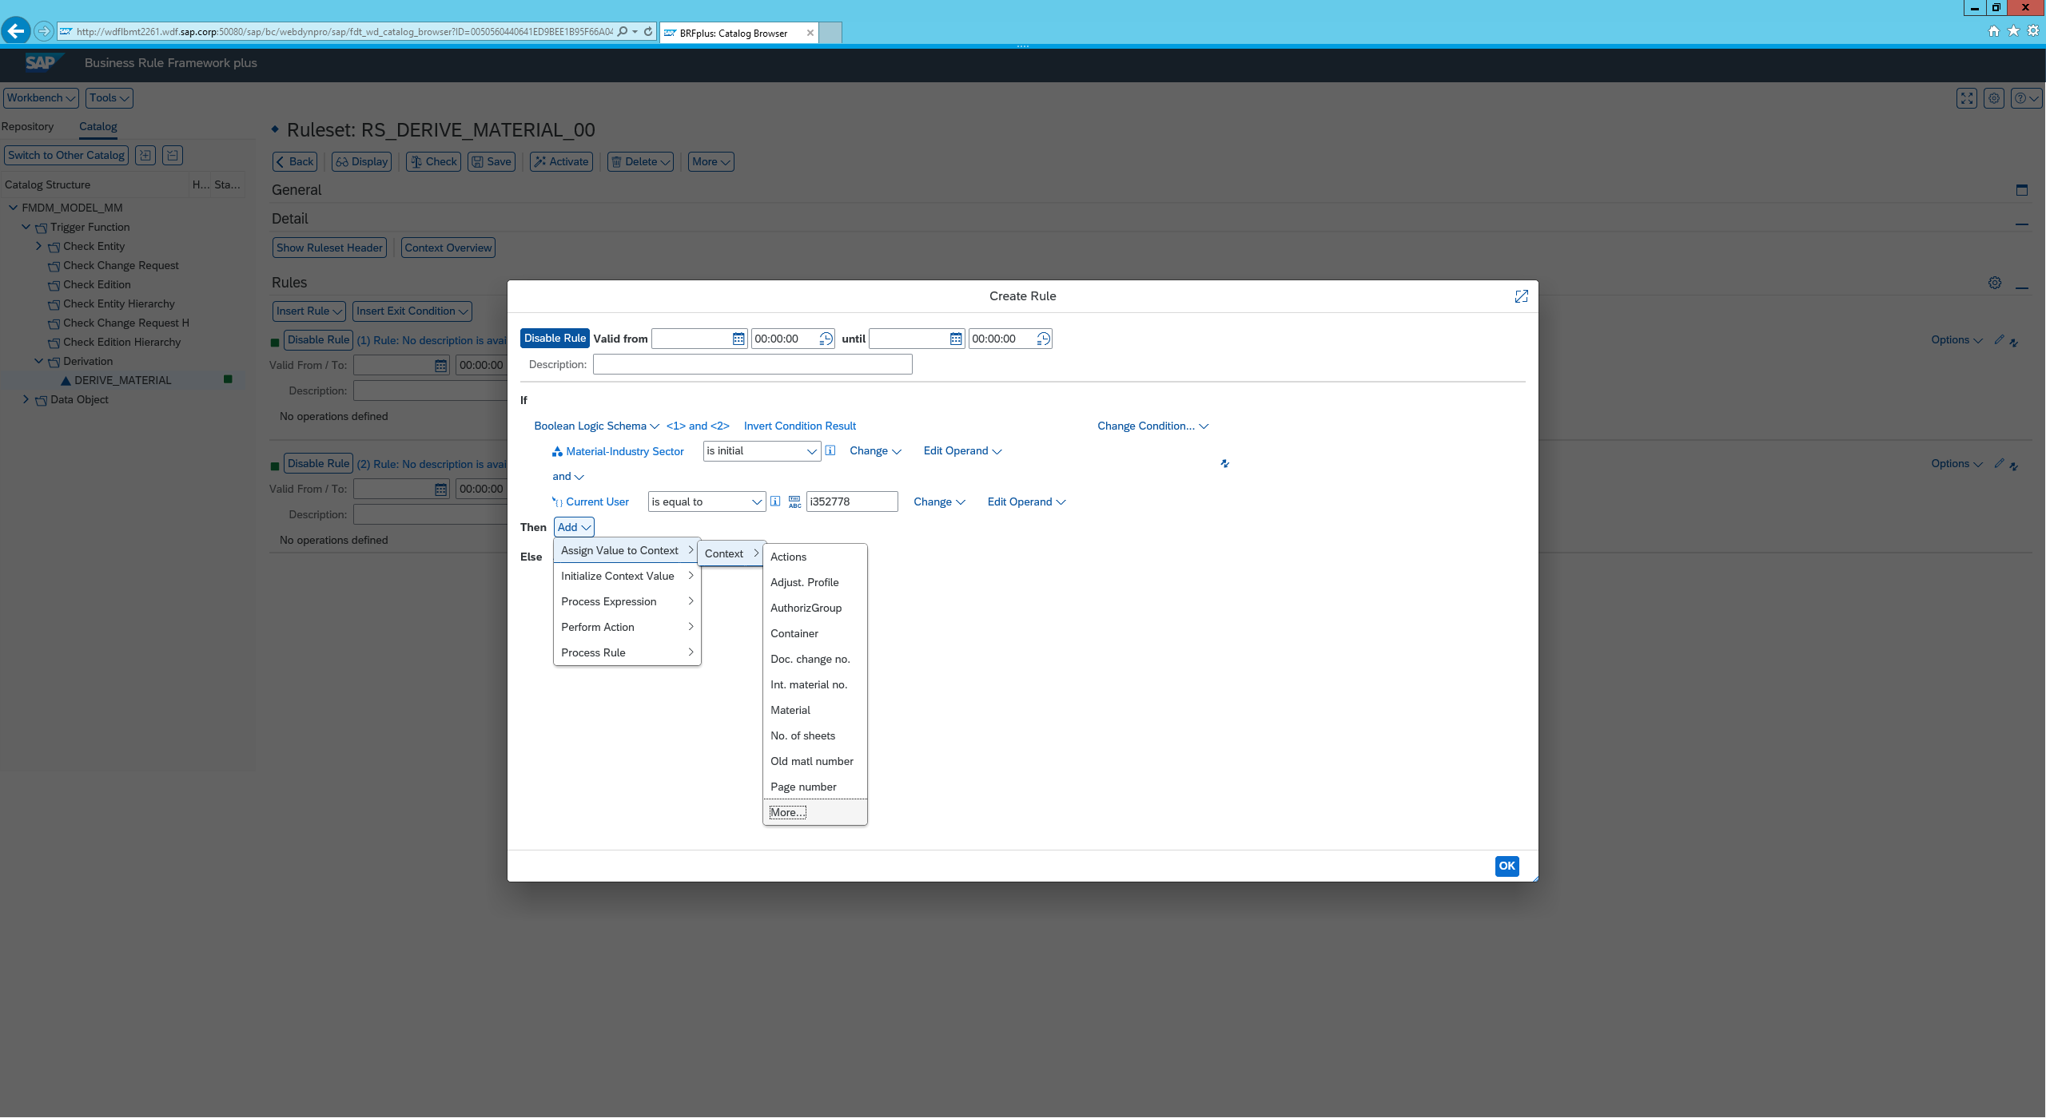

vii) Search as above for industry an add this, Input that the value will be changed to C

Your Derivation should look like this.

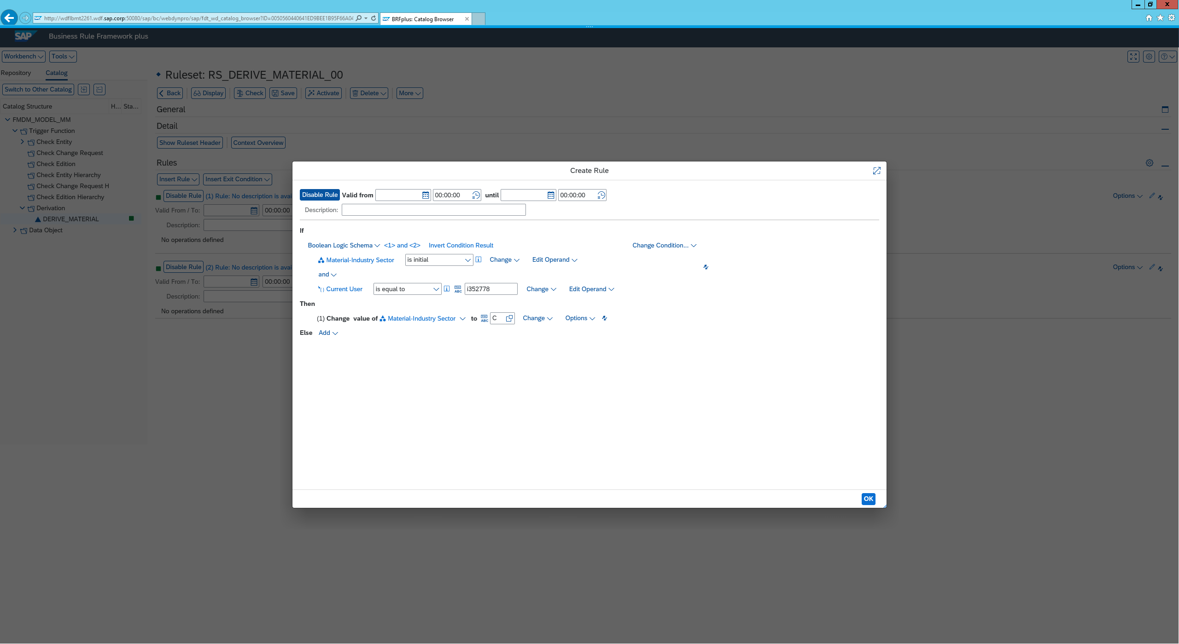

It is important to now activate and save the derivation