The Logical Operators
Chinese Checkers
Iteration 1

Curt Smith
Peter Pobojewski
Saajid Mohammed
Chris Kellendonk
James Kostiuk
Kuba Subczynski
Ben Stitt
Taylor Whited
Table of Contents

Requirements
Use Cases 3

Planning
Team Capacity Calculations 9

Design
Flow Diagrams 10
Class Diagrams 12
Architecture Design 14
GUI Design 17
Visual Design 20
AI Design 26

Testing
Phase 1 Testing Plan 27
Integration Testing 34
Acceptance Testing 36
Ease of Use Testing 44

References 49

Create New Game

Revision History
Date | Author | Description of change
2014/01/18 | Ben Stitt | Authored use case
2014/01/25 | Ben Stitt | Added ID number

Use Case: Create a Game

Id: IT-1-UC-1

Description
The user wishes to start a new game of Chinese checkers. Display the necessary game options and allow the user to interact with them.

Level: User Goal

Primary Actor
Player User

Stakeholders and Interests
Other players may be seeking opponents.

Pre-Conditions
The user has started the game application, and wishes to play a game.

Post Conditions

Success end condition
The game creation screen is displayed, where the user is able to adjust specific game settings, such as number of users, and user names.

Failure end condition:
Game creation screen is not loaded, is not displayed correctly, or the user cannot interact with it properly.

Minimal Guarantee
In the event that any of the above failure conditions occur, the system should remain responsive, and the user should be able to exit the game, without affecting the operating system or files on the device.

Trigger
The user clicks the “New Game” button on the main menu screen of the game application.

Main Success Scenario
- The user clicks “New Game”.
- Game option controls are loaded.
- Defaults are selected.
- The user interacts with option controls to select their preferences.
- The user confirms their options by clicking “Start Game”.

Extensions

This use case can be launched for both local and networked games. In the case of a networked game, the name entry fields need not be displayed.

Variations
In the case of a networked game, the user’s name can be retrieved from a stored profile.

Frequency: This use case should occur at the start of any game. Depending on how often the user plays, frequency may range from weekly to hourly.

Assumptions
The user can read English, and can interact through the use of a touch screen.

Special Requirements
The device must run Android and have the necessary space to install the game. If this use case is launched in relation to a networked game, the device must have access to the Internet.

To do

- Proceed to display game board.

Display Game Board

Revision History
Date | Author | Description of change
2014/01/18 | Ben Stitt | Authored use case
2014/01/25 | Ben Stitt | Added ID number

Use Case: Display game board

Id: IT-1-UC-2

Description
A new game has been created, and the user would like to see the game board.

Level: User Goal

Primary Actor
Player User

Stakeholders and Interests
The player’s opponents need the player to be able to interact with the game.

Pre-Conditions
The user has already used the game creation screen, and has confirmed their options.

Post Conditions

Success end condition
The game board graphics are being displayed to the screen.

Failure end condition:
Game board is not displayed, game board is displayed improperly, or game crashes.

Minimal Guarantee
In the event that the game board is not displayed, or is displayed improperly, the system should remain responsive, and the user should be able to exit the game, without affecting the operating system or files on the device.

Trigger
The user clicks the “Start Game” button on the game creation screen.

Main Success Scenario
- The user clicks “Start Game”.
- The game board module is loaded.
- The game grid is generated, and the pegs are placed on the grid.
- The graphics for the game board, the pegs, and the necessary user controls are rendered and displayed.

Extensions

As different numbers of players may be selected, the pegs generated must have the correct number, colours, and positions.

In addition, this use case may also be triggered by loading a local or online game, or joining an online game. As such, the colours and positions of pegs may be recovered from existing records.

Frequency: This use case should occur at the start or resumption of any game. As such, it may occur once after loading the game, or many times. Depending on how often the user plays, and how many games the user plays at once, frequency may range from weekly to every few minutes.

Assumptions
The device is capable of computing the game grid and displaying the game board.

Special Requirements
The device must run Android and have the necessary space to install the game. If this use case is launched in relation to a networked game, the device must have access to the Internet.

Issues

- How is game grid represented?
- How are graphics generated?

To do

- Also allow user to take their turn.
- Pass play control to the next player.

Team Capacity Calculations
Release Level Plan |  |  | Iteration Level Plan
Start | 9-Jan |  | Iteration # | # Weeks | Hours
Finish | 27-Mar |  | 1st iteration | 4 | 192
Last Day of Class | 4-Apr |  | 2nd iteration | 3 | 144
 |  |  | 3rd iteration | 3 | 144
Work Days | 77 |  | 4th iteration | 1 | 48
Work Weeks | 11
# of People | 8 |  | Total Hours |  | 528
Hours/Week/Person | 6
Total Hours | 528

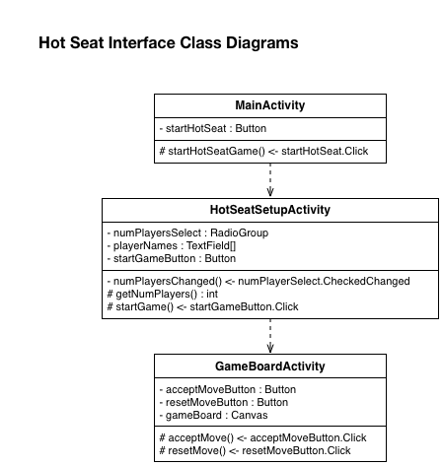
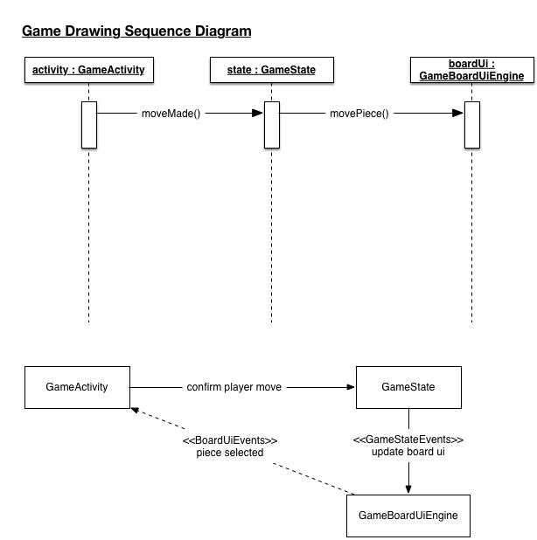
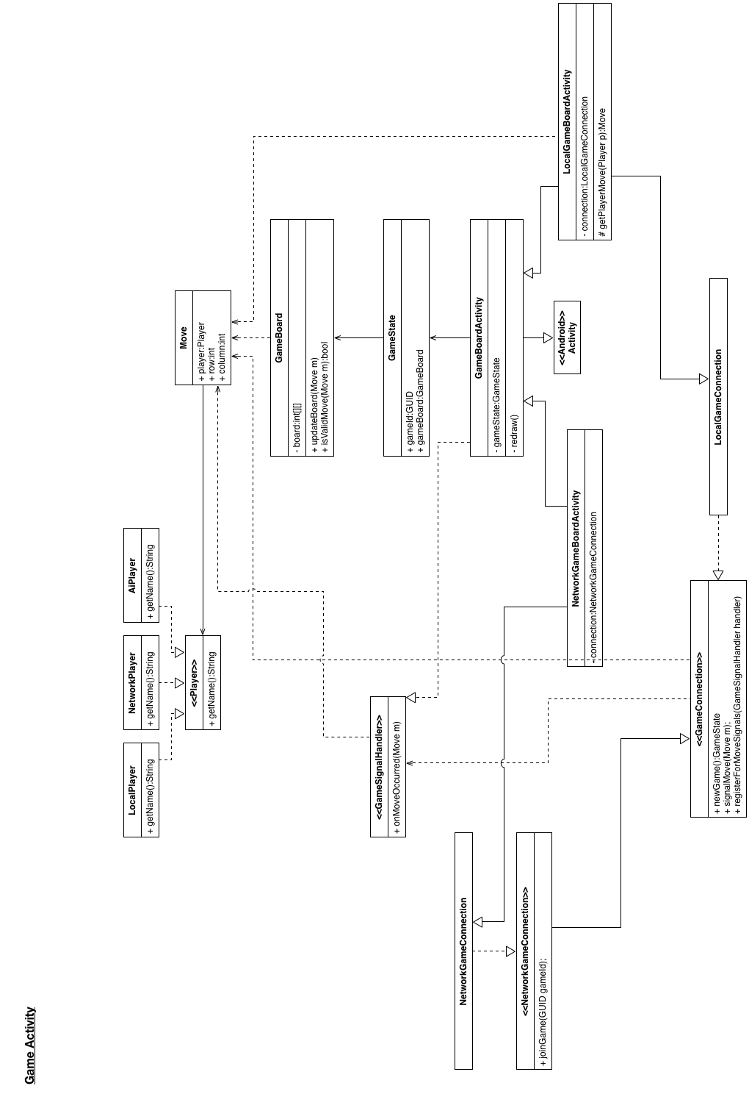

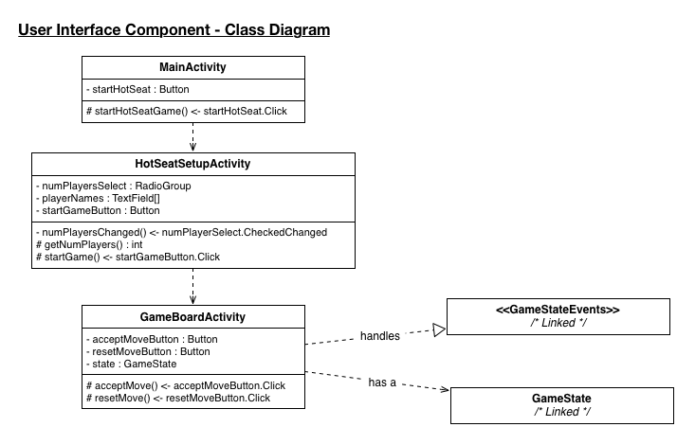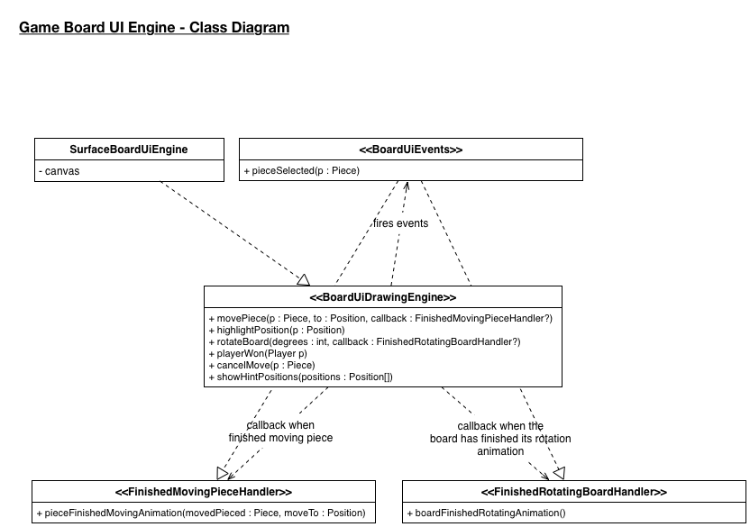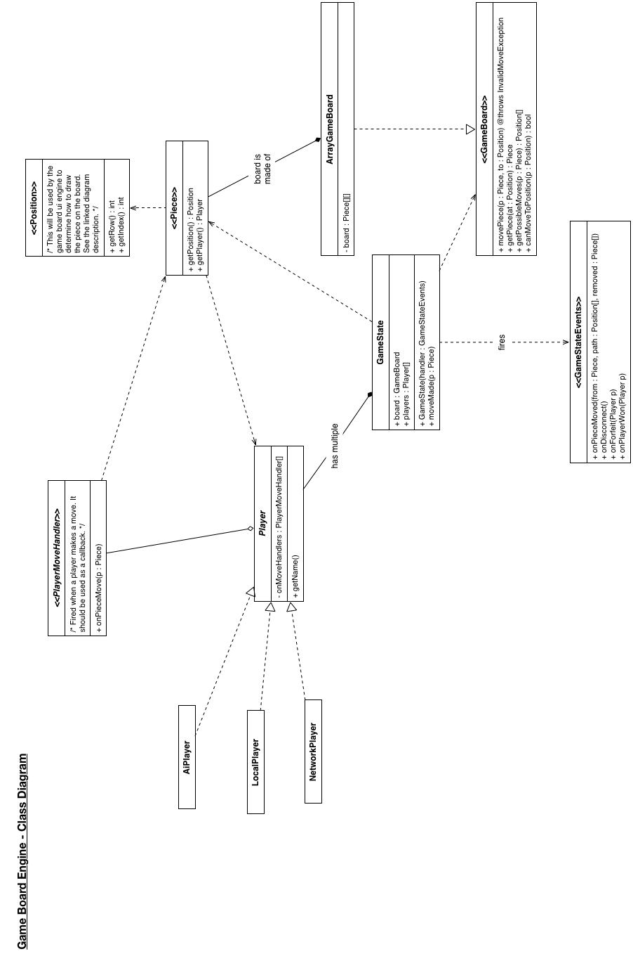

Game Board Engine

The Game Board Engine runs as an event driven system. The engine is made of three main components: the Game Activity, the Game State Manager, and the Game Board UI Drawing Engine. When the local user makes a move the game state is updated and then the game state notifies the drawing handler callback (implemented in the Game Activity) to redraw the board. The handler will then call the Drawing Engine to redraw the board. In this sense the drawing engine is a “dumb/slave” system. It doesn’t actually know about the state of the game, it is just given command to move pieces and do other visual activities.

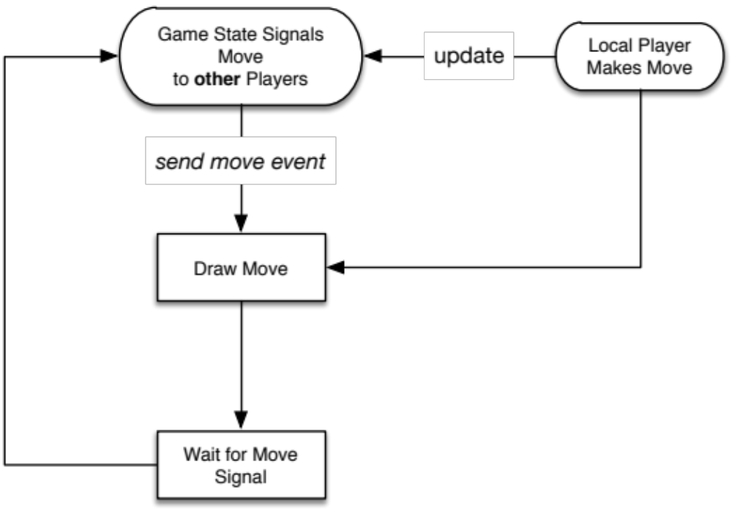

Figure 1 – Event flow when making a move.

Game State Manager

The game state manager manages making sure the state of the game board stays in sync with all other players playing the game. For network-based games this system will involve communicating with the server to send and receive moves to other players. The Hot Seat game play mode which works completely locally works by pretending that it is communicating with the server and handling the move events the same way. Thus those events can be forwarded to the Game Activity without the Game Activity needing much modification to work for both local and network based games.

Game Board UI Drawing Engine

The drawing engine receives commands telling it where to move pieces or what to draw from the Game Activity. It then executes those visual commands and redraws the board to reflect the changes.

This engine is also able to detect touch events on any visual element on the game board. Thus the Game Activity can register to be notified when a piece is touched.

The drawing engine expects that all position related information be given to it in row-index form starting at 0. There is an interface called “Position” that should be implemented and follow these constraints.

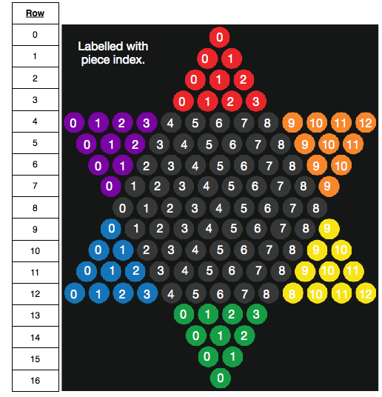
Figure 2 – The Row-Index Format
Game Activity

The Game Activity that holds the game board UI is responsible for handling all the intermediary actions to with updating the state of the game board in the Game State Manager and drawing the state onto the screen. This activity knows about the Game State Manger and the Game Board UI Drawing Engine. Using these the activity can receive events from the state manager and then signal to the drawing engine to move or redraw the board based on whatever state change occurred. The game activity can also signal any other drawing event to the drawing engine that it needs to. As well as it will receive touch events on the game board from the drawing engine, which it can then handle appropriately.

The Game Board

The game board is responsible for keeping the state of where all the players pieces are in the game. It also validates potential moves so that the player can check if a move is allowed. Every piece is guaranteedto be in a valid location based on our defined game rules. Currently players only have a name associated with them.

Players

There are three types of players that implement the “Player” interface.

Local Player

This is a player that is in contact with the actual device. A local player in one instance of a game will be a network player for someone else running the application.

Network Player

This player instance interacts with the server to get details about another player in the game as they are needed.

AI Player (Artificial Intelligence)

The AI player is just an extension of the local player. It can generate custom names as needed.
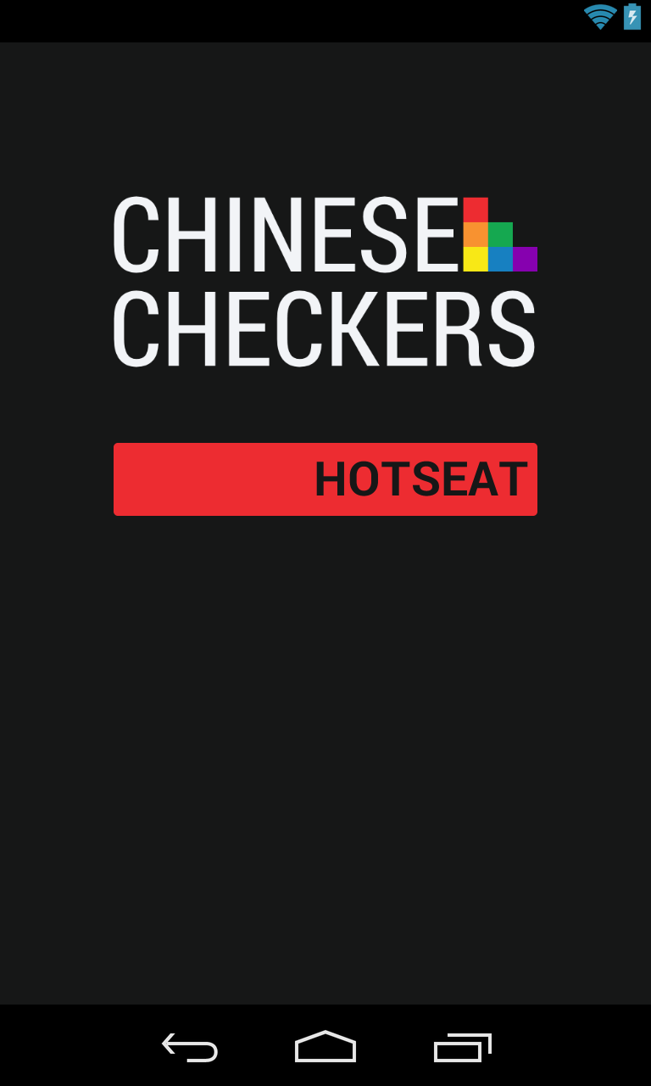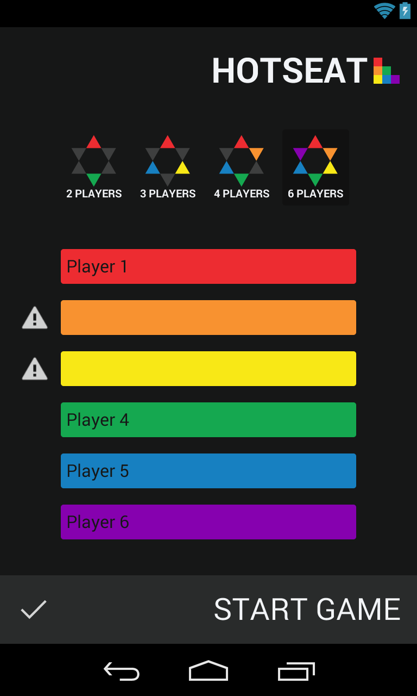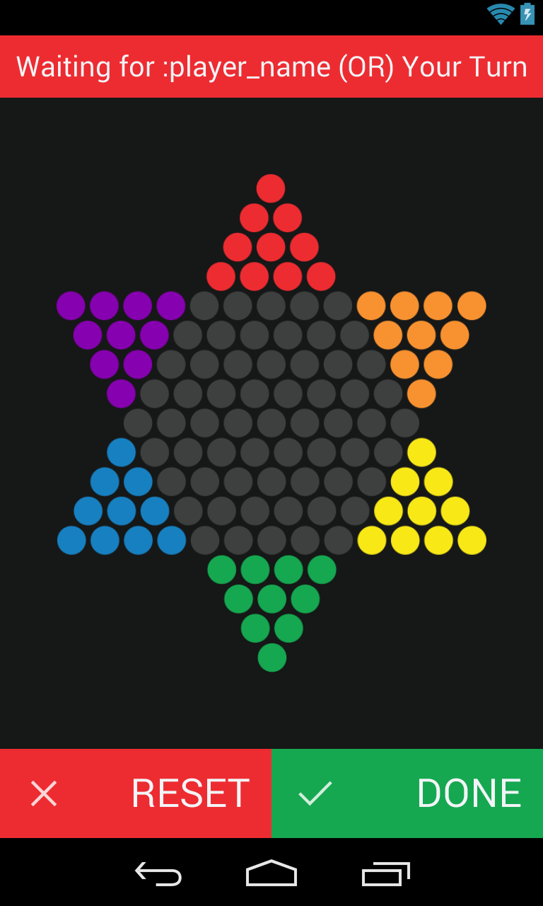
First Iteration Visual Design Document

Introduction
The purpose of this document is to analyse and describe why and how Joint Venture styled the Chinese Checkers interface for the first iteration version of the application. All visual designs and styles were created after an agreed upon user interface was created for the application. The first iteration visual design process will be the most intensive out of all of the iterations of the project because future iterations will be designed based upon the core specifications described in this document.

Textures

Less is More
Trends observed in both mobile and web-based applications in 2013 include: simplicity, minimalism, and less is more ("10 Web Design Trends for 2013", 2012). The Chinese Checkers application was designed with minimalistic and flat textures to ensure that the screen was not overwhelmed while being targeted for smaller devices. From the modern fonts to simplistic images – all have been chosen and designed to be fit with restrictive colour palette to achieve our flat design.

Colour Swatches

Primary Palette

rgb(237, 44, 49)

rgb(248, 146, 38)

rgb(248, 232, 22)

rgb(21, 168, 80)

rgb(23, 128, 193)

rgb(134, 1, 175)

Monochrome Palette

rgb(62, 63, 63)

rgb(124, 125, 127)

rgb(189, 191, 193)

rgb(242, 244, 247)

Chosen Swatches

Multiple swatches were produced for each palette: Primary and Monochrome. The current palettes chosen are a combination of the most attractive swatches from the original batch. The Primary Palette is used on game tokens such as players and pegs. The rainbow scheme should exist in every activity either in elements of the layout or in a graphic appropriately placed in the activity. The Monochrome Palette is used for the core application colours; from left to right: background, empty peg slot, extra, and text.

Rejected Swatches
As described above, multiple swatches were rejected to come up with the current palettes. Rejected swatches may be revisited in future iterations, but are not significant enough to this iteration to include in this design document.

Logo Design

Name
The name of the application is “Chinese Checkers” and, as such, it is the main text in the logo design for the application. The text is in the font Roboto Condensed (see Assets: Typography section for more information on fonts) and is left aligned.

Image
Included in the Chinese Checkers branding is a graphic that represents the six potential players in the six primary colours from the Primary Palette. The squares are aligned in decreasing, diagonal order because a North American user would read from left to right and top to bottom. This image will appear in presentations and other documents where the full brand logo is an inappropriate size.



On a White Background



On Application Background

Assets

Typography
In choosing a font, the team agreed to stay true to a flat and minimalistic style that encompassed the application. The font family Roboto by Android was introduced in Ice Cream Sandwich ("Typography", 2014) and had all of the characteristics of a modern font we required. Roboto comes in two flavours: Normal and Condensed; as well as multiple font styles such as bold, italic and medium. The font in the logo is Roboto Condensed, while the rest of the application is in Roboto Normal.

Iconography
An icon as defined in this document is a graphical representation of an action, status or application. Initially the choice of icon pack to use was the default Android Action Bar Icon Pack, but, after a team discussion, it was decided to use the Font Awesome, MIT licensed icon pack instead. Attribution to Font Awesome will be given in an About section.
The icons chosen are minimalistic, monochromatic images that can scale smoothly from mdpi to xxhdpi resolutions. The colour of the icons is Light Grayish Blue rgb(242, 244, 247) which is consistent with our chosen colour palette. (See Colour Swatches section for more information on colours.)

Roboto Normal
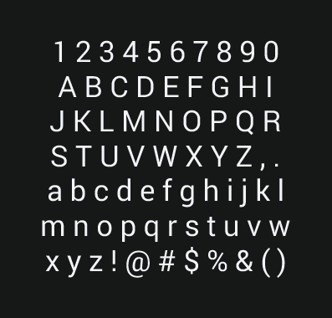

Android Action Bar Icon Pack


Font Awesome


Mock-ups

Main
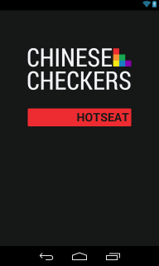

Hot Seat Configuration
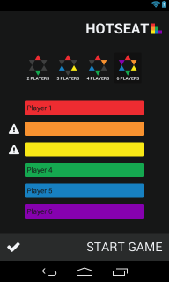

Hot Seat Game
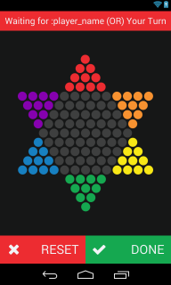

Taking into account the design requirements specified in this document, three mock-up images have been produced that display the layouts of the application for the first iteration as accurately as possible:
- The Main mock-up portrays the first screen that a user will see when the application is launched.
- The Hot Seat Configuration page will be accessed from the Hot Seat button in the Main mock-up.
- After Start Game is pressed in the Hot Seat Configuration mock-up, the user is displayed the game activity which is portrayed in the Hot Seat Game mock-up.

References

10 Web Design Trends for 2013. (2012, February 27). Awwwards. Retrieved January 13, 2014, from http://www.awwwards.com/10-web-design-trends-for-2013.html
Typography. (n.d.). Android Developers. Retrieved February 5, 2014, from http://developer.android.com/design/style/typography.html
AI Design for Chinese Checkers

Details:
Levels of AI to be created: 3
Naming Convention of AIs:
-Easy, Medium, Hard
-Alternatively: Sentinel, Skynet, HAL9000

Summary of AI Strategies:
Easy – A greedy algorithm based AI purely using vertical displacement from the goal state as its sole heuristic.
Medium – Based on the easy AI, the medium difficulty will add minimax algorithms to the heuristic, along with new heuristics such as horizontal displacement from the center of the board, back piece weight, and split.
Hard – Using the heuristics from the medium AI but extending them to thinking a move in advance and taking the best move this turn for the most optimal overall board state next turn. The hard AI will use a depth first search and alpha-beta pruning to reduce response time

Heuristics:
Vertical displacement – The main objective is to win in a game by getting all pieces from one side of the board to the other. This heuristic prevents the AI of using the strategy of keeping at least one piece in an opponent’s goal zone to prevent them from winning. It also will drive the pieces to the other side of the board to attempt to beat the opponent(s).
Minimax algorithm – There will be an algorithm adding to the heuristic value of each game state by attempting to maximize the board state for the AI itself while giving the least optimal potential moves to the opposing player(s).
Horizontal displacement – Keeping pieces in the center of the board minimizes the amount of moves required and increases the opportunities to jump opponent’s pieces.
Back piece weight – If all except one piece is in the goal state, that piece will take significantly longer to get there by sliding across the board each turn. By adding this heuristic no pieces will be left behind to cause increased completion times.
Split – Pieces move faster while jumping each other. If there is a large gap in a player’s pieces, it is commonly more beneficial to close that gap first so that all pieces may reach the goal state faster.

Optimization:
Advance only – With the split heuristic in place it becomes important to add this restriction to prevent pieces from moving toward the initial state just to ‘save’ a friendly piece. Only moves which advance towards the goal state will be measured, others will be rejected.
Take shortest path to win – If a move this turn has the same result as the optimal move next turn, use the shortest depth path to it.
More optimization to come during implementation and testing.

Phase One Testing Plan for Chinese Checkers

Prepared By:
Saajid Mohammed
January 20th, 2014.

Revised And Edited By:
Ben Stitt
January 23rd, 2014

Table of Contents:

- – Introduction

- – Objectives

- – Testing Phases
  - - Unit Testing
  - - Integration Testing
  - - Performance and Stress Testing
  - - Regression Testing
  - - Ease of Use Testing
  - - Acceptance Testing

- – Testing Feedback Procedure

- – Features To Be Tested

- – Features Not To Be Tested

- – Dependencies

- – Tools

- – Approvals

- – Introduction
The program to be tested is a framed out version of a Chinese checkers game for android. It contains three activities, the first with a button leading to the second, the second activity is a configuration screen for the game you wish to play it contains the options to set the number of players and their names it then launches the game activity which for the current phase contains a canvas with the game board drawn on it and buttons to confirm a players move and undo a move.

- – Objectives
Verify the current phase programming is functional and works consistently.

- – Testing Phases
  - - Unit Testing
Each activity shall be tested separately

- MainActivity
  - hotseatConfigurationActivityButton
    - Verify isClickable
    - Verify proper methods are being called
- HotSeatSetupActivity
  - hotseatTwoPlayerButton
    - Verify isClickable
    - Verify proper methods are being called
    - Verify 2 input fields are presented
  - hotseatThreePlayerButton
    - Verify isClickable
    - Verify proper methods are being called
    - Verify 3 input fields are presented
  - hotseatFourPlayerButton
    - Verify isClickable
    - Verify proper methods are being called
    - Verify 4 input fields are presented
  - hotseatSixPlayerButton
    - Verify isClickable
    - Verify proper methods are being called
    - Verify 6 input fields are presented
  - hotseatRedPlayerNameEditText
    - Verify accepts text
  - hotseatGreenPlayerNameEditText
    - Verify accepts text
  - hotseatPurplePlayerNameEditText
    - Verify accepts text
  - hotseatBluePlayerNameEditText
    - Verify accepts text
  - hotseatYellowPlayerNameEditText
    - Verify accepts text
  - hotseatOrangePlayerNameEditText
    - Verify accepts text
  - hotseatGameActivityButton
    - Verify isClickable
    - Verify proper methods are being called
    - Verify player name variables are being bundled to be passed
    - Verify intent is being generated and intent is being destroyed
- GameBoardActivity
  - Verify variables are being unwrapped from bundle
  - hotseatMoveResetButton
    - Verify isClickable
    - Verify proper methods are being called
  - hotseatMoveDoneButton
    - Verify isClickable
    - Verify proper methods are being called

  - - Integration Testing
- Home Activity and Hot Seat Configuration Activity Joined
  - Unit Tests are redone
  - Verify transition between activities are functional
- Home Activity and Hot Seat Configuration Activity and Hot Seat Game Joined
  - Unit Tests are redone on each activity
  - Verify transitions between activities are functional

  - - Performance and Stress Testing
    - Performance
- N/A
    - Stress Test
- N/A

  - - Regression Testing
N/A

  - - Ease of Use Testing
A focus group shall be assembled and given access to the functioning application they will also be given a set of tasks to accomplish. Each member of the focus group shall then fill out an Ease of Use Testing Form (Appendix B) . The forms will then be tallied and actions shall be taken in accordance with the results.

  - - Acceptance Testing
Criteria and this phase testing to be determined by team leader.

- – Testing Feedback Procedure
At the end of each test phase or immediately following a failure of an in phase test, a Test Feedback Form (Appendix A) shall be generated. The feedback form will be generated as an issue on GitHub with the contents of the Appendix A. Further action shall be determined on case bases. However failures for unit tests at the developer level are not required to generate a test feedback form, only passes specified in this document at the unit test phase are required to be documented with a test feedback form.

- – Features To Be Tested
- MainActivity
  - Button Functionality
  - Transition To Hot Seat Configuration Activity
- HotSeatSetupActivity
  - Buttons Functionality
  - EditText Functionality
  - Transition To Hot Seat Game Activity
- GameBoardActivity
  - Buttons Functionality

- – Features Not To Be Tested
N/A

- – Dependencies
Availability of classes and modules for current phase.

- – Tools
Eclipse
JUnit API
Android Testing API

- - Approvals
Name | Project Role | Signature | Date
1. Curtis Smith | Project Lead | ____________________________ | _________
2. Peter Pobojewski | Deputy Lead | ____________________________ | _________
3. Ben Stitt | Documentation Lead | ____________________________ | _________
4. Saajid Mohammed | Test Lead | ____________________________ | _________

APPENDICES

APPENDIX A: Test Feedback Form

Test Feedback Form

Project: ___________________________________________________________

Project Phase: _____________ Test Phase: _______________ Date: ______

Tester: ___________________

Pass\Fail\Extra Consideration Required: _______________________________

Remarks(If fail what caused failure): _____________________________________________________________________________________________________________________________________________________________________________________________________________________________________________________________________________________________________________________________________________________________________________________________________________________________________________________________________________________________________________________________________________________________________

Test Output (If Applicable): __________________________________________

Action Taken: __________________________________________________________________________________________________________________________

Tester Signature: _____________ Project Lead Signature:_______________

Test Lead Signature: ______________ Project Lead Name:_____________

Test Lead Name: _________________

APPENDIX B: Ease of Use Testing Feedback Form

Give each of the tasks a rating from 0 to 10 based on the difficulty of accomplishing the relevant tasks.

Task 1 Score: _____
Task Remarks: __________________________________________________________________________________________________________________________

Task 2: _____
Task Remarks: __________________________________________________________________________________________________________________________

Task 3: _____
Task Remarks: __________________________________________________________________________________________________________________________

Task 4: _____
Task Remarks: __________________________________________________________________________________________________________________________

Task 5: _____
Task Remarks: __________________________________________________________________________________________________________________________

Task 6: _____
Task Remarks: __________________________________________________________________________________________________________________________

Task 7:_____
Task Remarks: __________________________________________________________________________________________________________________________

General Remarks: ____________________________________________________________________________________________________________________________________________________________________________________________________________________________________________________

Test Feedback Form

Project: Chinese Checkers

Project Phase: 1 Test Phase: Integration Testing Date: 02/05/14

Tester: Saajid Mohammed

Pass\Fail\Extra Consideration Required: Pass

Remarks(If fail what caused failure): None

Test Output (If Applicable): See Attached As Integration Test Results

Action Taken: No Action Need

Tester Signature: _____________ Project Lead Signature: _______________

Test Lead Signature: ______________ Project Lead Name: Curtis Smith

Test Lead Name: Saajid Mohammed

21.38 s
All Tests: 9 total, 9 passed

4.15 s
ca.brocku.chinesecheckers.tests.HomeAndSeatTest

4.15 s
passedtestTransition

9.50 s
ca.brocku.chinesecheckers.tests.HomeSeatAndGameTest

9.50 s
passedtestTransition

6.73 s
ca.brocku.chinesecheckers.tests.HotseatConfigurationActivityUnitTest

2.58 s
passedtestActivity

951 ms
passedtestFourPlayerConfig

1.08 s
passedtestSixPlayerConfig

1.02 s
passedtestThreePlayerConfig

1.10 s
passedtestTwoPlayerConfig

500 ms
ca.brocku.chinesecheckers.tests.HotseatGameActivityUnitTest

500 ms
passedtestActivity

500 ms
ca.brocku.chinesecheckers.tests.MainActivityUnitTest

500 ms
passedtestActivity

Generated by Android Studio on 2/5/14 7:13 PM
Acceptance Test Plan
Chinese Checkers

COSC 3F00 Team #2 - Logical Operators
Authors: Curtis Smith

Document Management

Table of Contents
Document Managementh.gjdgxs
Table of Contentsh.30j0zll
Revisionsh.1fob9te
Introductionh.3znysh7
Project Descriptionh.tyjcwt
Test Team Personnelh.lnxbz9
Glossaryh.35nkun2
Deliverablesh.44sinio
Hardwareh.2jxsxqh
Softwareh.z337ya
Acceptance Test Planh.1y810tw
Structureh.4i7ojhp
Order of Testsh.1ci93xb
Testingh.2bn6wsx
Functional Testing
Workflow #1
Software Testingh.3as4poj
Deficienciesh.1pxezwc
Issuesh.49x2ik5
Action Planh.2p2csry
Final sign-offh.3o7alnk
Acceptance Testingh.23ckvvd
h.6wtnxhiwu0z1

h.6wtnxhiwu0z1
h.6wtnxhiwu0z1

Revisions
Version | Primary Author(s) | Description of Version | Date Completed
1 | Cutis Smith | Initial Version | February 5th, 2014

Introduction
This document outlines the methods and testing procedures for all acceptance testing for the Chinese Checkers application designed and developed by the COSC 3F00 team known as Logical operators. Each test has two possible outcomes: pass or fail. Any failed test is reason for the entire test sequence to be failed.

Project Description
We are creating a version of Chinese Checkers. Our target audience will be users that are 6 years of age and older. The game will be played with both human and computer players. Our target platform will be Android phones (original launch on OS version 4.0, API version level 14). If there is time we will also consider an implementation that can be used on a suitable tablet platforms.
We will be developing the solution using Android Studio using GitHub as our source code repository.
Graphics will be created using OpenGL.
Networking will be accomplished using the internet via HTTP and centralized on a web server using Node.js. Heavy processing for the AI will be executed on the web server so as to limit the processing power needed on the user's device. JSON will be the preferred method to exchange data between the Node server and Android clients.
The database solution will be MySQL.
We will implement the game as a "push game" -- where users are notified when it is there turn. This will add the option of playing a game over multiple sittings, while maintaining the ability to a play fast-paced game.
All technical documents and project tracking will be available from the GitHub wiki and service hooks available from this tool.

Test Team Personnel
The test team consists of one VENDOR NAME tester and one primary customer witness who have the authority to sign off tests. Optionally, a small, agreed number of additional customer observers can observe the tests and input their observations to the primary witnesses.
Name | Role | Team
Curtis Smith | Team Leader/Tester | COSC 3F00 Logical Operators
Saajid Mohammed | Test Lead | COSC 3F00 Logical Operators

Glossary
Term | Definition

Deliverables

Hardware
The following hardware items must be delivered fully inspected and functional.
Quantity | Deliverable | Pass / Fail | Model/Part #
n/a | n/a | n/a | n/a

Software
The following software items must be delivered fully inspected and functional.
Quantity | Deliverable | Pass / Fail | Product/Part #
n/a | n/a | n/a | n/a

Acceptance Test Plan

Structure
Each test process involve COSC 3F00 Logical Operator personnel running the test procedures described in this document to the satisfaction of the team.

Order of Tests
The tests in the following section are listed in the same order as they should be performed during acceptance testing. This is to help give a logical flow of work on the system. The order of the tests is designed to minimize the use of the same elements of the system at the same time.

Testing
All tests taking place during acceptance testing will be outlined in this section. The following table is an example. Columns that are colored grey mean that that particular test will not occur during that test phase.
# | Test Description | Expected Result | Phase 1 | Phase 2 | Phase 3 | Phase 4
1 | Action 1 performed... | Expected Result...
2 | Action 2 performed... | Expected Result...

Software Testing
Each software component provided by Logical Operators must be tested and perform to the expected standards outlined in the table below. It is expected that several bugs or unexpected behaviors may occur during testing. Any bug, unexpected behavior, or missing functionality will be documented as a deficiency. Each software deficiency must be resolved and tested prior to sign-off unless agreed upon in writing by both parties.
# | Test Description | Expected Result | Pass | Fail
1 | Touching the game logo icon from the main apps screen with the device oriented rightside up.. | The application will launch and come to rest on the HOTSEAT screen and will match the design mockup “main.png” | X
2 | Touching the game logo icon from the main apps screen with the device oriented upside down.. | The application will launch and come to rest on the HOTSEAT screen and will match the design mockup “main.png” |  | X
3 | On the HOTSEAT screen, touching the HOTSEAT button | The HOTSEAT game configuration screen will be displayed and will match the design mockup “hotseat_config.png” but will be defaulted to a 2 player game with the input text field for player 1 in focus and the 2 players game selection icon will appear in “selected” mode. | X
4 | On the HOTSEAT game configuration screen, touching the 3 players game option icon | A total of 3 Player input text fields will be displayed and the 3 players game selection icon will appear in “selected” mode. | X
5 | On the HOTSEAT game configuration screen, touching the 4 players game option icon | A total of 4 Player input text fields will be displayed and the 4 players game selection icon will appear in “selected” mode | X
6 | On the HOTSEAT game configuration screen, touching the 6 players game option icon | A total of 6 Player input text fields will be displayed and the 6 players game selection icon will display in “selected” mode. | X
7 | Touch the “START GAME” button on the HOTSEAT game configuration screen with at least one of the player name input fields left blank. | Validation of the player name input fields should prevent the application from navigating to the HOTSEAT game screen.  All empty player name input fields should be marked with an alert icon to indicate missing data | X
8 | Touch the “START GAME” button on the HOTSEAT game configuration screen with all the enabled player name input fields populated with data. | The application should navigate to the HOTSEAT game screen which will match the design mockup hotseat_game.png.  The name and color of the first player will be shown at the top of the screen.  The RESET and DONE buttons will be enabled | X

Deficiencies

Issues
# | Test # / Sequence | Description | Comments
1 | 2 | The HOTSEAT screen did not reorient itself and was displayed upside down | Ideally the application will reorient itself to display right side up at all times.

Action Plan
Deficiency | Action Plan
1 | A defect will be opened in GitHub and the feasibility of allowing reorientation of the application will be dicsussed by the team and a decision will be made on how best to proceed.

Final sign-off

Acceptance Testing
The Acceptance Testing for Chinese Checkers prepared by Logical Operators for COSC 3F00 was
ACCEPTED / ACCEPTED WITH DEFICIENCIES / REJECTED.
Tested by: | Date:
Curtis Smith | 2/5/14

Ease of Use Tasks

Task 1: Launch game
Task 2: Get to a new game setup screen
Task 3: Set up a game for two players using random names and start it
Task 4: Set up a game for six players
Put your name for Red
Put Curtis for Blue
Put Ben for Purple
Put Kuba for Yellow
Put Chris for Orange
Put Taylor for Green
Start the game
Ease of Use Testing Feedback Form

Give each of the tasks a rating from 0 to 10 based on the difficulty of accomplishing the relevant tasks.

Task 1 Score: 0
Task Remarks: Icon was visually attractive, it also worked when I clicked it which was nice

Task 2: 2
Task Remarks: I had to think about where on the screen to touch to begin the process.

Task 3: 0
Task Remarks: This task was not difficult at all, very organized and user friendly.

Task 4: 1
Task Remarks: N/A

General Remarks: Overall the program was visually appealing and user friendly. Good work.
Ease of Use Testing Feedback Form

Give each of the tasks a rating from 0 to 10 based on the difficulty of accomplishing the relevant tasks.

Task 1 Score: 0
Task Remarks: Vibrant app logo made it easy to

Task 2: 2
Task Remarks: Was unsure of where to click

Task 3: 0
Task Remarks: N/A

Task 4: 0
Task Remarks: N/A

Task 5: 0
Task Remarks: N/A

General Remarks: Very pretty app. Buttons on the setup screen were not centered.
Ease of Use Testing Feedback Form

Give each of the tasks a rating from 0 to 10 based on the difficulty of accomplishing the relevant tasks.

Task 1 Score: 0
Task Remarks: like the icon for the game.

Task 2: 2
Task Remarks: it would look better if the button and the logo was in the middle of the screen. easy to read.

Task 3: 7
Task Remarks: can’t see the word in the red box. _like the designs of the number of player selection buttons but would make them as big as a normal fingernail. Like the position of the selection input at the top.

Task 4: 9
Task Remarks: Harder than task 3 because there were more player name to enter. liked the colors. Liked the position of the input fields. Liked the game board size and position. Size of the name text could be bigger. Buttons at the bottom are good size.
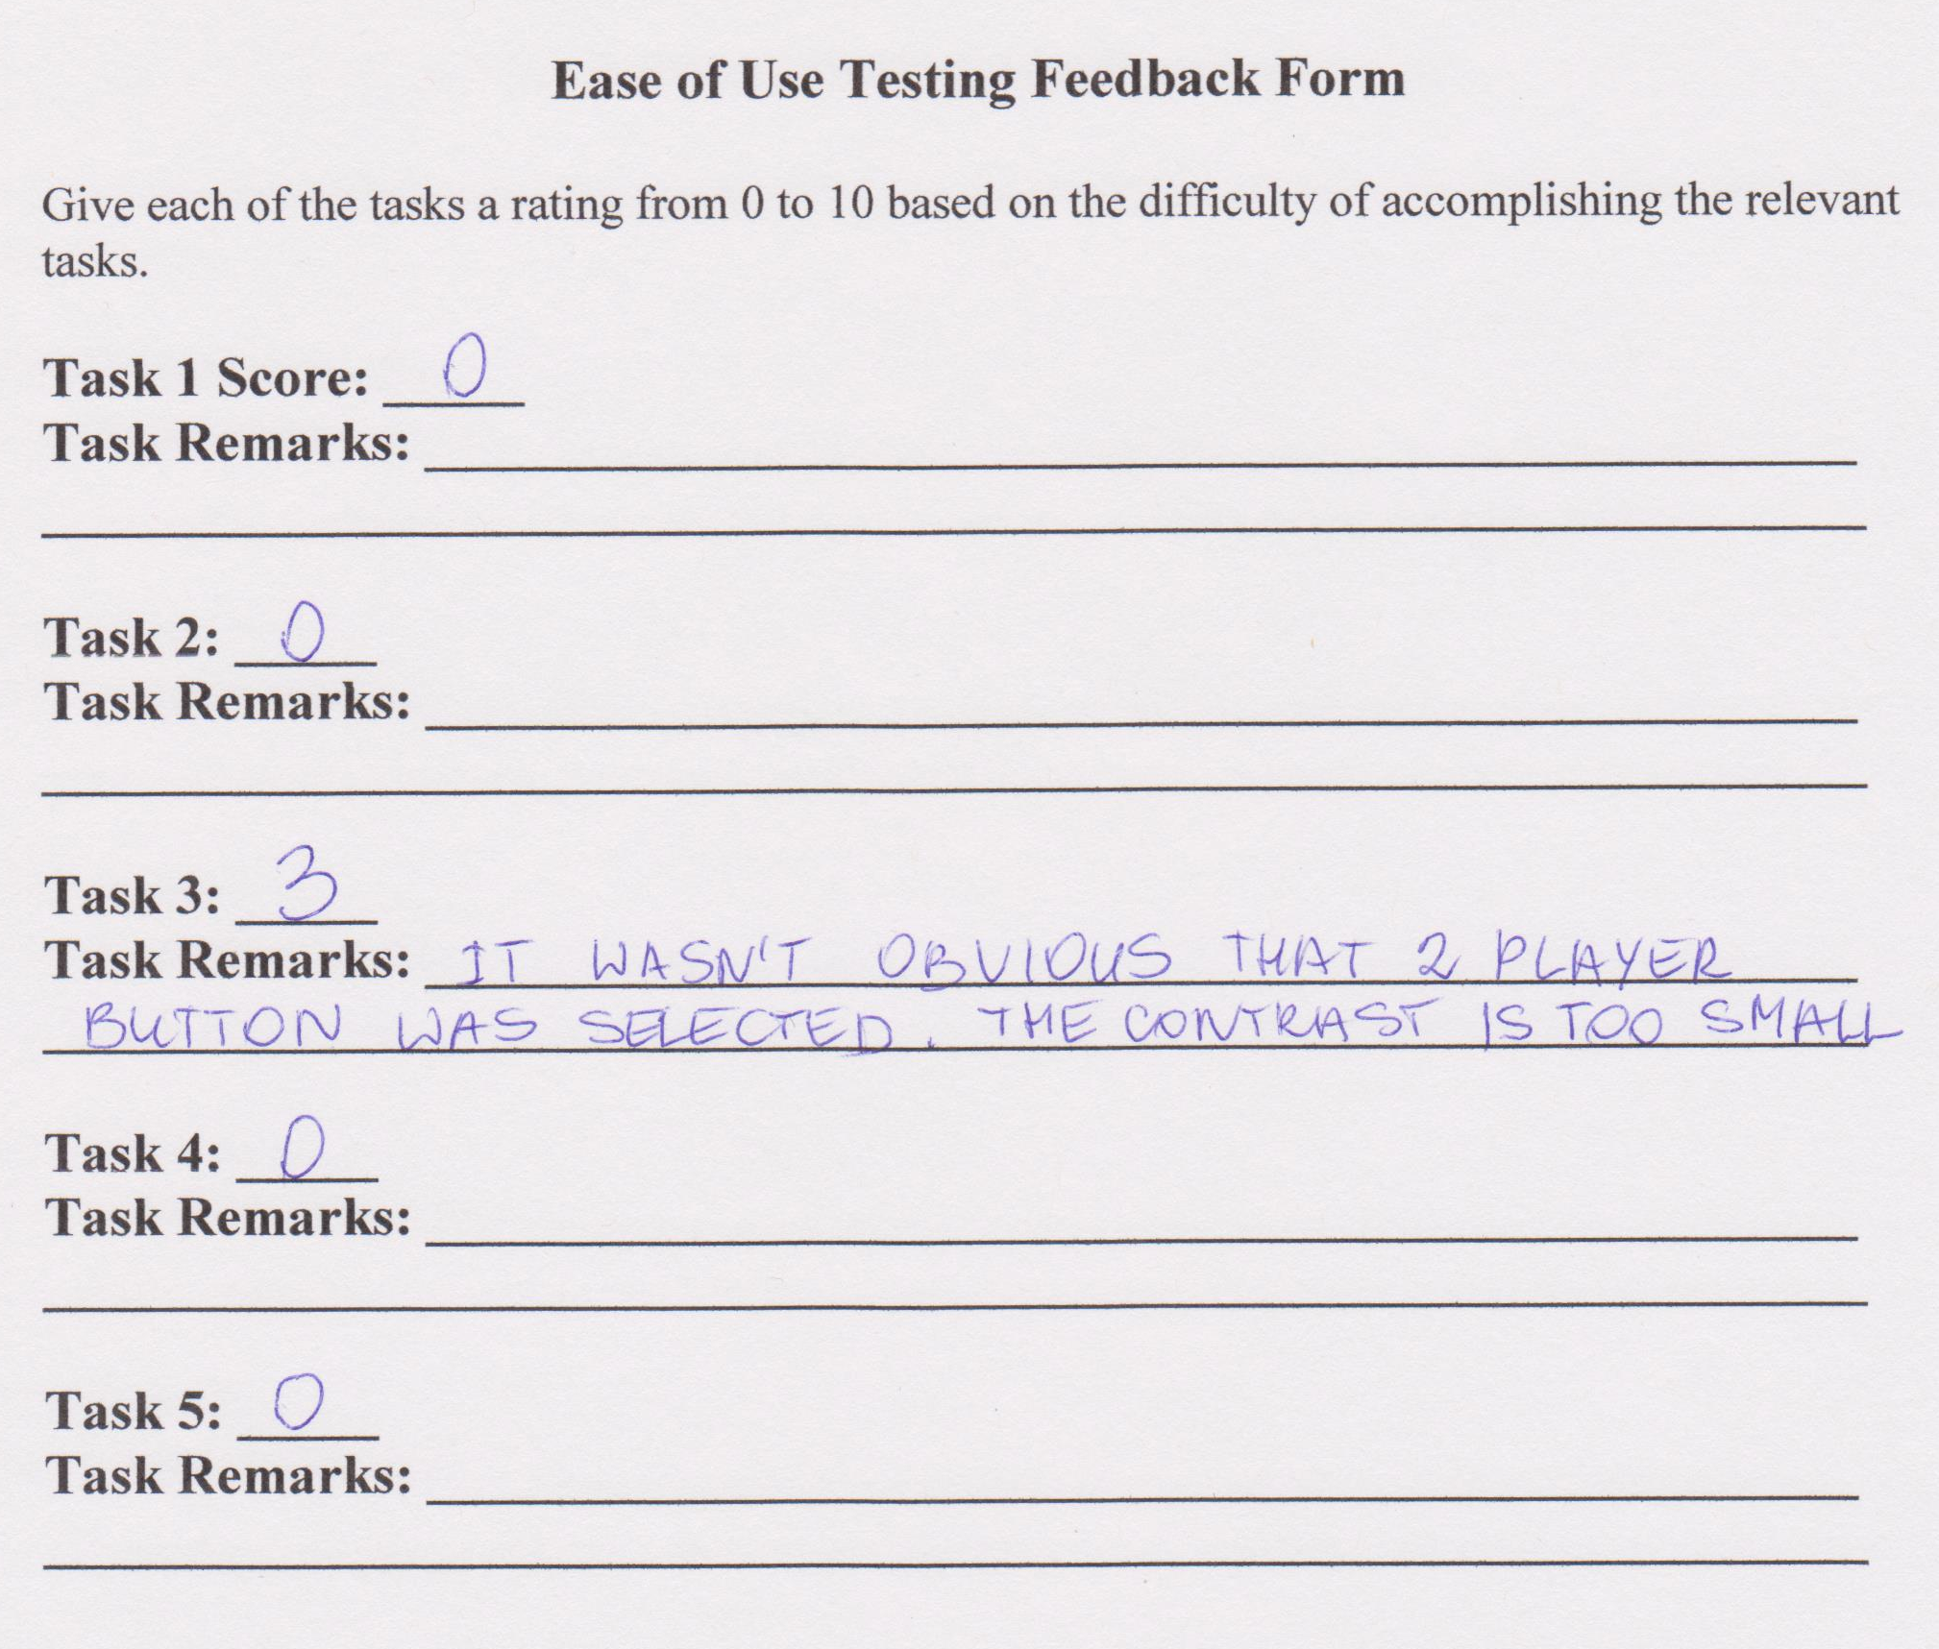
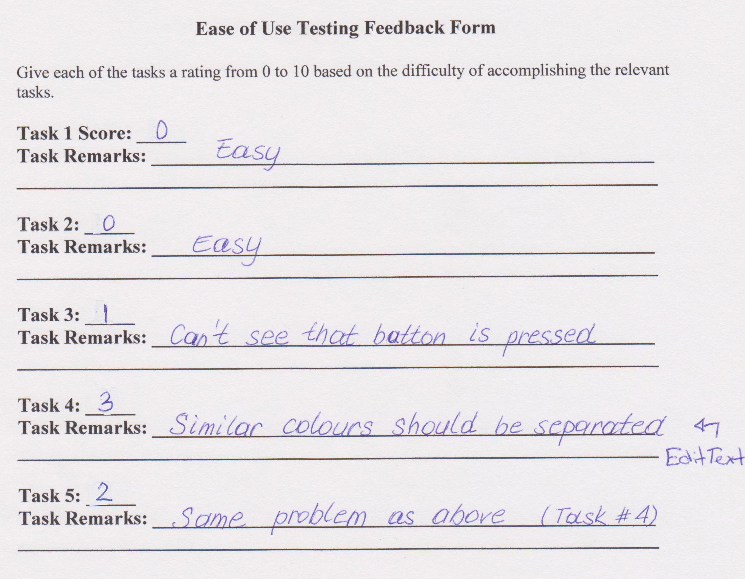
References

Use Case Template: Copyright (c) 2004-2005 TechnoSolutions Corporation
www.technosolutions.com

